Architectures for Software Systems
Present structures of software Architecture
Reading Questions 6
Nguyễn Sĩ Hiền – K14T01
Readings:
[Clement 02] Prologue, chapter 5, 6
Questions:
- Establish style guide for Allocation Viewtype
Answer:
- Allocation ViewType have three main common styles:
  - The deployment style describes the executable software on which hardware.
  - The implementation style describes the mapping of modules on a configuration management scheme and helps the organization of the files that implement the modules
  - The Work Assignment style describes the aggregation of modules according to the people, groups, or teams which are tasked with the actual development of the implementations of the modules
- And then is element, relations , and properties of allocation ViewType :
Elements | - Software element The software elements in a view of the allocation viewtype come from a view in either the module or C&C viewtype  - Environment element represent any piece of an environmental structure, such as a processor, disk farm, configuration item, or development group
Relations | - The relation in an allocation viewtype is the “allocated to” relation with the direction from the software element to the environmental element
Properties of elements | - A software element has “required” properties. An environmental element has “provided” properties that need to be matched.
Properties of relations | - dependent on the particular style
Topology | - Varies by style

- Allocation viewtype is for :
  - Supports analysis that requires the understanding of various aspects of the environment with which the software is associated.
  - Support analysis of project budget and schedule.
  - Understanding whether or not you have the right tool environment to implement the software will depend on understanding the allocation of software to its environment.
- Allocation isn’t for :
  - A single view of this viewtype, in isolation, is not a complete description of software architecture.
- About Notation for allocation viewtype, we have two notations to show Allocation viewtype. The first is notation informal. We use Informal graphical notations utilized in views in this viewtype contain the typical ingredients (boxes, circles, lines, arrows, etc.) The second is notation formal. We use policy in UML to show.

- List all styles of Allocation Viewtype. Each team member will be assigned one different style and establish style guide for that style.
Answer:
- Allocation Viewtype have three common Style :
  - Deployment style
  - Implement style ( install style )
  - Work Assignment Style
- And then, I establish style Guide for Deployment style
  - Overview: List all styles of Allocation Viewtype. Each team member will be assigned one different style and establish style guide for that style. On which the software executes. A valid allocation ensures that the requirements expressed by the software elements are satisfied by the characteristics of the hardware element(s).
  - Elements, relations, and properties :
Elements | - Environmental elements: hardware of the computing platform—processor, memory, disk, network (such as router, bandwidth, firewall, bridge), and so on. Useful properties of an environmental element are the significant hardware aspects that influence the allocation decision.  - Software element: elements from a C&C view. Useful properties to document include the significant features required from hardware, such as processing, memory, capacity requirements, and fault tolerance.
Relations | - Allocated-to. Physical units on which the software elements reside during execution. Properties include whether the allocation can change at execution time or not.  - Migrates-to, copy-migrates-to, and/or execution migrates- to if the allocation is dynamic. Properties include the trigger that causes the migration.
Properties of elements | - “Required” properties of a software element are the significant hardware aspects, such as processing, memory, capacity requirements, and fault tolerance.  - “Provided” properties of an environmental element are the significant hardware aspects that influence the allocation decision.
Properties of relations | - “allocated to” relation can be static or dynamic as discussed in section
Topology | - unrestricted

  - Deployment style is for:
    - A deployment view is useful for analyzing performance, availability, reliability, and security. Testers use this view to understand runtime dependencies, and integrators use it to plan integration and integration testing
    - A deployment view may also be used to support cost estimation when evaluating purchasing options for hardware.
  - Deployment style is not for:
    - An incorrect use of a deployment view is to treat it as the entire software architecture of a system. A single view in this style, in isolation, is not a complete description of a software architecture
    - Although this observation is true of every style, allocation styles seem especially susceptible. When asked to show their software architecture, architects sometimes present an impressive diagram that shows a network of computers with all their properties and protocols used and the software components running on those computers
    - Although these diagrams fill an important role by helping to organize the work and to understand the software, they do not fully represent the software architecture.
    - Don’t try to force a relationship between modules and hardware units
  - Notation for the deployment style :
    - Informal Notation: Informal graphical notations contain boxes, circles, lines, arrows, and so on to represent the software and environmental elements.
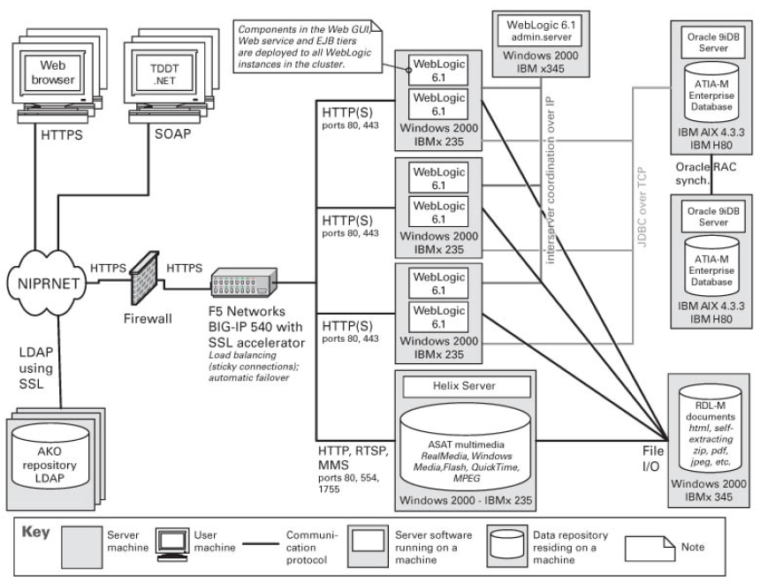
Figure 1: Example of a deployment view in an informal notation
    - Formal Notation : We use UML
[1 point for grammar and overall quality]

