Architectures for Software Systems
Document Architecture
Reading Questions 8
Nguyễn Sĩ Hiền – K14T01 – T086828
Readings:
[Bass 03] chapter 9
[Clement 02] Prologue
[Lattanze 08] chapter 6

Questions:

- Describe briefly seven rules for a sound architecture document. Explain why should keep it current, but not too current?
Answer:
- We have seven rules for architecture document view. That is :
  - Write from the point of view of the stakeholder. When reading a document, the reader wants to know more information easily. Your reader will appreciate your effort and be more likely to read your document. And Last, avoid writing four your convenience.
  - Avoid unnecessary repetition. Each kind of information should be recorded n exactly one place.
  - Avoid ambiguity. Architecture documentation is a communications vehicle. If the reader misunderstands, the documentation has failed.
  - Use a standard organization will make sure your writer adhere to document and make sure the reader know what it is.
  - Record rationale. In this part, we explain why you make certain design decisions.
  - Keep documentation current but not too current. We mustn’t update continues day to day. We must have plan update, so Stakeholder will easy to review version.
  - Review documentation for fitness of purpose.

- Show a template for documenting a view.
Answer:
- This is structure when we present view.
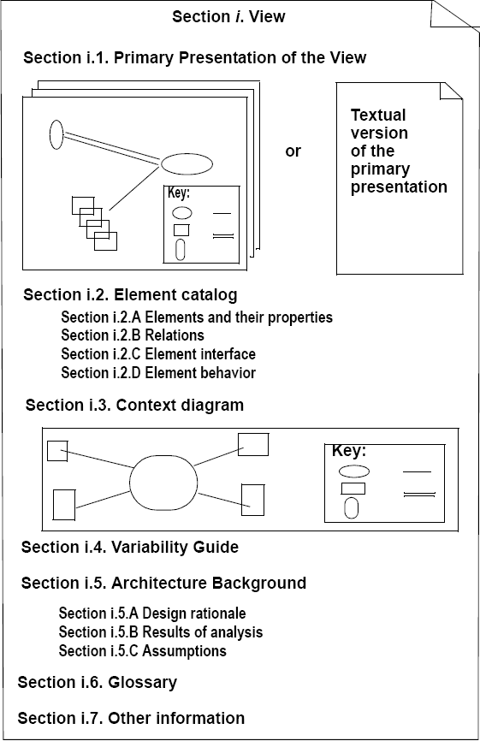
- Section i.1: Primary Presentation of the View: We will present element and relationships among them that popular the view. This can is graphics or table describable.
- Section i.2: Element Catalog: We will present detail and legend all elements.
  - Section i.2.A Elements and their properties: This is name of element and lists all properties of those elements.
  - Section i.2.B Relations : However, if the primary presentation does not show all of the relations, or there are exceptions to what is depicted in the primary presentation, this is the place to record that information
  - Section i.2.C: Element interface: The interface to an element is how it interacts with the outside world. This section is where element interfaces are documented.
  - Section i.2.D: Element Behavior:
- Section i.3: Context Diagram : showing how the system depicted in the view relates to its environment
- Section i.4: Variability Guide: showing how to exercise any variation points that are a part of the architecture shown in this view.
- Section i.5: Architecture background
  - Section i.5.1 Rationale: this explains why you make design decision.
  - Section i.5.2 Analysis Result: The architect should document the results of analyses that have been conducted, such the results of performance or security analysis, or a list of what would have to change in the face of a particular kind of system modification.
  - Section i.5.3 Assumption. List all assumption when we design system.
- Section i.6: Glossary of terms used
- Section i.7: Other information. Maybe all reference all document concern or relation with other View in document

- Show a template for software architecture document structure.
Answer:
- Software architecture document structure is :
  - Section 1 :Document Description: The purpose of this section is to describe who the intended audience is for the document, and to help them navigate and use the document
  - Section 2: Project Overview: The purpose of this section is to describe the project and its purpose and scope. Describe why the system is being built. Describe business, organizational, mission, or marketing concerns that are relevant to the project. List the relevant stakeholders, their organizations, and how they will interact with the system.
  - Section 3: Architecture Drivers: this section describe the architectural drivers for the system
  - Section 4: System Context. This section show overall context of system.
  - Section 5: Level X Decomposition. This section will present all view follow perspective.
  - Section 6: Mapping between Perspective: This section describe the architectural drivers for the system
  - Section 7: Document Directory: this section include an index, glossary, and acronym list
- You can read more detailed in ARCHITECTING SOFTWARE INTENSIVE SYSTEMS A Practitioner’s Guide bye Anthony J. Lattanze

- Fred Brooks (1995) provides a convincing argument that conceptual integrity is the key to sound system design. What does it means?
Answer:
- Conceptual integrity is the most important consideration in system design. So, the system must do the same things in the same way throughout. This aids in understanding, reduces development time, increases reliability, and enhances modifiability. To get achievement this, we must build a strong argument single lead architect whom is responsible for the overall design of the enterprise, system, or software being built and led the team design. So, this help team design :
  - Establish the context of the thing being built and define the boundaries of the enterprise, system, and software architecture
  - Establish the roles and responsibilities of the architecture team
  - Define the architectural design artifacts that must be created
  - Coordinate the efforts of the architecture team with management
[1 point for grammar and overall quality]

