Tyler O’Riley

CSD310 Module 4.3 Assignment

04/04/2023

PyCharm Screenshot

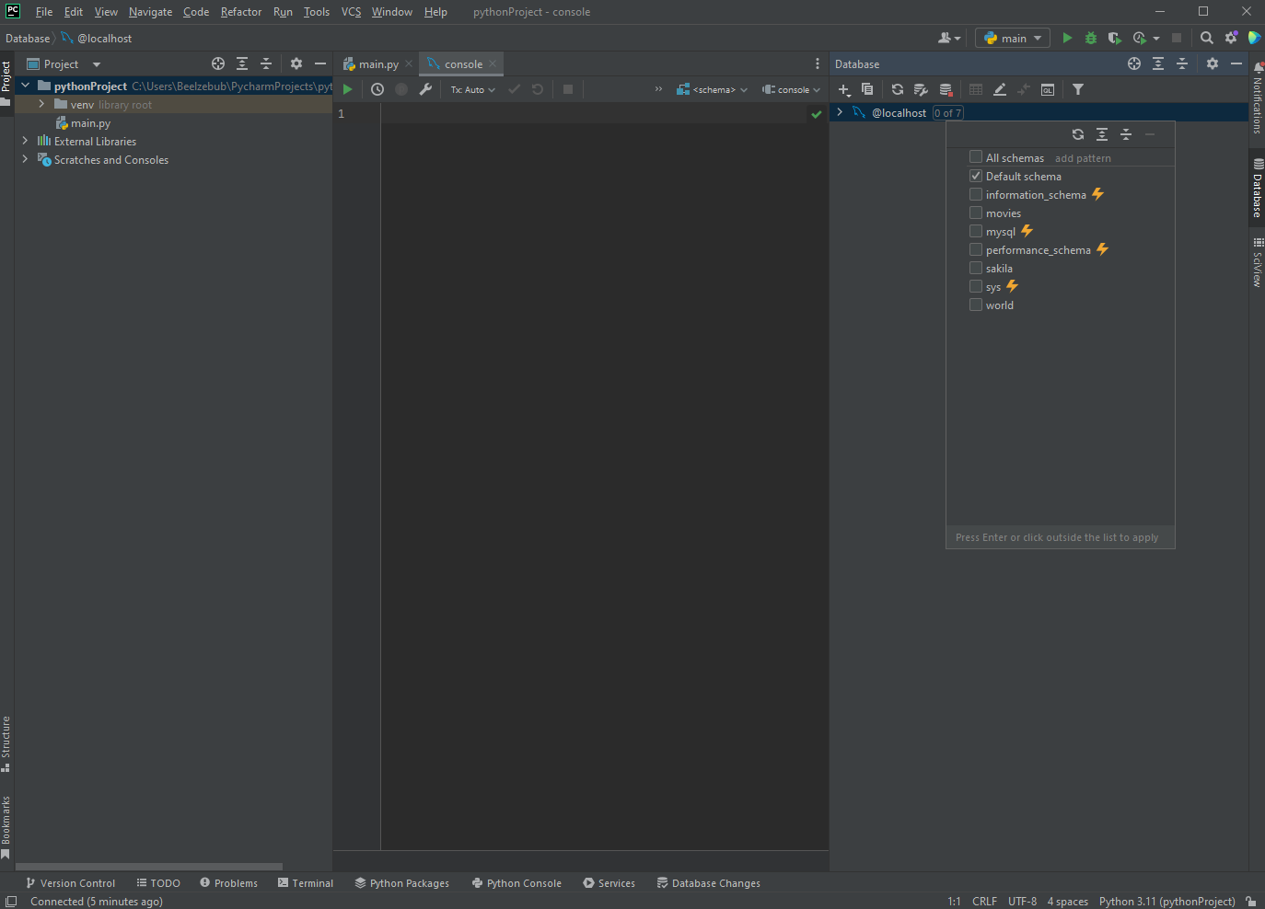

VS Code Screenshot

