Tyler O’Riley

CSD310 Module 5.3 Assignment

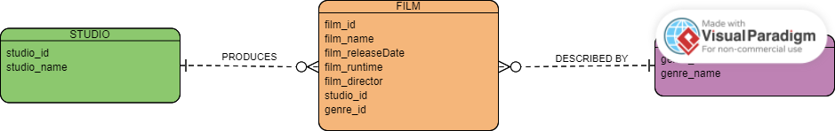ERD for films based on business rules provided. Screen shot included as official file came with the websites logo over my Genre entity.

