Tyler O’Riley

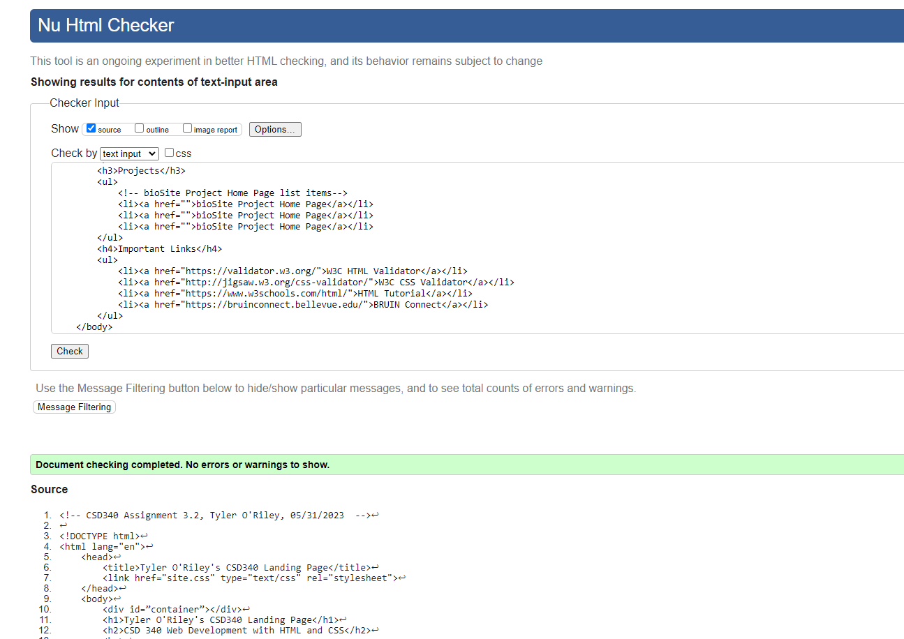CSD340 Assignment 3.2

5/31/2023

<https://github.com/T14oriley/CSD-340>

[https://t14oriley.github.io/CSD-340/ - GitHub Pages](https://t14oriley.github.io/CSD-340/)