Gentry Stayton Biosite Initial Draft

Tyler O’Riley

06/13/2023

Module 5 Assignment

BRIEF BIO:

Gentry Stayton is an individual of many talents and many diverse beliefs. They are scholars by all definitions of the word and hold a very open mind to all aspects of life. Meeting Gentry in college, they had graduated as valedictorian from their previous high school. Throughout college, Gentry engaged in all activities possible including broadcasting, small project videography, and music videos. After college, Gentry would find great success in moving south to Atlanta, Georgia to pursue their dreams of pursuing filmmaking. They found success and participated in a couple high profile music videos before moving on to the big screen. They found work in Disney working on multiple Marvel films in their time at the Atlanta film studios. Some of the big titles they worked on included Spiderman: No Way Home and Guardians Of The Galaxy: Volume 3.

After their adventures in Atlanta, Gentry moved home to Indiana to be close to family and those they love. They currently work locally with PNC Bank and help volunteer at their fiancée’s elementary school every Friday. They always have stories to tell and stay very involved with the current happenings in the country and do their best to stay socially involved.

IMAGES:



[NEWDAWNFILM](https://newdawnfilm.com/common-misconceptions-filmmaking/)



[POKEMON](https://tcg.pokemon.com/en-us/)

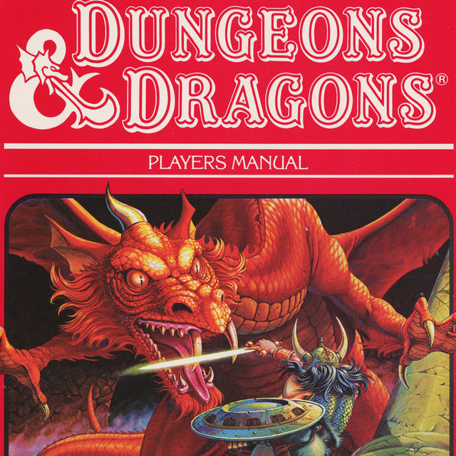

[DUNGEANS AND DRAGONS](https://www.nytimes.com/2016/04/18/us/when-dungeons-dragons-set-off-a-moral-panic.html)

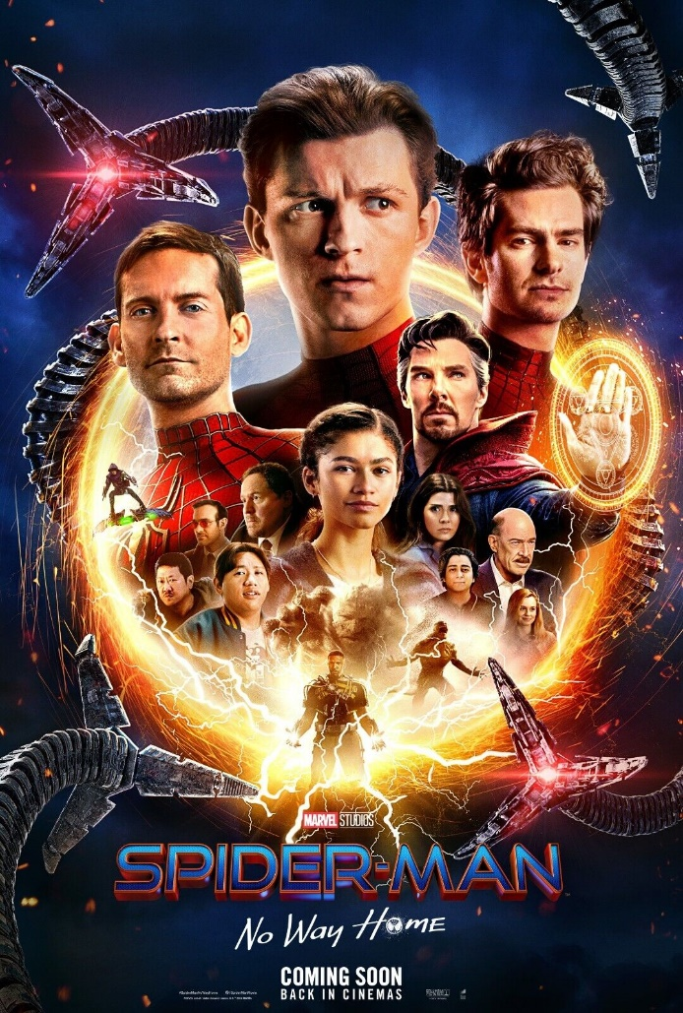

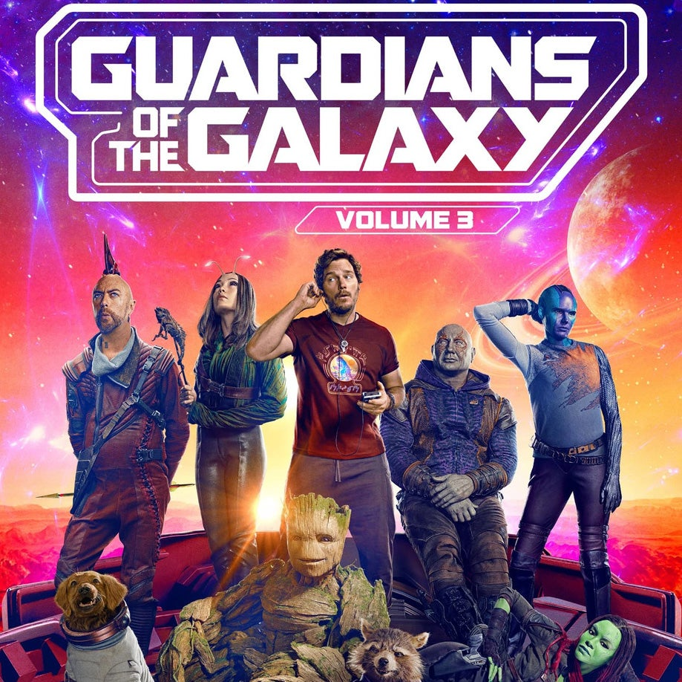[SPIDERMAN NO WAY HOME](https://www.ebay.com/itm/334540774083)

[GUARDIANS 3](https://www.ign.com/articles/guardians-of-the-galaxy-vol-3-james-gunn-reveals-a-key-characters-fate)



[TOMORROW WAR](https://www.imdb.com/title/tt9777666/)

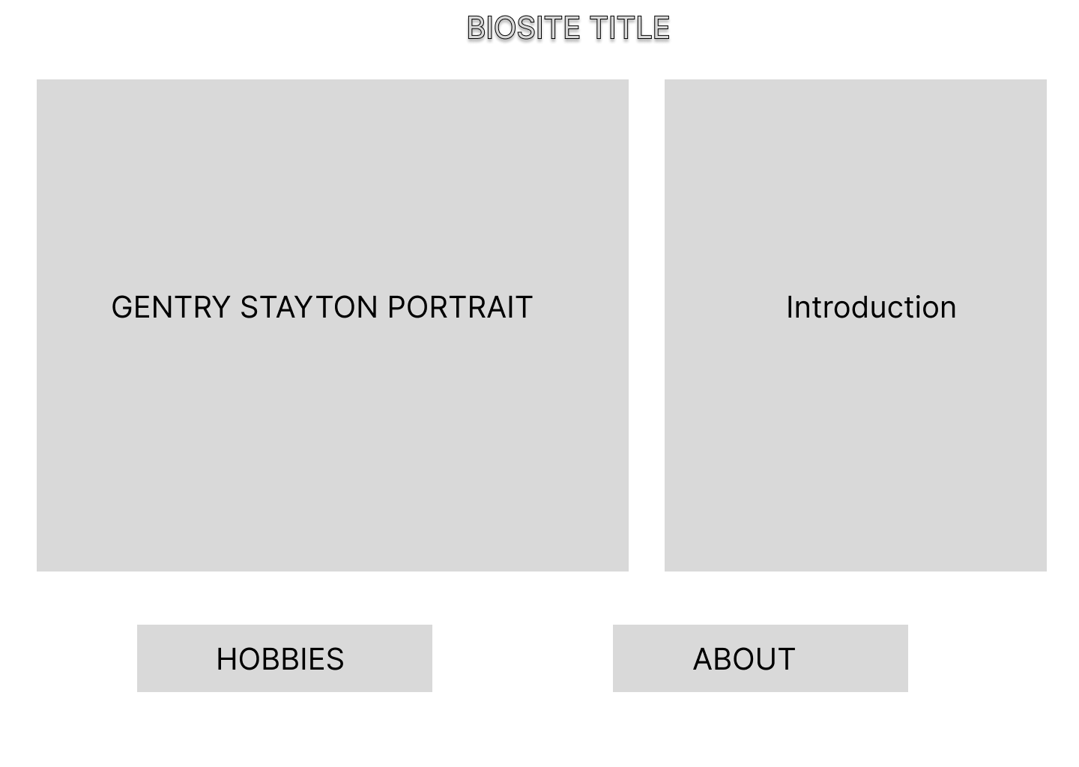WIRE FRAME INITIAL DRAFTS:

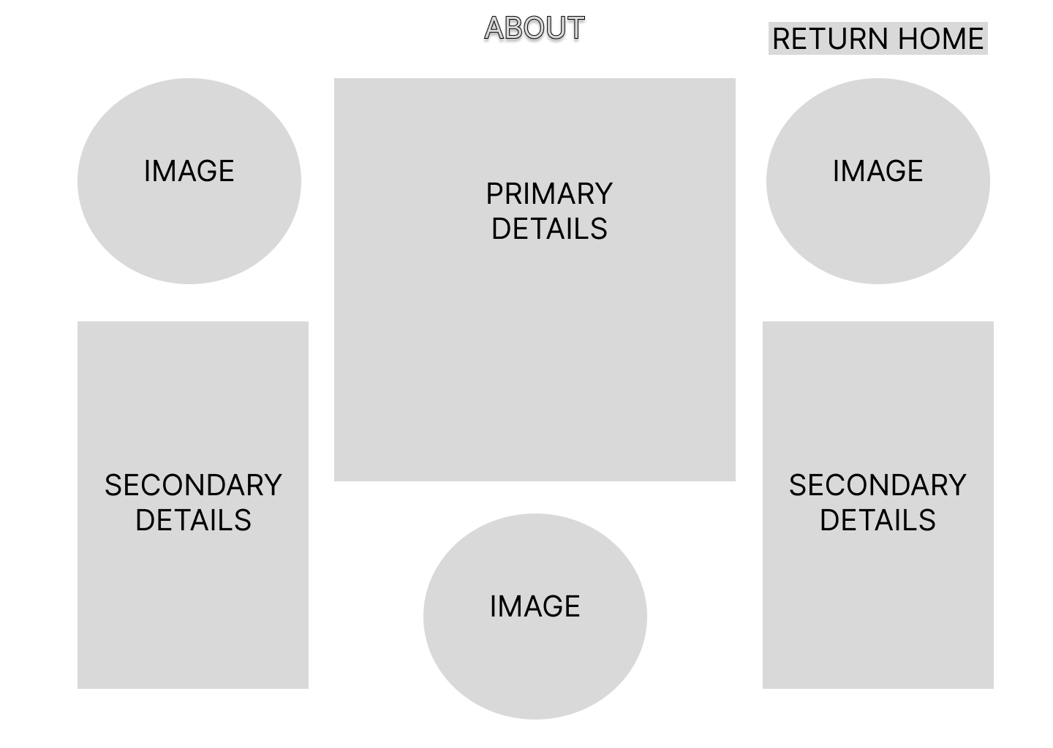

INTERVIEW QUESTIONS:

1. What is your favorite activity to do with friends?

Definitely Dungeons and Dragons. I have two campaigns I participate in, and they are both with friends I do not get to see as often. It is something I look forward to.

1. What do you feel has been positive since graduating college?

The opportunities I have had the privilege of undertaking. The Marvel films were hard work but seeing the end results and my name on the credits made it worth it.

1. Do you regret leaving Atlanta?

Not at all. My fiancée and family are here in Indiana. I eventually wanted to move home regardless and the work conditions I was exposed to pushed me further to this goal.

1. In retrospect, how was the overall environment working on Marvel films?

Not the best. The film industry is not as grand as most people think it is. Harsh work conditions, benefits, and pay are not the painting you would hope it is. I enjoyed film making but the industry is just not good to the people working in it.

1. Do you have any community events you participate in?

I currently assist at my fiancées’s elementary school. They have a pokemon club after school and I help the kids learn how to play so they have a fun after school activity to look forward to.

1. How do you like being back in Indiana?

Immensely. I see so many people I missed in my time in Atlanta. Even if the work is different here, the fact I can see those I love outweighs it 10-fold.

1. Do you have weekly activities you enjoy doing?

Every other Friday I go to a card shop with friends to play Pokemon. It’s a great time because there’s a taco truck outside the shop we love eating at while we play.

1. Could you imagine doing the things you have accomplished in high school?

Honestly no. I aspired to do what I did but I did not think I would jump that fast to film making right out of college.

1. Where do you see yourself in the future?

I am thinking about going into web design and working a tech job. I’m taking a couple certification classes to get me started.

1. Are you looking forward to getting married?

Absolutely. We’re going to Vegas for our wedding and plan to live up the week!

PORTRAIT:

