**I declare that in submitting all work for this assessment I have read, understood and agree to the content and expectations of the Assessment declaration.**

**My profile**

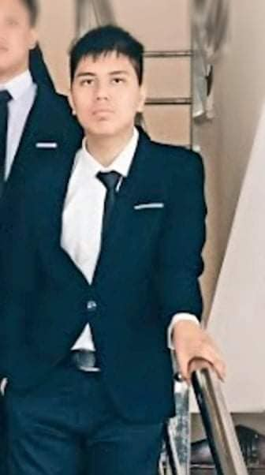

**1.Personal information:**

To begin with, My name is Doan Duy Bach. My student number is s3926953 and my e-mail address is s3926953@rmit.edu.vn. My home town is Thai Nguyen province in VietNam. I am an atheist and believe in the theory of evolution. I completed 12 years of schooling this year and I have learned English during that time. As a result, my spoken languages are Vietnamese and English. My hobbies are reading, playing sports such as football, badminton, and table tennis. At present, I have a goldfish as my pet. I have no IT experience now because I still a newbie in IT but I hope that I will gain more experience in the future soon.

**2.Interest in IT**

- My favorite activity related to IT is coding. I started coding when I was thirteen. At that time, I participated in an online coding course about Python in MindX, a famous technology school . After a few weeks of studying, I learned a lot of coding knowledge and I felt exciting whenever I completed a coding exercise and coding became my interest affiliated to IT from that time.

- I chose RMIT because of some reason. Firstly, its undergraduate program of Information Technology has excellent practical education which is based on international best methods to give them the necessary skills they need to succeed in their future careers. Moreover, it also has a world-class learning environment. According to QS rankings by subject in 2021, it is one of Australia's top ten universities for information technology and computer science studies. Lastly, its higher education alumni have several opportunities to develop the ability to seek or create jobs.

- During my studies at RMIT, I hope to learn many things. For starters, I expect to gain the crucial skills, knowledge, and experiences that I need to succeed in my future career. Moreover, I also want to learn and understand thoroughly about IT. Last but not least, I hope that I can learn new knowledge related to English to prepare for my future occupation.

**3.Ideal job**

- The link to the job advertisement: <https://www.vietnamworks.com/full-stack-python-developer-1-1437790-jv/?source=searchResults&searchType=2&placement=1437791&sortBy=date>

- A snapshot of the job advertisement: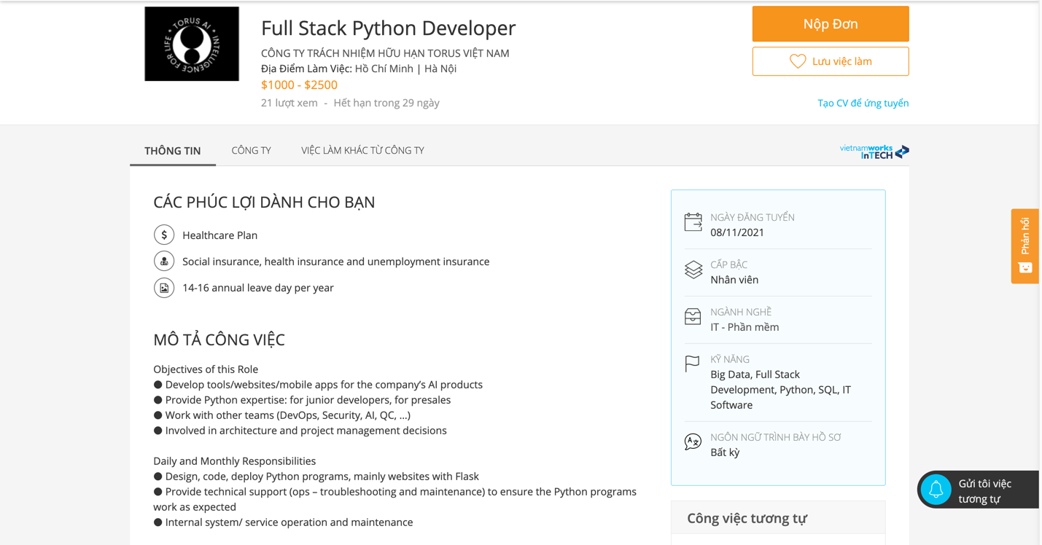

**Description of the position:**

-In the position, the developer has to build tools, websites, and mobile apps for the enterprise's products. That work makes me feel interesting because each new tool, website, or mobile app that I build may bring a completely new set of obstacles, as well as the chance to learn about new technologies, different systems, and various aspects of the business. Moreover, I also have the opportunity to impart Python knowledge and skills to novice developers so that I may make a positive impact on the next full-stack developer generation. Furthermore, working in this high-paying position might help me fulfill my needs and wants. Last but not least, joining a new company as an employee may allow me to become less stressed and tense.

**Description of the skills, qualifications, and experience required for the position:**

- Bachelor of Science in Computer Science, Engineering, or a related field

- Job applicants have to have:

+)3-4 years of experience in Python, Flask/FastAPI, HTML, CSS, javascript, and bash

- Job applicants have to know:

+)Databases and SQL

+)DevOps tools such as Docker and K8S

+)Version Control such as Git

+)Agile such as Scrum

- Job applicants should know:

+)AWS

+)Network &amp and security

+)Architecture design

+)AI and Big Data

+)Healthcare domains such as skins and spine

-Job applicants should be studious, have a positive attitude while solving problems in the enterprise, and have the necessary teamwork skills

**Description of the skills, qualifications, and experience I currently have:**

-At present, I have no qualifications but I have ten certificates in Coursera related to Python, HTML, CSS, JavaScript, and SQL (Link: https://www.linkedin.com/in/b%C3%A1ch-%C4%91o%C3%A0n-741491185/). As a result, I have some basic skills in those languages, However, I do not have a lot of coding practical experience at the moment since I just participated in an online coding course about Python in MindX, a famous technology school.

**My plan to gain the skills, qualifications, and experience which are required for the position:**

- Firstly, I will try my best to get an IT bachelor's degree from RMIT. Moreover, I will find online courses, offline classes, and self-study to have more knowledge and skills related to Python, Flask , FastAPI, HTML, CSS, JavaScript, bash, SQL, databases, DevOps tools, version control, Agile, and Scrum. It is going to take me 3-4 years to complete that and I will train soft skills and ability to multi-task through classes and activities in RMIT, as well as through internships in IT companies such as FPT Software, Amigo Fintech, and Robert Bosch Engineering Vietnam.

**4.Personal profile:**

**-** **The results of an online Myers-Briggs test:**

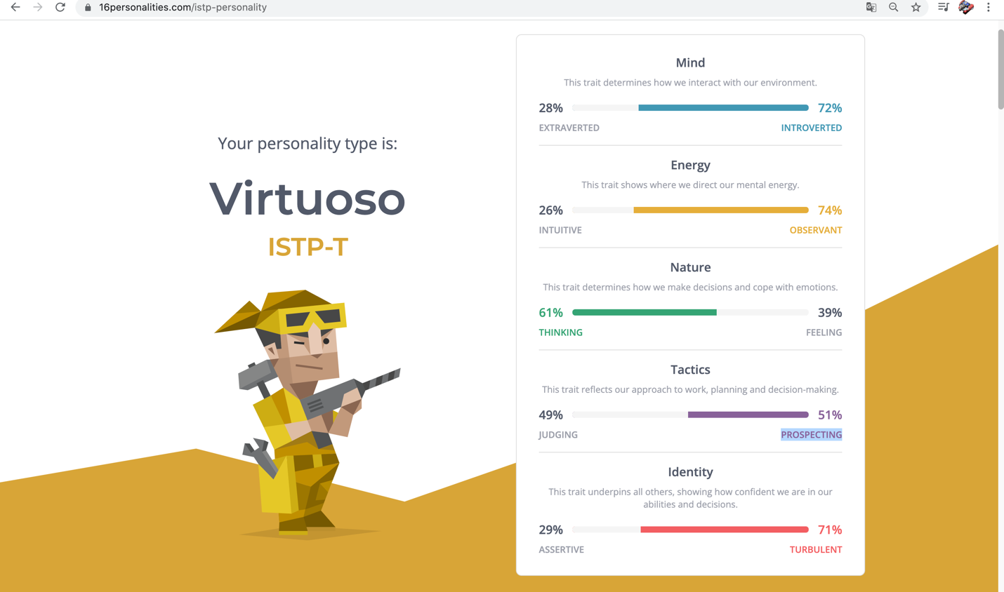

**- The results of an online learning style test:**

Link: <http://www.educationplanner.org/students/self-assessments/learning-styles-quiz.shtml?event=results&A=6&V=9&T=5>

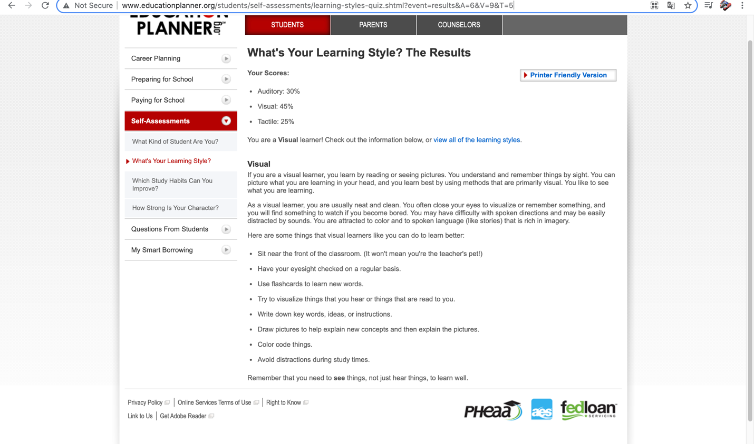

**- The results of one further online test: How create are you?**

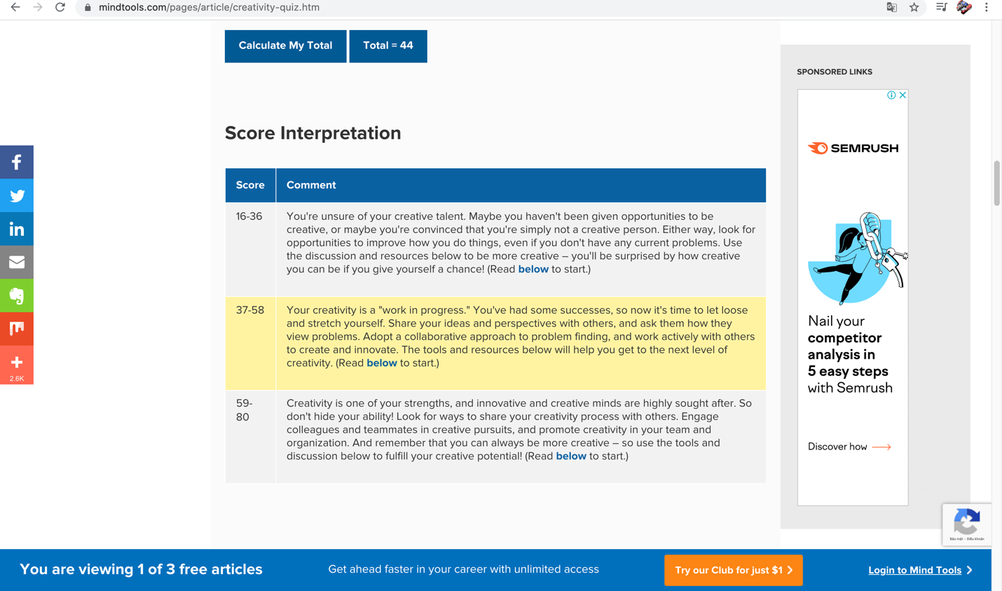

-I think the results of these tests let me know more about my personality, my learning styles, and my creativity so that I can improve my strengths and get rid of my weaknesses. For example, I've discovered that I have a high level of introversion, so I may give myself time to become comfortable in a situation before introducing myself to a new person.

- I think these results will have an impact on my behavior as a member of a team. Firstly, the results of the online Myers-Briggs test show me that as a team member, I might have a hard time reading other teammates' body language so that I may try to talk and understand more about them to overcome that weakness. Moreover, due to the results of the creativity test above, I may share my thoughts and viewpoints with other teammates, as well as ask them how they approach problems while working in a team.

- The results of these tests may be considered by me when I form a team. For starters, the teammates should be better than me at my weak section and vice versa. Moreover, they should have similar personalities like mine to be in concord with me while working.

**5. Project ideas**

**Overview:**

**-**I have always wanted to be a hero who fights with monsters and rescues the world, and I have had a lot of experiences playing adventure games on Play Store and Appstore so that I decided to create a adventure game in Unity, one of the most well-known game developers. In that game, there will be a hero whose mission is to save the world from being destroyed by monsters. Moreover, C# coding language and computer programming basics will be used to create this game. Lastly, the game will be released on both IOS and Android platforms in order to attract a lot of gamers.

**Motivation:**

-According to Statista, as of Sep 7, 2021, there were an estimated 3.24 billion gamers across the globe, so there is a sizable market for games.

Moreover, the game may help players improve their ability to reason and solve problems while fighting monsters. Furthermore, it can also allow people to enhance hand-eye coordination and aural perception.

Besides, they can play this game to entertain after a stressful day. Last but not least, there are many individuals whose dream is to become a hero and save the world. Hence, they may feel interested while playing this game because they can play as a hero and rescue the world.

**Description:** I plan to follow these steps to make the archetype of the game:

1. Learning and practicing C# coding language because C# is a powerful langue that can make basic game elements such as audio and graphics accessible, and decrease the redundancy of game development tasks.

2. Learning and gaining knowledge about the fundamentals of computer programming for Unity development through the Unity Essentials learning pathways.

3. Creating and setting up a Unity project to work on the game.

4. Creating the pictures of the main character, who is a beefy warrior with thick armor and a sharp sword, and designing images of items and monsters.

5. Adding empty scenes in which the battles will happen.

6. Import images and arts of the hero, monsters, and NPC in the game to the project.

7. Utilize Sprite to create a GameObject

8. Set coordinate for people and monsters in the game

9. Create scripts, which are a specific type of component, and put them to GameObject

10. Discover the default script in order to edit the script text.

11. Declaring variables that help me to retrieve different values of the things in the game like the hero, NPC, and monsters.

12. Making changes in GameObject and saving those changes

13. Constructing and checking scripts.

14. Making, designing, and decorating maps of different levels to attract players and bring a genuine feeling for them. I will follow some steps in order to complete these actions such as creating Tilemaps, making Tiles, adjusting Tileset, Tileset's Sprite Settings, assigning Sprites to Tiles, and painting Tilemaps.

15. Building the story of the hero who will save the world to make players sympathize with the main character.

16. Generating conversations between the hero and NPC in the game to make the game more lively and help players to understand more about the background and context of the world which is being attacked by dangerous monsters.

17. Making different kinds of monsters such as vampires, zombies, and chimera, and giving them dissimilar skills and abilities in order to prevent players from feeling boring when they play the game.

18. Setting up variables of the hero and monsters in the game like heath, speed, and score.

19. Creating a basic tutorial in the game-opening to make it easier for novice players to learn the fundamentals of the game.

20. Making available activities for players after taking down monsters and completing a level. For example, people can control their hero and make him move around the body of monsters to collect equipment, items, and money which can be used to strengthen their character or buy weapons.

21. Using C# coding language to make a lot of lines of codes to create and diversify the movement of the hero, NPC in the game, and monsters.

22. Introducing the prototype of the game to classmates and teachers and trying to receive reviews from them in order to fix any bugs which I can not find and enhance the quality of the game.

**Tools and Technologies:**

- There are some tools and technologies that can be used by me in order to create this adventure game. Firstly, I utilize Unity because it is a famous and preferred game maker. Moreover, its user-friendly design makes it simple for all kinds of developers to use. Furthermore, it also provides users with many resources such as available assets and free tutorials. The second tool is the C# coding language, which is used to make motions and interactions of everything in the game. Lastly, I will use art creation software to draw digital arts, artworks, and images for the adventure game.

**Skills Required:**

-Knowing how to use Unity to create and develop the adventure game

-Having knowledge about Unity, including the understanding of sprite, script, variable, axes, and GUI styles.

-C# programming skills to write code for each element in the world of the game.

-Having necessary skills related to using art creation software to draw and design arts and images of each part of the game.

-Familiarity with planning plans.

-Learning how to develop 3D/2D games through tutorials, online classes, and sources on the Internet.

-Understanding of game systems

- Having essential skills which can be utilized to work in a team and collaborate with other teammates

**Outcome:**

-The first outcome is from streamers and players who stream the adventure game on social networks such as Facebook and Twitter, and online video sharing platforms like Youtube.

-The second outcome comes from advertisements in the game.

-The third is from the money spent by players in order to exchange it for currency in the game in order to buy items or participate in events

-The fourth comes from selling unique skins and items for players who are eager to buy those.

-Making revenue from selling the adventure game to the customers from the stores such as Google Play and App Store