**KHWOPA SECONDARY SCHOOL**

**DEPARTMENT OF COMPUTER SCIENCE**

**Dekocha-06, Bhaktapur**

**A FINAL REPORT**

**ON**

**“WEBSITE CREATION OF IPLSCORES”**

A Report Submitted for the partial fulfilment of requirement for the degree of NEB in computer science

**Submitted by: Submitted to:**

Purushottam Karki (813260041054) Department of Computer Science

Sumit Bati (813260041707) Khwopa Secondary School

Supreme Shrestha (813260041730)

Bishwo Pokharel (813260040388)

Submission date:2025/03/04

# DECLARATION

We hereby declare the project entitled “**WEBSITE CREATION OF IPL LIVESCORES**” submitted to the Department of Computer Science, which is an original piece of work carried out under the supervision and guidance of the computer science teachers and is submitted for the partial fulfillment of the computer science course of grade 12. This project has not been submitted elsewhere for the award of any degree.

Name of the students:

Purushottam Karki (813260041054)

Sumit Bati (813260041707)

Supreme Shrestha (813260041730)

Bishwo Pokharel (813260040388)

# LETTER OF APPROVAL

This project work entitled “WEBSITE CREATION OF IPL LIVE SCORES” by Purushottam Karki (813260041054),Sumit Bati (813260041707),Supreme Shrestha (813260041730),Bishwo Pokharel (813260040388) of Khwopa Higher Secondary School, Dekocha, Bhaktapur prepared on the supervision of teachers of Computer Science submitted for the partial fulfillment of prerequisite of Computer Science of class 12 has been accepted.

.....................................................

**Supervisor**

Name: Jamin Rai

Department of Computer Science

Khwopa Secondary School

# ACKNOWLEDGEMENT

The acknowledgement is dedicated to all the individuals who have provided valuable assistance for the successful completion of the creation of website related to display of live scores of IPL.

First and foremost, we would like to thank our supervisor, Jamin Rai sir, for their invaluable guidance, support, and encouragement throughout the completion of the project. Their contribution has played a significant role in making this project exquisite, alluring and informative. We appreciate the creative efforts of the team in crafting an appealing and intuitive layout that reflects the excitement of the IPL. We would also like to extend our appreciation towards each other for the collaboration and assistance while accomplishing the project.

Together, we have created a platform that enhances the experience of IPL fans by providing real-time scores and updates with match scores and the standings of the team in the table. We look forward to further developments and improvements in the future

# ABSTRACT

The Indian Premier League (IPL) is one of the most popular cricket leagues globally, attracting millions of fans who seek real-time updates and live scores. This project focuses on the development of a dynamic website dedicated to providing live scores, match scores and related information for IPL matches such as standings of team in the league table. This project is constructed by using HTML,CSS and JS. The website aims to enhance user engagement by offering an intuitive interface and service for users, seamless navigation and real-time data updates about the season by the match results in a eye catching and simple manner. Key features of the website include live score updates, match schedules, standings and statistical data. The site will utilize APIs to fetch live data from official sources, ensuring accuracy and timeliness. In summary, the creation of a dedicated IPL live scores website aims to provide cricket fans with an engaging platform for real-time updates and comprehensive match information, ultimately enhancing their viewing experience.

Table of content

DECLARATION I

LETTER OF APPROVAL II

ACKNOWLEDGEMENT III

ABSTRACT IV

Introduction 1

Objective 2

Applications 2

Limitation 2

Methodology 3

Block diagram 3

Tools and Platform 3

Appendix 4

Conclusion 8

Reference 9

# Introduction

The Indian Premier League (IPL) is an Indian professional Twenty20 (T20) cricket league established in 2008. The league is based on a round-robin group and knockout format and has teams in major Indian cities. Till today's day it's been 17 years of inauguration of IPL in 2008. This league is prominent in finding new talents in the world of cricket. IPL is owned and operated by the Board of Control for Cricket in India (BCCI). The IPL's success in India comes from its blend of sports and entertainment, star-studded lineups, high competition level, short and exciting format, strong marketing, cultural integration, and opportunities for young talent. The inaugurated winners were Rajasthan royals. And the most successful team of IPL are Chennai Super Kings (CSK) and Mumbai Indians (MI) with 5 titles each. The Defending champions are Kolkata knight riders (KKR) which was their third title. The three months of IPL is celebrated all over the world by the cricket fans.

**Information table**

|  |  |
| --- | --- |
| Administrator | Board of Control for Cricket in India (BCCI) |
| Format | Twenty20(20 overs) |
| First edition | 2008 |
| Latest edition | 2024 |
| Tournament format | Round robin format with group system and playoffs |
| No of edition(recent) | 17 |
| No of teams(recent) | 10 |
| Most runs | Virat Kohli (8,004 runs) |
| Most wickets | Yuzvendra Chahal (205 wickets) |
| Most successful teams | Mumbai Indians and Chennai super kings (5 titles each) |
| Broadcasters | Star sports and sports 18 |
| Website | www.iplt20.com |

# Objective

* To provide users with live scores of IPL match scores and offer detailed information about each match

# Applications

* To provide real-time updates on IPL match scores
* Users can easily access upcoming fixtures and plan their viewing accordingly.
* All the latest information in one place so there will be no need to keep switching between channels or apps

# Limitation

* This website cannot provide detailed player statistics and over by over match score rather only final and direct match scores

# Methodology

**Block diagram**

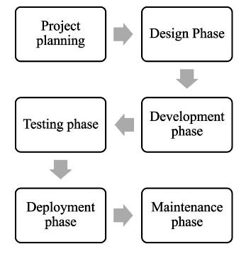

## **Tools and Platform**

* Visual Studio Code
* Browser : Brave/Chrome/Firefox
* Notepad
* HTML5
* CSS3
* JS(API integration)

# Appendix

**1.Home page/Results Page:**

HOME PAGE


Nav Bar in Results page

Footer in Results page

**2.Standings Page:**

Standings


Standings Page: Top

Standings


Standings Page: Bottom

**3.About Us Page:**

About Us page with information about our sources and team

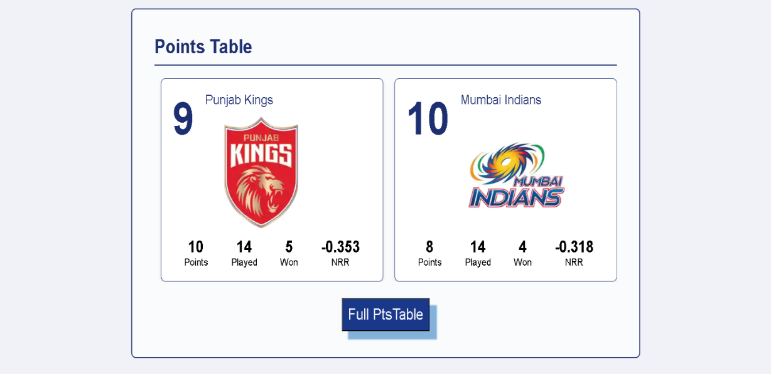

Points Table in About Page

Playoff Match data

# Conclusion

The website we have developed to display IPL live scores helps in significant advancement in enhancing the cricket viewing experience for fans worldwide.The integration of modern web technologies and APIs ensures that the information presented is accurate, timely, and easily accessible across various devices. This website provides platform where fans can connect, share insights, and celebrate their passion for cricket. The ongoing maintenance and updates will ensure that the website remains relevant and continues to provide information as the new edition progresses.  
  
In summary, the creation of the IPL live scores website not only fulfills the immediate need for real-time match information but also contributes to the broader cricket community by enhancing engagement and accessibility. As the IPL continues to grow in popularity, this platform will play a crucial role in keeping fans informed and connected to the excitement of the league.

# Reference

We have created our website and got the information from various sites and sources which are listed below:

Official IPL website : https://www.iplt20.com/

Code Explained : https://youtu.be/hkklHp67ADo?si=PLNtJoA52Xl2XcB5

Google: <https://www.google.com>

Wikipedia : https://en.wikipedia.org/wiki/2024_Indian_Premier_League

Rapidapi : https://www.rapidapi.com/

Livescores API in rapidapi : https://rapidapi.com/apidojo/api/livescore6