# Nechutne vela otazok bolo okolo Personal Health Dashboard + Trusted Advisor + reakcia na findings (t.j. Lambda (getcheckresult / refreshresult) alebo CW Events – pozor, su v us-east-1 tusim len). Plus k tomu ako sa to lisi pri roznych typoch supportu na danom AWS accounte…. To boli cele uplne novinky pre mna.

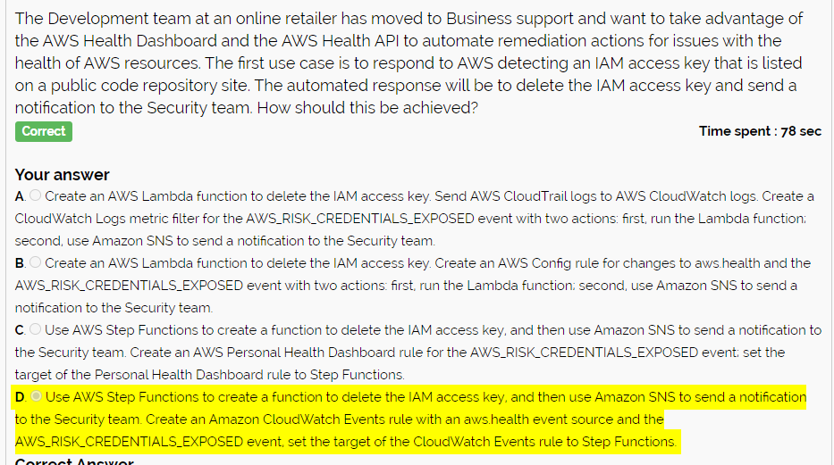

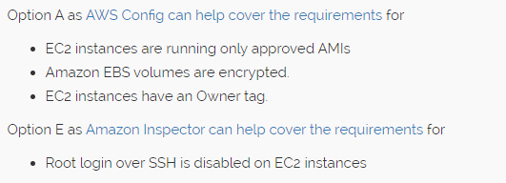

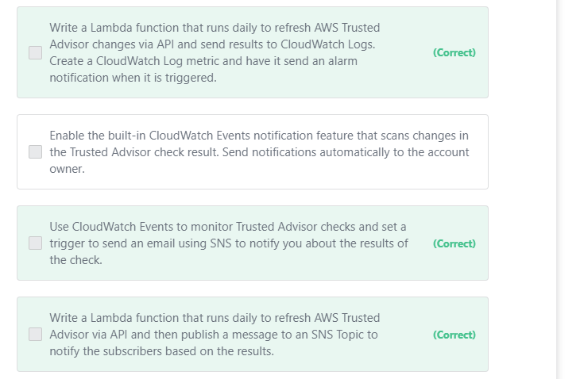

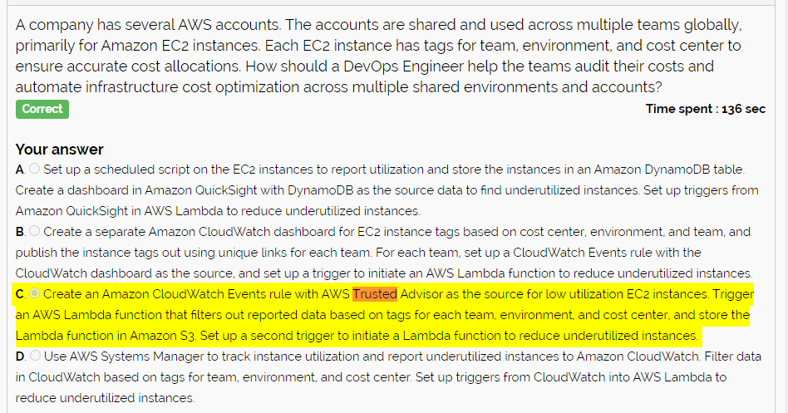

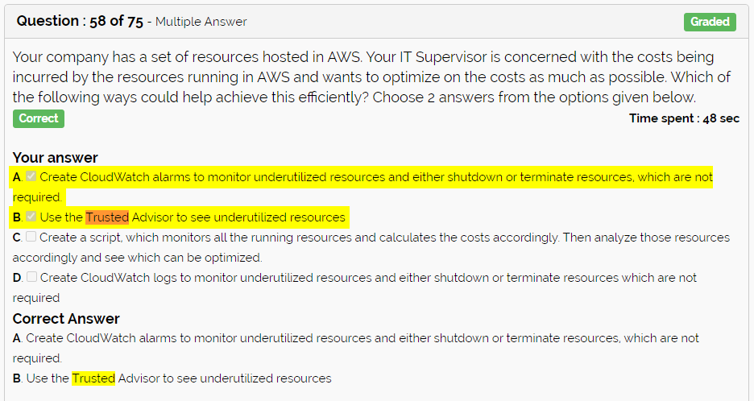

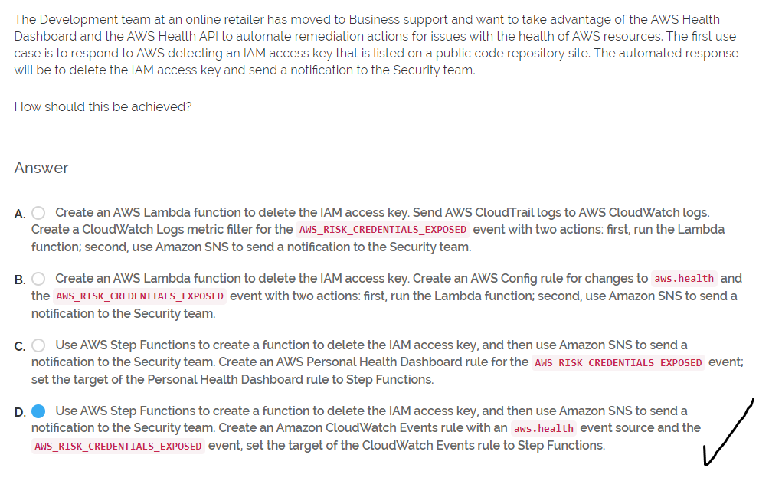

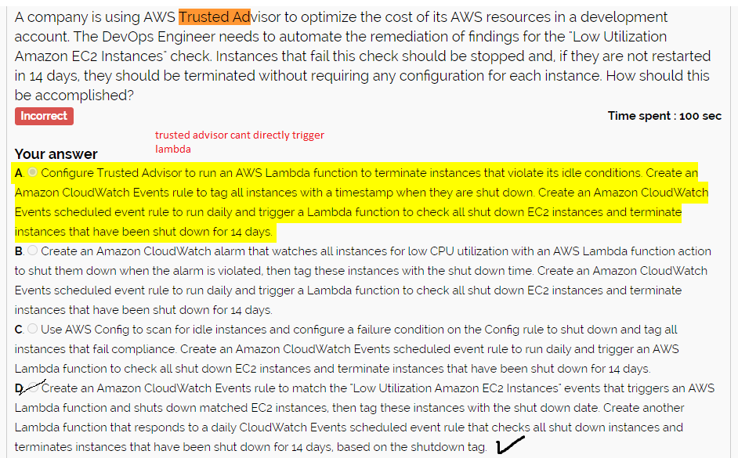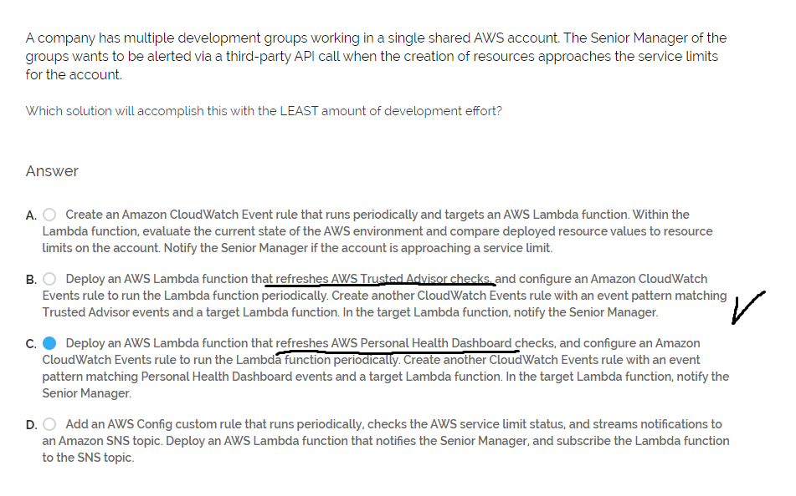

# Systems Manager – patching, automatizacia (Run), atd. PLUS ako sa to vztahuje na on-prem (hybrid activation pozri)

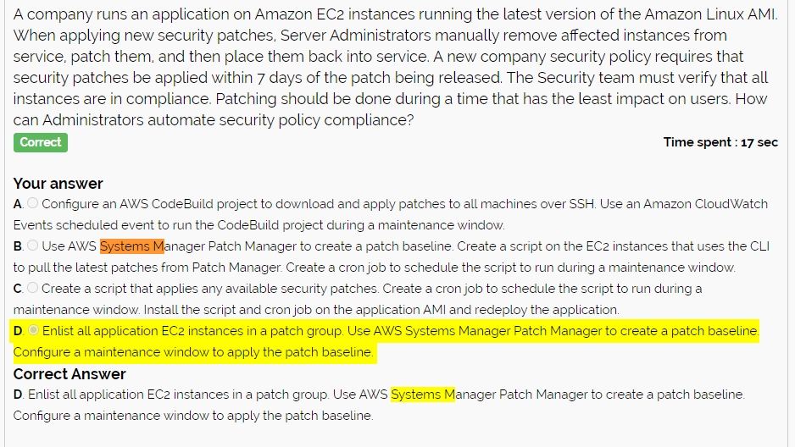

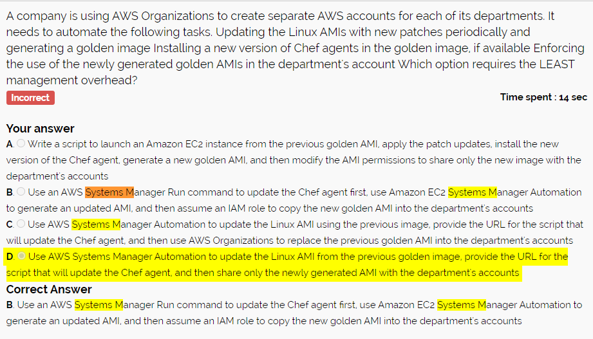

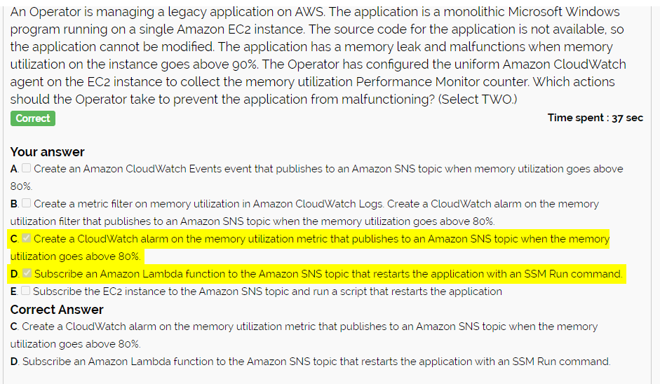

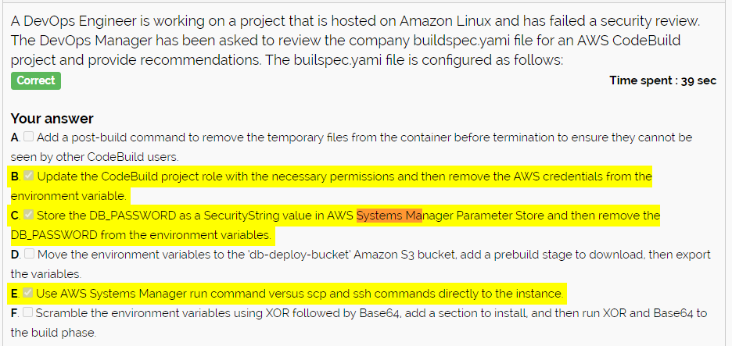

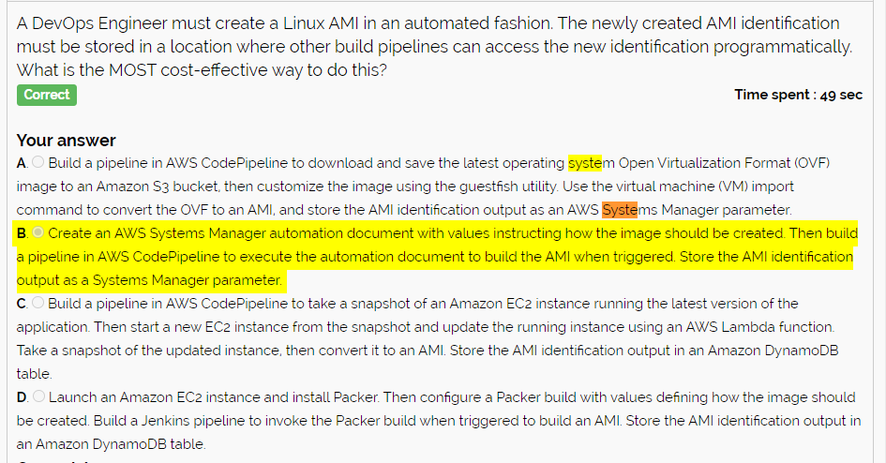

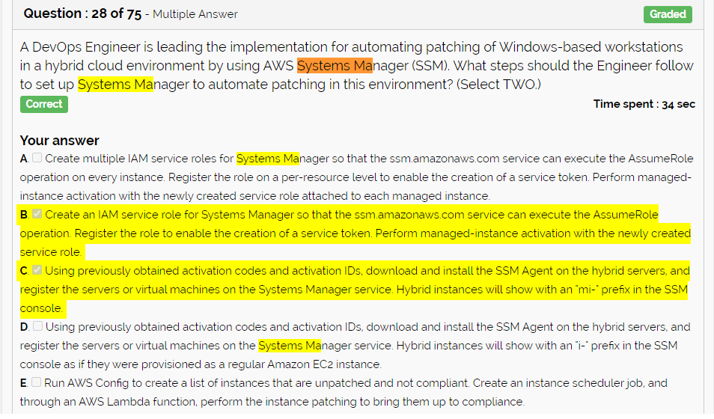

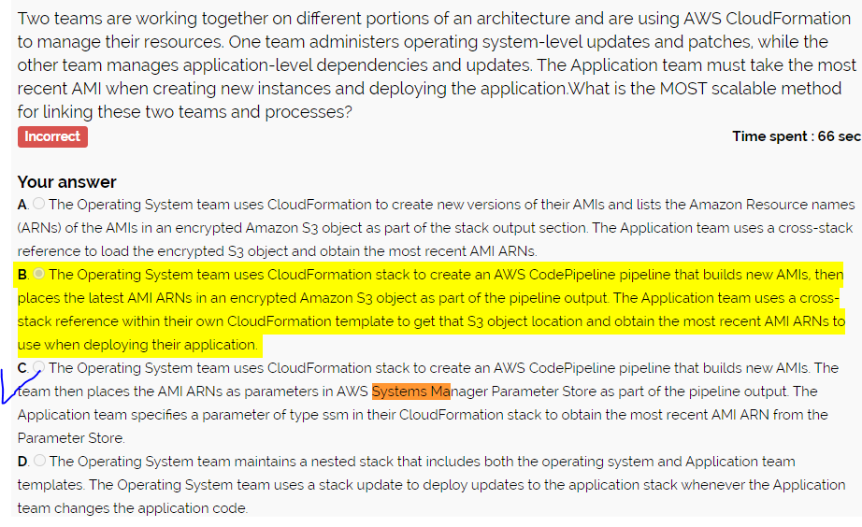

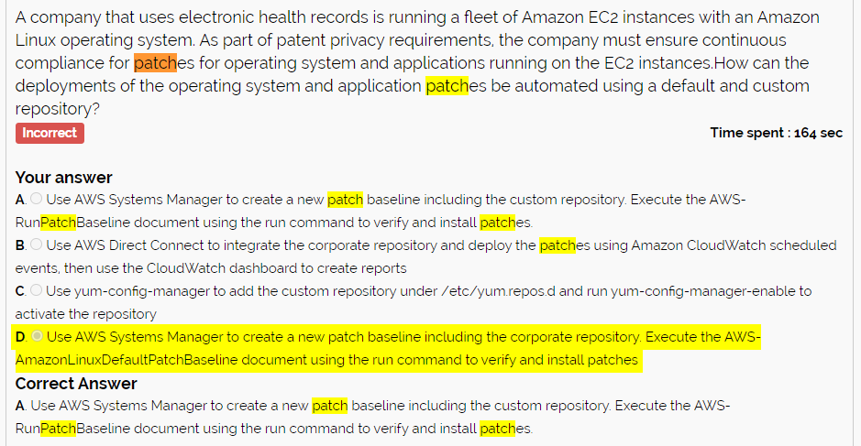

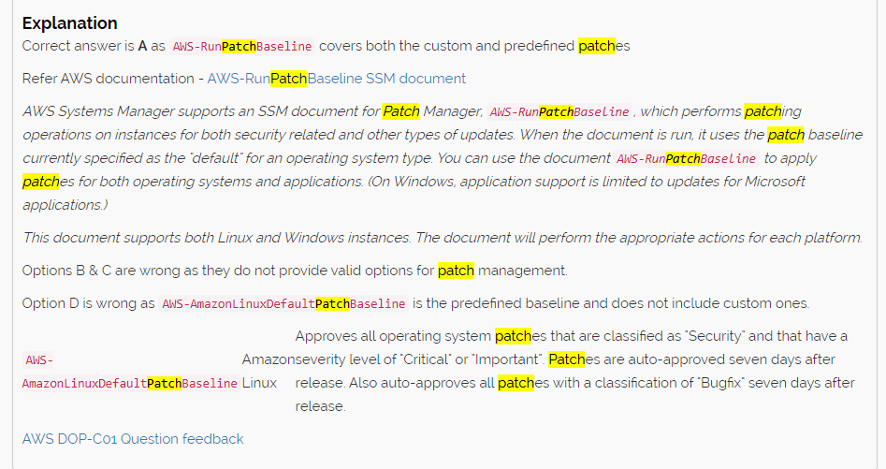

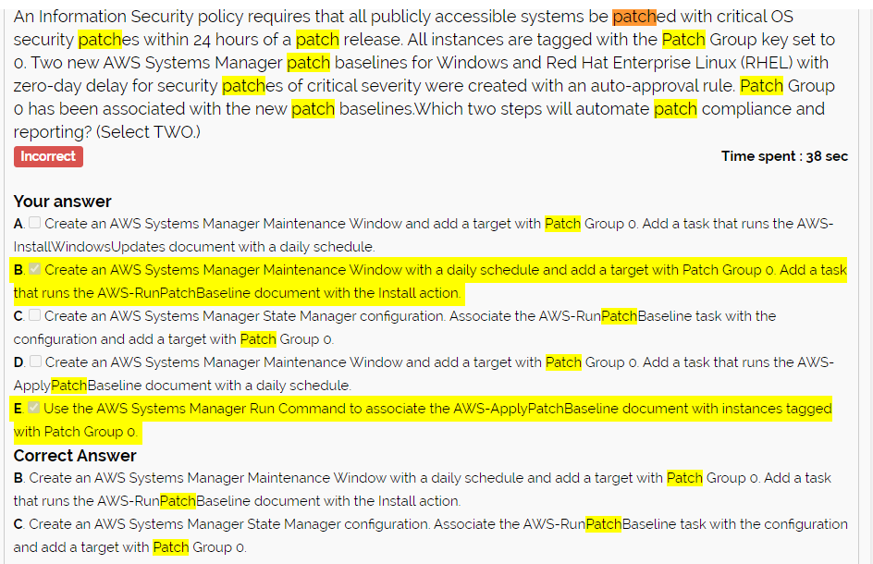

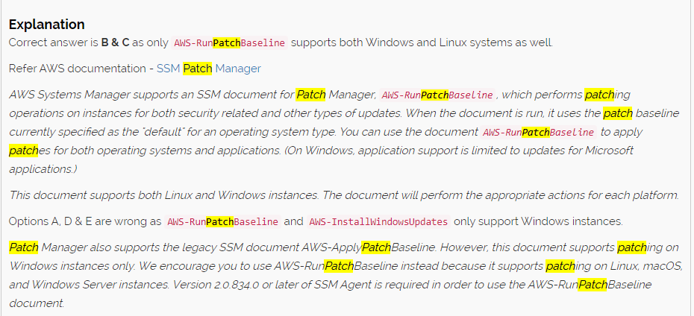

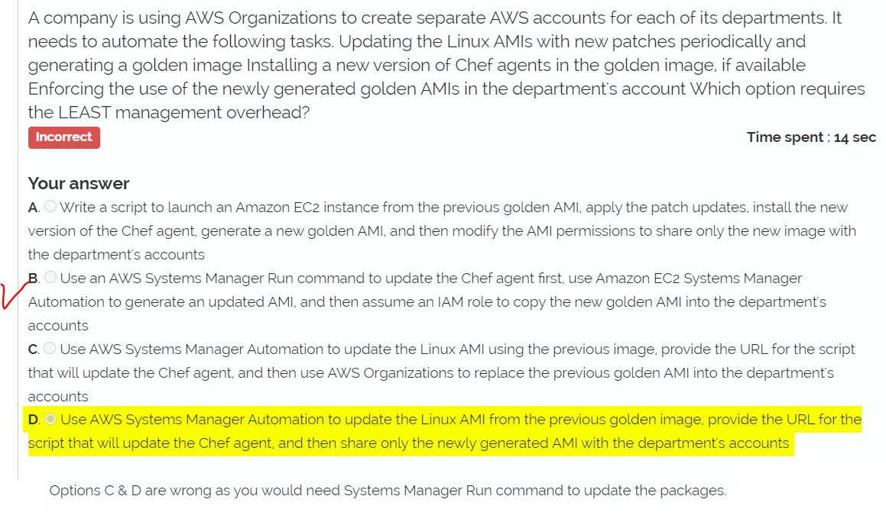

# CW metrics - + expiracia

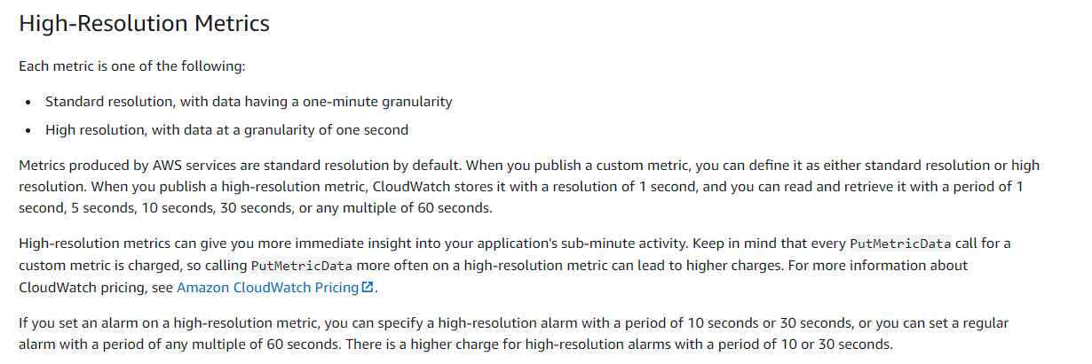

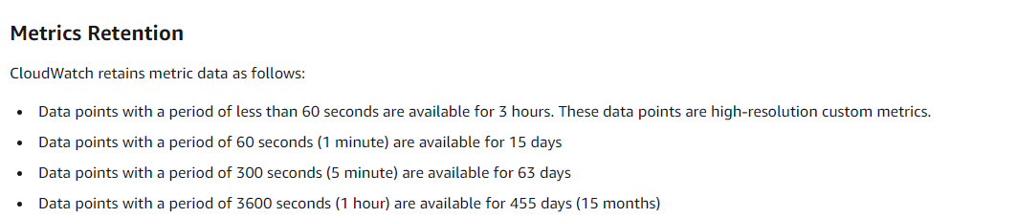

# Scenario ECS + EC2 v CloudFormation – ako referuju na seba

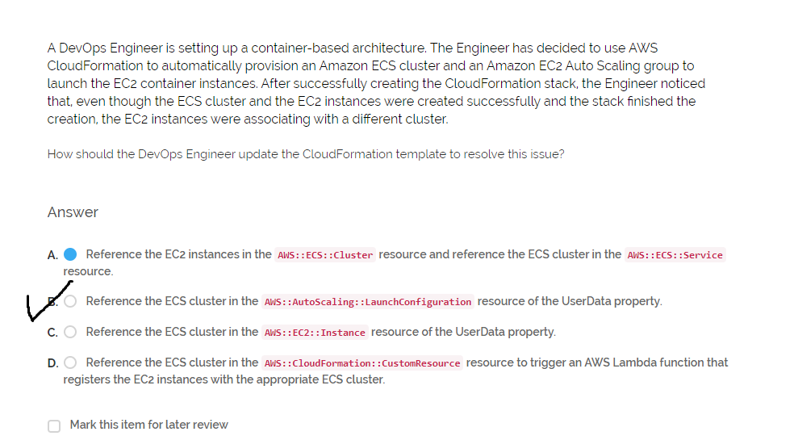

Cloudfromation + Autoscaling

* UpdatePolicy
  + RollingUpdate
    - MinSuccessful instances
    - Pause time
  + ReplacingUpdate (cost effective)
    - Willreplace – true (better rollback) / false

# Trocha KMS – scenario: mas SQS subscribnute na SNS topic. Mas oba zasifrovat. Kam das aku policy, resp. aku policy das na KMS

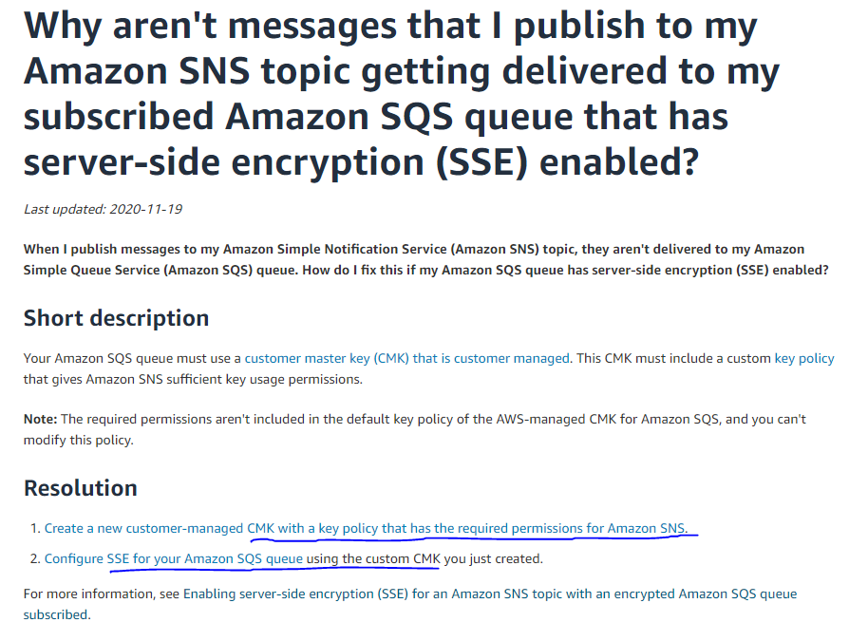

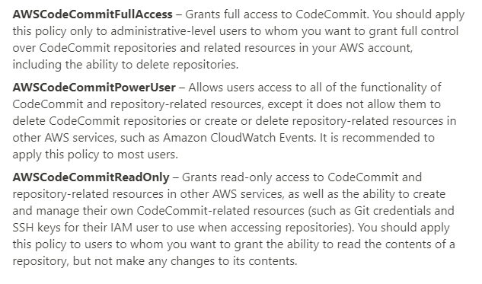

# RDS and Aurora DR, High-Availability

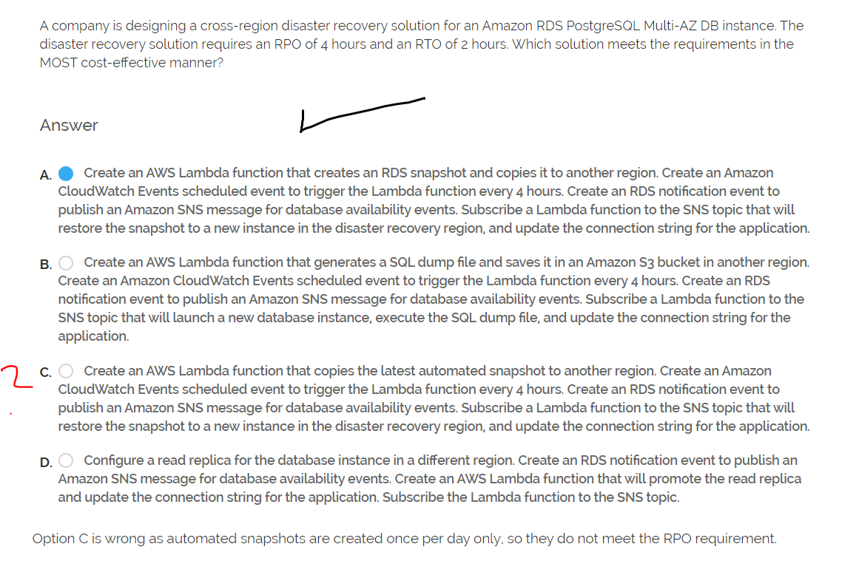

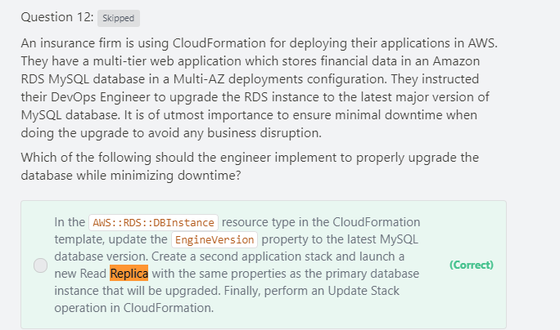

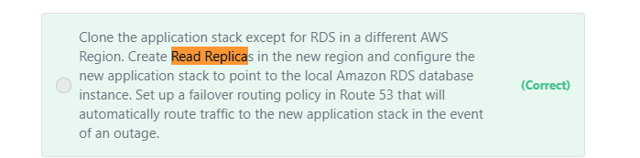

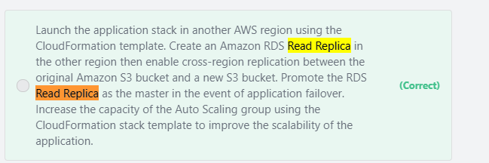

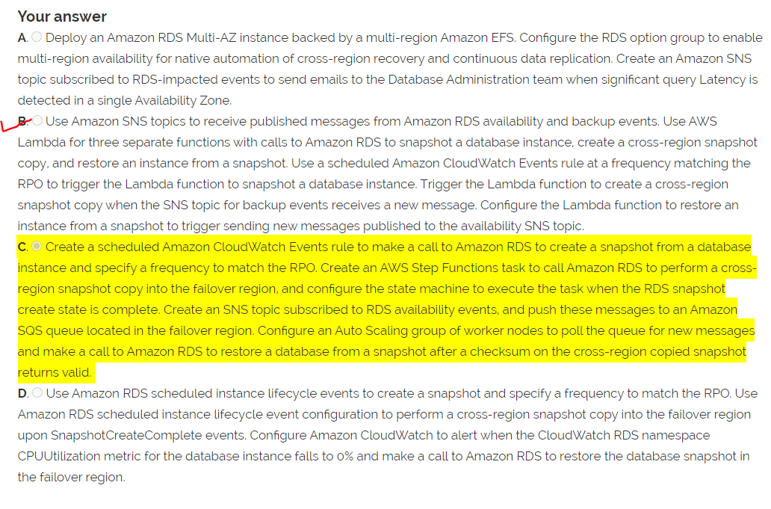

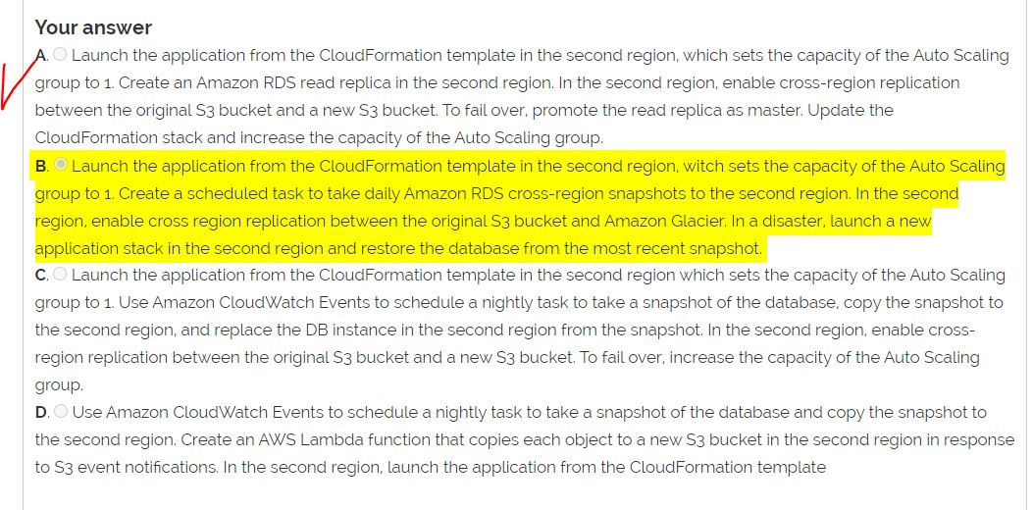

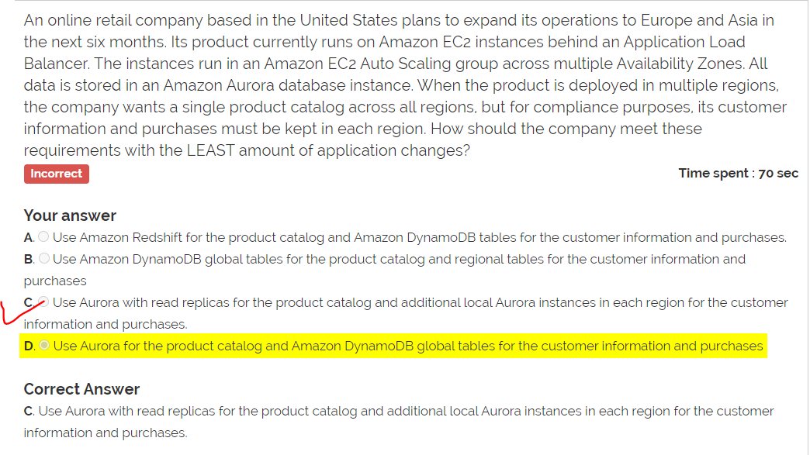

# [ TODO ]CloudWatch agent – co moze posielat, kam, ako sa instaluje CW logs

# EC2 auto healing / auto-recovery – to bola troche novinka aj pre mna

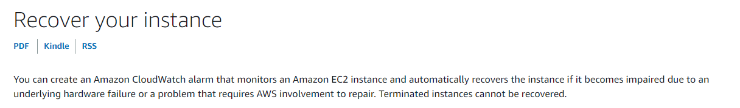

OpsWorks Auto Healing

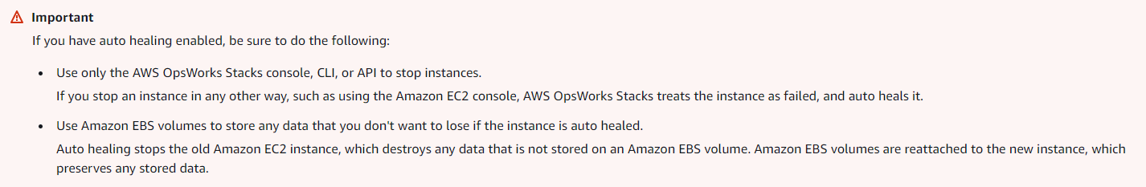

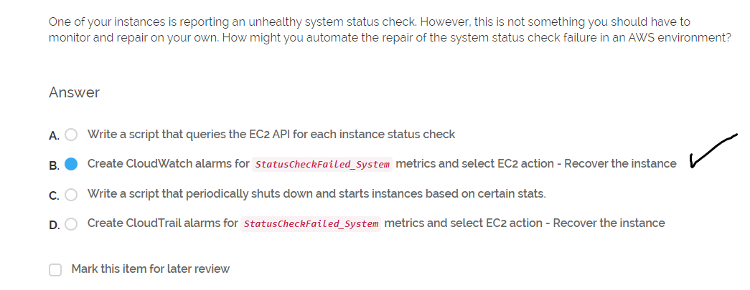

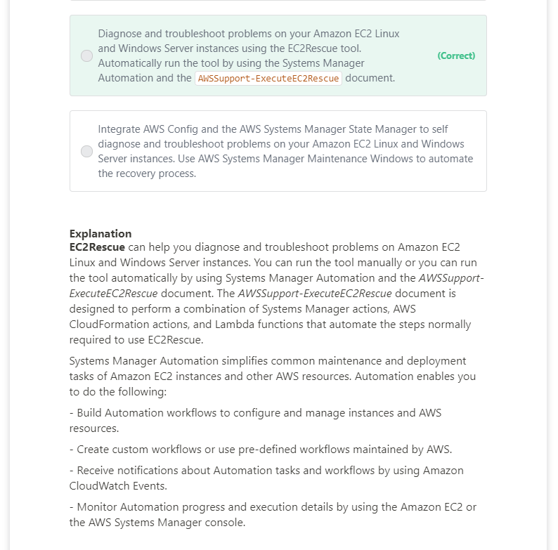

# [ TODO ] Cloudfront, Lambda@Edge, Kinesis

# Code Pipeline (git -> pipeline (build, test, deploy) + monitoring and rollback on failure)

