**Content**

1. Overview 2

1. Pricing 2

2. Use Cases 2

3. SPICE vs Direct Query 3

4. Manifest File 3

5. Quicksight built-in functions to generate calculcated fields 4

1. Overview
   1. Pricing

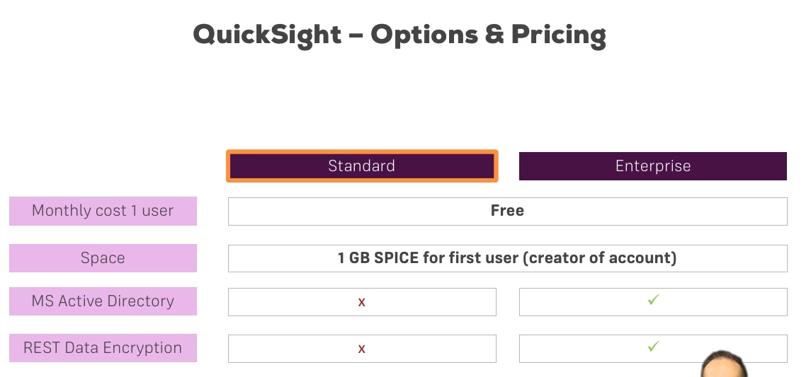

Amazon QuickSight offers a 60 day free trial for 4 users. If you maintain 1 user only, the Amazon QuickSight account remains free. [[Quicksight Pricing](https://docs.aws.amazon.com/quicksight/latest/user/setup-quicksight-for-existing-aws-account.html%20)]

*manage quicksight -> Your subscriptions

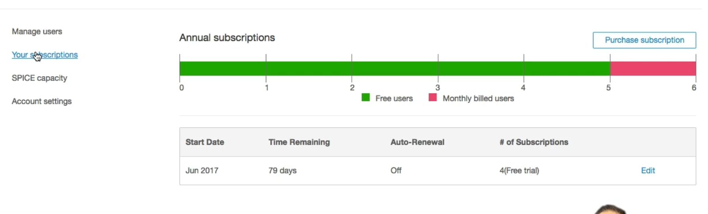

* 1. Use Cases

Quicksight is a powerful tool and we can do data preparation and cleaning up to a certain amount, but connecting it do different source files and then merging the tables and build and own data model – you cant do it just with quicksight. You need to have a certain structure of the source file, that you want quicksight to be connected to.

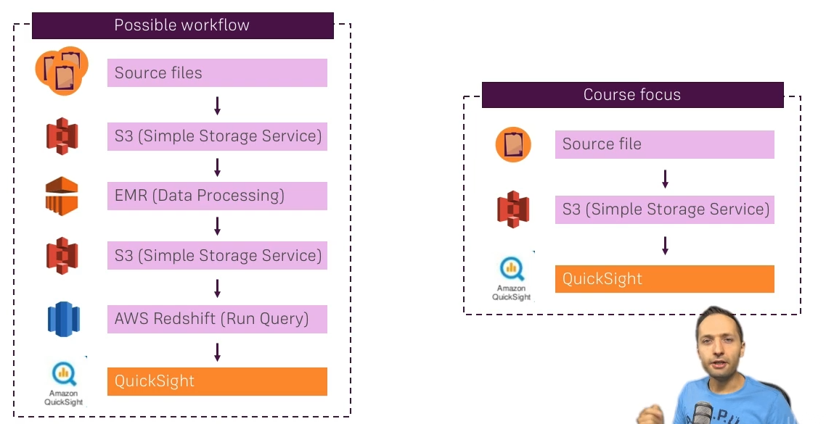

* 1. SPICE vs Direct Query

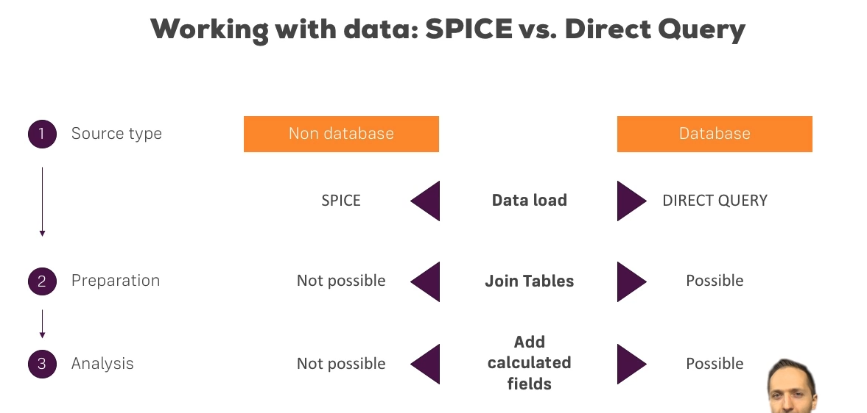

* 1. Manifest File

To load data from S3 to Quicksight we will need a manifest file:

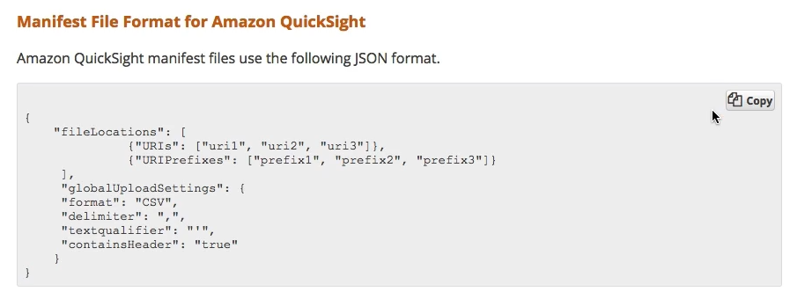

Permission to S3 is required as well.

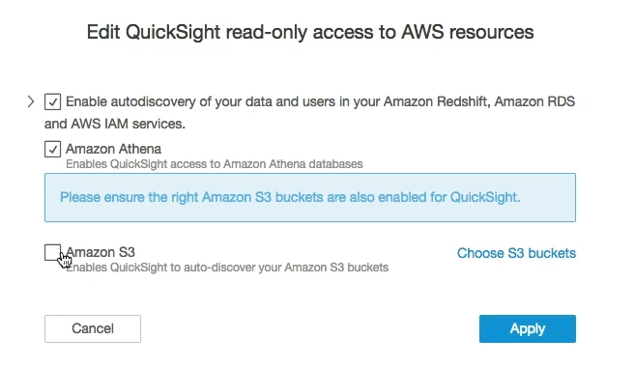

* 1. Quicksight built-in functions to generate calculcated fields

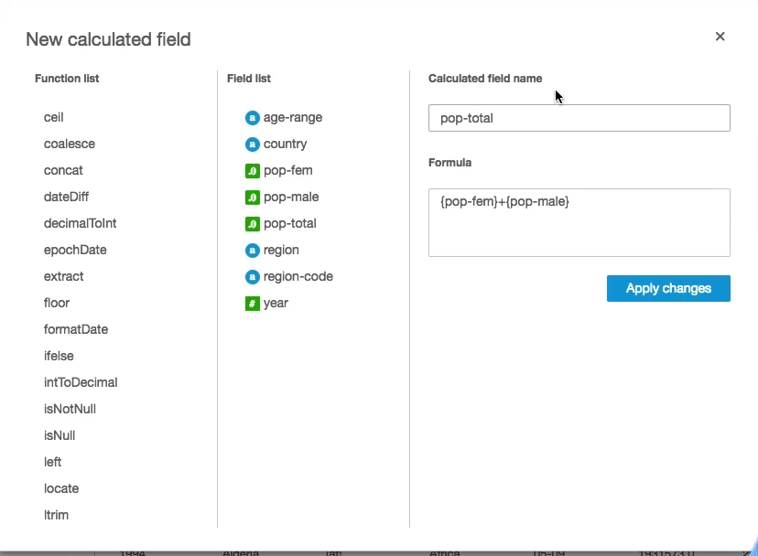

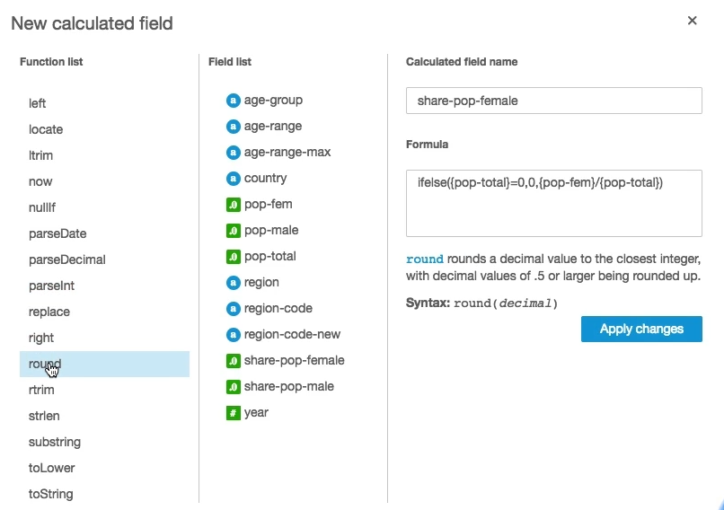

* 1. Filters

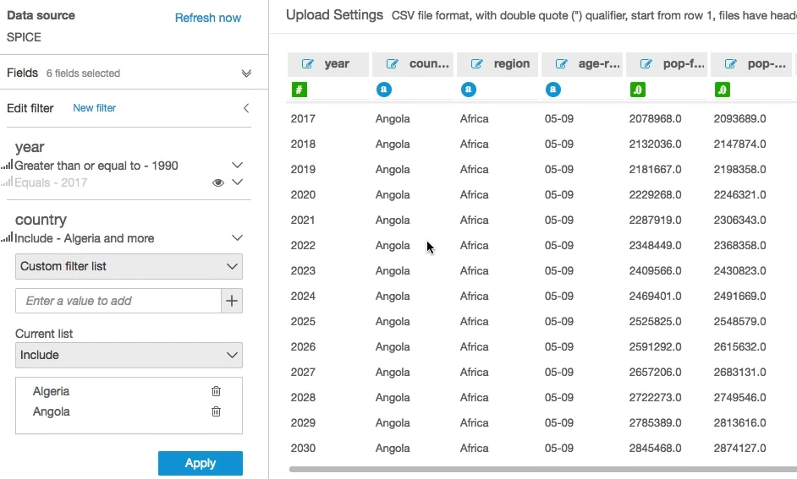

* 1. Analysis

Create new analysis to the dataset you have.

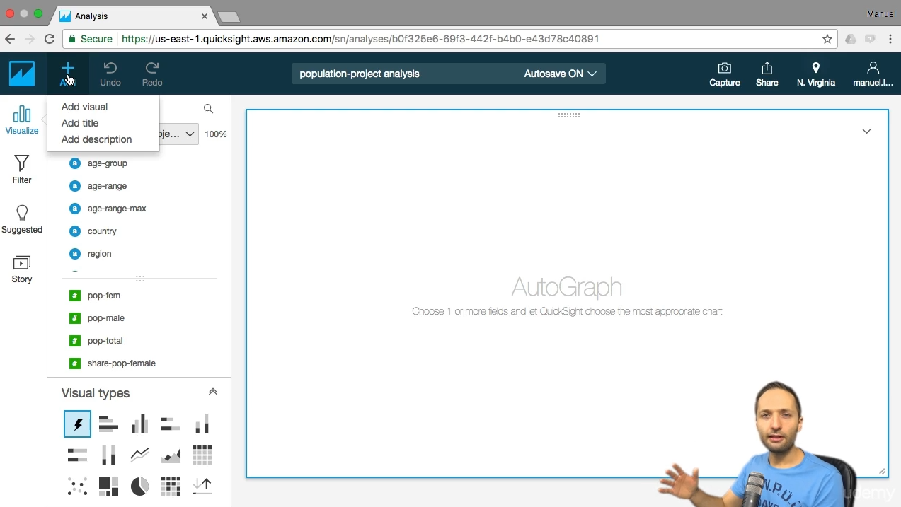

You can add multiple datasets into the analysis

* 1. Story

Display how our analysis evevolved. You can transfer all our analysis via 1 click into the story, as a given scene. Then change some of the analysis charst and you have a second scene + talk about what did you change, why did you change.

* 1. Pivot table
  2. Refresh

1. Refresh new
2. Scheduled refresh

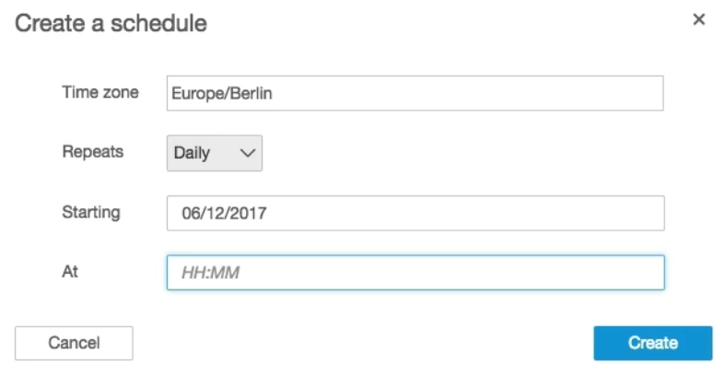

* 1. Adding users to Quicksight account

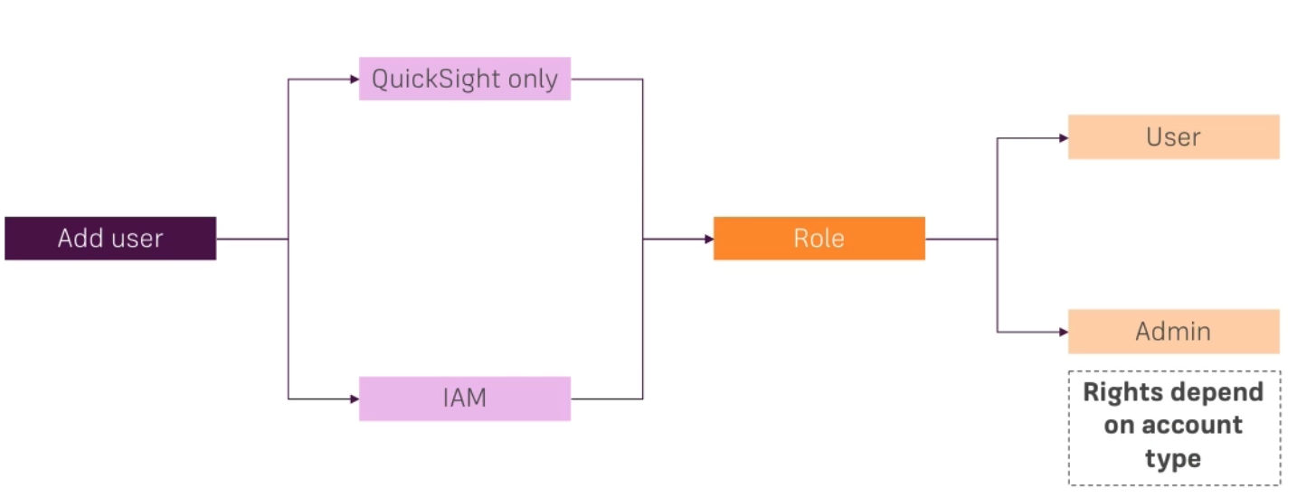

The quicksight user by default cannot have access to any datasets. We need to later invite them, to have access to the dataset.

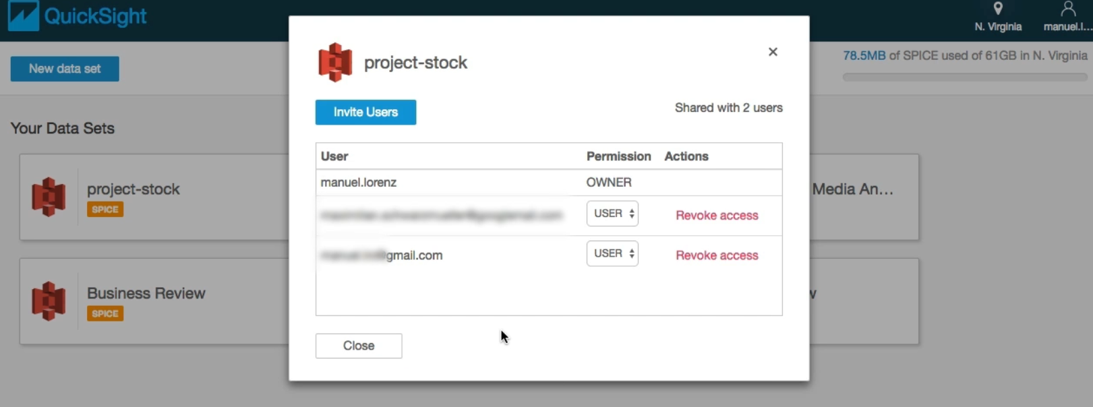

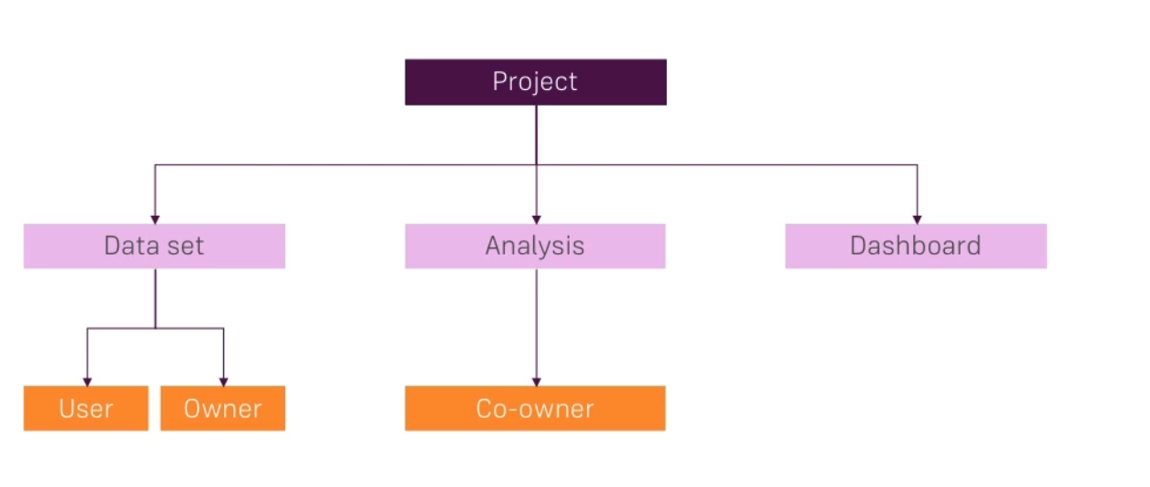

Dashboards are read only versions of the analysis. In the dashboaed you can read the analysis export, export the data to CSV and apply filters. But you cannot change the content.