**Content**

1. SAM 2

1. StepFunctions 2

1. SAM (Serverless Application Model)

AWS CloudFormation extension, optimized for serverless. Special serverless resource types: functions, APIs, tables, Layers and Applications. Supports anything AWS CloudFormation supports.

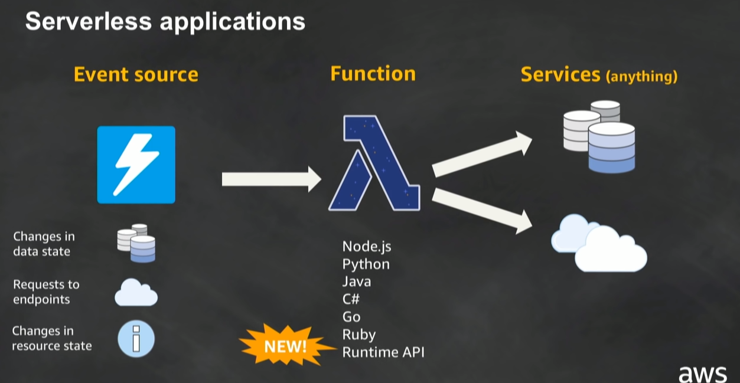

* 1. The file

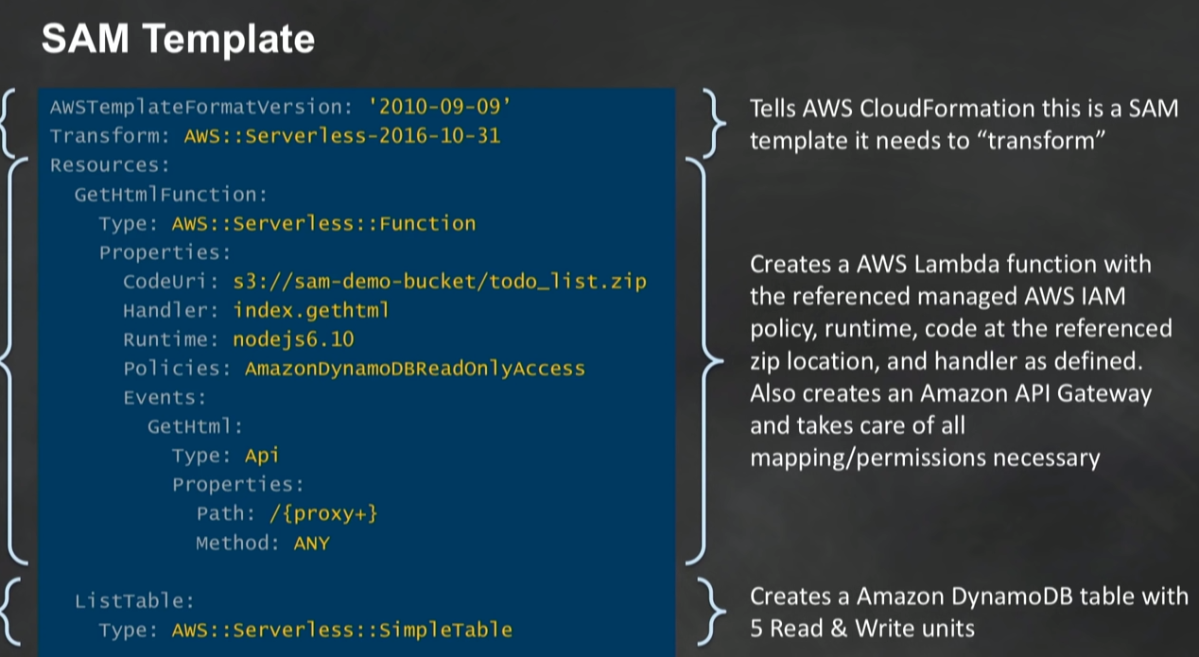

<https://bit.y/2xWycnj>

* 1. AWS SAM CLI

CLI tool for local development, debugging, testing, deploying and monitoring serverless applications. Uses open source docker-lambda images to mimic Lambda’s execution environment such as timeout, memory limits, runtimes.

* 1. StepFunctions

1. Lambda – versions and aliases

* You can publish one or more versions of your Lambda function
* Each Lambda Function has a unique ARN.
* After you publish a version it can not be charged
* The latest version of the function is tagged as $Latest
* Lambda supports creating aliases for each Lambda function version
* An alias is a pointer to a specific Lambda function version
* Each alias has unique arn
* Alieses can be modified. **You can update an alias to point to different version.**
* Lambda Canary: shit traffic between 2 versions based on weights.

