**Content**

1. Nadpis 1 3

1. Nadpis 1

* look for serverless keyword
* overlay multicast:
* 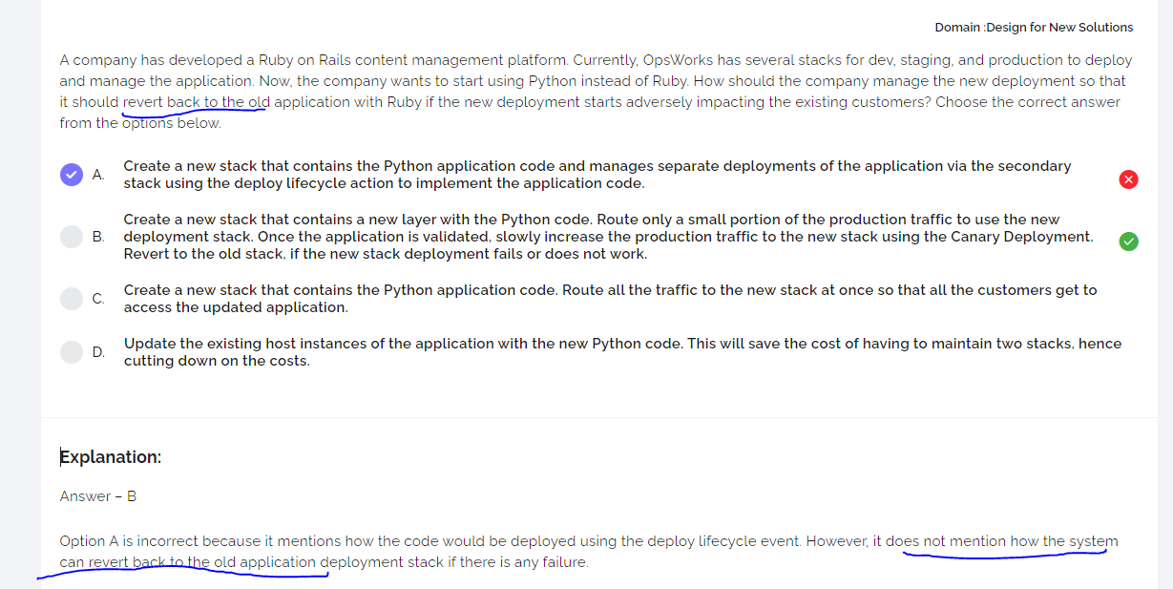

Insufficient answer most probably not the best

* AWS Global accelerator