**Content**

1. Organizational Complexity 2

1. SSO and Federation 2

2. Hybrid 2

3. Storage (general) 4

1.3.1. Storage types 4

1.3.2. Storage protocols 5

1.3.3. Storage gateway 6

1.3.4. S3 deep dive 7

4. Organizations 7

2. New Solutions 8

3. Migration Planning 10

4. Cost Control 11

5. Improving Architectures 12

1. Organizational Complexity
   1. SSO and Federation

* Simple AD – low scale basic AD
* AD Connector – you have your own
* AWS Managed Microsoft AD
* AWS SSO
* Cognito
  1. Hybrid

Direct connect gateway?

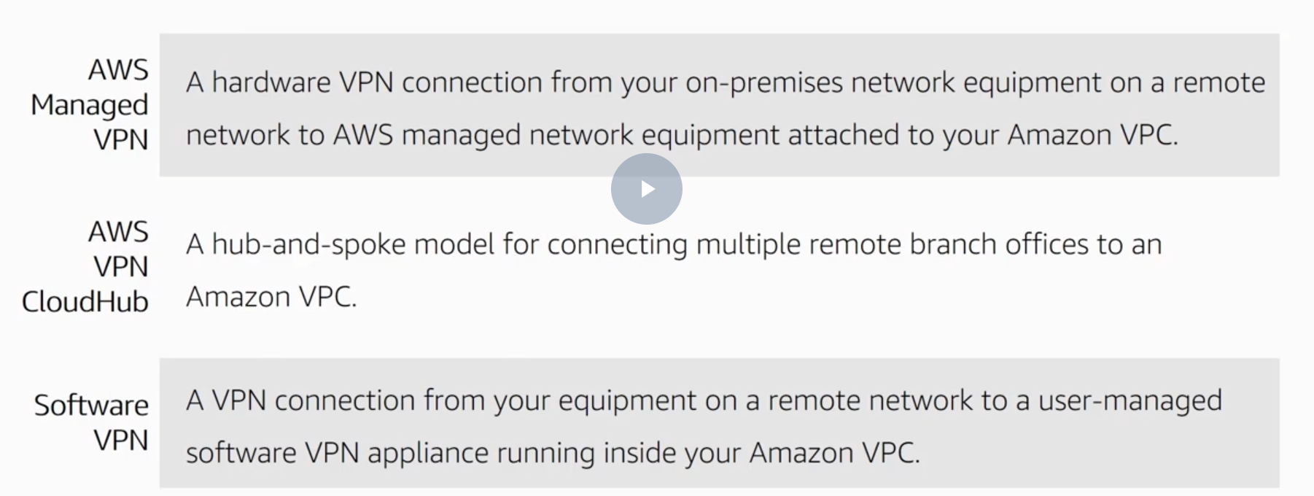

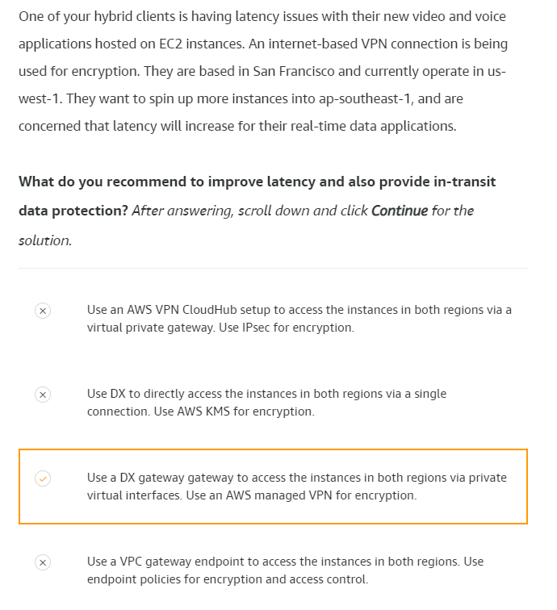

Direct connect and AWS Direct Connect Locations

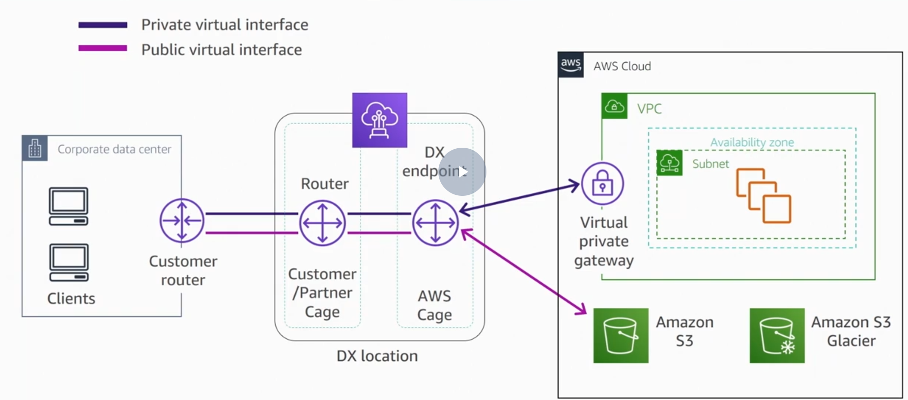

Storage Gateway

* 1. Storage (general)

RAID – redundant array of independent disks

* + 1. Storage types

Files, blocks, and objects are storage formats that hold, organize, and present data in different ways—each with their own capabilities and limitations.

* file storage organizes and represents data as a hierarchy of files in folders; (NAS)
* block storage chunks data into arbitrarily organized, evenly sized volumes; (SAN)
* object storage manages data and links it to associated metadata. (API + Cloud)

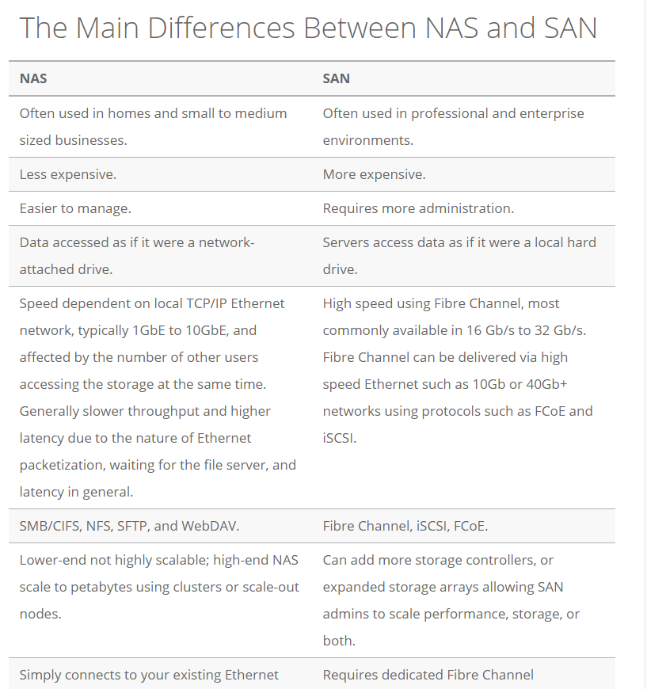

* + 1. Storage protocols

Probably the most heated debates come on the issue of whether to use network-attached storage (NAS) or storage area network (SAN), and lately the representational state transfer (REST) protocol for object storage has gotten into the act.

* iSCSI (Internet Small Computer System Interface). An IP based internet protocol, storage networking standard for linking data storage facilities. It provides block level access to storage devices.
* SMB (Server Message Block) protocol is a network file sharing protocol that allows applications on a computer to read and write to files and to request services from server programs in a computer network.
* NFS (Network File System), was designed in 1984 by Sun Microsystems. This distributed file system protocol allows a user on a client computer to access files over a network in the same way they would access a local storage file. Because it is an open standard, anyone can implement the protocol. NFS v3 / NFS v4.1
  + 1. Storage gateway

The AWS Storage Gateway is a service that can connect an on-premises software applience with cloud-based storage. Common Use Cases:

* Backup and archive
* Disaster recovery
* Data migration or mirroring
* Replace or expand on-premises storage

Storage Gateway enables you to reduce your on-premises storage footprint and associated costs by leveraging Amazon S3 cloud storage.

* File Gateway enables you to store and retrieve objects in Amazon S3 using file protocols such as Network File System (NFS) and Server Message Block (SMB). Objects written through File Gateway can be directly accessed in S3.
* Volume Gateway provides block storage to your on-premises applications using iSCSI connectivity. Data on the volumes is stored in Amazon S3 and you can take point in time copies of volumes which are stored in AWS as Amazon EBS snapshots. You can also take copies of volumes and manage their retention using AWS Backup. You can restore EBS snapshots to a Volume Gateway volume or an EBS volume.
* Tape Gateway provides your backup application with an iSCSI virtual tape library (VTL) interface, consisting of a virtual media changer, virtual tape drives, and virtual tapes. Virtual tapes are stored in Amazon S3 and can be archived to Amazon S3 Glacier or Amazon S3 Glacier Deep Archive. (use case – virtual tape library, archival, tape gateway has integration with other vendors. Some local cache, so u can do daily, / weekly restores if needed)

On-premises, you can deploy a virtual machine containing the Storage Gateway software on VMware ESXi, Microsoft Hyper-V, or Linux KVM, or you can deploy Storage Gateway as a hardware appliance. You can also deploy the Storage Gateway VM in VMware Cloud on AWS, or as an AMI in Amazon EC2.

Volume Gateway provides an iSCSI target, which enables you to create block storage volumes and mount them as iSCSI devices from your on-premises or EC2 application servers. The Volume Gateway runs in either a cached or stored mode.

* In the cached mode, your primary data is written to S3, while retaining your frequently accessed data locally in a cache for low-latency access. (use case – random reads/writes, backup, snapshots, ebs volumes)
* In the stored mode, your primary data is stored locally and your entire dataset is available for low-latency access while asynchronously backed up to AWS. Backup for onprem.

In either mode, you can take point-in-time snapshots of your volumes, which are stored as Amazon EBS Snapshots in AWS, enabling you to make space-efficient versioned copies of your volumes for data protection, recovery, migration and various other copy data needs

* + - 1. Creating storage gateways

Can be used on

* Microsoft Hyper-V 2008 R2
* Microsoft Hyper-V 2012
* VMWare ESXi
* Amazon EC2 - use cases are backup and data mirroring. (volume stored cant be on ec2)
  + 1. S3 deep dive
  1. Organizations

1. New Solutions

Cache Use Cases

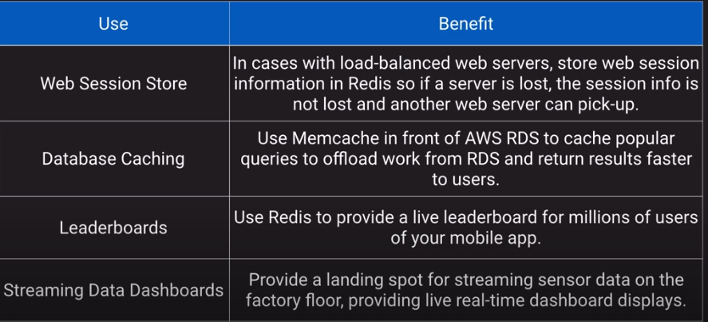

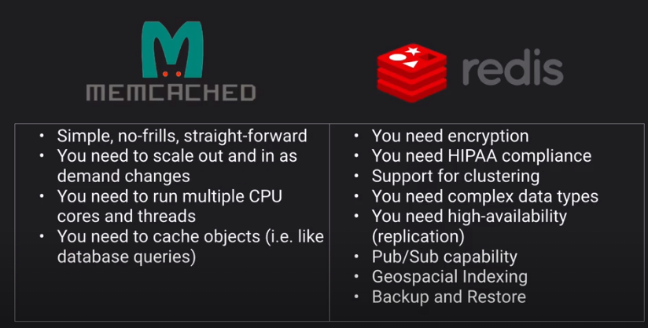

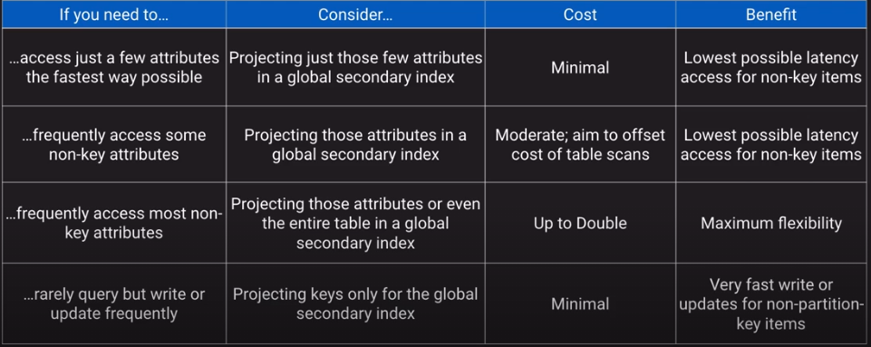

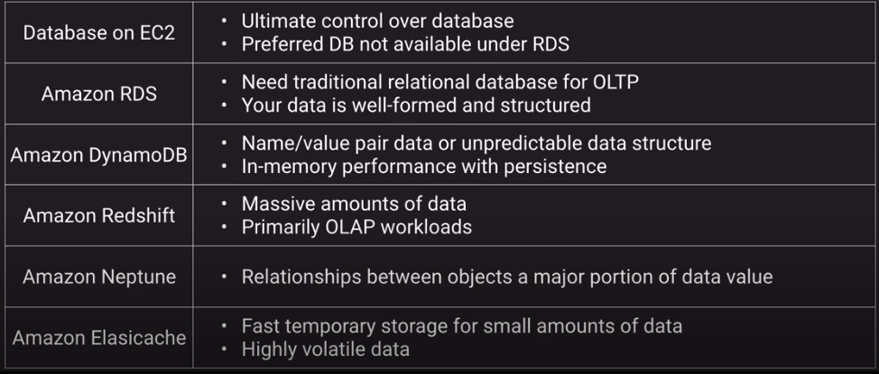

1. Migration Planning
2. Cost Control
3. Improving Architectures