**Content**

1. LinuxAcademy Networking 2

2. LA networking exam tips [todo] 4

1. On-prem and AWS connectivity 4

2. Some random network components 4

3. Ephemeral ports via NACL and SGs 4

4. BGP 5

5. VPC peering 5

6. Internet Gateways 5

3. High Availability 6

1. LinuxAcademy Networking

* VPC Endpoint vs VPC Gateway
* NAT instance vs Egress Only Internet Gateway
* How BGP works
* Difference between security groups and NACLS
* Differernce between nat instance and nat gateway
* Enhanced networking SR-IOV, Intel 82599 VF Interface 10gbps, Elastic Network Adapter 25 Gbps
* 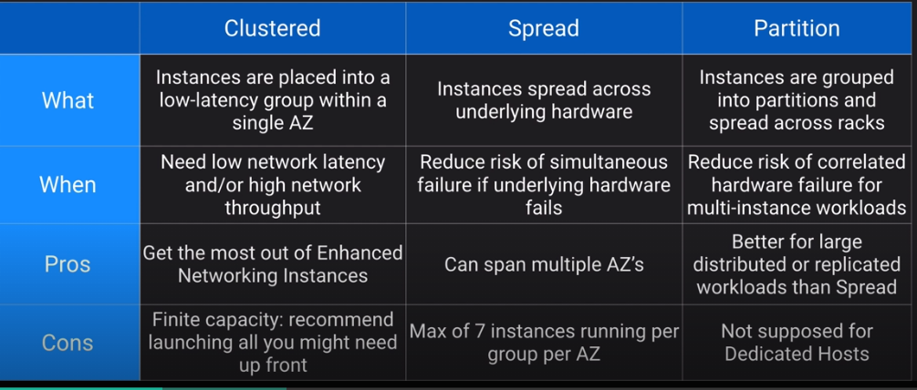
* Dedicated hosts – works well with cluster placement groups. An Amazon EC2 Dedicated Host is a physical server with EC2 instance capacity fully dedicated to your use
* Nslookup
* DNS how it works, route 53 records
* Cloudfront
* Route 53
* 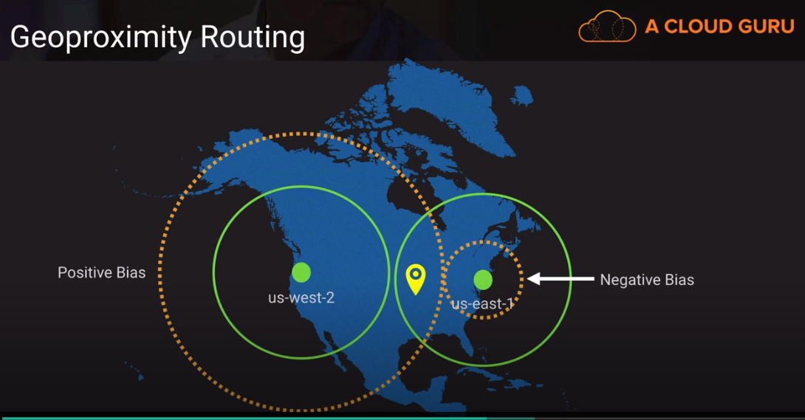
* 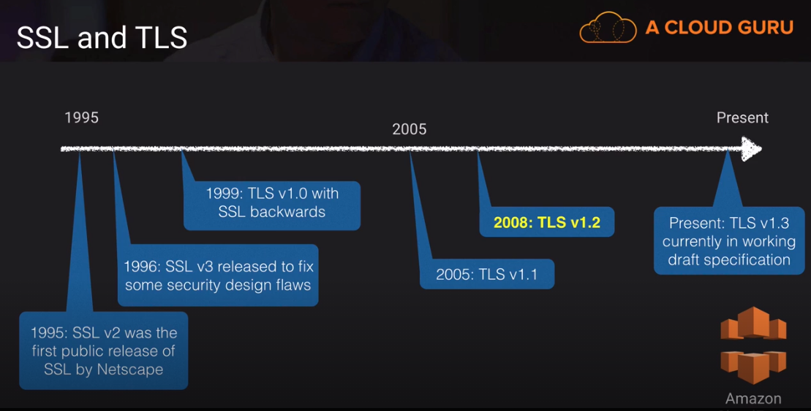
* Cloudfront SNI (server name indication)

1. LA networking exam tips [todo]
   1. On-prem and AWS connectivity

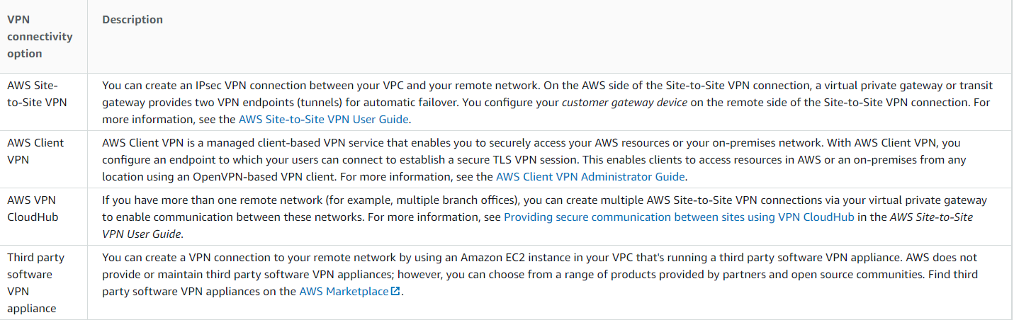

* Direct connect is not inheretely redundant. Either 2 connections or 2nd via vpn.
* Virtual private gateway is inheretely redundant. Customer gateway should be duplicated 2x

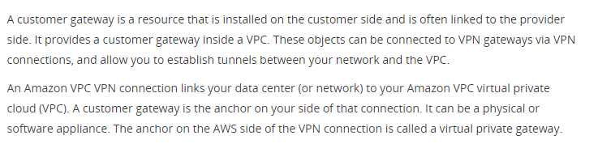

* 1. Some random network components
  2. Ephemeral ports via NACL and SGs

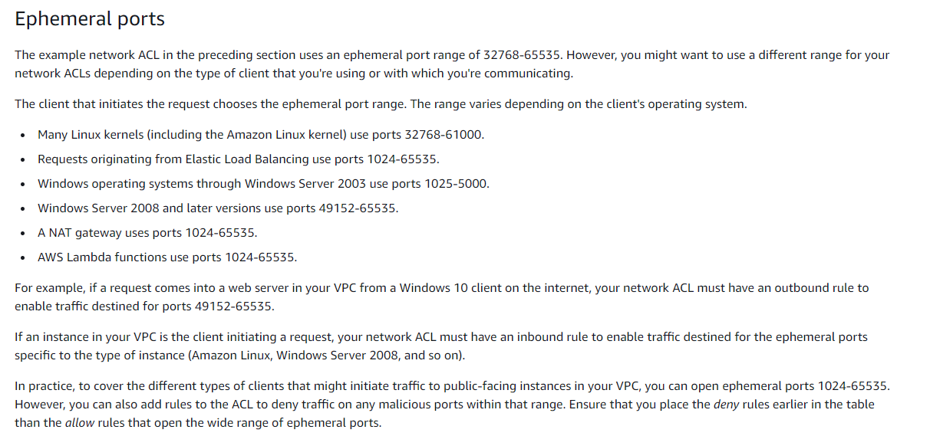

* 1. BGP

AWS supports only BGP (routing protocl and static routes). None others. BGP uses weights, prioritisation-wise the most specific route wins.

* 1. VPC peering

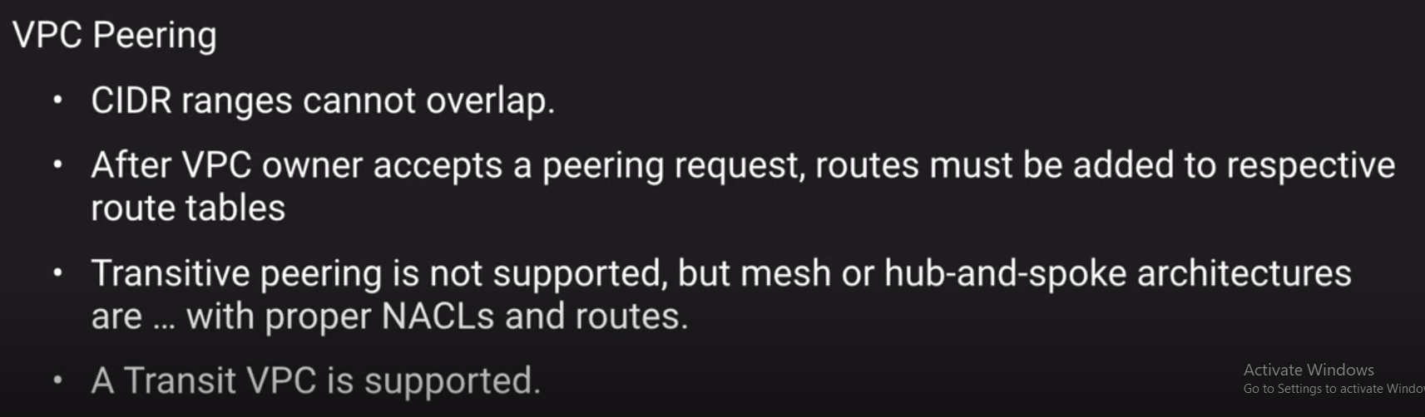

* 1. Internet Gateways
* Nat gateway
* Nat instance
* Internet Gateway
* Egress-only gateway for ipv6
  1. Cloudfront
* OAI
* SNI
* Certificate manager
* Lambda@Edge
* Create a cloudfront distribution

1. High Availability

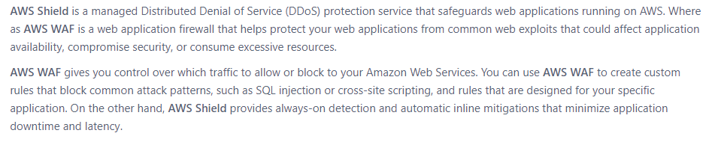

1. Storage

* Storage Gateway

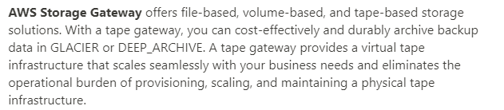

1. Certificates, STS, SSO

