**Content**

1. Gradient Descent 2

2. Magnitude 5

1. Gradient Descent

In machine learning we optimize a lot of staff.

In linear regression we optimize a linear equation:

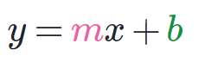

Slope is **m**, intercept is **b**. The y-coordinate of the y-intercept is b. In other words, the line’s y intercept is at (0, b).

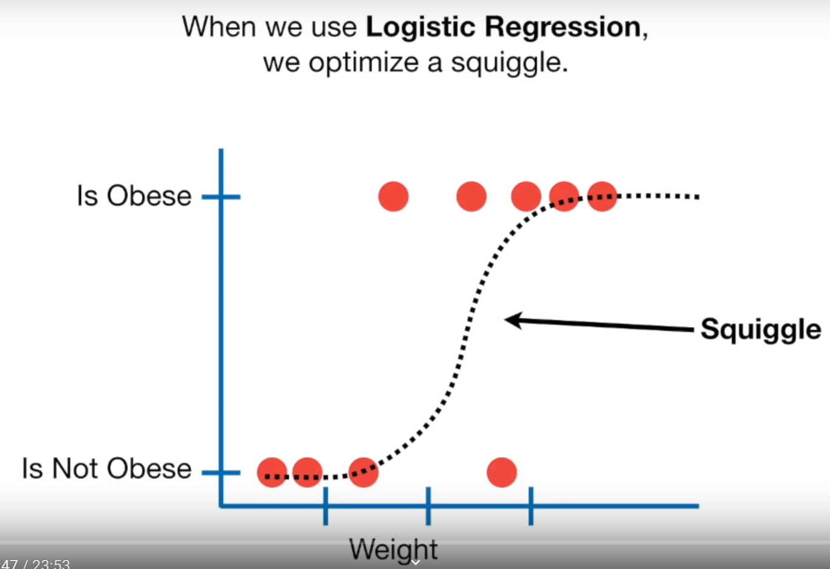

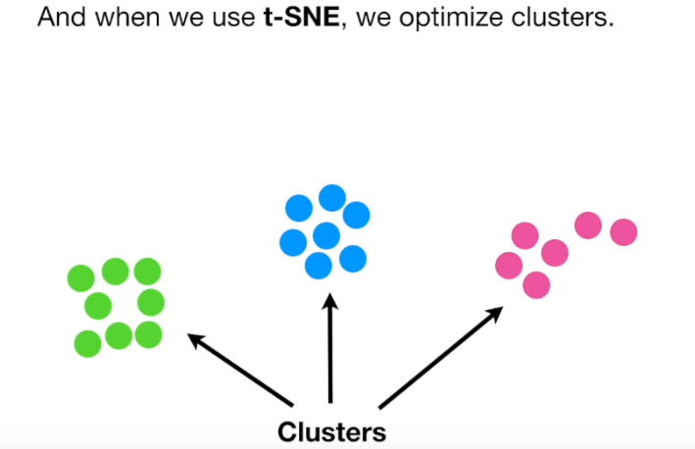

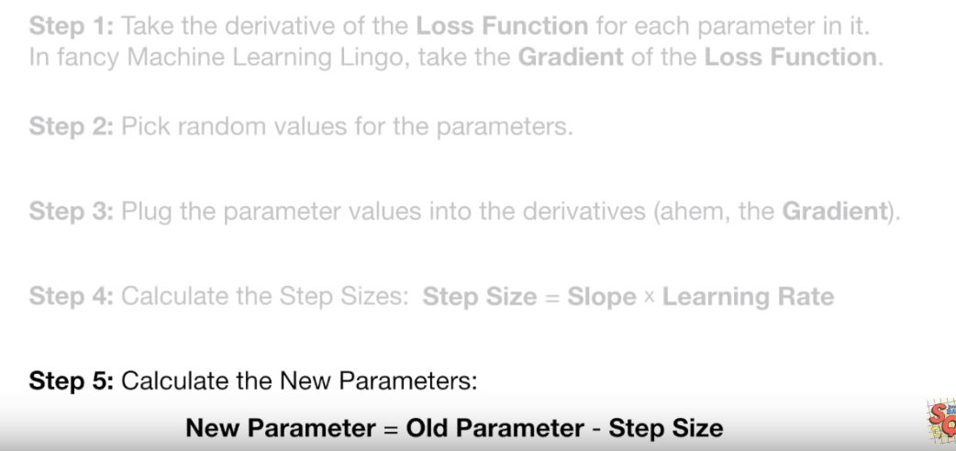

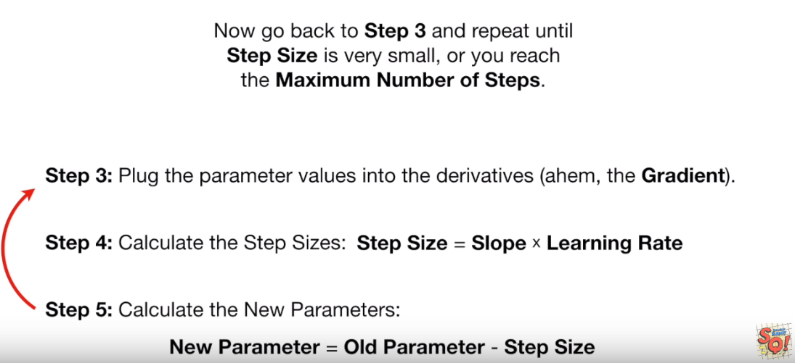

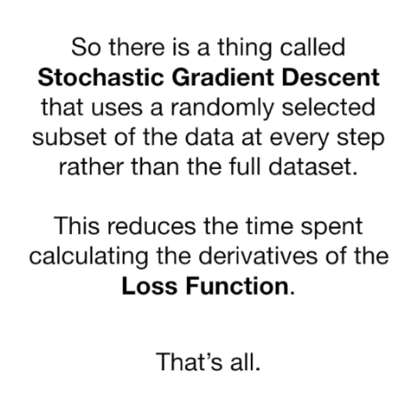

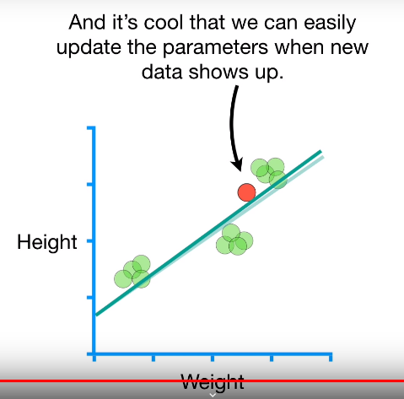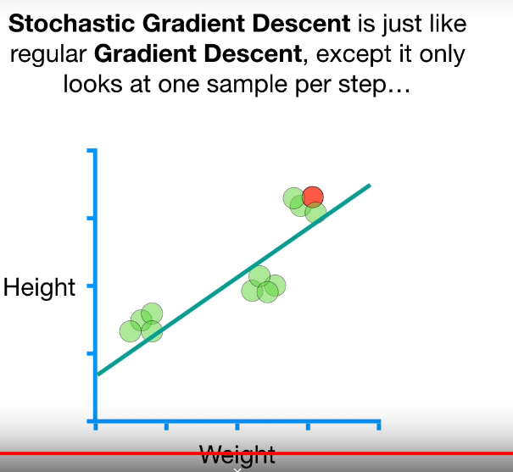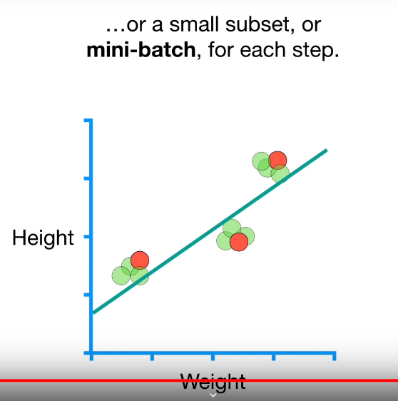 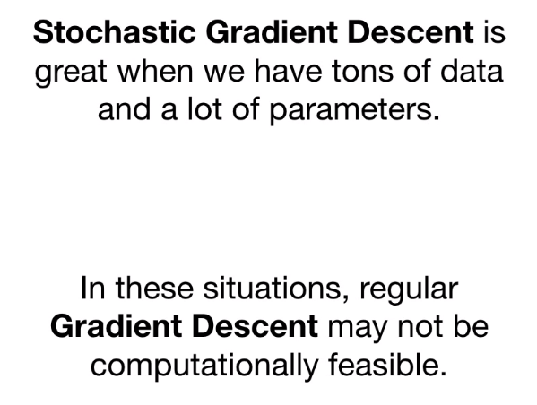

1. Magnitude

In mathematics, magnitude is the size of a mathematical object, a property which determines whether the object is larger or smaller than other objects of the same kind. More formally, an object's magnitude is the displayed result of an ordering (or ranking) of the class of objects to which it belongs.