**Content**

1. Edge Computing 2

2. IoT 3

3. CyberSecurity 4

4. Big Data 5

5. BlockChain 6

6. Functional Programming 7

1. Edge Computing

<https://www.youtube.com/watch?v=l9tOd6fHR-U>

Edge Computing + Machine Learning + IoT.

Sensors!

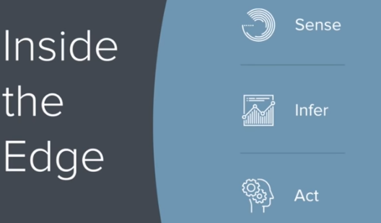

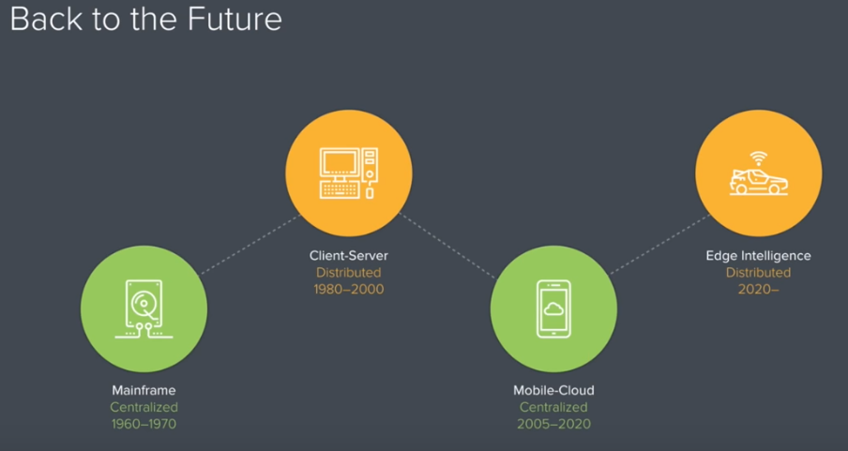

1. IoT

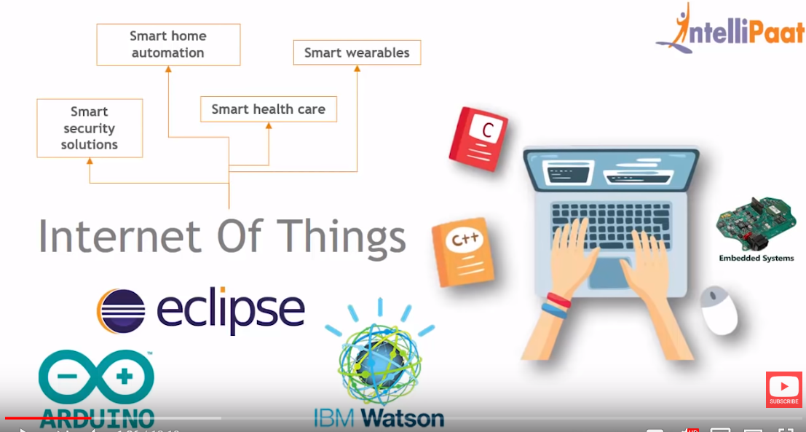

1. CyberSecurity

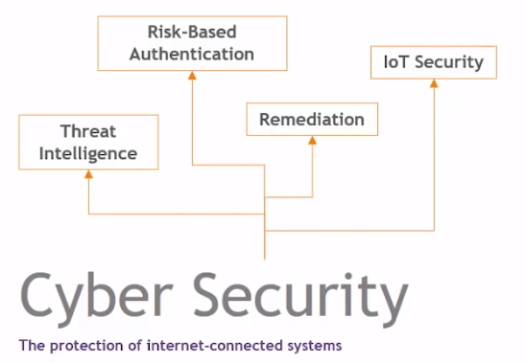

1. Big Data

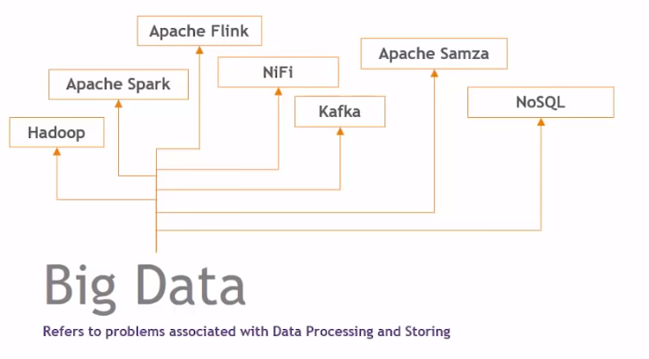

1. BlockChain
2. Functional Programming

<https://www.youtube.com/watch?v=QyJZzq0v7Z4>