**Content**

1. Introduction into the world of APIs 2

1. Terms 3

2. What is an API 4

1. Rapid API 4

2. Mash-up 5

3. API vs Web Service 5

3. Protocols 6

1. HTTP 6

2. XML 6

4. SOAP 8

1. Introduction into the world of APIs

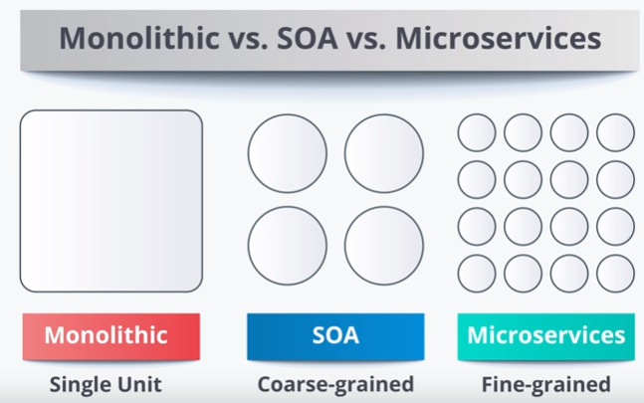

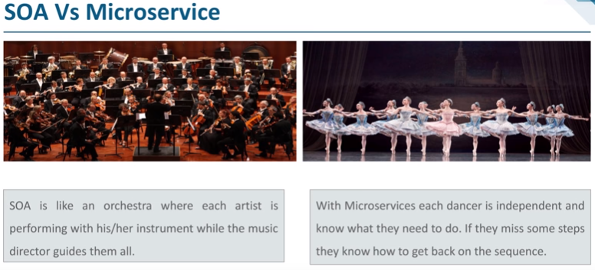

Microservices are decentralized.

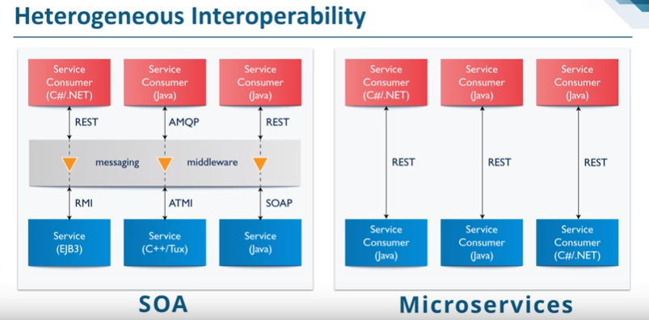

In computing, the Java Remote Method Invocation (Java RMI) is a Java API that performs remote method invocation, the object-oriented equivalent of remote procedure calls (RPC), with support for direct transfer of serialized Java classes and distributed garbage-collection.

Asynchronous Task and Memory Interface, or ATMI, is a runtime framework and programming model for heterogeneous CPU-GPU systems.

* 1. Terms
* **Monolithic Applications**

A single executable single process in a single big …. There is 1 thing which has all the capabilities. Unreliable, 1 feature down, the whole system down. Inflexible. No place for updates. Complex.

* **REST**
* **SOA**
* **Microservices**

“maybe we can’t get a definition but we can identify common things” /Martin Fowler/

* **GraphQL**
* **API management tools**
* **OAuth**

1. What is an API

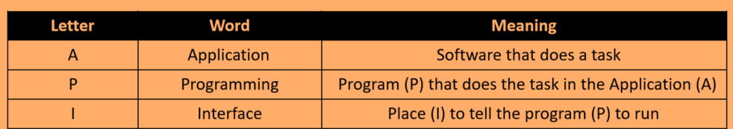

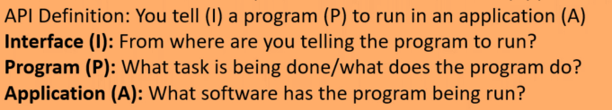

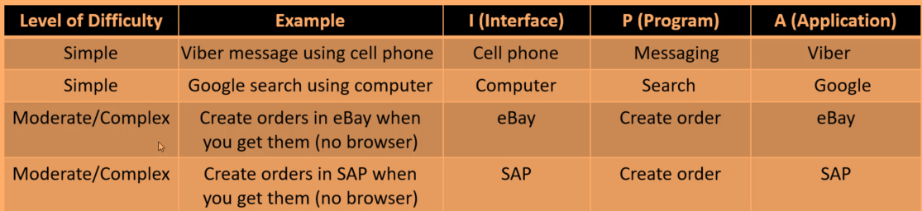

Tell a program to run that you don’t know.

* Just use the program, don’t write it
* Platform independent (you just tell it to run)
* Upgrade safe
  1. Rapid API

Rapid API is the largest marketplace for APIs, it is free to sign up. If you are a developer it’s a one-stop location of public APIs for you.

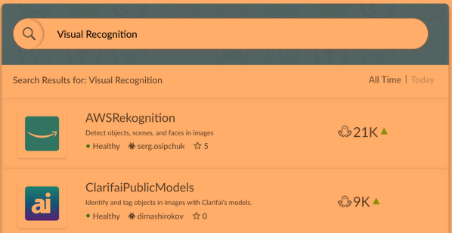

* 1. Mash-up

Combining different APIs. Google Flights / Travelocity – by searching for flight in the background it calls the APIs of different airlines and provides me the most beneficial. Not a commonly used word in the IT, but can be the future. APIs calls APIs and so on…

* 1. API vs Web Service

Web = internet

Service = API

Not all APIs use internet, but obviously there which are web services.

So, all web services are APIs, but not all APIs are web services. Not all APIs use the internet.

Web Services use XML or JSON format, you cannot use whatever format. REST, SOAP, or XML/RPC to transfer that data (protocols)

When people talk about APIs they usually talk about web services.

1. Protocols
   1. HTTP

Hypertext: What is regular text? [www.google.com](http://www.google.com) – what does regular text do? Nothing. HTTP makes it special, Hyper, goes somewhere else. HTTP allows him to go to a google computer, makes it hypertext.

1. Start Line
2. Headers – header fields (content-type, url, cache-control …. )
3. Blank Line
4. Body

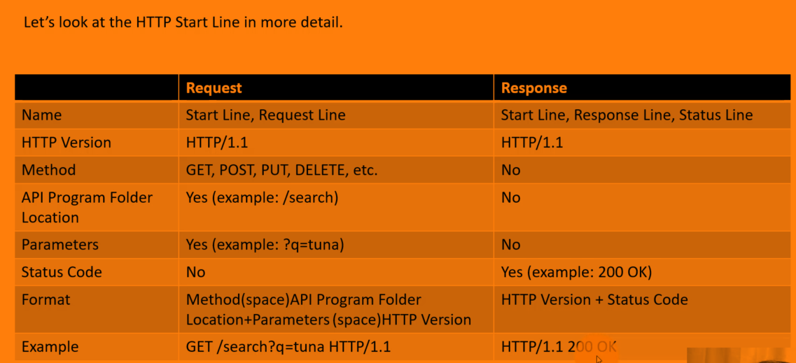

**Idempotence:** can do as many times as you want and result stays the same (safe repeat)

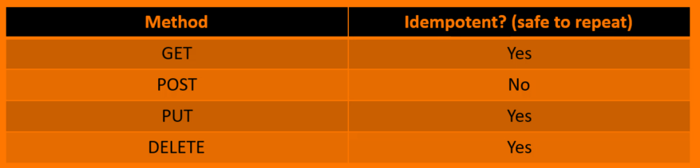

* 1. XML

eXtensible –you can customize them, sister of HTML, there are not customizable. Buth created by W3C organization.

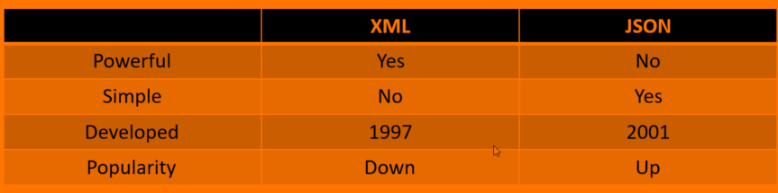

XML is more powerful, has the ability to transform XML , query, security, email schemas, capabilities.

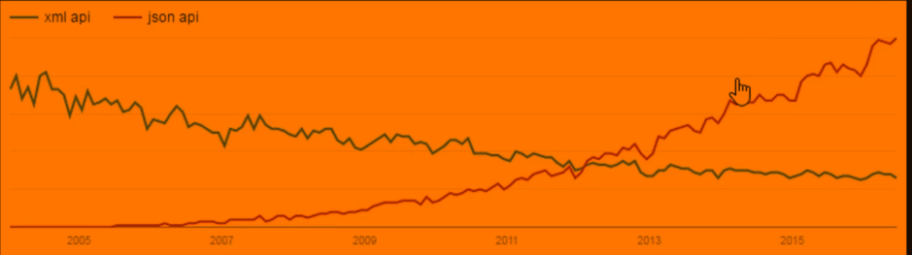

1. SOAP and REST

* They are ways doing web services.
* Ways to form HTTP requests and responses
* REST is simpler

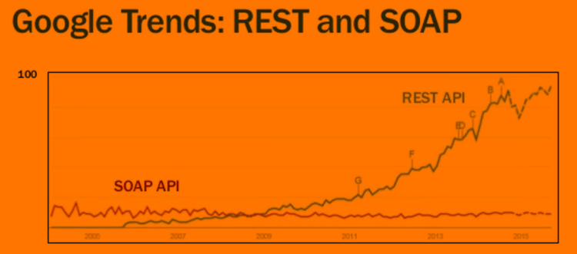

Simple - subjective

Object - API

Access

Protocol - rules, ways to do something, follow the rules, get it done.

WSDL – Web Services Description Language

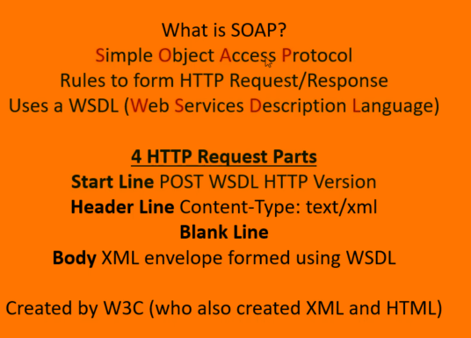

* 1980 – SUN RPC (was not HTTP based)
* 1989 – HTTP
* 1998 – XML-RPC ( P, Procedure, API) – python mbe?
* 1999 – SOAP – better , always POST
* 2000 – REST (1 guy, not org) – in rest you have methods, stateless ?!