**Content**

1. What is what 2

2. Nginx 3

3. Database Administration 4

4. API Management tools 5

5. Configuration tools 6

1. Ansible 6

6. Middleware 7

1. Turing Machine

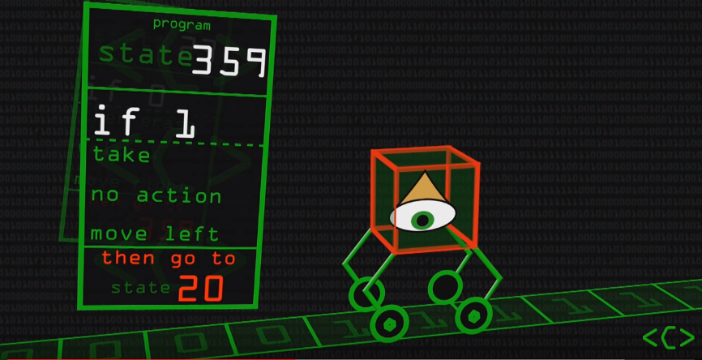

Tape (as long as we want it to be) with 1s and 0s. They are modified based on needs and the machine finishes (halts)

1. Trends in IT

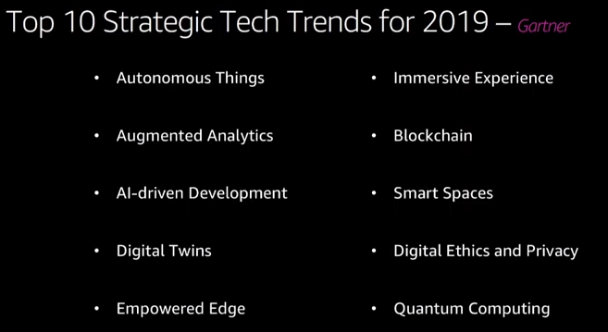

1. What is what

* Packer
* Ansible
* Kafka
* Sonar
* Prometheus
* OpenShift
* Selenium
* Cucumber
* TFS
* Pivotal
* Zabbix
* DBA
* React proxy – nagios?

1. Nginx

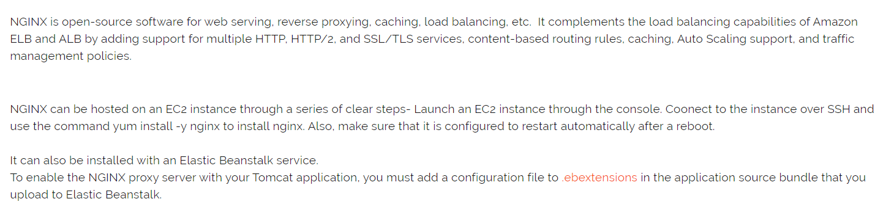

1. Database Administration
2. API Management tools
3. Configuration tools
   1. Ansible
4. Middleware

Postgres, Wireguard, Jboss, Wildfly Tomcat VMware