**Content**

1. Concepts 2

1. Continuous Integration 2

2. Jenkins 5

1. Installation 5

2. Master and Slave Architecture 5

3. Terminology 5

1. Concepts
   1. Continuous Integration

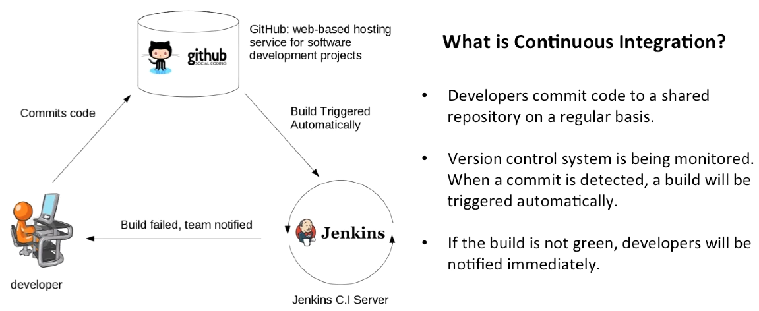

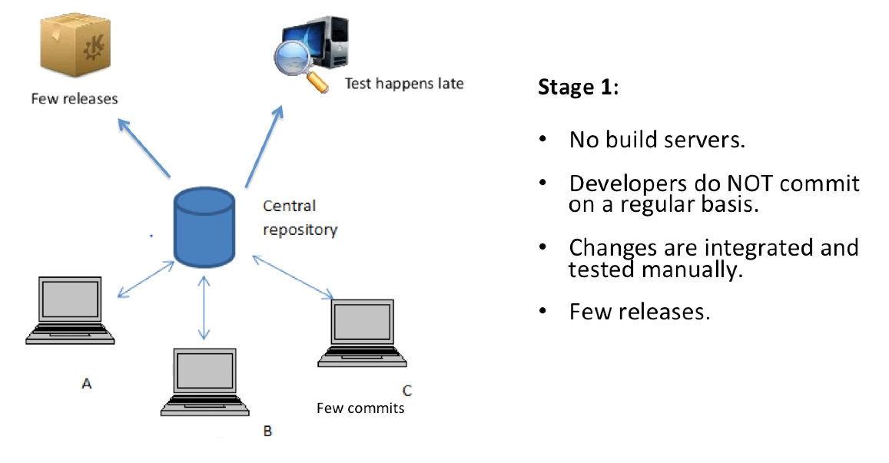

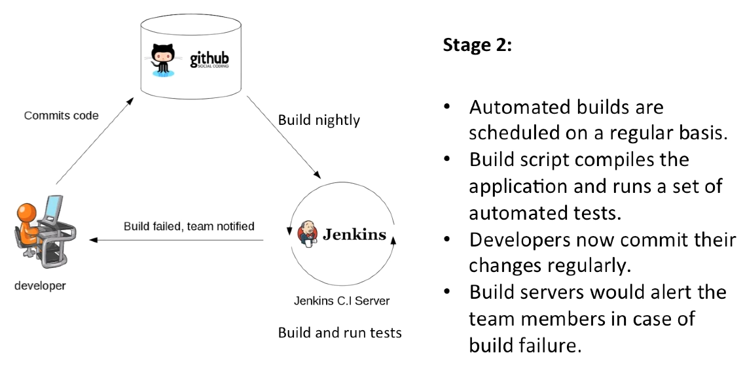

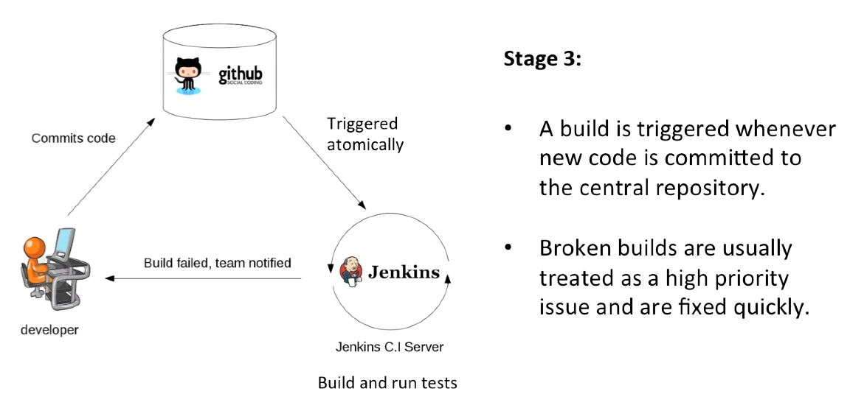

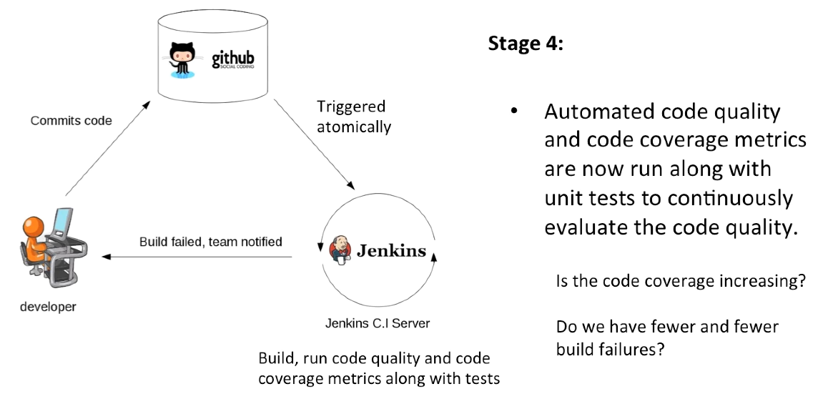

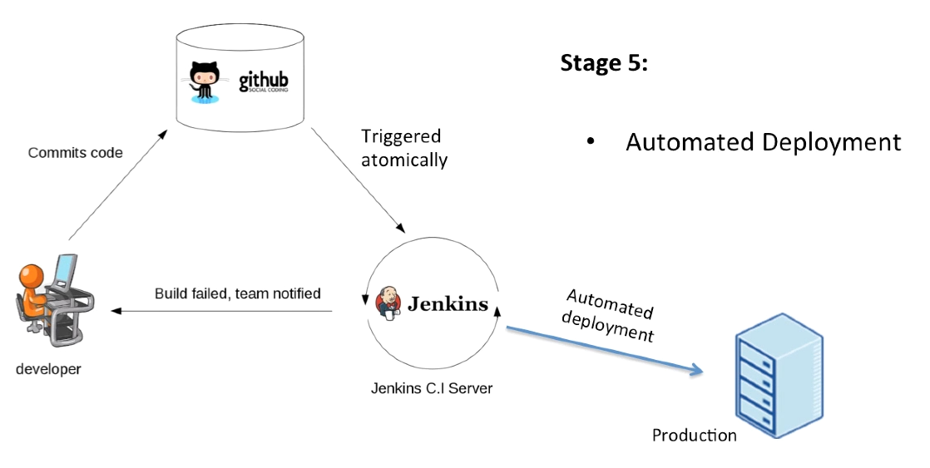

**Continuous Integration**

The practice of merging development work with the main branch constatntly.

**Continuous Delivery**

Continual delivery of code to an environment once the code is ready to ship. This could be staging or production. The idea is the product is delivered to a user base, which can be a QUs or customers for review and inspection.

**Continuous Deployment**

The deployment or release of code to production as soon as it is ready.

Non-hosted solutions: Jenkins

Hosted solutions: circleci

Others:

* Buddy
* TeamCity
* TravisCI
* Bamboo
* GitLab CI
* Codeship
* codefresh

1. Jenkins

* CI and build server
* Used to manually, periodically, or automatically build software development projects
* It is an open source CI tool written in Java
* Language support : Groovy, PHP, .NET, Ruby, C/C++, Android, Java, Python
* Easy to use, lots of plugins
  1. Installation

JAVA_HOME env var points to the installation path for the JDK

Address: <http://localhost:8080>

echo %JAVA_HOME%

cd %JENKINS_HOME%

jenkins [stop | start]

* 1. Master and Slave Architecture

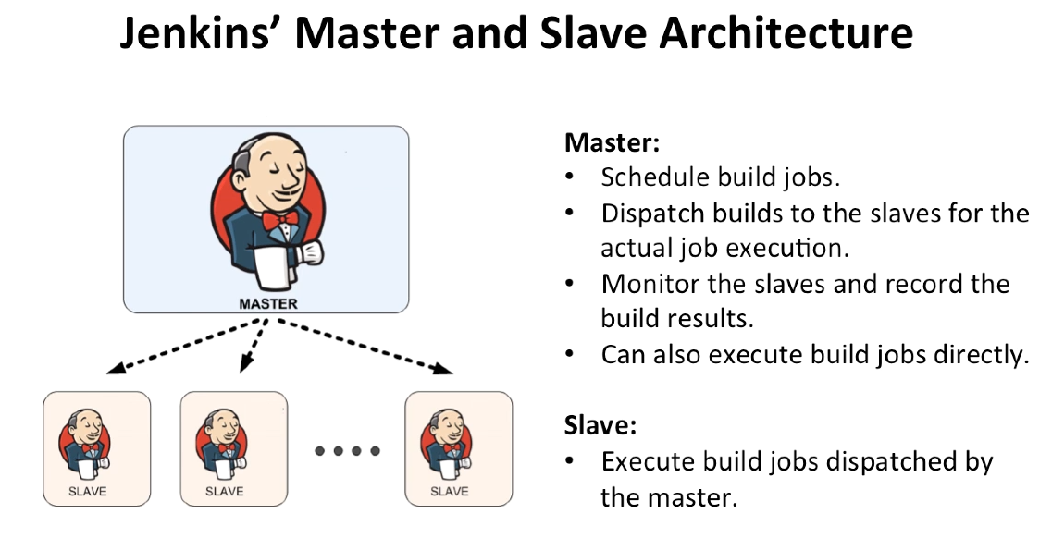

Slave is a small java program that listens to the request

* 1. Terminology

**Job / Project**

Those 2 terms are used interchangeably. They all refer to runnable tasks that are controlled / monitored by Jenkins.

**Slave / Node**

Slaves are computers that are set u to build projects for a master. Jenkins runs a separate program called “slave agent” on slaves. When slaves are registered to a master, a master starts distributing loads to slaves. Node is used to refer to all machines that are part of Jenkins grid, slaves and master.

**Executor**

A separate stream of builds to be run on a node in parallel. A node can have 1 or more executors.

**Build**

Is a result of one of the projects.

**Plugin**

A Plugin, like plugins on any other system, is a piece of software that extends the core functionality of the core Jenkins server.