**Content**

1. Introduction 2

1. Introduction

**Definition**:

Nginx is an open source reverse proxy server for HTTP, HTTPS, SMTP, POP3 and IMAP protocols as well as a load balancer, HTTP cache and web server.

* reverse proxy

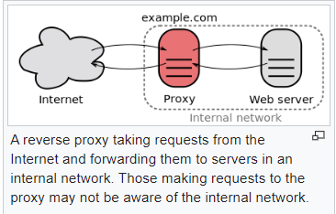In computer networks, a **reverse** **proxy** is a type of proxy server that retrieves resources on behalf of a client from one or more servers. These resources are then returned to the client, appearing as if they originated from the proxy server itself. Unlike a **forward** **proxy**, which is an intermediary for its associated clients to contact any server, a reverse proxy is an intermediary for its associated servers to be contacted by any client. In other words, a proxy acts on behalf of the client(s), while a reverse proxy acts on behalf of the server(s).

**How it is different from Apache:**

Mainly, nginx differs in „how“ it handles requests. Apache HTTP Server’s default model of request handling is „threaded“ or „process-oriented“. Instead of taking that approach, nginx uses an async event-driven handler for requests. This allows nginx to more accurately provide predictable performance under very high loads.

Written to solve the C10K problem (10K Concurrent Connections)

High Performance web server

**SSL/TLS Termination**

**Content caching and compression**

**HTTP:** Defines the format for sending information between web clients and web servers. The language of the internet.

**HTTPS:**  Encrypted communication between web clients and servers using TLS/SSL.

JWT Authentication

OpenID Connect SSO

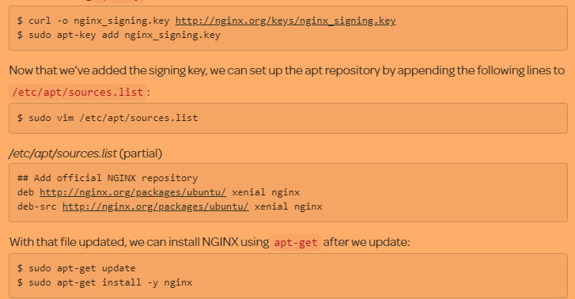

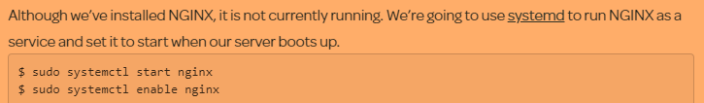

1. Configuration

* User
* Worker_process
* Error_log
* Pid
* Events
* Worker_connections
* Include
* Default_type
* http
* log_format
* sendfile
* access_log
* keepalive_timeout