**Content**

1. Java Concepts 2

1. Lambda expressions 2

2. Polymorphism in java – Runtime and Compile time polymorphism 2

1. Java Concepts
   1. Lambda expressions

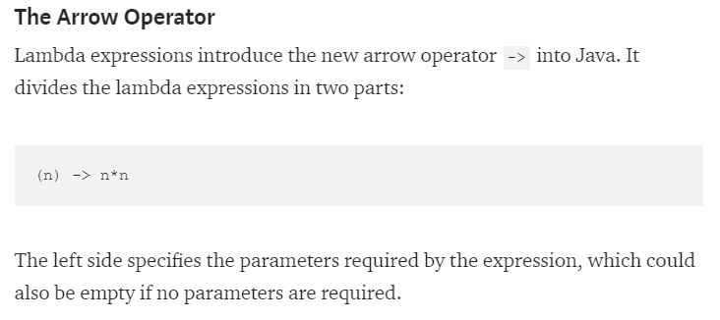

The right side specifies the actions of the lambda.

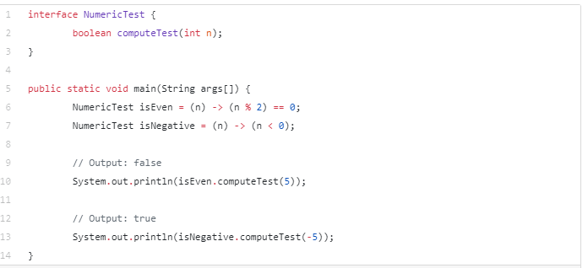

isEven equals what n becomes then (n % 2) == 0

true

* 1. Polymorphism in java – Runtime and Compile time polymorphism
* Compile time – Method Overloading
* Runtime –

Public class Circle extends Shape...

Circle c = new Shape();