**Content**

1. JavaScript 2

1. Experss.js 2

2. Arrow functions 2

1. JavaScript
   1. Experss.js

A framework to handle request – response

* 1. Arrow functions

1. Node

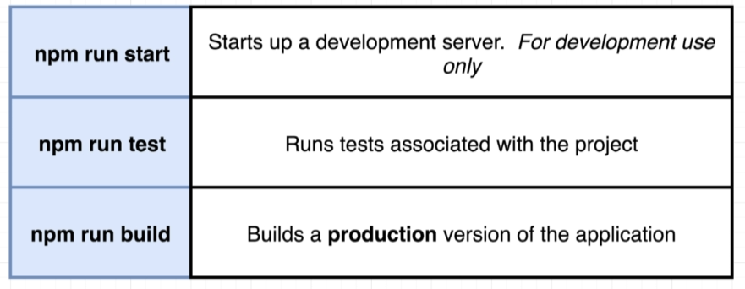

* 1. Axios – the React proxy