**Content**

1. Computer security principles - Základné princípy počítačovej bezpečnosti 3

1. Confidentiality – Utajenost 3

2. Integrity - Integrita 4

3. Availability - Dostupnost 5

4. Further concepts 5

2. Cyptography 7

1. Symmetric Key Cryptography 8

2.1.1. DES 9

2.1.2. SSL 9

2.1.3. AES 9

2. Asymmetric Key Encryption 9

2.2.1. Diffie – Helman 10

2.2.2. RSE 10

3. Use of cryptography to provide integrity 10

2.3.1. Hashing algorithms 10

2.3.2. Message Authentication Code (MAC) 11

2.3.3. Digital signatures 11

2.3.4. PKI – Public Key Infrastructure 12

4. Further concepts 12

3. Identification and autentification 13

1. Autentification 13

2. Ideas what to talk about 14

3. Summary 15

4. Kontrola prístupu, bezpečnostné modely 16

5. Web Security 17

1. Computer security principles - Základné princípy počítačovej bezpečnosti

**Computer security** is the protection of the items you value, called the assets of a computer or computer system. There are many types of assets, involving hardware, software, data, people, processes, or combinations of these. To determine what to protect, we must first identify what has value and to whom. [hardware, software, and data].

**Value of the asstest:** after identifying the assets to protect, we next determine their value. We make valuebased decisions frequently, even when we are not aware of them.

A **vulnerability** is a weakness in the system, for example, in procedures, design, or implementation, that might be exploited to cause loss or harm.

A **threat** to a computing system is a set of circumstances that has the potential to cause loss or harm.

A human who exploits a vulnerability perpetrates an **attack** on the system.

**Controls** prevent **threats** from exercising **vulnerabilities**.

Harm can also be characterized by four acts: **interception**, **interruption**, **modification**, and **fabrication**. **Confidentiality** can suffer if someone **intercepts** data, **availability** is lost if someone or something **interrupts** a flow of data or access to a computer, and **integrity** can fail if someone or something **modifies** data or **fabricates** false data.

**Computer security seeks to prevent unauthorized viewing (confidentiality) or modification (integrity) of data while preserving access (availability).**

* 1. Confidentiality – Utajenost

*the ability of a system to ensure that an asset is viewed only by authorized parties*

**Data** **confidentiality** : Assures that private or confidential information is not made available or disclosed to unauthorized individuals. **Privacy** : Assures that individuals control or influence what Information related to them may be collected and stored and by whom and to whom that information may be disclosed.

Nastroje pre zabezpecenia utajenia:

* + Sifrovanie
  + Kontrola Pristupu
  + Autentifikacia
  + Autorizacia
  + Fyzicka kontrola pristupu

A failure of data confidentiality:

* An unauthorized person accesses a data item.
* An unauthorized process or program accesses a data item.
* A person authorized to access certain data accesses other data not authorized (which is a specialized version of “an unauthorized person accesses a data item”).
* An unauthorized person accesses an approximate data value (for example, not knowing someone’s exact salary but knowing that the salary falls in a particular range or exceeds a particular amount).
* An unauthorized person learns the existence of a piece of data (for example, knowing that a company is developing a certain new product or that talks are underway about the merger of two companies).
  1. Integrity - Integrita

*the ability of a system to ensure that an asset is modified only by authorized parties*

**Data** **integrity** : Assures that information and programs are changed only in a specified and authorized manner. **System** **integrity** : Assures that a system performs its intended function in an unimpaired manner, free from deliberate or inadvertent unauthorized manipulation of the system.

Nastroje pre zabezpecenia integrity

* + Zalohovanie
  + Kontrolne Sumy

we say that we have preserved the integrity of an item, we may mean that the item is:

* precise
* accurate
* unmodified
* modified only in acceptable ways
* modified only by authorized people
* modified only by authorized processes
* consistent
* internally consistent
* meaningful and usable
  1. Availability - Dostupnost

*the ability of a system to ensure that an asset can be used by any authorized parties*

Nastroje:

* + Redundancie
  + Fyzicka ochrana

an object or service is thought to be available if the following are true:

* It is present in a usable form.
* It has enough capacity to meet the service’s needs.
* It is making clear progress, and, if in wait mode, it has a bounded waiting time.
* The service is completed in an acceptable period of time.

We can construct an overall description of availability by combining these goals. Following are some criteria to define availability:

* There is a timely response to our request.
* Resources are allocated fairly so that some requesters are not favored over others.
* Concurrency is controlled; that is, simultaneous access, deadlock management, and exclusive access are supported as required.
* The service or system involved follows a philosophy of fault tolerance, whereby hardware or software faults lead to graceful cessation of service or to work-arounds rather than to crashes and abrupt loss of information. (Cessation does mean end; whether it is graceful or not, ultimately the system is unavailable. However, with fair warning of the system’s stopping, the user may be able to move to another system and continue work.)
* The service or system can be used easily and in the way it was intended to be used. (This is a characteristic of usability, but an unusable system may also cause an availability failure.)
  1. Further concepts

**Authentication**: the ability of a system to confirm the identity of a sender

**nonrepudiation** or **accountability**: the ability of a system to confirm that a sender cannot convincingly deny having sent something

**Auditability**: the ability of a system to trace all actions related to a given asset.

* **Istota**, **Dovernost** (**Accountability** ?!)

Manažment dôveryhodnosti (dôvernost medzi systémom a používatelom) je na takom stupni, že systém a používatel si dôverujú navzájom.

* **Autentickost (Authenticity)**

Stanovenie, že údaje, postupy a práva vydané osobami alebo systémom sú pravé

Under Integrity. Je to stanovenie, že **údaje**, postupy a práva **vydané** **osobami** **alebo** **systémom** **sú** **pravé**. Hlavným nástrojom na zaistenie autentickosti je **digitálny** **podpis**.

* **Anonymita**:

Je to vlastnosť, že určité **záznamy alebo transakcie nepripadnú ku žiadnemu jednotlivcovi.** Nástroje pre zabezpečenie anonymity sú: **Agregácia** – kombinácia dát od viacerých používateľov. **Mixácia** – agregovanie informácií z viacerých strán a spájanie ich do zložiek, ktoré sa nedajú rozložiť. **Proxy** – dôveryhodní agenti, ktorí nahrádzajú skutočnú identitu používateľa. **Pseudonym** – fiktívna identita používateľa, ktorý predstiera identitu.

1. Cyptography

*Cryptography conceals data against unauthorized access.*

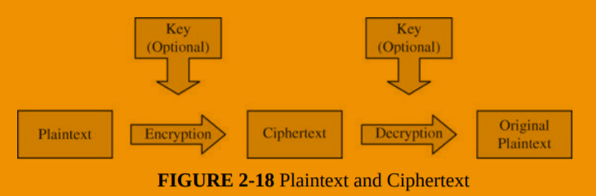

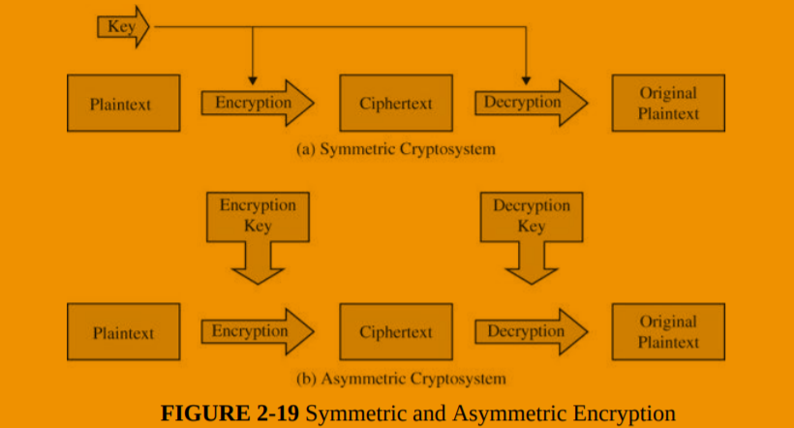

**Work factor**: amount of effort needed to break an encryption (or mount a successful attack)

Applications:

* SSL and TLS (https://)
* VPN
* Hash on a downloaded file
* Digital signatures

Cipher – a system used to create an encoded or secret message (not key)

Cryptography and CIA:

* Confidentiality: file, message and link encryption
* Integrity: digital signatures, hashes

Stream cypher vs block cypher:

Stream cypher performs opearion on each bit, not on the whole string at once, or a proportion of it.

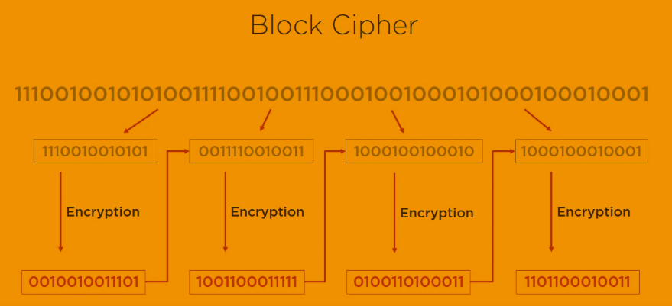

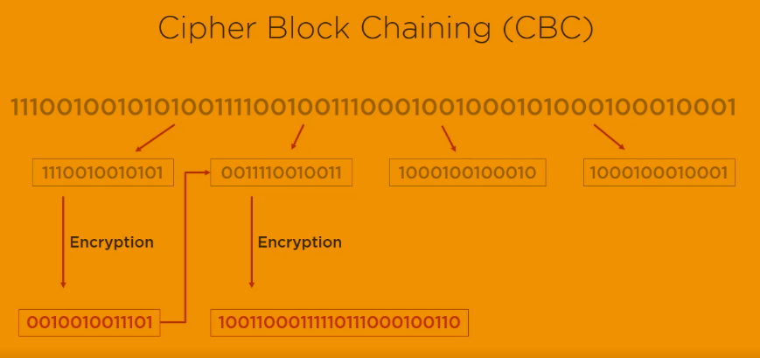

* 1. Symmetric Key Cryptography
* File encryption for transmision – AES256
* Encryption of files in storage
* Financial transactions – triple DES
* VPC encryption – AES256

Weaknesses:

* Method for secure transfer is needed
* Does not provide non-repudiation
* Key management can be difficult
* Not recommended: digital signatures, key transfer, web security, message security
  + 1. DES

A block cipher is an encryption/decryption scheme in which a block of plaintext is treated as a whole and used to produce a ciphertext block of equal length.

Many block ciphers have a Feistel structure. Such a structure consists of a number of identical rounds of processing. In each round, a substitution is performed on one half of the data being processed, followed by a permutation that interchanges the two halves. The original key is expanded so that a different key is used for each round.

The Data Encryption Standard (DES) has been the most widely used encryption algorithm until recently. It exhibits the classic Feistel structure. DES uses a 64-bit block and a 56-bit key.

Two important methods of cryptanalysis are differential cryptanalysis and linear cryptanalysis. DES has been shown to be highly resistant to these two types of attack.

DES – 64bit key, 16 rounds, cracked in 1998

Tripe DES (quickfix) – 168bit key, 48 rounds. The changes made encryption time 3 times longer as well.

Blowfish and Twofish – free algorithms

* + 1. SSL
    2. AES

128, 192, 256 bit keys, 10;12;14 rounds. With fewer round and longer keys better perofrmance and higher security is achieved.

RC4;RC5;RC6

* 1. Asymmetric Key Encryption

Pros:

* Secure key exchange
* Authentication + Encryption
* Digital Signature
* Key exchange; Message encryption; Part of web security; Message authenication

Contra

* Slower than symmetric key cryptography
* Not a competition, use both types together
  + 1. Diffie – Helman

Uses a public and private key to generate symmetric key. The original algorithm was found vulnerable against man in the midle attack. If the attacker intercepts the public key he can send the client its own and read the messages. Can be solved by digital sigantures and an another level of authentification.

* + 1. RSE

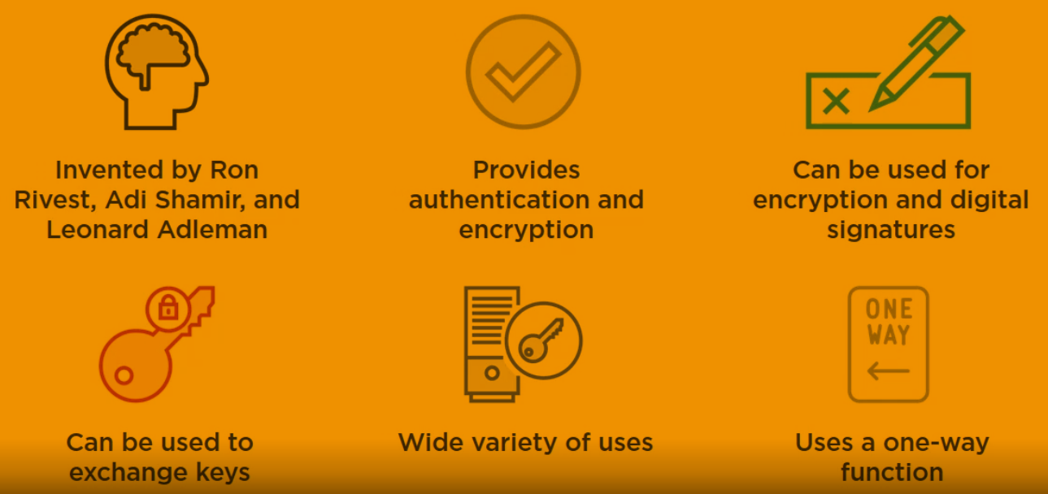

Other: ECC (mbe even better than RSE, less vulnerable against quantum computing, google uses it in its certificate) , el gamal (usually the slowest, extendion of Diffie-Helman)

* 1. Use of cryptography to provide integrity
     1. Hashing algorithms

They take data and produce a unique hash value.

MD5 – vulnerability (different input provides the same hash value), not used anymore in SSL.

SHA-1 and SHA-256 (best) haval, tiger

* + 1. Message Authentication Code (MAC)

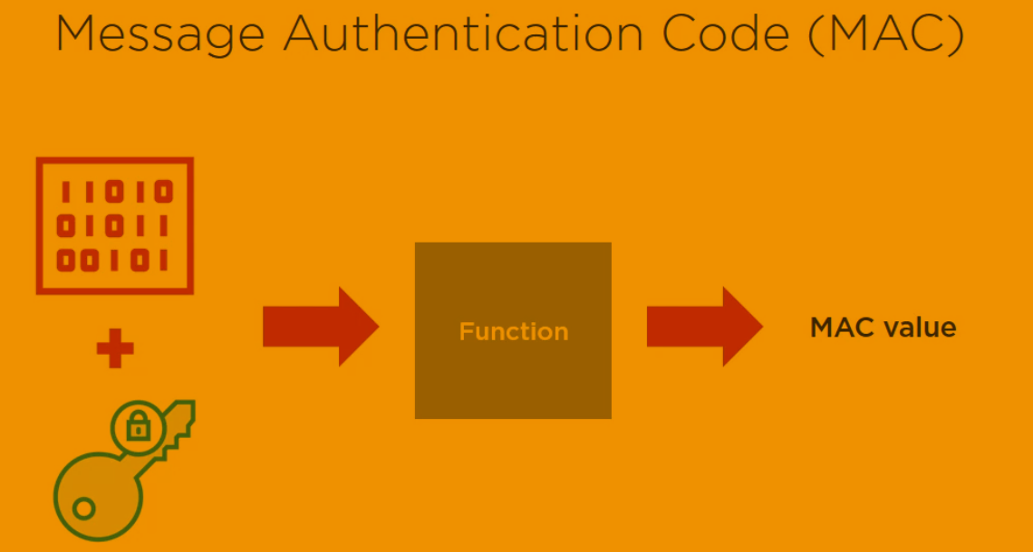

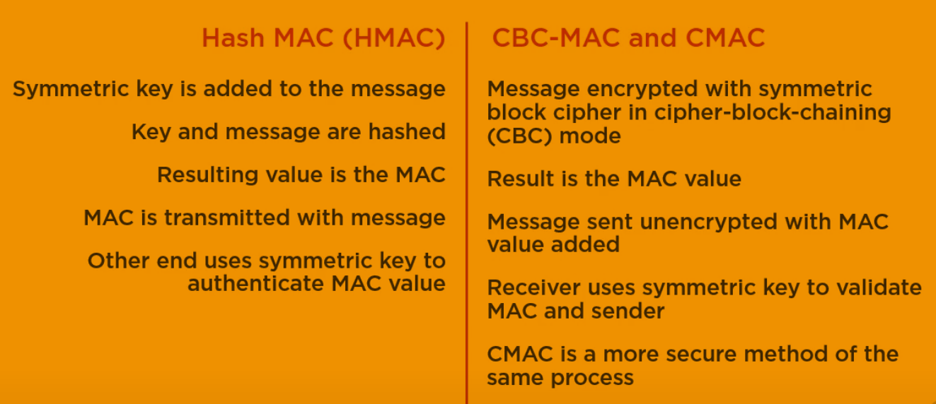

* + 1. Digital signatures

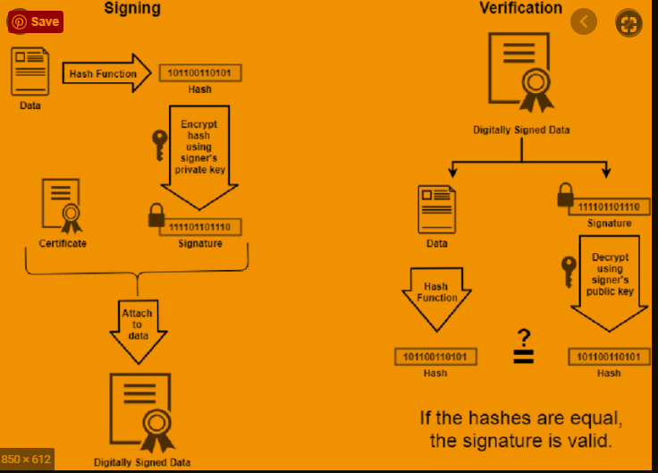

Email: S/MIME – Secure Multipurpose Internet Mail Extention, standard for encrypting and digitally signing email. RDS + SHA (example).

PGP – Pretty Good Privacy, RSA + MD5. Examples of different types types of cryptography methods combined.

* + 1. PKI – Public Key Infrastructure

**Trusted third party** = **Certificate Authority** (internal or external) they provide **Certificate** using Registration Authority.

Similar to: You go to a certificate to verify that you say the truth when you say you know this and this.

* 1. Further concepts
* Explosion in Number of Keys

1. Identification and autentification

* Identification is the act of asserting who a person is.
* Authentication is the act of proving that asserted identity: that the person is who she says she is.

Identities are typically public or well known. Authentication should be private.

**Authorization** is the allocation of permissions for specific types of access to restricted information. In the real world, **authorization** is conferred on real human beings; in contrast, information technology normally confers authorization on user **identifiers** (IDs). Computer systems need to link specific Ids to particular authorized users of those IDs. Even inanimate components, such as network interface cards, firewalls, and printers, need IDs. Identification is the process of ascribing an ID to a human being or to another computer or network component. Authentication is the process of binding an ID to a specific entity. For example, authentication of a user’s identity generally involves narrowing the range of possible entities claiming to have authorized use of a specific ID down to a single person.

* 1. Autentification

Authentication is based on something you know, are, have or do.Authentication mechanisms use any of three qualities to confirm a user’s identity:

* What only you know (passwords and passphrases)
* What only you have (tokens: physical keys, smart cards)
* What only you are (static biometrics: fingerprint, face, retina, and iris recognition)
* What only you do (dynamic biometrics: voice, handwriting, and typing recognition).

Every password can be guessed; password strength is determined by how many guesses are required. Rainbow Table, Brute Force attacks, security questions, the storage of unencrypted user passwords; passwords is that they can be stolen without knowledge of the user;

authentication based on biometrics (fingerprint) – what you are. Costly.

What you have - Cookies, Tokens + SSO (Active Directory) Federated identity management unifies the identification and authentication process for a group of systems. Single sign-on takes over sign-on and authentication to several independent systems for a user. MFA

* 1. Ideas what to talk about
* Risk of Undetected password theft
* Risk of Undetected password sharing
* Risk of Weakest – by finding out the weakest password other passwords can be revealed
* Dictionary attacks
* Risk of Online Guessing – based on exploiting best practices and personal information
* Risk of Off-Line Dictionary Attacks – checking against hash
* Risk of Password Replay

1. The hash is sufficient for a dictionary attack unless a salt is used and kept secret.
2. The attacker does not even need to recover the password. Instead, the attacker can replay the hash of the password when needed.
3. send passwords from client to server encrypted using the server’s public key !!

Risk of Server Spoofing

Risk of Password Reuse

Authentication Using Recognition of Symbols – pictures the user know

TOKEN-BASED AUTHENTICATION:

1. Card Entry Systems
2. Proximity and Touch Cards
3. Smart Cards and Dongles
4. Soft Tokens
5. One-Time Password Generators
6. Authentication Using Mobile Devices - SMS

BIOMETRIC AUTHENTICATION

CROSS-DOMAIN AUTHENTICATION - SAML

RELATIVE COSTS OF AUTHENTICATION

TECHNOLOGIES

* 1. Summary

Passwords are widely used in practice and will continue to be a dominant form of user authentication. There are many risks in deploying passwords, and a number of widely used password systems have serious vulnerabilities. Nonetheless, technical measures can mitigate the inherent vulnerabilities of passwords. Although it takes great skill and care, with our current understanding it is technically possible to build and deploy strong password-based authentication systems using commercial products. The truly inherent risks of undetected theft and undetected sharing can be largely mitigated by new technologies, such as intrusion detection systems. Undetected sharing may be deterred further by a system that couples high-value secret data, such as credit card account numbers, with passwords. Tokens are available to generate one-time passwords or to communicate directly with authentication systems. Although costs have been dropping, tokens are still not as widely deployed as early predictions suggested they would be. Biometric authentication has been implemented only infrequently and on a small scale but offers great potential, especially for high-security applications. Interesting new research and applications are extending the use of authentication (and authorization) over untrusted networks between federated organizations.

* + - 1. Salting

In cryptography, a salt is random data that is used as an additional input to a one-way function that hashes data, a password or passphrase.



A fixed salt is when a programmer uses the same salt for every hashed password.

While this will make current rainbow tables useless (if the salt is properly chosen), if the salt is hard-coded into a popular product that salt can be extracted and a new rainbow table can be generated using that salt.

Using a single fixed salt also means that every user who inputs the same password will have the same hash (unless the password hash is also dependent on the username). This makes it easier to attack multiple users by cracking only one hash.

* + - 1. Pepper

In cryptography, a pepper is a secret added to an input such as a password prior to being hashed with a cryptographic hash function.

1. Kontrola prístupu, bezpečnostné modely
2. Web Security

From: file:///C:/Users/nbarto/Desktop/Statne%20Skusky%202020/02-knihy/Stallings_Cryptography_and_Network_Security.pdf

* Secure socket layer (SSL) provides security services between TCP and applications that use TCP. The Internet standard version is called transport layer service (TLS).
* SSL/TLS provides confidentiality using symmetric encryption and message integrity using a message authentication code.
* SSL/TLS includes protocol mechanisms to enable two TCP users to determine the security mechanisms and services they will use.
* Secure electronic transaction (SET) is an open encryption and security specification designed to protect credit card transactions on the Internet.

Škodlivý kód

Programová bezpečnosť

Bezpečnosť operačných systémov

Bezpečnosť databázových systémov

Bezpečnosť v počítačových sieťach

Webová bezpečnosť

Forénzna analýza IKT