**24-650 Applied Finite Element Analysis**

**Assignment 2**

submitted by

Letian Leng

**Objective**

The goal of this assignment is to explore the steady-state thermal critical radius of the insulation. The main object is a cast iron pipe with a 90-degree bend. The inside and outside diameters are 70 mm and 90 mm, accordingly.

**Assumptions and Conditions**

1. Heat transfer is steady-state in part A, and is transient in part B.
2. The pipe ends are adiabatic.
3. No radiation.
4. The thermal conductivity, density and specific heat of the pipe is given below:

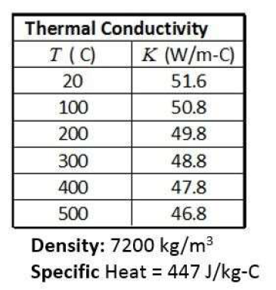

**Model and Geometry**

The cast iron pipe (see in Fig.1) has inside and outside diameters are 70 mm and 90 mm, accordingly. Also heat insulation is applied to the outer surface of the pipe (see in Fig.2). For the mesh size, 0.01m element size has been used under the balance of solution accuracy and computation time. From the result section below, one can see that the contour edges of different colors are smooth without sharp curves.

|  |  |  |
| --- | --- | --- |
|  |  |  |
| Figure 1. The curved pipe | Figure 2. The pipe with foam insulation (green) | Mesh Settings |

**Boundary Conditions (Part A)**

The pipe is carrying steam at 150 ℃, with an outside temperature of 20 ℃.

We assume that the pipe ends are adiabatic.

The inside surface has a convention coefficient of 20 W/m2 -C, with an outside surface convention coefficient of 3.7 W/m2 -C.

|  |  |
| --- | --- |
| A white and black text  Description automatically generated with medium confidence  Convection for inner surface | A screenshot of a computer  Description automatically generated  Convection for outer surface |

**Results (Part A)**

|  |  |  |  |
| --- | --- | --- | --- |
| A computer generated image of a curved pipe  Description automatically generated  Result example, outside temp (℃) | | A computer generated image of a green tube  Description automatically generated  Result example, heat loss (W) | |
| Insulation thickness (mm) | Max Outside Temperature (Co) | | Heat Loss (W) |
| 0 | 125.09 | | -39.67 |
| 2 | 121.25 | | -38.88 |
| 4 | 117.73 | | -40.02 |
| 6 | 114.52 | | -40.11 |
| **8** | **111.60** | | **-40.15** |
| **10** | **108.94** | | **-40.15** |
| 12 | 100.03 | | -36.23 |

From the table above, one can find that the heat loss reaches the maximum at between 8-10mm thickness, so the conclusion is the critical thickness happens in between 8-10mm thickness of insulation, most likely around **9mm** thickness.

**Boundary Conditions (Part B)**

The initial temperature of the entire structure is uniform at 20°C.

The inner surface of the pipe experiences a sudden convection shock, with rapidly moving steam at 150°C and a convection coefficient of 50 W/m2-C.

The outer convection coefficient is 3.7 W/m2-C, and the highest external temperature is 20°C.

It is assumed that the pipe ends are adiabatic.

The insulation has density and specific heat properties of 2500 kg/m3 and 840 J/kg-C, respectively.

Pipe with 15-mm thick insulation.

|  |  |
| --- | --- |
| Convection for inner surface | Convection for inner surface |
|  |  |

**Results (Part B)**

From above, the maximum temperature at 10 minutes is **28°C.**

From the figure above, the maximum temperature to achieve the steady-state outside temperature (103°C) is about **3600s**, which is about **an hour**.

**Conclusion**

From this assignment, one can find that when doing computation-extensive task, such as long-time transient thermal analysis, the mesh density and time step can be traded off if the computation time is long. The increasing of timestep and decreasing of mesh element size significantly reduced the computing time.