**24-650 Applied Finite Element Analysis**

**Assignment 6**

submitted by

Letian Leng

**Objective**

The goal of this assignment is to perform an analysis of nonlinear contact and plasticity of a 4-point bend specimen. The results are:

**Part A:** FS1 = **0.168**, FS2 = **0.202**

**Part B:** FS3 = **1.61**, Max equivalent plastic strain = **0.0201** mm/mm

**Assumptions and Loading Conditions**

1. The specimen is notched and made of a **soft aluminum alloy**: E = 67 GPa, v = 0.33.Wind load 9000N at the top.
2. Its yield strength, Sy, and ultimate strength, Su, are 220 MPa and 640 MPa.
3. The support and load pins are made of **machine steel:** E = 205 GPa, v = 0.29.
4. The load pins are constrained against in-plane motion and each load by an imposed deformation: delta = 1mm.



**Model**

Figure 2. The geometry of the specimen.

**Boundary Conditions (Part A&B)**

The boundary conditions of support on bottom of the pin is indicated below.

Figure 3. Support BC

Two displacement BCs are indicated below:

|  |
| --- |
|  |
|  |

Figure 4. Displacement BCs.

**Contacts**

The four contacts with a **friction coefficient of 0.15** is indicated below:

**Analysis Settings**

In this case, for the step settings, the sub-step has been settled with slow and careful loads, as indicated below:

**Mech Settings**

The mesh setting stays at default except for the **refinement factor of 2** around the notch area.

**Results (Part A)**

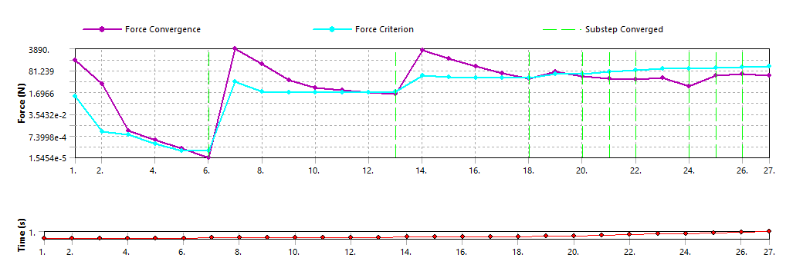

|  |  |
| --- | --- |
|  |  |
|  |  |

**Results (Part B)**

|  |  |
| --- | --- |
|  |  |
|  |  |

**Conclusion**

In this assignment, we performed an analysis of nonlinear contact and plasticity of a 4-point bend specimen.

For model contact, implementing robust contact algorithms within the simulation software to accurately capture the interactions between different components during the forming process, and define contact interfaces between the contact and target material helped to correct the model contact.

Over-penetration occurs when the explosive force penetrates the target material excessively, leading to undesirable deformation or damage. To minimize over-penetration, optimize the explosive charge design, including its shape, size, and placement relative to the target material such as the steel pin is slightly wider than the notched alloy.

Based on the result, the strain-rate is not relatively high, so in this case a large deformation is not necessary.

During this assignment, we also explored the difference between elastic and plastic material, as their performance could be completely different under same boundary conditions.