Peer-to-Peer

Every device connected to a peer-to-peer network is capable of serving as both a client and a server, allowing users to share resources directly with one another without the need of a centralized server. Since Peer-to-Peer networks are decentralized, teamwork would be encouraged between those on the network. Because Peer-to-Peer networks don't need a dedicated server, they are typically simple to operate. Connecting with one another to exchange files or resources is simple for users. Computers that are connected to one another typically use a Universal Serial Bus to transfer files between each other. This means that Peer-to-Peer networks are fairly easy to set up since they don’t require any server configuration. This kind of network is effective and can perform well when it is used for small scale collaboration. However, once the number of computers (nodes) increases, the network will become overloaded with traffic and may encounter performance issues. There is also the security risk of having to allow direct connection your computer for this network to work. The use of Peer-to-Peer is suitable for small scale activities where using a centralised server would not be practical. This can range from file sharing, such as torrenting, collaborative work or simple LAN lobbies in videogames.

Essentially this kind of network is useful for small scale operation but outside of that it is not very efficient to use.

Example of a Peer-to-Peer network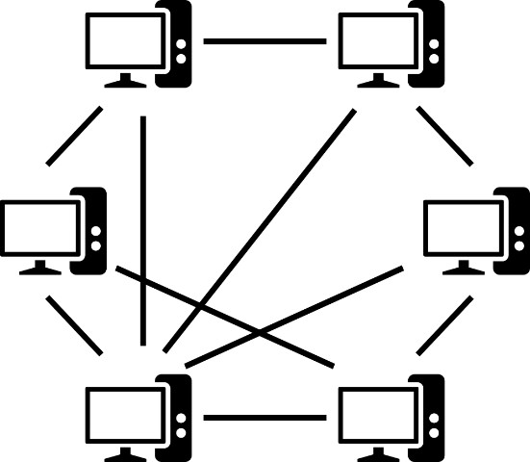

Client/ Server

In a client/server network, there is a dedicated server that provides resources and services to multiple clients. Clients request services, and servers fulfil these requests, creating a centralized architecture. This network is user friendly to users on the client side as they simply send requests to the server and the server completes the request. The server side of this network can be tricky to set up without the correct specialist knowledge, this means that for those without it they would need to have a network technician set it up which could be costly. This would also be required for troubleshooting. Setting up this network is much more complex than something like Peer-to-Peer as this requires configuring a server, placing security measures on the device and continued maintenance. Although once these steps are overcome the network will offer a much more organised structure. Once it is set up the client/server network is well suited to handle large scale operations. Handling heavy loads efficiently while maintaining performance is what makes this network type beneficial to businesses who manage databases, website hosts and for those who want to run large scale online game communities. Downsides to using this network is that if the server goes down for any reason, anything that is hosted off the server will also go down meaning loss of revenue for the hosts and general inconvenience for their clients. There is also the curve of getting past the initial setup of the server due to its complexity.

Example of the server/client network. 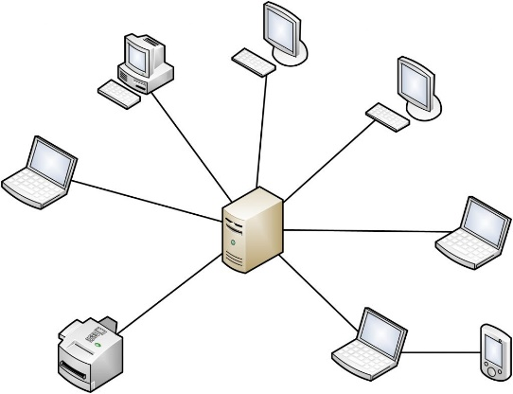

Thin Client Network Model

The Thin Client network model revolves around a centralized architecture where most processing tasks occur on a dedicated server, while lightweight client terminals handle user interactions. Thin clients are characterized by their simplicity, providing users with a straightforward interface to access applications and resources hosted on the central server. The ease of use stems from the minimalistic nature of the terminals. While the initial setup may involve configuring a robust server infrastructure, managing and updating applications centrally is generally more straightforward. The performance of a thin client network is contingent on the server's capabilities, making it efficient for tasks that don't demand significant local processing power. This model is particularly suitable for environments where centralized management is crucial, such as virtual desktop infrastructure setups. Examples of thin client systems include Citrix Virtual Apps and Desktops. However, drawbacks include a dependency on network stability and limited offline functionality, factors that should be carefully considered when implementing thin client architectures.

Diagram of Thin Client Network

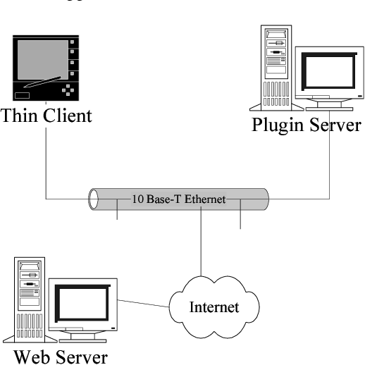

Bring your own Device

Bring your own device represents a policy allowing employees to use their own personal devices for work related tasks, introducing a dynamic to network architecture. The user friendly nature of this policy enhances employee satisfaction since they can utilise equipment and devices that is familiar to them in a professional environment. However, to implement this policy requires careful consideration of compatibility issues and the potential security concerns that come with allowing external devices onto the network, such as data leaking and the devices own vulnerabilities. The ease of use is balanced by the complexity of the initial set up which involves configuring secure access points and ensuring that various devices can seamlessly connect. The bring your own device policy is particularly suitable for a workplace that prioritises flexibility and their employees satisfaction, which is common in corporate environments. An example of the policy would be allowing employees to access work emails from their smartphones. This policy allows a much more flexible working environment, though to take full advantage of it, companies need to address the security challenges that comes along with it.

Diagram of Bring Your Own Device

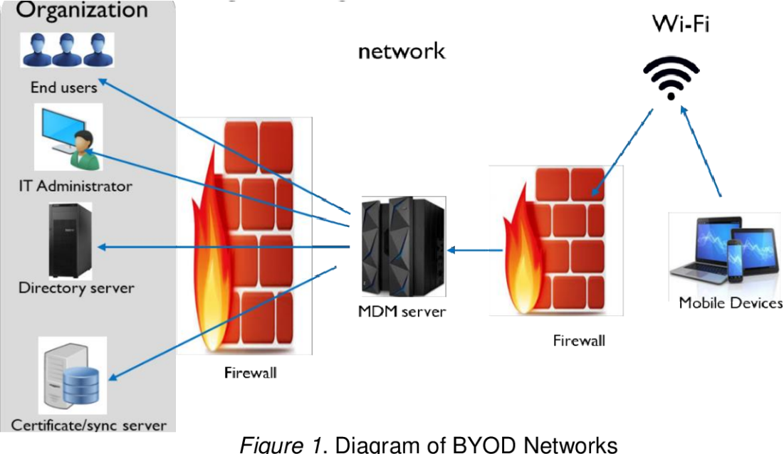

Cloud

The Cloud is a revolutionary networking tool that has changed the landscape of network models by delivering computer services such as storage, processing power, and applications over the internet from remote servers. Use of the cloud is extremely user friendly as it allows users to access all of these resources from any location with an internet connection. Setting up cloud services is straightforward, and users can scale the resources based on demand. The performance of the Cloud varies depending on the service model, which the cloud has 3 which are commonly used, Infrastructure as a Service (IaaS), Platform as a Service (PaaS), and Software as a Service (SaaS). The performance can also vary depending on how stable the internet connection is. Each service model is tailored to a specific range of applications, the laas model is commonly used for website hosting, the SaaS model is used for online tools that would help boost productivity and laaS is generally used as an administrative tool as it can allow more control over operating systems.

Diagram of The Cloud

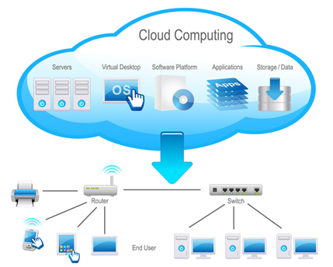

IOT

The Internet of Things (IoT) is a transformative concept that interconnects everyday devices, establishing a network for seamless data exchange and enhanced functionality. In consumer applications such as smart thermostats and fitness trackers, IoT devices prioritize intuitive user interfaces, ensuring user-friendly experiences. While consumer devices often feature plug-and-play setups, industrial applications demand more intricate configurations, reflecting the diversity in ease of setup. The performance of IoT hinges on efficient communication protocols, especially crucial in real-time applications like healthcare and industrial automation. Versatile in its applications, IoT spans smart homes, healthcare monitoring, and industrial optimization, exemplified by devices ranging from Amazon Echo to sensors enabling predictive maintenance. However, the implementation of IoT is not without challenges, particularly in addressing security and privacy concerns. Striking a careful balance between innovation and overcoming potential drawbacks is imperative for the successful integration of IoT across diverse domains.

Diagram of IoT

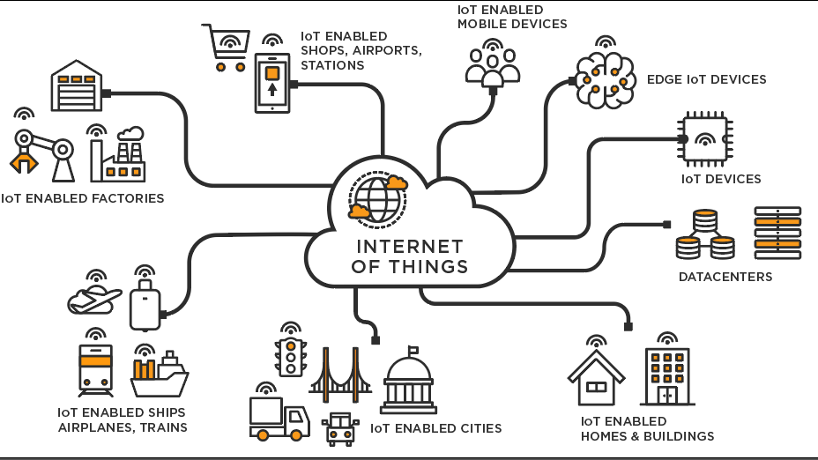

Internet

The internet is a global network connecting millions of private, public, academic, business, and government networks, facilitating the exchange of information, communication, and services. The internet is inherently designed to be user-friendly, providing a seamless experience for accessing a vast array of information, communication tools, and services through web browsers and applications. The setup of internet access for end-users is typically straightforward, involving the connection of a device to an internet service provider (ISP). However, the infrastructure setup on a larger scale, involving routers, switches, and servers, can be complex. Internet performance varies based on factors like bandwidth, latency, and network congestion. While high-speed broadband connections offer fast performance, issues such as network congestion during peak times can impact the user experience. The internet serves as the backbone for a multitude of applications. It's essential for web browsing, communication (email, social media), online collaboration, and various online services like e-commerce and streaming. The internet's openness introduces security challenges, such as the risk of cyber attacks and unauthorized access. Reliance on the internet also exposes users to potential privacy issues, emphasizing the importance of robust security measures. The internet's user-friendly nature and diverse applications underscore its pivotal role in contemporary society. While it provides unparalleled access to information and services, considerations around security and infrastructure complexities should be addressed to ensure a robust and reliable internet experience for users worldwide. Diagram of the Internet

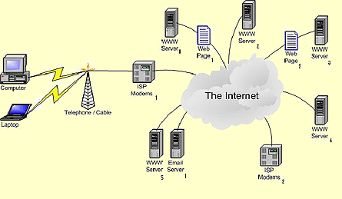

Extranet

An extranet is an extension of an intranet that allows controlled access to authorized external users, facilitating secure collaboration and information sharing beyond organizational boundaries. Extranets are designed to be user-friendly for authorized external users, providing intuitive interfaces for seamless collaboration while maintaining controlled access to specific resources. Setting up an extranet involves configuring secure access points and defining user permissions. While it may require careful planning and security measures, the setup process can be streamlined with proper protocols in place. Extranets are particularly suitable for scenarios where controlled collaboration with external partners, clients, or suppliers is crucial. Examples include secure file sharing, joint project management, and shared databases. In a business context, an extranet could be utilized for a collaborative project between two companies, allowing secure access to project documents and shared resources. Additionally, a university may use an extranet to provide controlled access to research materials for external researchers. While extranets offer controlled collaboration, security is a paramount concern. Unauthorized access, data breaches, or vulnerabilities in the extranet infrastructure pose risks. Moreover, coordinating and managing access permissions can become complex as the number of external users grows.

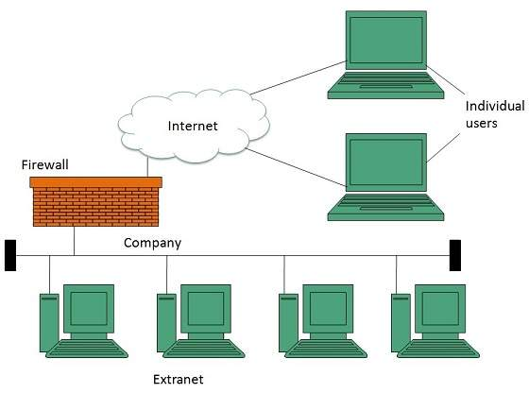 Diagram of Extranet

Intranet

An intranet is a private network within an organization that uses internet technologies to securely share information, resources, and communication tools among internal users. Intranets are designed to be user-friendly for employees within an organization. The interface is often tailored for intuitive navigation, providing easy access to shared documents, communication platforms, and internal applications. Setting up an intranet involves configuring internal servers, security protocols, and user permissions. While it may require initial setup complexity, modern intranet solutions often offer streamlined deployment processes. Intranets are versatile and can be applied to various organizational needs. They are commonly used for internal communication, document sharing, collaborative projects, employee directories, and centralized access to company resources. While intranets excel at internal collaboration, they may face challenges in scaling for large organizations. Maintenance of up-to-date content and ensuring security against internal threats are ongoing concerns. Additionally, remote access to the intranet may pose challenges for organizations with geographically dispersed teams. Intranets serve as essential tools for fostering internal communication, collaboration, and resource-sharing within organizations. Their benefits in streamlining internal processes and enhancing team collaboration are significant. However, continuous attention to security measures, content management, and adaptability to the organization's growth are crucial for sustained success. The balance between ease of use and robust security measures is pivotal in maximizing the effectiveness of intranets across diverse applications within an organization.

Diagram of Intranet

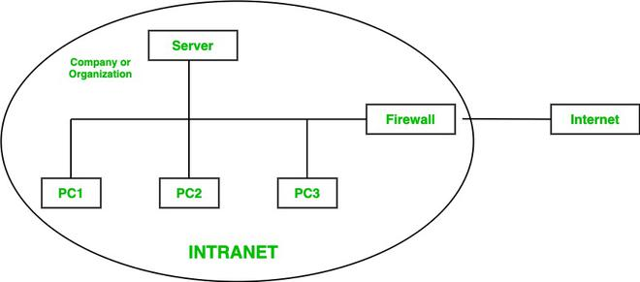

LAN

Router

A LAN router is a hardware device that serves as the central point for connecting multiple devices within a local network. It facilitates the transmission of data between devices on the local network and provides a gateway for communication between the local network and external networks, such as the internet. The router hardware contains a routing table and network interface cards to determine the most efficient path for data packets to travel within the local network and beyond. The routing functions are managed by the router's operating system, which executes routing protocols to make decisions about how to forward data packets. Routers often include firewall features in their hardware to inspect and control incoming and outgoing network traffic based on predetermined security rules. Firewall rules and configurations are managed by the router's software, allowing administrators to define access policies for enhanced network security. Routers include components for logging and monitoring network activities, such as CPU and memory usage. The router's operating system includes software components that manage logging and monitoring functions, providing administrators with insights into network performance and potential issues. Wireless routers have additional hardware components like antennas and radio transceivers to enable wireless connectivity for devices such as laptops and smartphones. The router's software manages the wireless functionality, including security protocols (WPA, WPA2) and channel management to optimize wireless performance.

LAN

Hub

A LAN hub is a basic networking device that operates at the physical layer of the OSI model. It connects multiple devices in a local network, allowing them to share data. Unlike more advanced networking devices, a hub does not make decisions about where to send data; instead, it broadcasts data to all connected devices. A hub consists primarily of ports where devices can be connected, and it operates by broadcasting data received on one port to all other ports. Hubs operate at the physical layer and do not involve complex software functions. They lack decision-making capabilities regarding data distribution. Hubs forward incoming data packets to all connected ports, essentially replicating the received data to all devices in the network. The hardware-centric nature of hubs means that there is minimal software involvement in packet forwarding. No decision-making based on IP addresses or MAC addresses occurs at the software level. Hubs are often associated with a star topology where multiple devices connect to a central hub. The concept of network topology is more relevant to the hardware design than the software functionality of a hub. The software involved is primarily limited to basic signal amplification and broadcast functions.

LAN

Switch

A LAN switch is a network device that operates at the data link layer of the OSI model. It connects multiple devices within a local network, efficiently managing data traffic by making intelligent decisions based on MAC addresses. Switches use specialized hardware, including application-specific integrated circuits, to make rapid and intelligent decisions about where to forward data packets based on MAC addresses. Switches have embedded firmware or operating systems that control and optimize the hardware's switching functions, ensuring efficient data forwarding. Switches operate in full-duplex mode, allowing simultaneous data transmission in both directions, which helps avoid collisions. Software algorithms in switches manage collision avoidance mechanisms, ensuring that data transmission occurs without contention and conflicts. Switches segment broadcast domains by only forwarding broadcasts to the specific ports where devices with corresponding MAC addresses are located. Software controls the logic behind broadcast segmentation, ensuring efficient network traffic management.

LAN

Ethernet Cable

A LAN Ethernet cable is a physical cable that connects network devices within a local network. It follows the Ethernet standard and is commonly used to transmit data using the Ethernet protocol. The Ethernet cable consists of copper or fiber optic wires that physically transmit electrical signals carrying data between connected devices. No direct software involvement in the cable itself, but the connected devices' network interfaces use software protocols to interpret the data received from the cable. Ethernet cables primarily operate at the physical layer of the OSI model, facilitating the transmission of raw bits. However, the connected network interfaces implement the data link layer protocols for framing and addressing. Software at the data link layer manages the framing and addressing of data packets, ensuring reliable communication over the Ethernet cable. Different categories of Ethernet cables (Cat5e, Cat6) support varying speeds and bandwidth capacities. The hardware construction influences the cable's ability to transmit data at higher speeds. The network interfaces of connected devices must support the same or compatible data transfer speeds to fully utilize the cable's capabilities. Ethernet cables come in various categories (Cat5e, Cat6, Cat7) with different specifications. The hardware design ensures compatibility with specific networking standards. Device network interfaces and operating systems should support the Ethernet standard corresponding to the cable category for seamless compatibility.

LAN

Comms Cable

An LAN communications cable is a physical cable designed to connect devices within a local network, facilitating the transmission of data through standardized networking protocols. LAN communication cables, typically Ethernet cables, consist of twisted pairs of copper wires or fiber-optic strands that physically transmit electrical signals carrying data between connected devices. While the cable itself doesn't involve software, the connected devices' network interfaces interpret the electrical signals using software protocols. Ethernet cables operate at the physical layer of the OSI model, providing the medium for raw data transmission. The connected devices' network interfaces implement data link layer protocols for framing and addressing. Software at the data link layer manages the framing and addressing of data packets, ensuring reliable communication over the LAN communications cable.

WAN

Router

A Wide Area Network router is a crucial component in network infrastructure, responsible for connecting and managing data traffic between different geographical locations. The functions of both hardware and software in a WAN router are integral to its overall performance. The primary function of a WAN router's hardware is to route data packets between different networks. It uses routing tables and algorithms to determine the most efficient path for data transmission. WAN routers have multiple interfaces to connect to various types of networks and devices. These interfaces can include Ethernet ports, serial ports, and other interface cards to accommodate different connectivity options. Hardware-based security features like firewall capabilities, intrusion detection and prevention systems, and VPN support are often integrated into WAN routers to ensure data integrity and confidentiality. WAN routers often include redundant hardware components such as dual power supplies and hot-swappable modules to ensure high availability and minimize downtime. The router's software implements routing protocols like OSPF (Open Shortest Path First), BGP (Border Gateway Protocol), and RIP (Routing Information Protocol) to exchange routing information with other routers on the network. Software components enable logging and monitoring capabilities, allowing administrators to track network activity, detect issues, and analyze performance metrics. Software components enable logging and monitoring capabilities, allowing administrators to track network activity, detect issues, and analyze performance metrics.

WAN

Hub

Interfaces supporting various WAN technologies (such as MPLS, leased lines, or broadband) are integrated into the hub to establish connections with remote sites. WAN protocols are implemented to ensure seamless communication over the diverse network links. Security appliances like firewalls and intrusion detection/prevention systems may be part of the hub's hardware to enforce security policies. Security protocols, encryption, and access control mechanisms are implemented to protect data in transit and control access to the network. Management interfaces and ports enable administrators to configure and monitor the hub's hardware components. Network management tools and protocols are utilized for monitoring performance, diagnosing issues, and configuring settings remotely. Scalable architecture allows the hub to accommodate the growing number of connected remote sites. Dynamic routing protocols and scalable configurations ensure that the hub can adapt to changes in the network's size and topology.

WAN

Switch

The switch's hardware includes routing capabilities, allowing it to make forwarding decisions based on Layer 3 information. Routing protocols like OSPF, BGP, or RIP may be implemented to exchange routing information and make dynamic routing decisions. High-speed switching fabric and multiple ports enable the switch to forward data frames efficiently within the network. Switching algorithms and protocols, such as Spanning Tree Protocol (STP) for loop prevention, are implemented to manage the flow of data. WAN switches are equipped with various interfaces to connect to different WAN technologies, such as T1/E1 lines, T3/E3 lines, or other types of WAN links. Configuration settings for these interfaces and WAN protocols are managed through the switch's software. QoS mechanisms in the hardware, such as traffic prioritization and queuing, help manage bandwidth and ensure optimal performance for critical applications. Configuration of QoS policies and settings is done through the switch's software. Some switches may have hardware-based security features, including access control lists (ACLs) and port security. Security policies, encryption, and access control are configured and managed through the switch's software. Redundant components like power supplies and interfaces contribute to high availability. Protocols like HSRP (Hot Standby Router Protocol) or VRRP (Virtual Router Redundancy Protocol) are implemented for failover and redundancy.

WAN

Modem

A WAN modem serves as a bridge between a local area network and a wide area network. Its primary role involves transforming digital signals originating from the LAN into a format suitable for transmission across the WAN. Conversely, it also demodulates incoming signals from the WAN back into digital form. These modems feature diverse physical interfaces like Ethernet ports, USB ports, or serial ports, catering to various devices and network types. The establishment and management of connections through these interfaces are facilitated by drivers and software protocols. Certain modems incorporate hardware components designed for authentication and security functionalities, exemplified by support for protocols like CHAP (Challenge Handshake Authentication Protocol) or PAP (Password Authentication Protocol). The responsibility of ensuring secure access to the WAN lies within the modem's software, which manages security protocols and configurations. In addition to signal modulation and demodulation, WAN modems possess the capability of protocol translation. This involves converting communication protocols between the LAN and WAN sides. The intricate processes of protocol translation are typically governed by software running on the modem.

WAN

Ethernet Cable

Ethernet cables play a crucial role in linking devices within a local area network (LAN) and can also establish connections between the LAN and networking equipment, such as routers. The functionality of Ethernet is primarily grounded in hardware, with the cables serving as the physical medium for data transmission. While software configurations may include settings for Ethernet interfaces on devices, the cable's primary role is physical in nature. Routers are pivotal components that facilitate the connection between a LAN and a wide area network (WAN). In the context of LAN-to-WAN connectivity, essential hardware components encompass routers, WAN interfaces, and Ethernet cables. The software side of this connection involves the configuration of routing protocols, security settings, Quality of Service (QoS) policies, and other parameters. These configurations are crucial for establishing efficient and secure communication between the local and wide area networks. Within routers, there may be hardware support for Quality of Service mechanisms, offering the ability to prioritize specific types of traffic over others. This hardware capability is complemented by QoS policies configured through software. These policies ensure that critical applications receive the required bandwidth and prioritize traffic based on predefined criteria.

WAN

Fibre Optics

WAN fiber optics operate through a well-coordinated synergy of specialized hardware and software components, ensuring the efficient transmission of high-speed data over extended distances. Key hardware elements encompass transceivers, optical cables, Wavelength Division Multiplexing (WDM) systems, amplifiers, routers, and switches. On the software front, interfaces play a pivotal role in configuring, monitoring, and managing various aspects of the optical network, contributing to its overall efficiency and security. In the context of WAN connectivity using fiber optics, the hardware lineup includes crucial components like fiber optic transceivers. These transceivers, also known as optical modules, serve as essential hardware by converting electrical signals into optical signals for transmission and vice versa upon reception. Software interfaces come into play for the configuration and monitoring of transceivers, providing diagnostic capabilities and facilitating the optimization of optical signal parameters. Wavelength Division Multiplexing hardware emerges as another integral hardware component, enabling the simultaneous transmission of multiple data streams over a single optical fiber using different wavelengths of light. This hardware functionality is complemented by software interfaces that allow network administrators to configure and manage WDM settings, optimizing bandwidth usage for enhanced efficiency. Moreover, certain optical network components incorporate hardware-based security features, including encryption capabilities to safeguard data during transit.

Wireless Networks

Wireless Access Point

A Wireless Access Point (WAP) serves as a crucial networking hardware device facilitating the connection of Wi-Fi-enabled devices to a wired network. Functioning as a bridge between wired and wireless components, WAPs play a vital role in providing seamless connectivity, managing security measures, optimizing performance, and enabling the integration of wireless and wired networks. Equipped with radio transceivers, WAPs broadcast and receive wireless signals, operating on specific frequencies like 2.4 GHz or 5 GHz within the radio spectrum. The software embedded in the WAP takes charge of configuring and optimizing radio frequencies, channel selection, and transmit power. The WAP's network interface, often an Ethernet port, facilitates connectivity to the wired network infrastructure. Configuration settings for this interface, encompassing IP addressing and routing, are efficiently managed through the WAP's software. In larger wireless networks, WAPs may function as part of a centralized controller system that oversees multiple access points. The controller software assumes responsibility for tasks such as seamless roaming, load balancing, and centralized configuration management across various WAPs. WAPs demonstrate versatility by supporting multiple SSIDs, allowing the establishment of guest networks with distinct access and security settings. Configuration of guest network parameters, including authentication and access restrictions, is seamlessly handled through the WAP's software interface.

Network Systems Software

Networking Systems Software

Network Systems Software is an extensive array of software tools and operating systems meticulously crafted to oversee and enhance the functionality of computer networks. In harmonious collaboration with specialized hardware components, these tools collectively ensure the secure, efficient, and reliable operation of network systems. In essence, Network Systems Software serves as the comprehensive suite that manages, operates, and optimizes computer networks. Operating systems form the bedrock of network systems, offering a foundational framework for managing hardware resources, executing applications, and facilitating network-related functions. Examples include Windows Server, Linux, or Unix. Facilitating the work of network administrators, network management tools play a pivotal role in monitoring, configuring, and optimizing network performance. These tools encompass SNMP managers, network analysers, and configuration management software. Operating based on predetermined security rules, firewalls filter and control incoming and outgoing network traffic, thwarting unauthorized access and safeguarding against cyber threats. Proxy servers, acting as intermediaries between client devices and the internet, contribute to improved performance, enforcement of security policies, and provision of anonymity. This function is achieved through a combination of dedicated hardware appliances and software solutions. To ensure the seamless operation of network systems, network monitoring software becomes indispensable. This category of software empowers administrators to track network performance, detect issues, and troubleshoot problems by employing tools for real-time monitoring, logging, and report generation.

Network Systems Software

Network Monitoring

Network monitoring is a critical aspect of effective network management, leveraging a combination of specialized hardware and software components. Dedicated software applications, including tools like Wireshark, Nagios, and PRTG Network Monitor, serve as the backbone for tracking and analysing network performance. Hardware elements play a role through packet sniffers, network probes strategically placed for data collection, and devices specialized in performance monitoring, measuring factors like network latency and packet loss. Flow analysers, utilizing both hardware appliances and software applications, provide insights into traffic patterns and potential bottlenecks. Alerting systems in network monitoring software notify administrators of critical events, while log analysers interpret log files for issue identification. Configuration management tools track changes to network device configurations, ensuring consistency and security. Network mapping tools visually represent network topology, aiding in troubleshooting. Bandwidth monitoring tools track data transfer rates, identifying bandwidth-intensive applications. Security Information and Event Management systems analyze security events in real-time, providing a comprehensive view of network security. Combining historical data storage, both in hardware appliances and software solutions, network monitoring enables trend analysis, capacity planning, and long-term issue identification, collectively enhancing the efficiency and reliability of the network.

Network Systems Software

Management and Troubleshooting tools

Management and troubleshooting tools within Network Systems Software are pivotal for ensuring the optimal functioning of computer networks. These tools, both in hardware and software forms, contribute to network performance monitoring and issue resolution. Software applications like the Performance Monitor track and assess various performance metrics, providing insights into network utilization and resource usage. Packet analysers, such as Wireshark, aid in troubleshooting by capturing and decoding data packets, offering detailed visibility into network traffic. Network probes, deployed strategically, contribute to issue identification by monitoring and analysing network data. Configuration management tools assist in troubleshooting by monitoring changes to device configurations, ensuring consistency. Diagnostic tools like ping and traceroute help diagnose connectivity issues, while alerting and notification systems ensure prompt responses to critical events. Log analysers review log files for information on system activities and potential security incidents. Remote Monitoring and Management tools enable administrators to troubleshoot remotely. Historical data storage, supported by both hardware and software, is crucial for trend analysis and capacity planning. Collectively, these tools empower administrators to monitor, diagnose, and address network issues, ensuring the sustained efficiency and reliability of network infrastructure.

Network Systems Software

Events and Logs viewer

Events and Log Viewer, a vital component of Network Systems Software, operates through a combination of hardware and software functionalities. This tool serves as a centralized hub, collecting and aggregating log data from diverse network devices, servers, and applications. Utilizing log analysers, it interprets these logs to extract valuable information about system activities, errors, and events, facilitating troubleshooting and performance analysis. Both hardware appliances and software solutions contribute to the centralized storage of log data, ensuring accessibility for compliance, forensic analysis, and long-term issue identification. Events and Log Viewer software provides real-time monitoring of events, enabling administrators to receive immediate alerts for critical occurrences and allowing proactive responses to potential issues. Integration with Security Information and Event Management systems enhances security capabilities, correlating data for a holistic view of network security. With features such as custom log filters, archiving policies, search capabilities, and graphical visualization, Events and Log Viewer empowers administrators to efficiently navigate and analyse log data, contributing to a proactive and secure network management approach.

Network Systems Software

Network Applications

Network applications, integral components of Network Systems Software, encompass a diverse array of tools designed for specific functions such as database management and document handling. These applications, supported by a combination of hardware and software, are pivotal for enhancing collaboration, data storage, and information sharing within an organizational network. Database Management Systems like MySQL and Oracle Database provide a structured framework for organizing and manipulating data. Document Management Systems such as SharePoint and Documentum facilitate document organization, version control, and collaboration. Collaboration tools like Microsoft Teams and Slack streamline real-time communication and collaborative editing. Networked file systems, exemplified by Network Attached Storage devices and file systems like NFS and CIFS, offer centralized file storage accessible across the network. Web servers such as Apache and Microsoft IIS handle requests and serve web pages, while load balancers distribute network traffic for optimal resource utilization. Database servers, middleware, and virtualization platforms contribute to efficient data management and application deployment. Security appliances like firewalls and intrusion detection systems safeguard network applications against unauthorized access and security threats. Collectively, these network applications and their supporting infrastructure play a vital role in fostering productivity, data organization, and seamless communication within networked environments.