System Deployment & Integration

Technology Stack
The Hospital ERP System is built using a modern and scalable technology stack:
- Backend:
• ASP.NET Core 8.0 MVC
• Entity Framework Core (Code-First / Database-First)
• ASP.NET Identity for Authentication and Authorization
- Frontend:
• Razor Pages (MVC Views)
• HTML5, CSS3, JavaScript
• Bootstrap (Responsive UI)
- Database:
• Microsoft SQL Server (MSSQL)
• Stored Procedures, Views, Foreign Key Constraints
- Reporting & Analytics:
• RDLC / FastReport.NET / Razor Reports
- Hosting & Deployment:
• IIS (On-Premises) or Azure App Service (Cloud Hosting)

Deployment Diagram
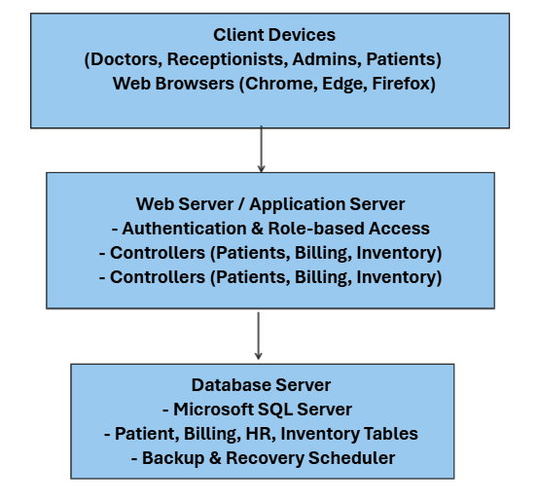

Component Diagram
