**Title of your Database Project**

*A Project Report Submitted*

*to*

**MANIPAL ACADEMY OF HIGHER EDUCATION**

*For Partial Fulfillment of the Requirement for the*

*Award of the Degree*

*Of*

**Bachelor of Technology**

*in*

**Computer and Communication Engineering**

*by*

**Your Name, Your Name, Your name**

**210953XXX, 210953XXX, 210953XXXX**

*Under the guidance of*

Dr. XYZ (Lab Faculty 1) Dr. ABC (Lab faculty 2)

Designation of Faculty Designation of Faculty

Department of I&CT Department of I&CT

Manipal Institute of Technology Manipal Institute of Technology

****Manipal, Karnataka, India Manipal, Karnataka, India

**March 2024**

**ABSTRACT**

**Good abstract to be written.**

**At the end add ACM taxonomy (You can search and write the keywords related to your project)**

**For example:**

**[Security and Privacy]: Cryptography management; Access Control; Symmetric Cryptography;**

**Write the suitable Sustainable Development Goal (There are about 17 SDGs proposed by Govt of India) to which your project belongs to (Please get the development goals from the Govt of India website)**

**For example:**

**[SDG]: Quality Education**

**Table of Contents**

**List of Tables**

**List of Figures**

**Abbreviations**

**Chapter 1**

**Chapter Title**

This is an introduction chapter.

* 1. Section 1

This section is 1.1 and it describes the aspects of Introduction [1].

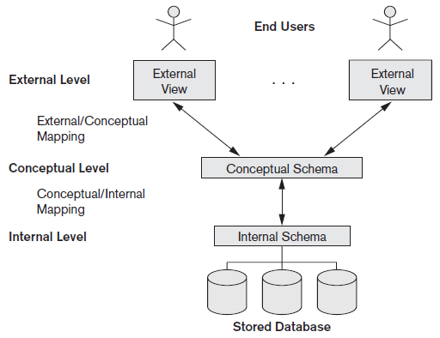

**Figure 1.1: Three Tier Architecture**

**Chapter 2**

**Chapter Title**

**2.1 Section 1**

**References**

**[1]** Y. Okada, K. Dejima, and T. Ohishi, \Analysis and comparison of PM synchronous motor and induction motor type magnetic bearings," IEEE Trans. on EE, vol. 31, pp. 1047{1053, Sep./Oct. 1995.

**Specifications to be followed:**

1. **Font size: 12 for regular text, font size: 14 for side headings and font size: 26 for chapter numbers and title**
2. **Font Type: Times New Roman**
3. **Text alignment: Justified (Both Sides)**
4. **References to be put in IEEE format**

**For further clarifications contact the faculty.**

**Following list of chapters will be expected:**

1. **Introduction**
2. **Literature Survey / Background**
3. **Objectives/Problem Statement**
4. **Data design (ER Diagram, Reduction, Schema Diagram, Normalization with suitable justifications)**
5. **Methodology (Implementation Details with block diagram to explain the project in detail. Do not put code here.)**
6. **Results**
7. **Conclusion and Future Work**
8. **References**