**Page 1 of the report – Exec Summary**

**This page manifests the Adventure Works Cycles business overview, including all significant KPIs. We can also visualize category and subcategory-wise business-driving products in terms of sales and profits, geographically as well as time period-wise.**

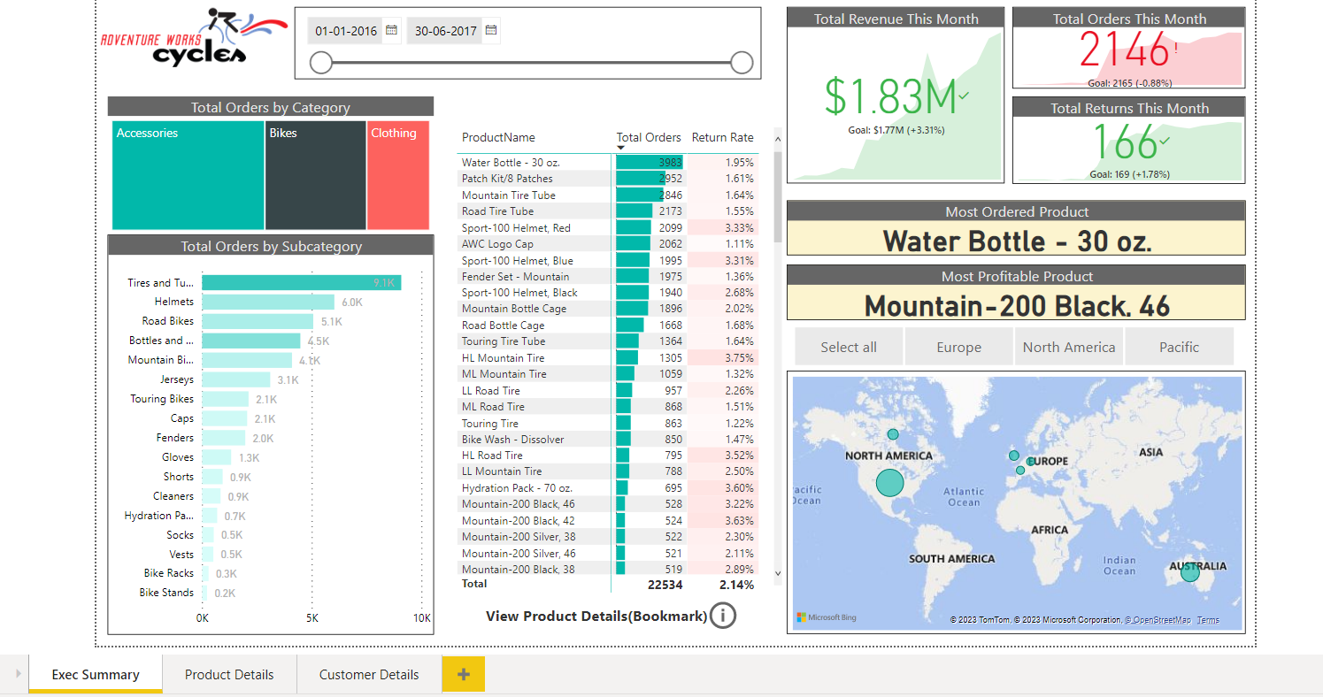

**Page 2 of the report – Product Details**

**This page is linked to any visualization (containing product names) through the drill-through filter. Click on any product name and you will land on this page filtered with the specific details of the product you clicked.**

**You can see the trends of returns, orders, and profits of the specific product. There is also scenario building type feature on this particular product page, which helps you determine what would have been the profit trend with respect to changes in the prices.**

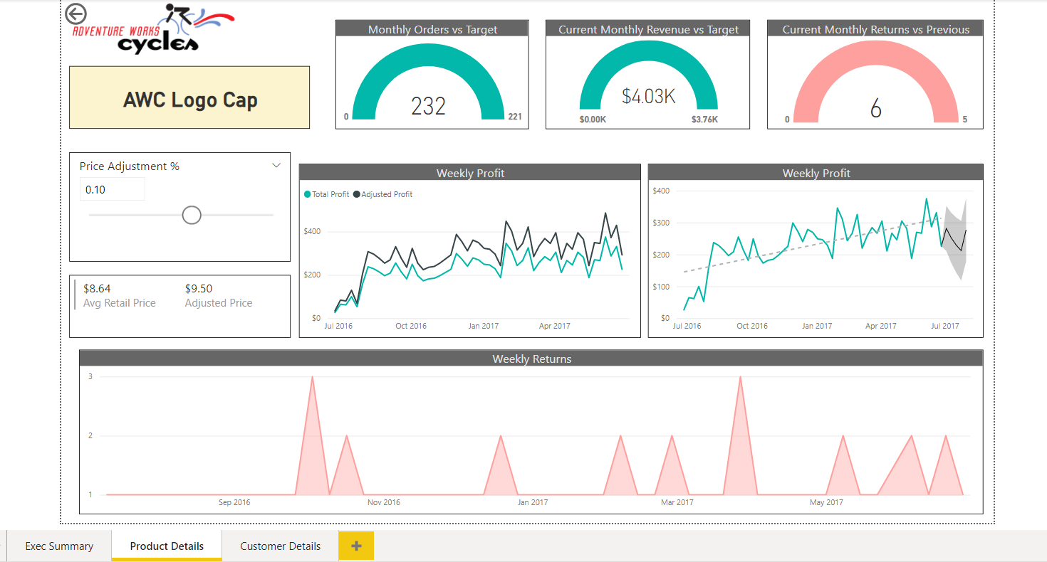

**Page 3 of the report – Customer Details**

**This page reflects the details of the customers of the business. We can have all kinds of visualizations for all metrics like orders and revenue, based on customer fields like gender, age, income, and many more.**

