**Interactive Dashboards for 4 months orders data of a Food Delivery Company**

**Dashboard 1 : Overall Numbers – For an overview**

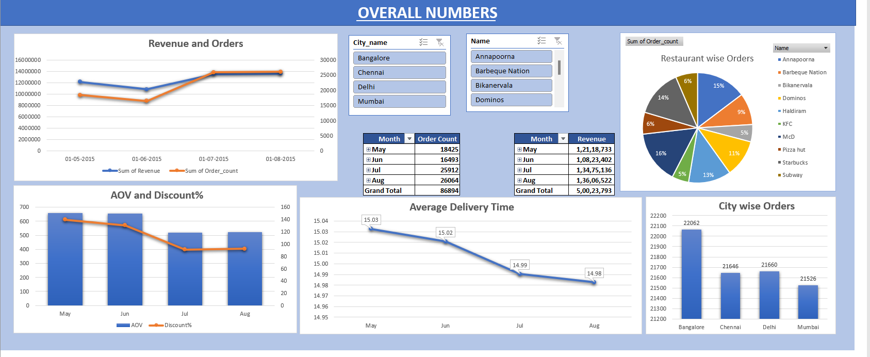

**Dashboard 2 : City Wise Report – For city wise orders data**

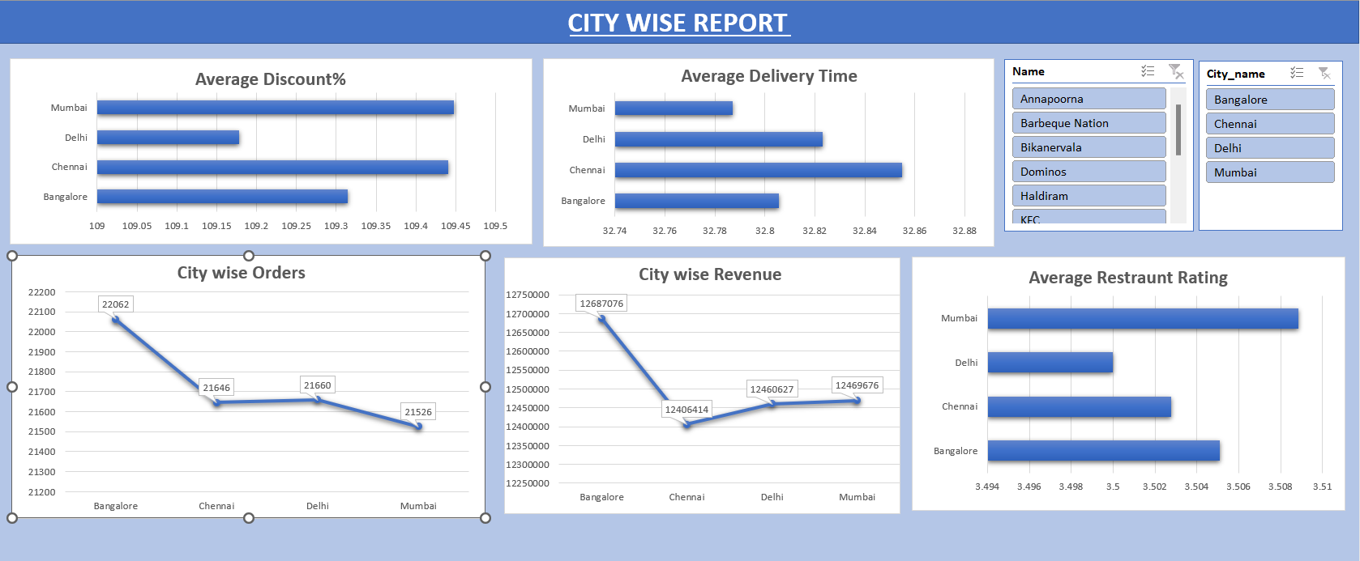

**Dashboard 3 : Restaurant Wise Report – For restaurant wise orders data**

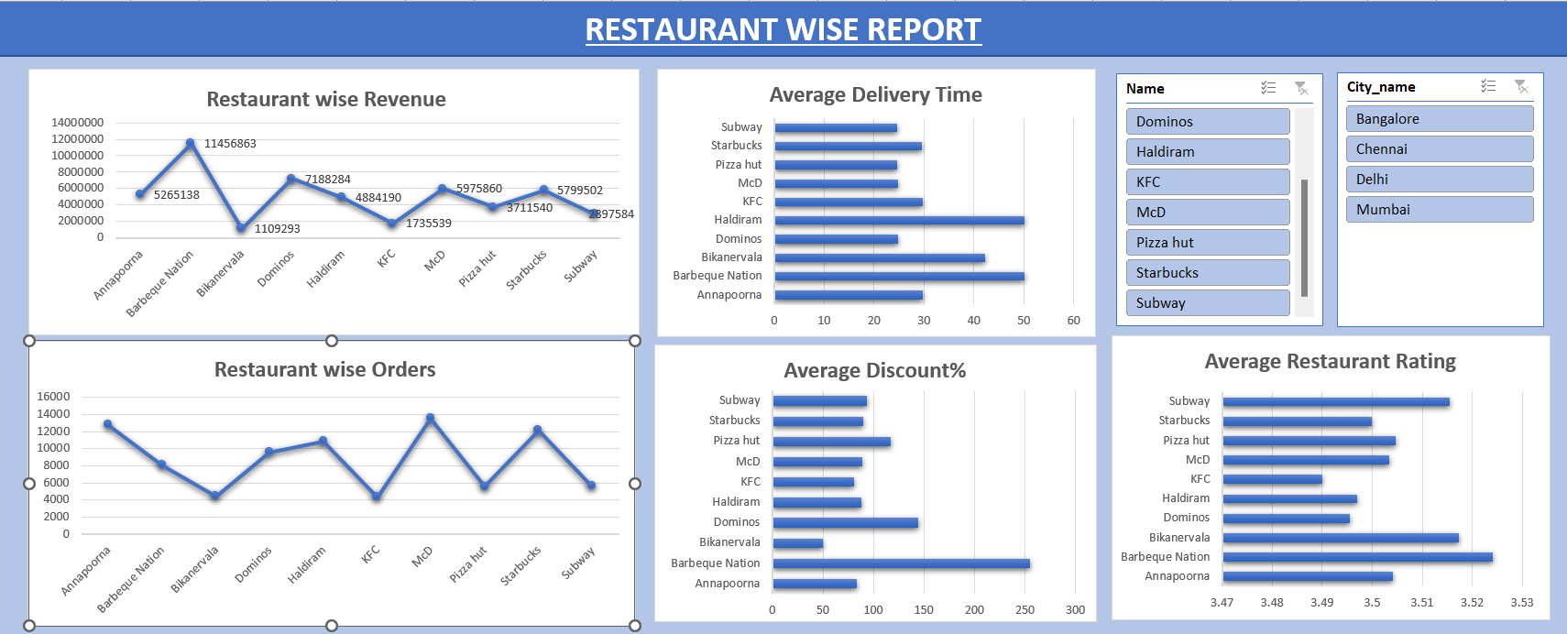

**Dashboard 4 : Reporting Key Findings to Manager**

