|  |  |
| --- | --- |
| **Course Title** | Database Systems 1 |
| **Course Number** | CPS 510 |
| **Semester/Year** | F2021 |
| **Instructor** | Dr. Abdolreza Abhari |

**Application Name: Online Job Bank System.**

|  |  |
| --- | --- |
| **Assignment Number** | 10 |
| **Group** | 11 |
| **Assignment Title** | Final Project - Database Management System |

|  |  |  |  |  |
| --- | --- | --- | --- | --- |
| **Full Name** | **Student Number** | **Group #** | **Section Number** | **Initial** |
| **Tusaif Azmat** | **500660278** | **11** | **04** | **T.A** |
| **Ankit Dheedsa** | **500975118** | **A.D** |
| **Mahdi Alam** | **500969935** | **M.A** |

**Table of Contents**

Application Description 3

Entity-Relationship Diagram 4

Schema Design 5

Design Views and Queries 10

UNIX Shell Implementation 21

Functional Dependencies and Database Normalization 24

Normalization 3NF 27

Normalization BCNF 29

GUI Python 35

Simple and Advanced Database Queries (with Relational Algebra) 39

Conclusion 42

**Application Description:**

This Online Job Bank application will work the same way as any other online job bank where job seekers and employers will use. We want to create an application similar to **Linkedin** and **Indeed** etc. These online job banks have been soaring in popularity and are crucial as they connect people all around the world on one platform.

We have selected this project because it will allow us to have hands-on experience with SQL database systems. We believe that we could use the experience and knowledge gained in this course to fully utilize it during the development process for this group project.

The main objective is to create a platform where users (Both Job Seekers and Employers) gain access to an online job bank database. Where they use as a job seeker will look through the database for jobs and be able to apply online using the provided services. Also an employer will gain access to the database and post new job postings and delete old postings. It will also have system administrator access along with all the company employees.

Our online Job Bank application will provide users with various job opportunities that can be accessed with just a click of a button. We will be taking inspiration for our application from other established services such as Linkedin and Indeed, we intend to incorporate networking components from Linkedin and job filtering components from Indeed. Our application will make possible the interactions between potential job candidates and hiring managers and provide an easy-to-use interface where users can easily identify and apply for jobs that are tailored to their needs.

In our DBMS, users can also opt for a subscription based premium service in which they can get further detailed information about jobs and a direct connection to interviewers. Large and small companies also reap the benefits of these subscription services as they could pool these applicants in a different bracket and hire them based on company needs. This application will have the ability to hold specific types of information about jobs that will make it easier for the user to follow.

Some of the basic functions that our system will be capable of doing are outlined below:

|  |  |
| --- | --- |
| **Function** | **Description** |
| User Login | This function will allow users to log in after authentication. After log in they could access the services provided. |
| Search Jobs | This is how users will search for jobs based on the search criteria. Users will search jobs based on employers and current jobs etc. |
| Job posting | This is where users will post jobs and remove existing postings. This option will be provided to the companies/employers. |
| Job Application Status | This is where users can see what jobs they applied to, the status of their application, and where they can accept job offers. |
| Dashboard | This is essentially a home page geared for the user. They can see news related to their job offers, see surveys and reports, see their Job Application Status, Job postings geared to them, etc. |
| Notifications Log | View important updates in a list. One can see the contents of the update, the timestamp of the update, and occasionally a button to do certain actions related to the notification. |
|  |  |

**Initial ER_Diagram:**

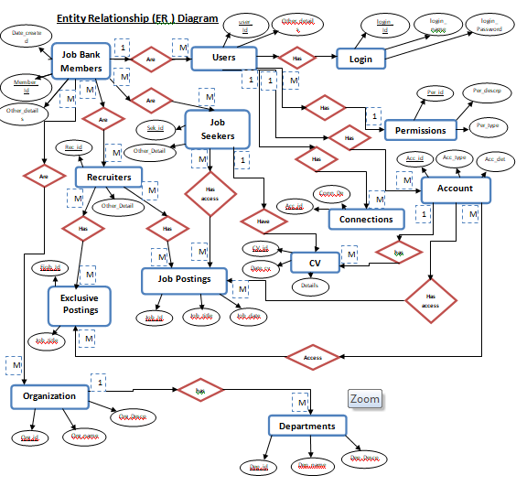

#### Finalized ER-diagram after BCNF Normalization

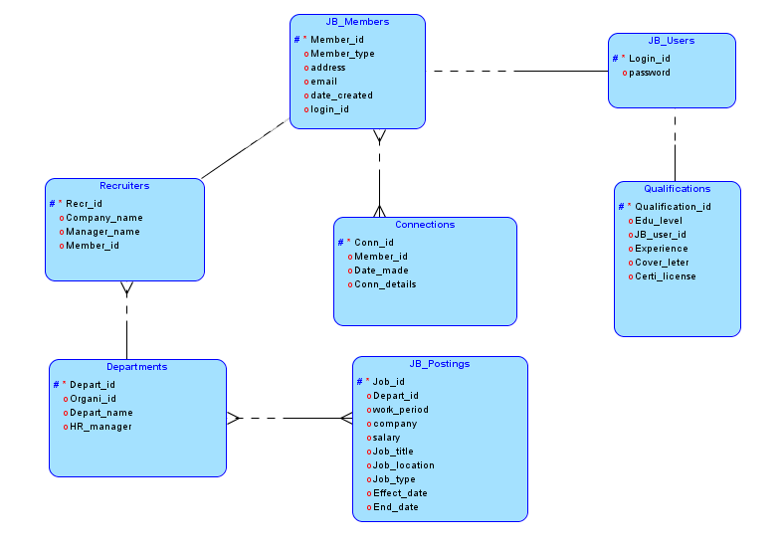

**Schema Design:**

**Source Code:**

DROP TABLE JB_Users CASCADE CONSTRAINTS;

DROP TABLE JB_Members CASCADE CONSTRAINTS;

DROP TABLE Recruiters CASCADE CONSTRAINTS;

DROP TABLE JB_Postings;

DROP TABLE Qualifications;

DROP TABLE Memberships;

DROP TABLE Connections;

DROP TABLE HR_Department;

CREATE TABLE JB_Users (

login_id VARCHAR2(25 CHAR),

user_password VARCHAR2(25 CHAR),

CONSTRAINT user_login_id_pk PRIMARY KEY(login_id)

);

CREATE TABLE JB_Members (

member_id VARCHAR2(25 CHAR),

member_type VARCHAR2(25 CHAR),

address VARCHAR2(25 CHAR),

org_id VARCHAR2(25 CHAR),

email VARCHAR2(25 CHAR),

date_Created VARCHAR2(25 CHAR),

member_name VARCHAR2 (25 CHAR),

CONSTRAINT member_pk PRIMARY KEY(member_id),

CONSTRAINT JBUser_fk FOREIGN KEY (member_name) REFERENCES JB_Users(login_id) -- Foreign Key

);

CREATE TABLE Recruiters (

recr_id VARCHAR2(25 CHAR),

member_id VARCHAR2(25 CHAR),

job_id VARCHAR2(25 CHAR),

date_created VARCHAR2(25 CHAR),

email VARCHAR2(25 CHAR),

phone VARCHAR2(12 CHAR) DEFAULT '(000)-000-0000',

address VARCHAR2(25 CHAR),

CONSTRAINT Recruiters_pk PRIMARY KEY(recr_id),

FOREIGN KEY (member_id) REFERENCES JB_Members (member_id)

);

CREATE TABLE JB_Postings (

job_id VARCHAR2 (20 CHAR),

work_period NUMBER,

company VARCHAR2(25 CHAR),

salary NUMBER,

job_title VARCHAR2(25 CHAR),

job_location VARCHAR2(25 CHAR),

job_type VARCHAR2(25 CHAR),

effective_date VARCHAR2(25 CHAR),

end_date VARCHAR2(25 CHAR),

CONSTRAINT jobs_pk PRIMARY KEY (job_id),--primary key

FOREIGN KEY (company) REFERENCES recruiters (recr_id) --Foreign Key

);

CREATE TABLE Qualifications(

qualification_id VARCHAR2(10 CHAR),

user_degree VARCHAR2(50 CHAR) DEFAULT 'Undergraduate',

JB_User_id VARCHAR2(25 CHAR) NOT NULL,

years_experience NUMBER CHECK (years_experience BETWEEN 0 AND 30),

coverLetter VARCHAR2(1000 CHAR),

license VARCHAR2(25 CHAR),

CONSTRAINT qualification_pk PRIMARY KEY (qualification_id),--Primary ID

FOREIGN KEY (JB_user_id) REFERENCES JB_Users (login_id) --Foreign Key

);

CREATE TABLE Memberships (

permission_id VARCHAR2(10 CHAR),

user_id VARCHAR2(25 CHAR),

Type VARCHAR2(25 CHAR),

Description VARCHAR2(25 CHAR),

Start_date VARCHAR2(25 CHAR),

End_date VARCHAR2(25 CHAR),

CONSTRAINT permission_pk PRIMARY KEY(permission_id),

FOREIGN KEY (user_id) REFERENCES JB_Users (login_id)

);

CREATE TABLE Connections (

conn_id VARCHAR2(12 CHAR),

user_id VARCHAR2(25 CHAR),

date_made VARCHAR2(25 CHAR),

details VARCHAR2(150 CHAR),

CONSTRAINT conn_pk PRIMARY KEY(conn_id),

FOREIGN KEY (user_id) REFERENCES JB_Users (login_id)

);

CREATE TABLE HR_Department (

depart_id VARCHAR2(25 CHAR),

organization_id VARCHAR2(25 CHAR),

depart_name VARCHAR2(50 CHAR),

hr_manager VARCHAR2(50 CHAR),

no_employees NUMBER,

CONSTRAINT depart_pk PRIMARY KEY(depart_id),

FOREIGN KEY (organization_id) REFERENCES Recruiters (recr_id)

);

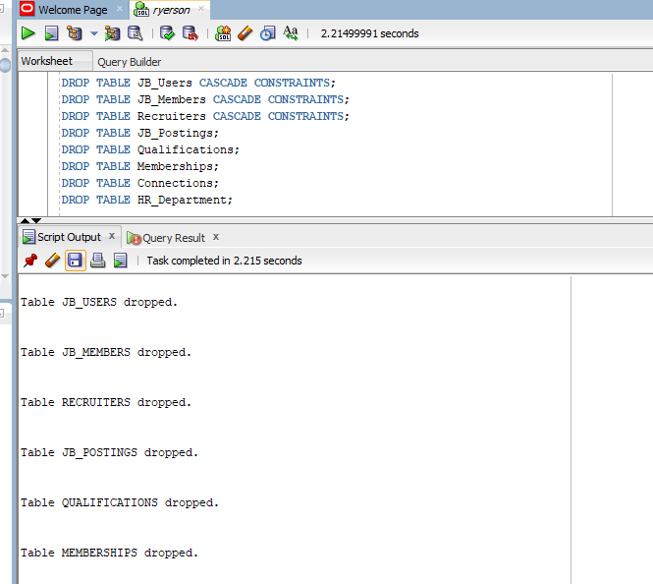

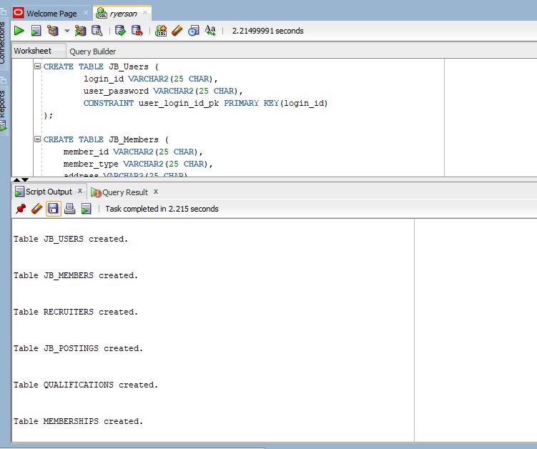

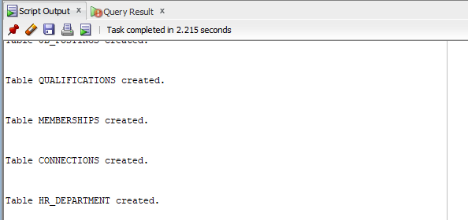

**Views and Queries**

-- Table Views

CREATE VIEW MEMBER_WITH_MEMBERSHIPS AS

SELECT MEMBER_ID, MEMBER_TYPE, MEMBER_NAME, M_TYPE

FROM JB_MEMBERS, MEMBERSHIPS

WHERE JB_MEMBERS.MEMBER_NAME = MEMBERSHIPS.USER_ID;

select * from member_with_memberships;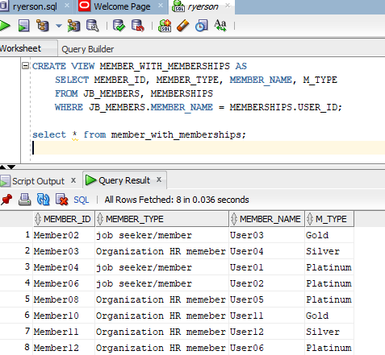

CREATE VIEW MEMBER_WITH_CONNECTIONS AS

SELECT JB_MEMBERS.MEMBER_ID, CONNECTIONS.DETAILS

FROM JB_MEMBERS, CONNECTIONS

WHERE JB_MEMBERS.MEMBER_ID = CONNECTIONS.MEMBER_ID;

select * from MEMBER_WITH_CONNECTIONS;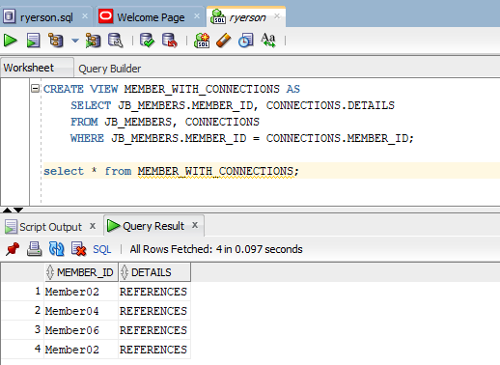

CREATE VIEW ORGANIZATIONS_WITH_DEPARTMENTS AS

SELECT RECR_ID, DEPART_NAME, NO_EMPLOYEES

FROM RECRUITERS, DEPARTMENTS

WHERE RECR_ID = ORG_ID;

select * from ORGANIZATIONS_WITH_DEPARTMENTS;

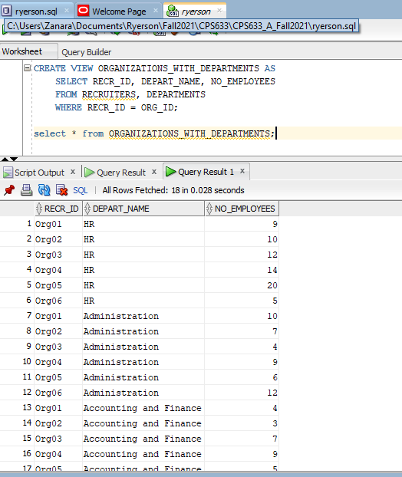

CREATE VIEW posting_by_recruiter as

SELECT job_id,job_title,job_location FROM JB_Postings

WHERE company = 'org01';

select * from posting_by_recruiter;

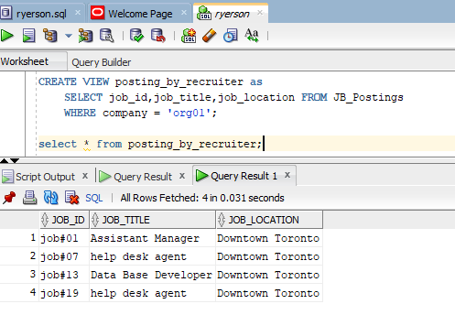

**-- advanced Queries**

-- Join Queries

SELECT JB_Members.member_type, JB_Members.member_name FROM JB_Members

FULL OUTER Join Connections ON JB_Members.member_id=Connections.member_id

ORDER BY JB_Members.member_name;

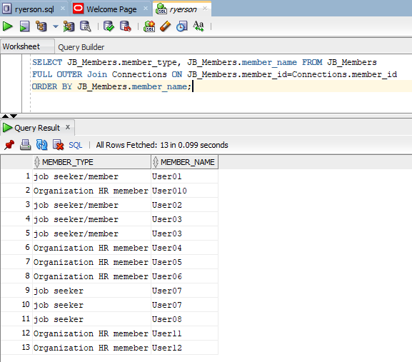

SELECT JB_users.login_id AS UserID, Qualifications.user_degree AS EducationLevel,

Qualifications.coverLetter AS Details, Qualifications.years_experience

FROM JB_Users, Qualifications

Where JB_Users.login_id <> Qualifications.JB_User_id

ORDER BY JB_Users.login_id;

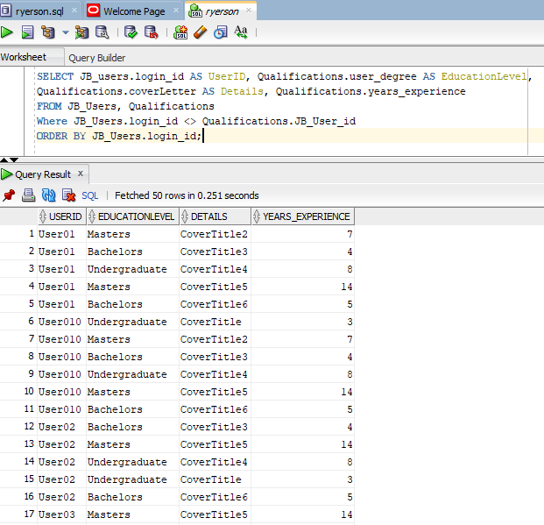

--DISTINCT Queries

SELECT DISTINCT organization_id from HR_Department;

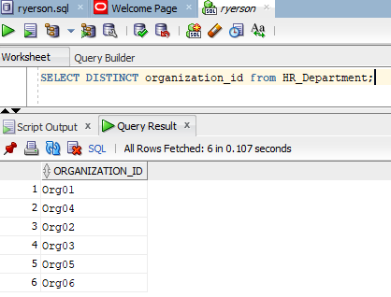

SELECT COUNT(DISTINCT organization_id) from HR_Department;

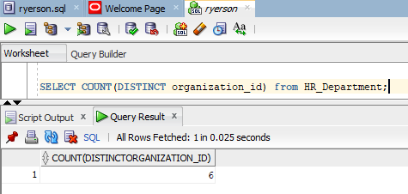

SELECT DISTINCT company FROM JB_Postings;

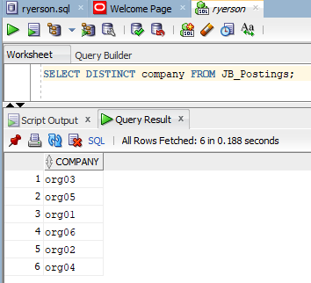

--Grouping/Sorting Commands

SELECT COUNT(member_id),member_type FROM JB_Members GROUP BY member_type;

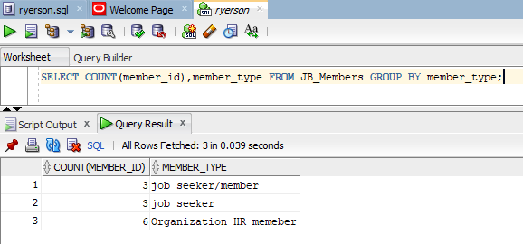

* Use of **Where** clause

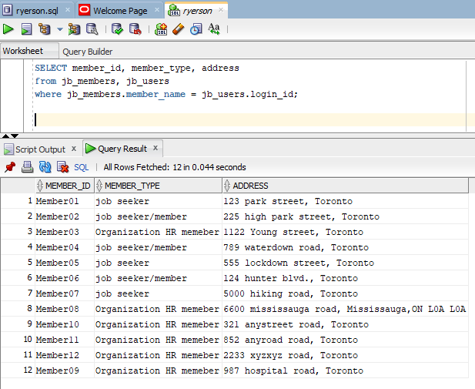

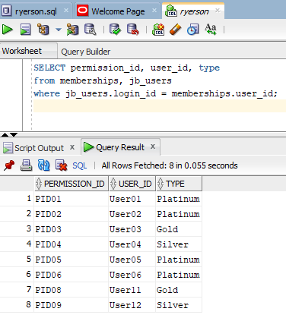

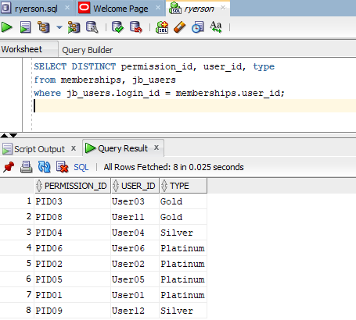

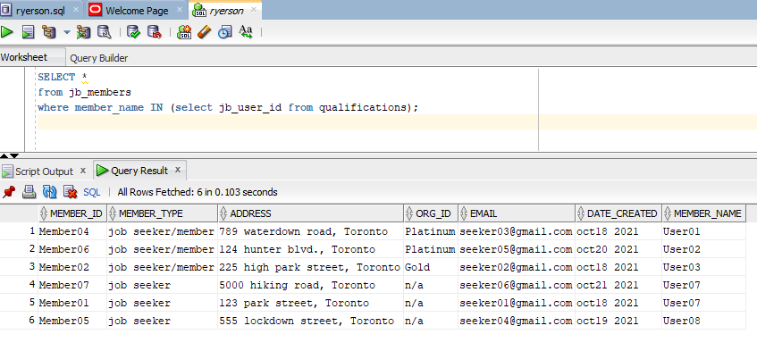

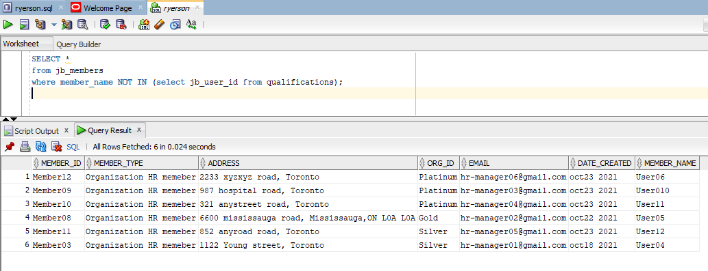

**Screen Shots:**

**JB_Users Table Views and Queries.**

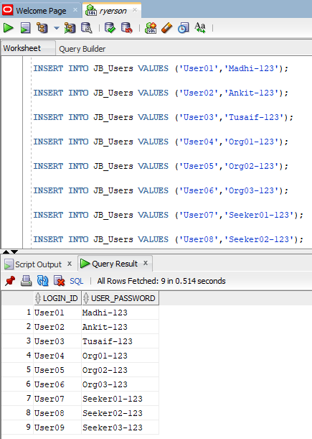

**JB_Members Table Views and Queries.**

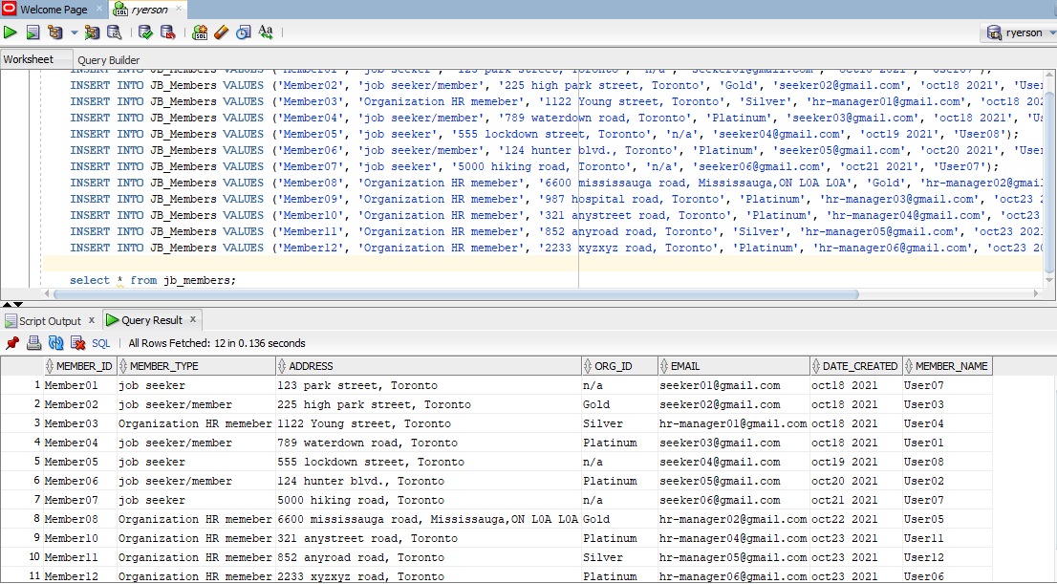

**JB_Members Table Views and Queries.**

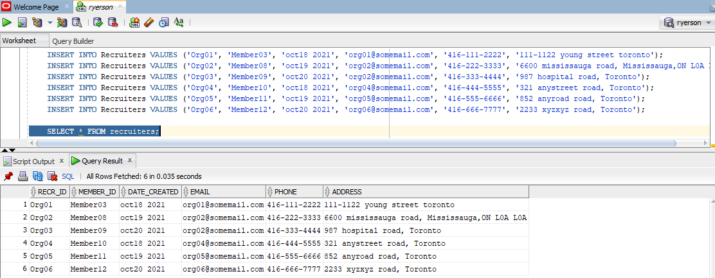

**JB_Postings Table Views and Queries.**

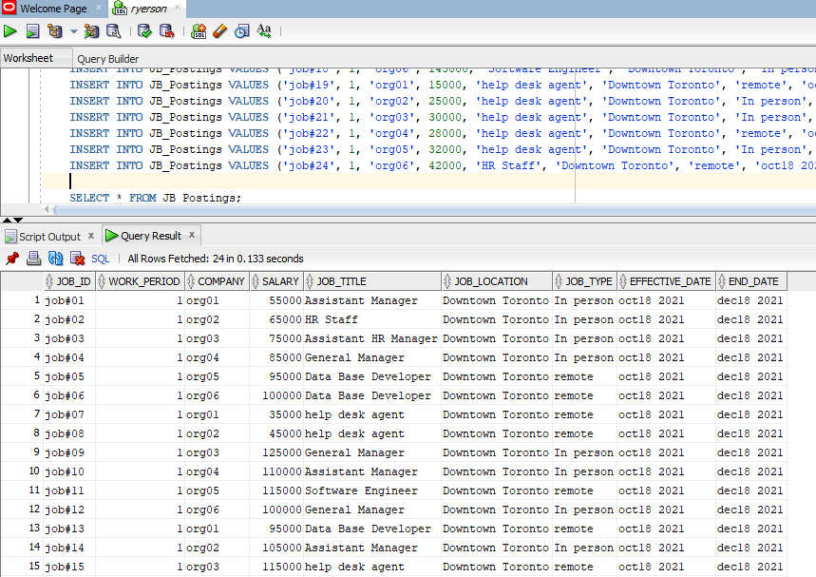

**Qualifications Table Views and Queries.**

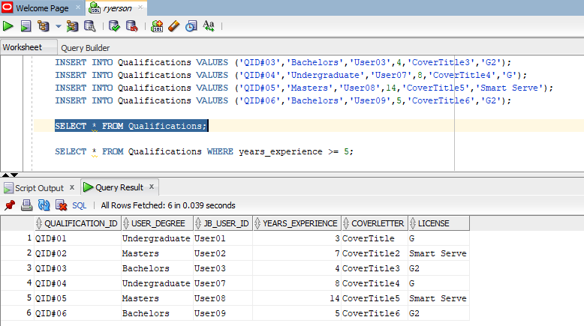

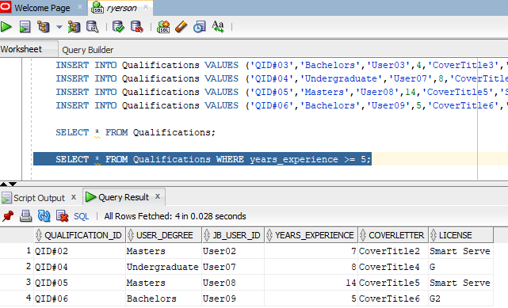

**Memberships Table Views and Queries.**

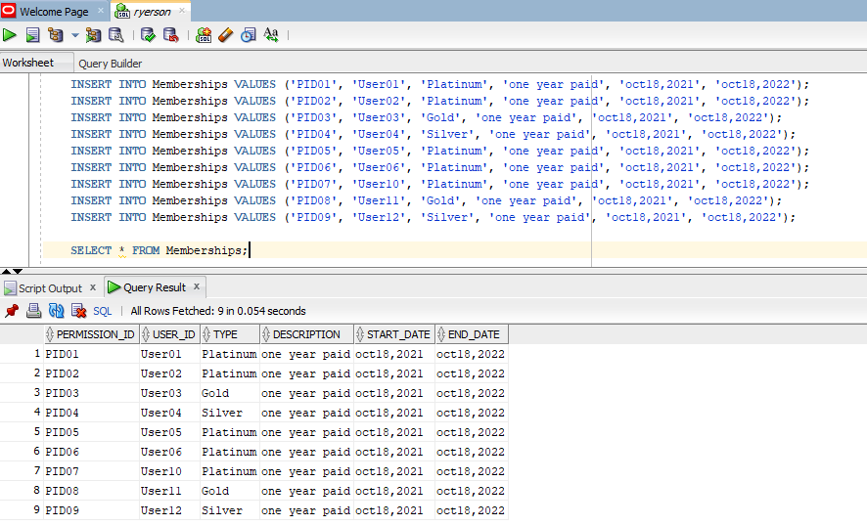

**Connections Table Views and Queries.**

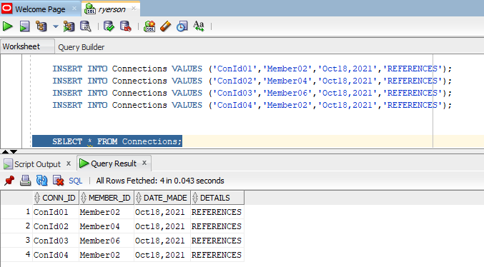

**HR_Department Table Views and Queries.**

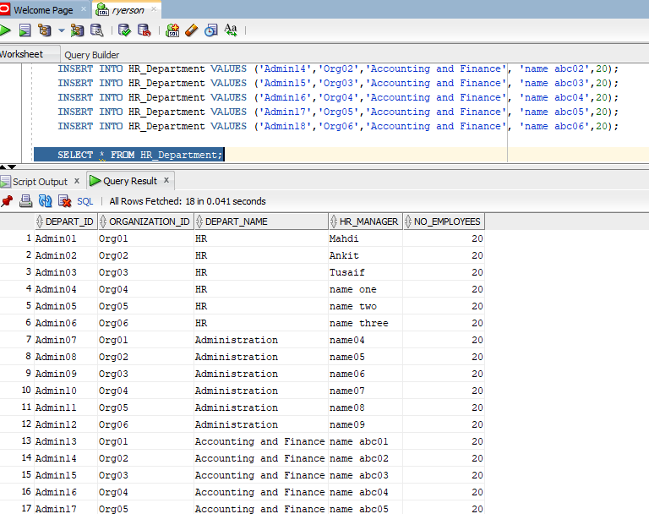

**Shell Script**

-- table_queries.sh

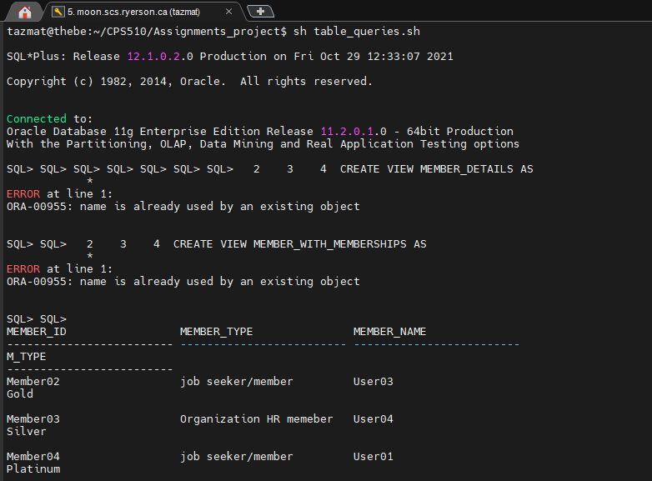

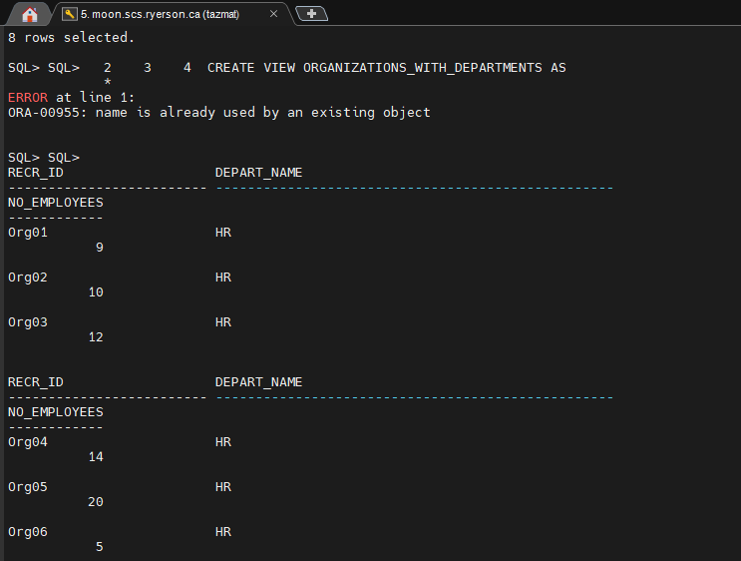

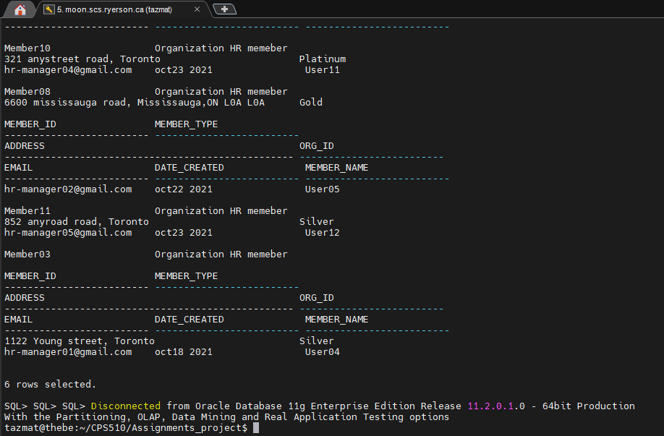

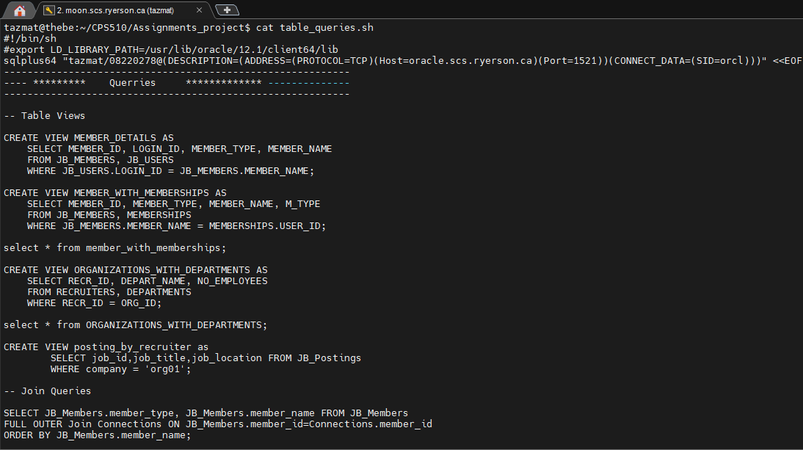

* **Drop tables**

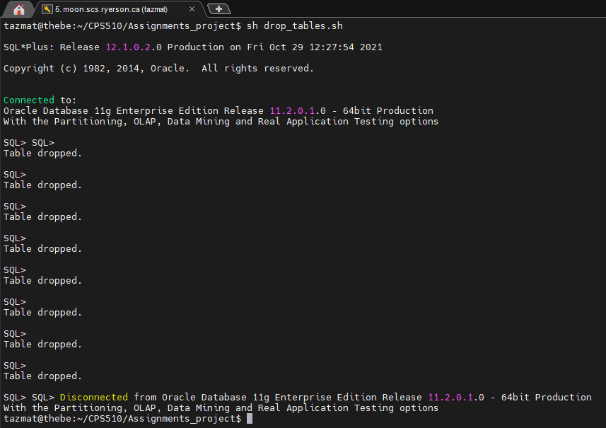

* **Create tables**

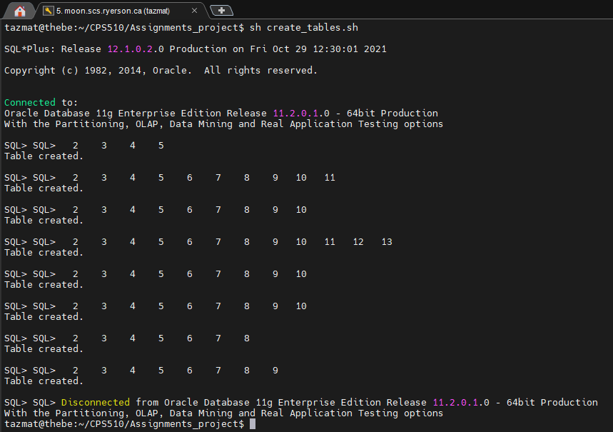

* **Populate tables**

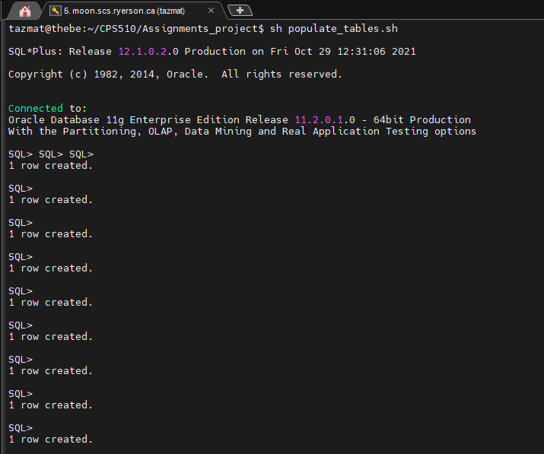

**Functional Dependencies**

**-- Functional Dependencies**

We have completed our database design and the next step is to normalize our DBMS design. In order to normalize our design, we first outlined the functional dependencies in the system. We normalized each table with 1NF and 2NF procedures.

We take each table and apply the normalization technique:

|  |  |  |
| --- | --- | --- |
| **JB_Users** | | |
| PK | Login_id  password | Char  Char |
| **JB_Members** | | |
| PK  FK | Member_id  Member_type  Address  Email  Date_created  Subscriptions  Login_id | Char  Char  Char  Char  Date  Char  Char |

In the table JB_Members,

Member_type, Address, Email, Date_created and Subscriptions depended on Member_id.

So, Memebr_id--🡪 Member_type, Address,Email,Date_created, subscriptions.

But Login_id does not depend on Member_id as it belongs to another table.

This table is of the form 1NF and 2NF.

In the table JB_Users,

Password depend on Login_id.

So, key Login_id -🡪 password.

If we look at the relationship between these two tables, each JB_Member will have one Login_id, so Member_id and login_id will have one to one relationship and vice versa. This table is of the form 1NF and 2NF.

2.

|  |  |  |
| --- | --- | --- |
| **Recruiters** | | |
| PK  FK | recr_id  Company_name  Manager_name  Member_id | Char  Char  Char  Char |

In this table Recruiters recr_id is a on which all the other attributes depend on company_name and Manager_name but Member_id does not depend on recr_id and that is okay as it belongs to another table and is a primary key to another table.

Represented as Recr_id🡪company_name,Manager_name.

Recruiter Table has one to one relationship with JB_Members table and holds dependencies. Recr_id🡪Member_id and vice versa. This table is of the form 1NF and 2NF.

3.

|  |  |  |
| --- | --- | --- |
| **Qualifications** | | |
| PK  FK | Qualification_id  Edu_level  Experience  Cover_letter  Certi_License  JB_user_id | Char  Char  Number  Char  Char  Char |

In this table Qualification_id is a key on which all the other attributes depend.

Represented as Qulification_id🡪Edu_level,Experience,Cover_leter and Certi_license.

Whereas Jb_user_id is a key to another table and acts as forign key here and does not depends on Qualification_id.

Having a foreign key makes the relationship between Qualifications table and JB_Users table and we can describe that as a one to one relationship. As you see, each JB_user_id is associated with only one Qualification_id. In other words each JB_user will have one qualification to hold. This table is of the form 1NF and 2NF.

4.

|  |  |  |
| --- | --- | --- |
| **HR_Department** | | |
| PK  FK | Depart_id  Depart_name  HR_Manager  Org_id | Char  Char  Number  Char |

In the table Departments key Depart_id has attributes that directly depend on it.

We could represent by Depart_id🡪Depart_name,Hr_Manger

Whereas Org_id is a foreign key and doesn’t depend on depart_id.

The table departments hold relation with Recruiters table as one to many relationships. That means Recruiter could have many departments but one department would have only one recruiter/company. Relationship between the two tables (Recruiter and Departments) will represent in term of functional dependencies as Depart_id depend on Recr_id (Depart_id🡪Depart_id).

5.

|  |  |  |
| --- | --- | --- |
| **JB_Postings** | | |
| PK  FK | Job_id  Company  Salary  Job_title  Job_location  Job_type  Effect_date  End_date  depart_id | Char  Char  Number  Char  Char  Char  Date  Date  Char |

This Table holds functional dependency with the HR_Department table as Job_id from JB_Postings table depends on Depart_id.

It holds many to one relationship with the HR_department table as one HR will have many job postings.

If you look at the table JB_posings all the attributes depend on the Job_id key of the table.

We can represent this as Job_id 🡪company,Salary,Job_tile,Job_location,Job_type,Effect_date and End_date.

This table is of the form 1NF and 2NF.

6.

|  |  |  |
| --- | --- | --- |
| **Connections** | | |
| PK  FK | Conn_id  Date_made  Conn_details  Member_id | Char  Date  Char  Char |

This table holds the many-to-many relationship with JB_Memebrs table as each connection will have many members and many connections belong to one member.

So conn_id depends on Member_id (conn_id 🡪 member_id) and member_id depends on conn_id (member_id 🡪 conn_id).

If we look at the conn_id key all the other attribute depends on Conn_id so date_made and Conn_details. This table is of the form 1NF and 2NF.

**Conclusion:** All the tables in our DBMS are normalized to 1NF and 2NF form.

**-- Normalization/ 3NF**

In order to normalize our design, we first outlined the functional dependencies in the system. We have normalized each table with 1NF and 2NF procedure and now we will apply the 3rd NF.

In our database no table use any transitive keys to make primary keys, so our database if of form 3NF.

We take each table and apply the 3NF normalization technique:

|  |  |  |
| --- | --- | --- |
| **JB_Members** | | |
| PK  FK | Member_id  Member_type  Address  Date_created  Subscriptions  Login_id | Char  Char  Char  Char  Date  Char  Char |

All the non key attributes in the table depends on the primary key Member_id and all non-key attribute are non-transitively dependent on Member_id that makes it to 3NF.

JB_Members (Member_id, Member_type,Address,Email,Date_created,Subscriptions).

So, Member_id--🡪 { Member_type, Address,Date_created, subscriptions}.

This table has only one candidate key and that is the primary key (Member_id) of the table.

But Login_id does not depend on Member_id as it’s belonging to another table. This table is of the form 3NF.

2.

|  |  |  |
| --- | --- | --- |
| **JB_Users** | | |
| PK | Login_id  Password | Char  Char |

In the table JB_Users, all the non-key attributes depends on key attribute which is Login_id depends on Password.

Also there is no transitive key in the table.

So, key Login_id -🡪 password.

**Note:** If we look at the relationship between these two tables, each JB_Member will have one Login_id, so Member_id and Login_id will have one to one relationship and vice versa. Both tables are functionally dependent and all primary keys are non-transitive. This table is of the form satisfies all three form 1NF, 2NF and 3NF.

3.

|  |  |  |
| --- | --- | --- |
| **Recruiters** | | |
| PK  FK | recr_id  Company_name  Manager_name  Member_id | Char  Char  Char  Char |

In this table Recruiters (recr**_id**, Company_name, Manager_name) all the non-key attributes depends on recr_id and that is a primary key of the table. This table has no transitive keys as all keys are unique.

Represented as Recr_id🡪company_name,Manager_name.

This table is of the form 3NF.

4.

|  |  |  |
| --- | --- | --- |
| **Qualifications** | | |
| PK  FK | Qualification_id  Edu_level  Experience  Cover_letter  Certi_License  JB_user_id | Char  Char  Number  Char  Char  Char |

In this table Qualification_id is a key on which all the other non-key attributes depends on and there is no key that is transitively dependent of any other table keys. All the keys of the table are unique.

Represented as Qualification_id🡪Edu_level,Expeience,Cover_leter and Certi_license.

Whereas Jb_user_id is a key to another table and acts as forign key her and does not depends on Qualification_id. This table is of the form 3NF.

5.

|  |  |  |
| --- | --- | --- |
| **HR_Department** | | |
| PK  FK | Depart_id  Depart_name  HR_Manager  Org_id | Char  Char  Number  Char |

All the non key attributes in the table depends on the primary key Depart_id and all non-key attribute is non-transitively dependent on Depart_id that makes it to 3NF.

All the non-key attributes are unique.

We could represent by Depart_id🡪Depart_name,Hr_Manger

Whereas Org_id is a foreign key and doesn’t depends on depart_id. This table is of the form 3NF.

6.

|  |  |  |
| --- | --- | --- |
| **JB_Postings** | | |
| PK  FK | Job_id  Company  Salary  Job_title  Job_location  Job_type  Effect_date  End_date  depart_id | Char  Char  Number  Char  Char  Char  Date  Date  Char |

If you look at the table JB_posings all the non-key attributes depends on Job_id key of the table. There are no transitive relations in the table.

We can represent this as Job_id 🡪company,Salary,Job_tile,Job_location,Job_type,Effect_date and End_date.

This table is of the form 3NF.

7.

|  |  |  |
| --- | --- | --- |
| **Connections** | | |
| PK  FK | Conn_id  Date_made  Conn_details  Member_id | Char  Date  Char  Char |

If we look at the conn_id key all the other non-key attribute depends on Conn_id so 🡪 date_made and Conn_details. This table is of the form 3NF.

**Conclusion:** All the tables in our DBMS are normalized to 1NF, 2NF and 3NF form as all keys are unique.

Normalization / BCNF

**Conversion of 3NF to BCNF Normalize form by using Algorithm**

**-- Normalization/ Conversion of 3NF to BCNF with the help of Algorithm.**

**--- We used Bernstein’s Algorithm to achieve this task:**

**Bernstein’s Algorithm - Broken down into 4 steps:**

## Determine all the functional dependencies

## a) Find and remove redundancies

## b) Find and remove partial dependencies

## Find keys

## Create tables

# Step 1 (finding all functional dependencies)

- **Member_id** 🡪 {Member_type, address, date_created, Subscriptions}

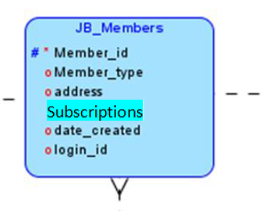

* **Login_id** 🡪 { password}

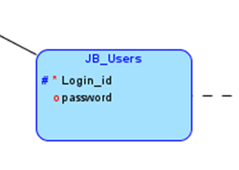

**--Recr_id** 🡪 {company_name, Manager_name}

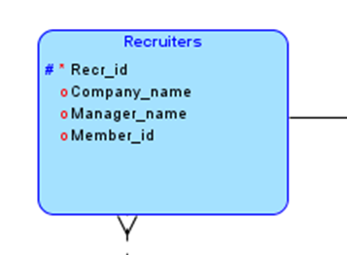

* **Qualification_id🡪** {Edu_level, Experience, cover_letter, Certi_license}

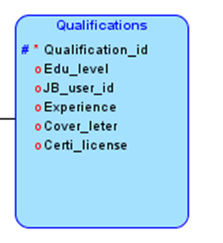

* **depart_id** 🡪 {depart_name, HR_manager}

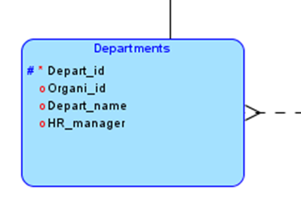

* **job_id** 🡪 {work_period, company, salary, job_title, job_location, job_type, Effect_date, End_date}

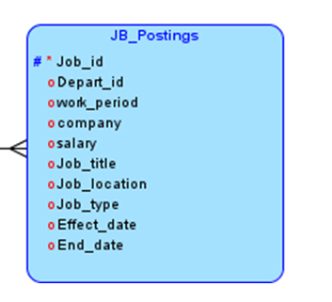

* **Conn_id** 🡪 {Date_made, Conn_details}

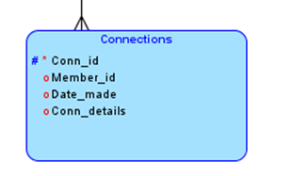

# Step 2a (Break RHS and find redundancies)

Get rid of Redundancies

- **Member_id** 🡪 {Member_type, address, date_created, Subscriptions}

* + Reduced list of FD’s:
  + **Member_id🡪** {Member_type}
  + **Member_id** 🡪{address}
  + **Member_id** 🡪{date_created}
  + **Member_id** 🡪{Subscriptions}

# No redundancies

* **Login_id** 🡪 { password}
  + Reduced list of FD’s:
  + **Login_id** -> {password}

# No redundancies

* **Recr_id** 🡪 {company_name, Manager_name}
  + Reduced list of FD’s:
  + **Recr_id** 🡪 {company_name}
  + **Recr_id** 🡪 {Manger_name}

# No redundancies

* **Qualification_id 🡪** {Edu_level, experience, cover_letter, Certi_license}
  + Reduced list of FD’s:
  + **Qualification_id** 🡪 {user_degree}
* **Qualification_id** 🡪{ experience}
* **Qualification_id** 🡪{cover_letter}
* **Qualification_id** 🡪{Certi_license}

# No redundancies

* **depart_id 🡪** {depart_name, HR_manager}
  + Reduced list of FD’s:
  + **depart_id** 🡪 {depart_name}
  + **depart_id** 🡪 {HR_manager}

# No redundancies

* **job_id** 🡪 {work_period, company, salary, job_title, job_location, job_type, Effect_date, End_date}
  + Reduced list of FD’s:
  + **job_id** 🡪{work_period}
  + **job_id** 🡪{company}
  + **job_id** 🡪 {salary}
  + **job_id** 🡪 {job_title}
  + **job_id** 🡪 {job_location}
  + **job_id** 🡪{job_type}
  + **job_id** 🡪{Effect_date}
  + **job_id** 🡪{End_date}

# No redundancies

* **Conn_id** 🡪 {money}
  + Reduced list of FD’s:
  + **conn_id 🡪** {Date_made}
  + **conn_id 🡪** {conn_details}

# No redundancies

**Step 2b (Minimize LHS, find and remove partial dependencies)**

* LHS is already minimized, therefore there are no partial dependencies

# Step 3(Find keys) (relational schema)

* **Member_id🡪** {Member_type, address, date_created, subscriptions}
  + Attributes on RHS but not on LHS (cannot be keys)
    - Member_type
    - Address
    - Date_created
    - Subscriptions
  + Possible Keys
    - Member_id
* **Login_id** 🡪 { password}
  + Attributes on RHS but not on LHS (cannot be keys)
    - password
  + Possible Keys
    - Login_id
* **Recr_id** 🡪 {company_name, manager_name}
  + Attributes on RHS but not on LHS (cannot be keys)
    - Company_name
    - Manger_name
  + Possible Keys
    - Recr_id
* **depart_id** 🡪 {depart_name, HR_manager}
  + Attributes on RHS but not on LHS (cannot be keys)
    - depart_name
    - HR_Manger
  + Possible Keys
    - depart_id
* **qualification_id** 🡪 {Edu_level, experience, cover_letter, Certi_license}
  + Attributes on RHS but not on LHS (cannot be keys)
    - Edu_level
    - Experience
    - Cover_letter
    - Certi_license
  + Possible Keys
    - Qualification_id
* **job_id** 🡪 {work_period, company, salary, job_title, job_location, job_type, Effect_date, End_date}
  + Attributes on RHS but not on LHS (cannot be keys)
    - work_period
    - company
    - salary
    - job_title
    - job_location
    - job_type
    - Effect_date
    - End_date
  + Possible Keys
    - job_id
* **Conn_id** 🡪 {Date_made, Conn_details}
  + Attributes on RHS but not on LHS (cannot be keys)
    - Date_made
    - Conn_details
  + Possible Keys
    - Conn_id

**Step 4(Make tables)**

**R1** (**member_id**, member_type, address, date_created, subscriptions, login_id)

With

FD: **member_id** 🡪 { member_type, address, date_created , subscriptions }

**R2** (**Login_id**, password)

With

FD: **user_id** 🡪{ user_password}

**R3** (**recr_id**, company_name, manager_name, member_id)

With

FD: **recr_id** 🡪{company_name, manager_name }

**R4** (**depart_id**, depart_name, hr_manager,Org_id)

With

FD: **depart_id** 🡪{ depart_name, hr_manager }

**R5** (**qualification_id**, edu_level, experience, cover_letter, Certi_license, user_id)

With

FD: **qualification_id** 🡪 { edu_level, experience, cover_letter, Certi_license }

**R6** (**job_id**, work_period, company, salary, job_title, job_location, job_type, effect_date,end_date, depart_id)

With

FD: **job_id** 🡪{, work_period, company, salary, job_title, job_location, job_type, effect_date,end_date }

**R7** (**conn_id**, date_made, conn_details, member_id)

With

FD: **conn_id** 🡪 { date_made, conn_details }

**BCNF (Boyce/Codd Normal Form)**

# Step 1 (finding all functional dependencies (List of all attributes and FDs))

- **member_id** 🡪 { member_type, address, date_created, subscriptions, login_id }



* **Login_id** 🡪 { password}



* **Recr_id** 🡪 {company_name, Manager_name, member_id}



* **Qualification_id🡪** {Edu_level, Experience, cover_letter, Certi_license, jb_user_id}



* **depart_id** 🡪 {depart name, HR_manager, Organi_id}



* **job_id** 🡪 {work_period, company, salary, job_title, job_location, job_type, Effect_date, End_date, depart_id, Depart_id}



* **Conn_id** 🡪 {Date_made, Conn_details, member_id}



# Step 2 (make sure that the left hand side are keys, if not decompose)

Consider the relation schema

**R1** (**member_id**, member_type, address, date_created, subscriptions, login_id)

With FD

**member_id** 🡪 { member_type, address, date_created , subscriptions }

This schema has one candidate key

member_id

Therefore this schema is in BCNF

Consider the relation schema

**R2** (**Login_id**, password)

With FD

**Login_id** 🡪 {password}

This schema has one candidate key

login_id

Therefore this schema is in BCNF

Consider the relation schema

**R3** (**recr_id**, company_name, manager_name, member_id)

With FD

**recr_id** 🡪 {company_name, manager_name }

This schema has one candidate key

recr_id

Therefore this schema is in BCNF

Consider the relation schema

**R4** (**depart_id**, depart_name, hr_manager,Org_id)

With FD

**depart_id** 🡪 { depart_name, hr_manager }

This schema has one candidate key

depart_id

Therefore this schema is in BCNF

Consider the relation schema

**R5** (**qualification_id**, edu_level, experience, cover_letter, Certi_license, user_id)

With FD

**qualification_id** 🡪 { edu_level, experience, cover_letter, Certi_license }

This schema has one candidate key

qualification_id

Therefore this schema is in BCNF

Consider the relation schema

**R6** (**job_id**, work_period, company, salary, job_title, job_location, job_type, effect_date,end_date, depart_id)

With FD

**job_id** 🡪 { work_period, company, salary, job_title, job_location, job_type,effect_date,end_date}

This schema has one candidate key

job_id

Therefore this schema is in BCNF

Consider the relation schema

**R7** (**conn_id**, date_made, conn_details, member_id)

With FD

**conn_id** 🡪 { date_made, conn_details }

This schema has one candidate key

conn_id

Therefore this schema is in BCNF

**Step 3 (final BCNF schema for R)**

**R1** (**member_id**, member_type, address, date_created, subscriptions, login_id)

**R2** (**Login_id**, password)

**R3** (**recr_id**, company_name, manager_name, member_id)

**R4** (**depart_id**, depart_name, hr_manager,Org_id)

**R5** (**qualification_id**, edu_level, experience, cover_letter, Certi_license, user_id)

**R6** (**job_id**, work_period, company, salary, job_title, job_location, job_type, effect_date,end_date, depart_id)

**R7** (**conn_id**, date_made, conn_details, member_id)

Note: All the tables are of the form BCNF and we didn’t need to combine any tables for this stage.

**Graphical User Interface Python Code:**

#!/usr/bin/env python  
import tkinter as tk  
import cx_Oracle  
import connect_info  
from tkinter import N, S, W, E, simpledialog  
  
  
def find_query_name(query):  
 *"""  
 Used to find a query name  
 """* return query[:query.find('(')]  
  
  
class main_window:  
 *"""  
 The main application window containing up to 4 buttons:  
 CREATE,POPULATE,DROP Tables, and Run a custom query  
 """* def __init__(self):  
 self.root = tk.Tk()  
 self.root.title('Job Bank App')  
 self.root.geometry("600x400")  
 self.label = tk.Label(self.root)  
  
 self.buttonTopLeft = tk.Button(self.root,  
 text='Please Connect to DataBase',  
 command=self.connect_to_db)  
 self.buttonTopRight = tk.Button(self.root,  
 text='DROP TABLES',  
 command=self.dropTables)  
 self.buttonBottomLeft = tk.Button(self.root,  
 text='POPULATE TABLES',  
 command=self.populateTables)  
 self.buttonBottomRight = tk.Button(self.root,  
 text='RUN A CUSTOM QUERY',  
 command=self.runCustomQuery)  
  
 self.buttonTopLeft.grid(column=0, row=0, sticky=N + S + E + W)  
 self.buttonTopRight.grid(column=1, row=0, sticky=N + S + E + W)  
 self.buttonBottomLeft.grid(column=0, row=1, sticky=N + S + E + W)  
 self.buttonBottomRight.grid(column=1, row=1, sticky=N + S + E + W)  
 self.label.grid(column=2, row=2, sticky=N + S + E + W)  
  
 # set weight to make the window responsive  
 for i in range(2):  
 self.root.grid_rowconfigure(i, weight=1)  
 for i in range(2):  
 self.root.grid_columnconfigure(i, weight=1)  
  
 # temporary hide the 3 other buttons  
 self.buttonTopRight.grid_remove()  
 self.buttonBottomLeft.grid_remove()  
 self.buttonBottomRight.grid_remove()  
 # run the mainloop  
 self.root.mainloop()  
  
 def quit(self):  
 self.root.destroy()  
 self.cursor.close()  
 self.connection.close()  
  
 def createTables(self):  
 create_file = open('createTables.txt', 'r')  
 create_tables_list = create_file.read().split(';')  
 try:  
 for table in create_tables_list:  
 print(f"Executing {find_query_name(table)}")  
 self.connection.cursor().execute(table)  
 string = "Successfully created tables"  
 self.connection.cursor().execute('CREATE TABLE Qualifications (qualification_id VARCHAR2(10 CHAR),edu_level VARCHAR2(50 CHAR),JB_User_id VARCHAR2(25 CHAR),experience NUMBER,coverLetter VARCHAR2(1000 CHAR),certi_license VARCHAR2(25 CHAR),PRIMARY KEY(qualification_id),FOREIGN KEY(JB_User_id) REFERENCES JB_Users(login_id));')  
 except:  
 string = 'Some Tables may not be created...'  
 string = "Successfully created tables"  
 newWin = tk.Tk()  
 textBox = tk.Text(newWin)  
 textBox.insert(tk.INSERT, string)  
 textBox.config(state=tk.DISABLED)  
 textBox.pack()  
 newButton = tk.Button(newWin, text='close', command=newWin.destroy)  
 newButton.pack()  
 newWin.mainloop()  
  
 def populateTables(self):  
 populate_file = open("populateTables.txt", "r")  
 populate_tables_string = populate_file.read().split(';')  
 try:  
 for table in populate_tables_string:  
 print(f"Executing {find_query_name(table)}")  
 self.connection.cursor().execute(table)  
 string = "Successfully populated tables"  
 except:  
 string = 'some table might not got populated...'  
 string = "Successfully populated tables"  
 newWin = tk.Tk()  
 textBox = tk.Text(newWin)  
 textBox.insert(tk.INSERT, string)  
 textBox.config(state=tk.DISABLED)  
 textBox.pack()  
 newButton = tk.Button(newWin, text='close', command=newWin.destroy)  
 newButton.pack()  
  
 newWin.mainloop()  
  
 def dropTables(self):  
 drop_file = open('dropTables.txt', 'r')  
 drop_tables_list = drop_file.read().split(";")  
 try:  
 for drop_table in drop_tables_list:  
 self.connection.cursor().execute(drop_table)  
 string = "Successfully dropped tables"  
 except:  
 string = 'Some tables might not got dropped.'  
 string = "Successfully dropped tables"  
 newWin = tk.Tk()  
 textBox = tk.Text(newWin)  
 textBox.insert(tk.INSERT, string)  
 textBox.config(state=tk.DISABLED)  
 textBox.pack()  
 newButton = tk.Button(newWin, text='close', command=newWin.destroy)  
 newButton.pack()  
 newWin.mainloop()  
  
 def runCustomQuery(self):  
 try:  
 query = simpledialog.askstring(title="Query Results", prompt=("Input Custom Query Here: " + " " * 100))  
 self.cursor.execute(query)  
  
 result = self.cursor.fetchall()  
 print(result)  
 string = ''  
  
 for res in result:  
 for x in res:  
 string = string + str(x) + ', \n'  
 string = string + '\n'  
 except cx_Oracle.Error as error:  
 string = error  
  
 newWin = tk.Tk()  
 textBox = tk.Text(newWin)  
 textBox.insert(tk.INSERT, string)  
 textBox.config(state=tk.DISABLED)  
 textBox.pack()  
 newButton = tk.Button(newWin, text='close', command=newWin.destroy)  
 newButton.pack()  
  
 newWin.mainloop()  
  
 def connect_to_db(self):  
 *"""  
 Connect to the Oracle DMBS and restore the right layout through  
 self.restore_layout()  
 """* self.connection = None  
 try:  
 self.connection = cx_Oracle.connect(  
 connect_info.username,  
 connect_info.password,  
 connect_info.dsn,  
 encoding=connect_info.encoding)  
 self.cursor = self.connection.cursor()  
  
 # show the version of the Oracle Database  
 string = 'Connected successfully to: ' + self.connection.version  
 print(self.connection.version)  
 except cx_Oracle.Error as error:  
 string = error  
 print(error)  
  
 # restore the layout to the correct one  
 self.restore_layout()  
  
 newWin = tk.Tk()  
 textBox = tk.Text(newWin)  
 textBox.insert(tk.INSERT, string)  
 textBox.config(state=tk.DISABLED)  
 textBox.pack()  
 newButton = tk.Button(newWin, text='close', command=newWin.destroy)  
 newButton.pack()  
  
 newWin.mainloop()  
  
 def restore_layout(self):  
 *"""  
 Change the text on the right button and restore the other 3 buttons in the grid  
 """* # change the text on the top left button  
 self.buttonTopLeft.configure(text="CREATE TABLES", command=self.createTables)  
  
 # return buttons to the window  
 self.buttonTopRight.grid()  
 self.buttonBottomLeft.grid()  
 self.buttonBottomRight.grid()  
 self.root.geometry("800x600")  
  
  
if __name__ == "__main__":  
 main_window()

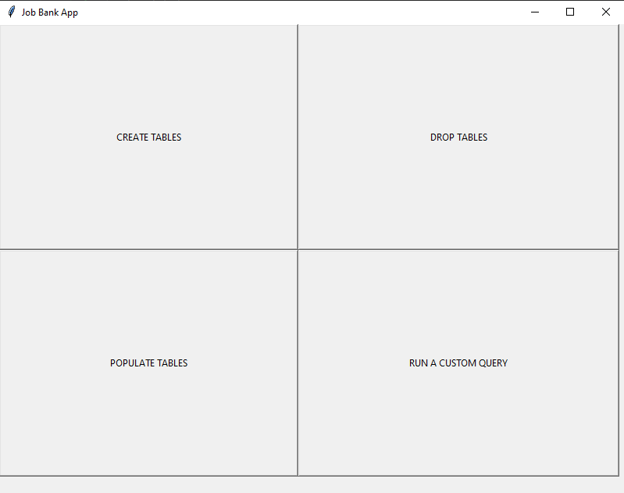

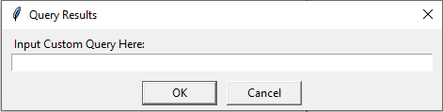

**Simple and Advanced Database Queries (with Relational Algebra):**

-----------------------------------------------------------

---- ********* Queries ************* --------------

-----------------------------------------------------------

**SQL**

SELECT *

FROM JB_Postings

WHERE job_location = 'Toronto';

**Relational Algebra**

𝛔 Location = ‘Toronto’ (JB_postings)

**SQL**

SELECT *

FROM Qualifications

WHERE years_experience >= 5;

**Relational Algebra**

𝛔 year_experience ≥ 5 (Qualifications)

**SQL**

SELECT *

FROM JB_Members

WHERE Subscription = 'Premium' AND member_type = 'recruiter';

**Relational Algebra**

𝛔 (Subscription = ‘Premium’) AND (member_type = ‘recruiter’) (JB_Members)

**SQL**

SELECT *

FROM Department

ORDER BY Org_id DESC, depart_name ASC;

**Relational Algebra**

𝛔 ( (Org_id DESC) AND (depart_name ASC)) (Department)

**SQL**

SELECT company_name AS company

FROM JB_Recruiters

ORDER BY Manager_name;

**Relational Algebra**

𝛔 company_name ASC 𝚷 Manager_name (JB_Recruiters)

**SQL**

SELECT job_location, COUNT(job_id) AS INTEGER_located

FROM JB_Postings

GROUP BY job_location;

**Relational Algebra**

𝚷 job_location, job_id (𝓖 job_location )( JB_Postings)

**SQL**

SELECT login_id, edu_level, experience

FROM Qualifications, JB_Members

24

WHERE ((edu_level = 'University of Toronto' OR edu_level = Seneca

College')

AND experience BETWEEN 2 AND 10);

**Relational Algebra**

𝚷 login_id, edu_level, experience (𝛔 (edu_level = ‘University of Toronto) OR (edu_level = ‘Seneca College’) AND

(experience ≥ 2) AND (experience ≤ 10)) (Qualifications >< JB_Members)

**SQL**

SELECT subscription, login_id, edu_level, job_title

FROM JB_Postings j, Qualifications q, JB_Users a, JB_Members s

WHERE (s.subscription = ‘Gold’ AND q.edu_level = Seneca College');

**Relational Algebra**

𝚷 subscription, login_id, edu_level, job_titile (𝛔 (subscription = ‘Gold’) AND (user_degree = ‘Seneca College’) )(JB_Postings ><

Qualifications >< JB_Users >< JB_Members)

**SQL**

SELECT JB_Members.member_id, JB_Members.date_created, Connections.date_made,

Connections.details

FROM JB_Members

INNER JOIN Connections

ON JB_Members.member_id = Connections.member_id;

**Relational Algebra**

𝚷 member_id, date_created, date_made, details (𝛔 member_id = member_id) (JB_Members Connections)

**Conclusion:**

## Working on this Online Job Bank Database Management System has provided us with a foundation in all the aspects of database design and implementation. Through the course of the 10 assignments, we realized how important it was to represent data in a clear and concise manner. With the theoretical knowledge and the understanding of entity relationship diagrams, relational schema design, functional dependencies, normalization, etc., we were able to turn various meaningless sets of data into a useful and accessible database.

## In the technical aspect, we familiarize ourselves with the services provided by Oracle 12g and SQL. Using the tools provided, we learned how to create tables, drop tables, populate tables and create custom queries that can display query information in any format. Finally, creating a GUI using python also familiarized us with the interactions between the front-end and back-end components of the database.

## This project was also crucial in exercising our teamwork and communication skills along with improving our technical abilities with project management and software development.

## Overall, working on the job bank DBMS was different, challenging yet an enjoyable experience. It truly unlocked our potential to use the knowledge and skills that we have acquired in this course for the future career development.