**CPS510 Fall2021 Section 04**

**Group-11**

**Assignment 4**

**Views and Queries**

**Demo of Designing Views/ Queries**

**Application Name: Online Job Bank System.**

Group Member names:

1. Tusaif Azmat

Student#: 500660278

1. Ankit Dheedsa

Student#: 500975118

1. Mahdi Alam

Student#: 500969935

-- Table Views

CREATE VIEW MEMBER_WITH_MEMBERSHIPS AS

SELECT MEMBER_ID, MEMBER_TYPE, MEMBER_NAME, M_TYPE

FROM JB_MEMBERS, MEMBERSHIPS

WHERE JB_MEMBERS.MEMBER_NAME = MEMBERSHIPS.USER_ID;

select * from member_with_memberships;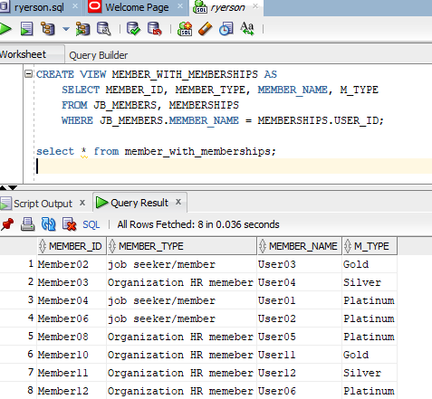

CREATE VIEW MEMBER_WITH_CONNECTIONS AS

SELECT JB_MEMBERS.MEMBER_ID, CONNECTIONS.DETAILS

FROM JB_MEMBERS, CONNECTIONS

WHERE JB_MEMBERS.MEMBER_ID = CONNECTIONS.MEMBER_ID;

select * from MEMBER_WITH_CONNECTIONS;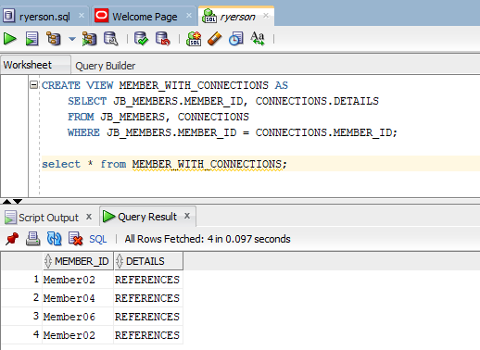

CREATE VIEW ORGANIZATIONS_WITH_DEPARTMENTS AS

SELECT RECR_ID, DEPART_NAME, NO_EMPLOYEES

FROM RECRUITERS, DEPARTMENTS

WHERE RECR_ID = ORG_ID;

select * from ORGANIZATIONS_WITH_DEPARTMENTS;

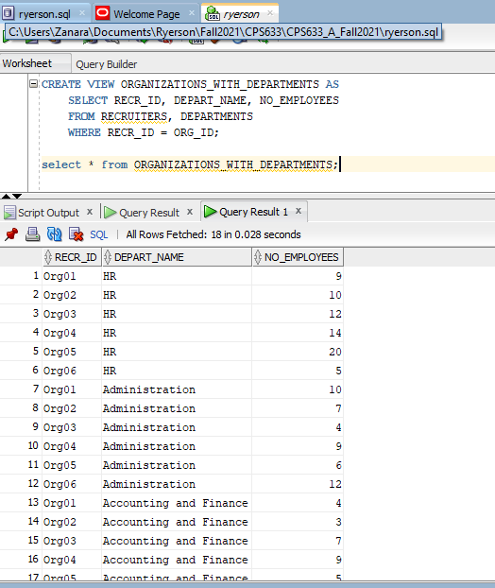

CREATE VIEW posting_by_recruiter as

SELECT job_id,job_title,job_location FROM JB_Postings

WHERE company = 'org01';

select * from posting_by_recruiter;

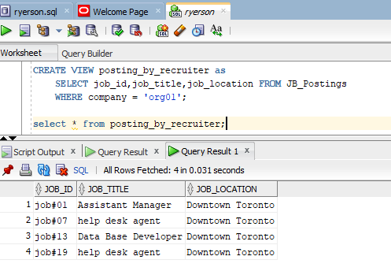

**-- advanced Queries**

-- Join Queries

SELECT JB_Members.member_type, JB_Members.member_name FROM JB_Members

FULL OUTER Join Connections ON JB_Members.member_id=Connections.member_id

ORDER BY JB_Members.member_name;

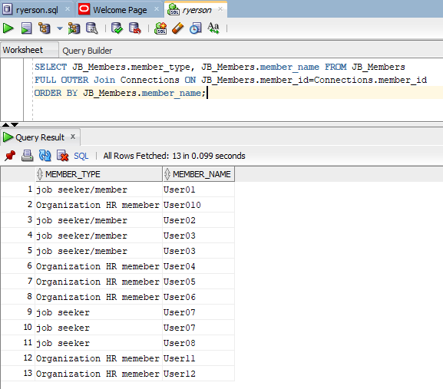

SELECT JB_users.login_id AS UserID, Qualifications.user_degree AS EducationLevel,

Qualifications.coverLetter AS Details, Qualifications.years_experience

FROM JB_Users, Qualifications

Where JB_Users.login_id <> Qualifications.JB_User_id

ORDER BY JB_Users.login_id;

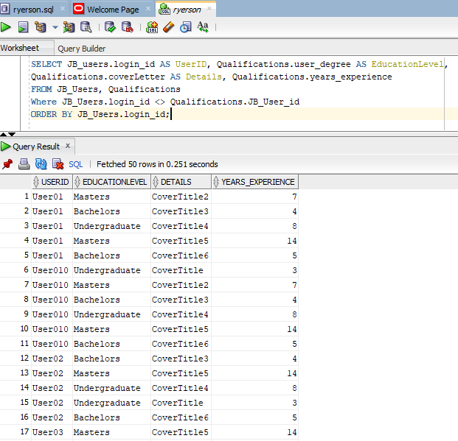

--DISTINCT Queries

SELECT DISTINCT organization_id from HR_Department;

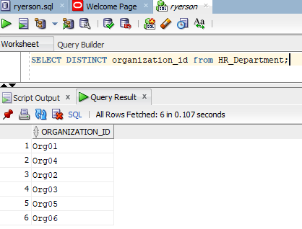

SELECT COUNT(DISTINCT organization_id) from HR_Department;

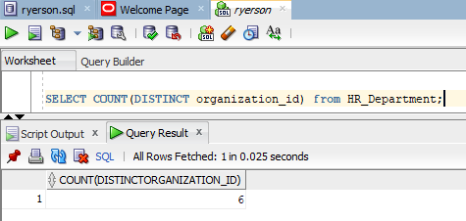

SELECT DISTINCT company FROM JB_Postings;

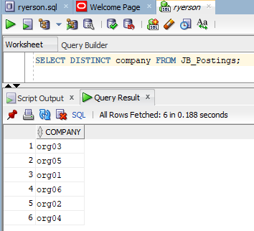

--Grouping/Sorting Commands

SELECT COUNT(member_id),member_type FROM JB_Members GROUP BY member_type;

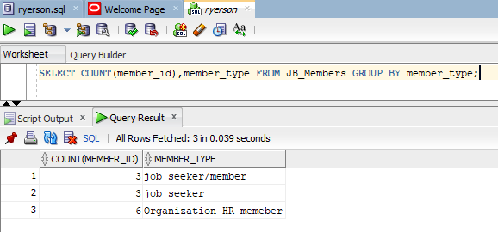

* Use of **Where** clause

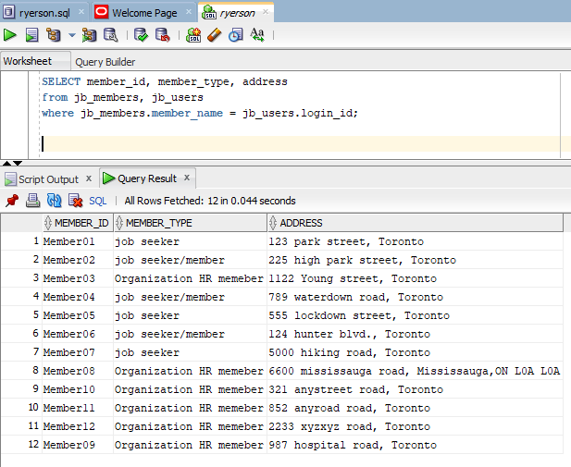

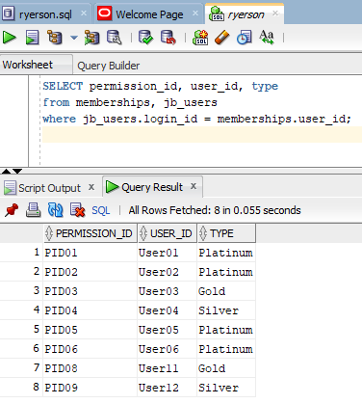

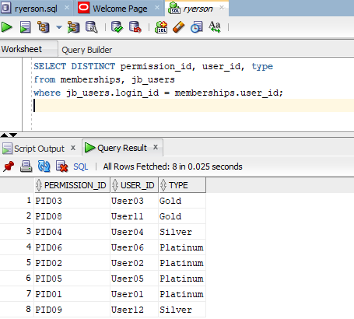

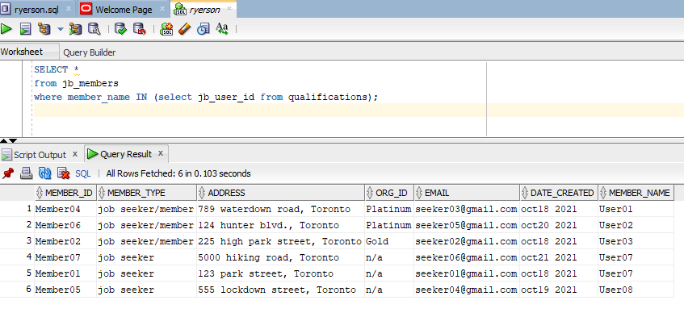

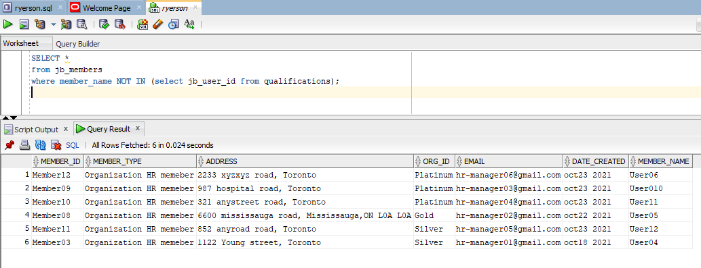

**Screen Shots:**

**JB_Users Table Views and Queries.**

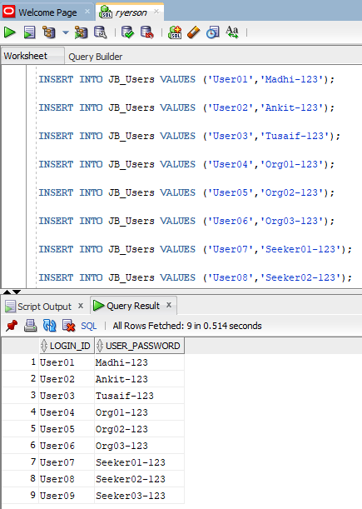

**JB_Members Table Views and Queries.**

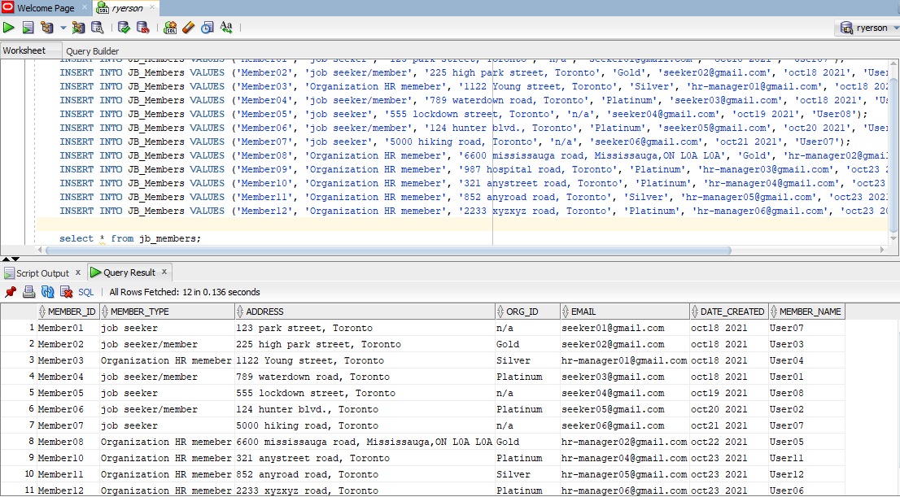

**JB_Members Table Views and Queries.**

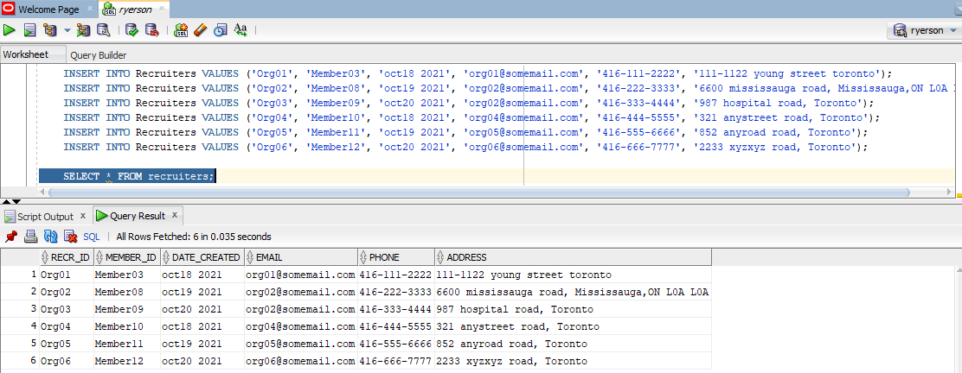

**JB_Postings Table Views and Queries.**

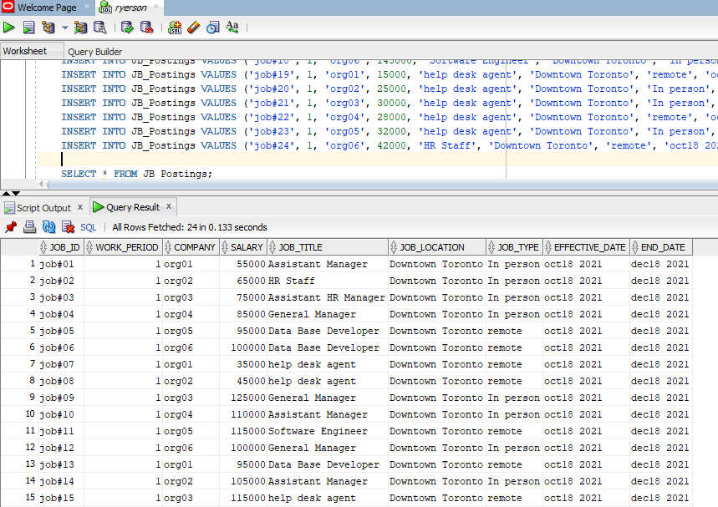

**Qualifications Table Views and Queries.**

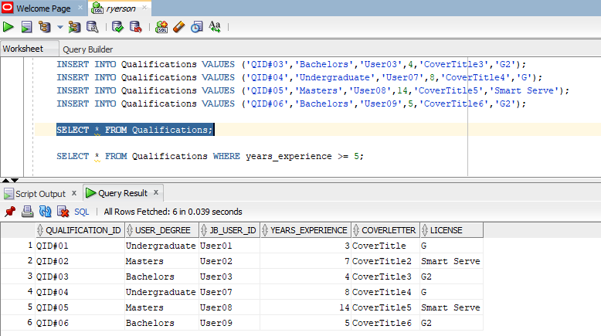

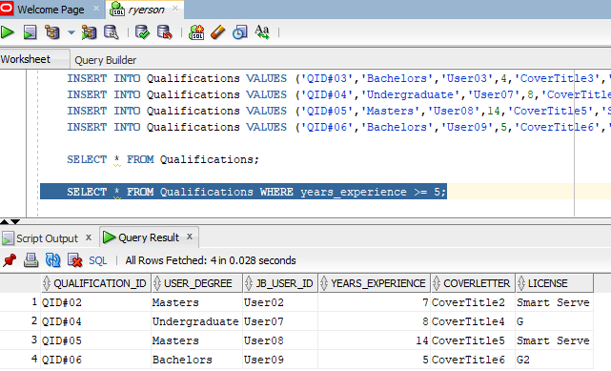

**Memberships Table Views and Queries.**

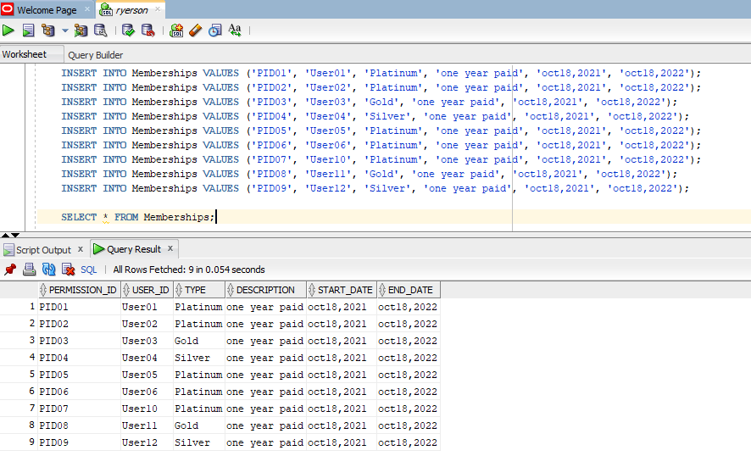

**Connections Table Views and Queries.**

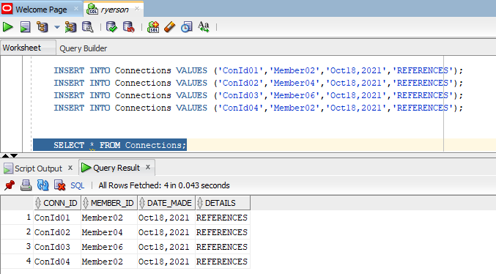

**HR_Department Table Views and Queries.** 