**CPS510 Fall2021 Section 04**

**Group-11**

**Assignment 5**

**Shell Script**

**Demo of Designing Views/ Queries by shell script**

**Application Name: Online Job Bank System.**

Group Member names:

1. Tusaif Azmat

Student#: 500660278

1. Ankit Dheedsa

Student#: 500975118

1. Mahdi Alam

Student#: 500969935

-- table_queries.sh

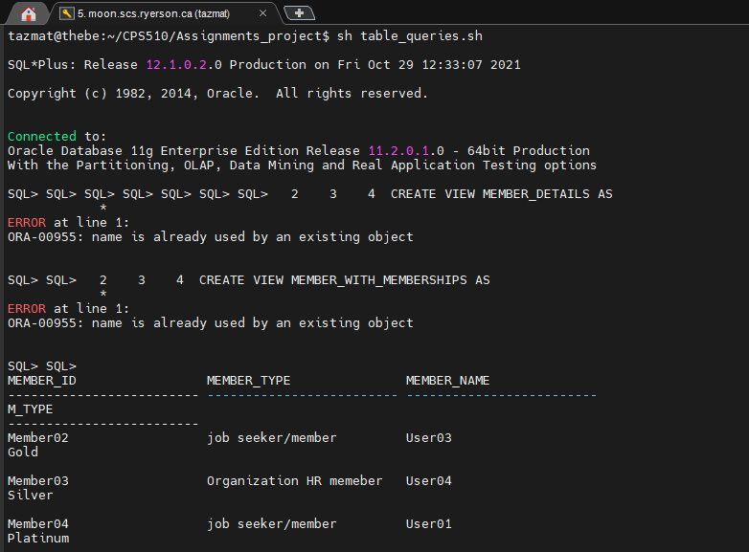

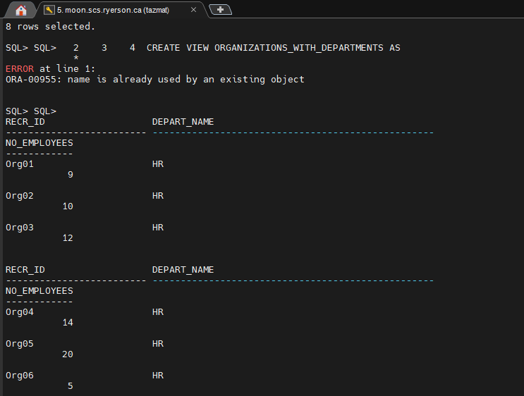

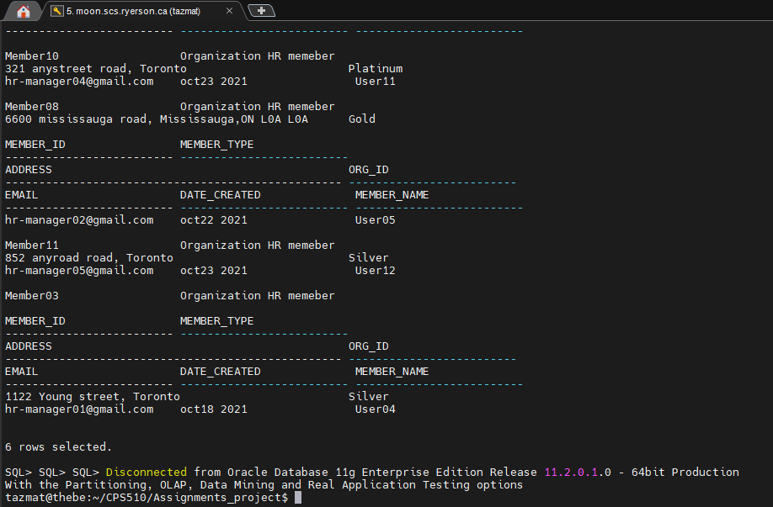

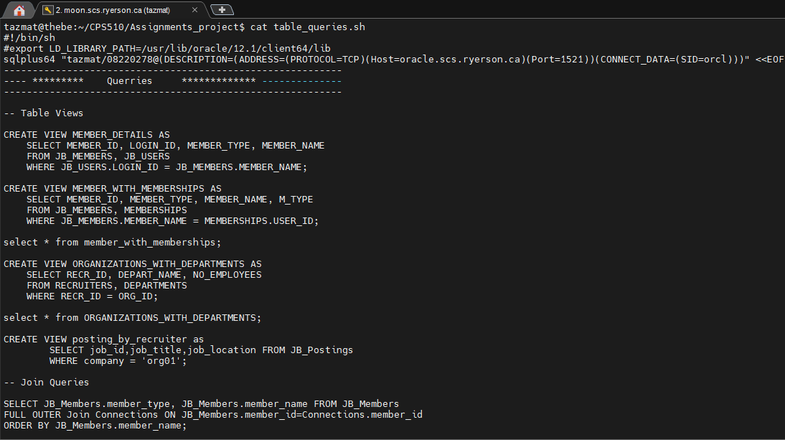

* **Drop tables**

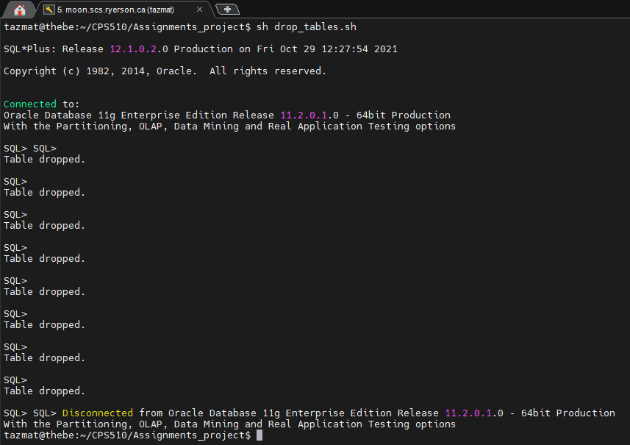

* **Create tables**

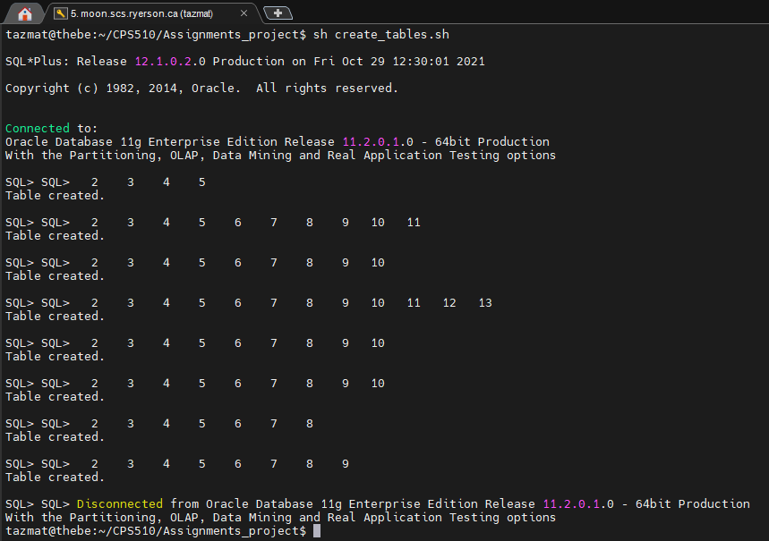

* **Populate tables**

