**CPS510 Fall2021 Section 04**

**Group-11**

**Assignment 8**

Normalization / BCNF

**Conversion of 3NF to BCNF Normalize form by using Algorithm**

**Application Name: Online Job Bank System.**

Group Member names:

1. Tusaif Azmat

Student#: 500660278

1. Ankit Dheedsa

Student#: 500975118

1. Mahdi Alam

Student#: 500969935

**-- Normalization/ Conversion of 3NF to BCNF with the help of Algorithm.**

**--- We used Bernstein’s Algorithm to achieve this task:**

**Bernstein’s Algorithm - Broken down into 4 steps:**

## Determine all the functional dependencies

## a) Find and remove redundancies

## b) Find and remove partial dependencies

## Find keys

## Create tables

# Step 1 (finding all functional dependencies)

- **Member_id** 🡪 {Member_type, address, date_created, Subscriptions}

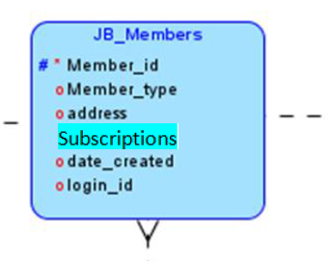

* **Login_id** 🡪 { password}

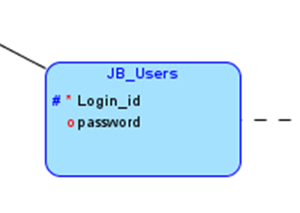

* **Recr_id** 🡪 {company_name, Manager_name}

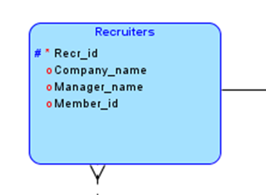

* **Qualification_id🡪** {Edu_level, Experience, cover_letter, Certi_license}

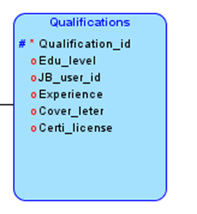

* **depart_id** 🡪 {depart_name, HR_manager}

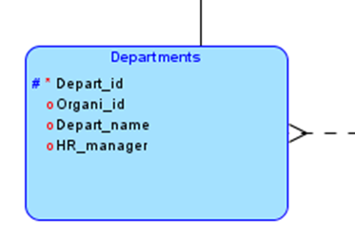

* **job_id** 🡪 {work_period, company, salary, job_title, job_location, job_type, Effect_date, End_date}

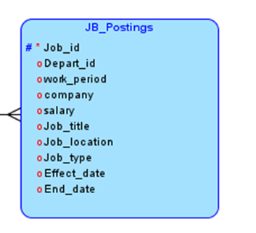

* **Conn_id** 🡪 {Date_made, Conn_details}

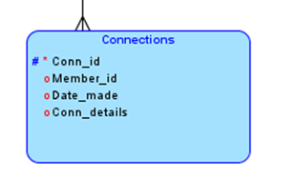

# Step 2a (Break RHS and find redundancies)

Get rid of Redundancies

- **Member_id** 🡪 {Member_type, address, date_created, Subscriptions}

* + Reduced list of FD’s:
  + **Member_id🡪** {Member_type}
  + **Member_id** 🡪{address}
  + **Member_id** 🡪{date_created}
  + **Member_id** 🡪{Subscriptions}

# No redundancies

* **Login_id** 🡪 { password}
  + Reduced list of FD’s:
  + **Login_id** -> {password}

# No redundancies

* **Recr_id** 🡪 {company_name, Manager_name}
  + Reduced list of FD’s:
  + **Recr_id** 🡪 {company_name}
  + **Recr_id** 🡪 {Manger_name}

# No redundancies

* **Qualification_id 🡪** {Edu_level, experience, cover_letter, Certi_license}
  + Reduced list of FD’s:
  + **Qualification_id** 🡪 {user_degree}
* **Qualification_id** 🡪{ experience}
* **Qualification_id** 🡪{cover_letter}
* **Qualification_id** 🡪{Certi_license}

# No redundancies

* **depart_id 🡪** {depart_name, HR_manager}
  + Reduced list of FD’s:
  + **depart_id** 🡪 {depart_name}
  + **depart_id** 🡪 {HR_manager}

# No redundancies

* **job_id** 🡪 {work_period, company, salary, job_title, job_location, job_type, Effect_date, End_date}
  + Reduced list of FD’s:
  + **job_id** 🡪{work_period}
  + **job_id** 🡪{company}
  + **job_id** 🡪 {salary}
  + **job_id** 🡪 {job_title}
  + **job_id** 🡪 {job_location}
  + **job_id** 🡪{job_type}
  + **job_id** 🡪{Effect_date}
  + **job_id** 🡪{End_date}

# No redundancies

* **Conn_id** 🡪 {money}
  + Reduced list of FD’s:
  + **conn_id 🡪** {Date_made}
  + **conn_id 🡪** {conn_details}

# No redundancies

**Step 2b (Minimize LHS, find and remove partial dependencies)**

* LHS is already minimized, therefore there are no partial dependencies

# Step 3(Find keys) (relational schema)

* **Member_id🡪** {Member_type, address, date_created, subscriptions}
  + Attributes on RHS but not on LHS (cannot be keys)
    - Member_type
    - Address
    - Date_created
    - Subscriptions
  + Possible Keys
    - Member_id
* **Login_id** 🡪 { password}
  + Attributes on RHS but not on LHS (cannot be keys)
    - password
  + Possible Keys
    - Login_id
* **Recr_id** 🡪 {company_name, manager_name}
  + Attributes on RHS but not on LHS (cannot be keys)
    - Company_name
    - Manger_name
  + Possible Keys
    - Recr_id
* **depart_id** 🡪 {depart_name, HR_manager}
  + Attributes on RHS but not on LHS (cannot be keys)
    - depart_name
    - HR_Manger
  + Possible Keys
    - depart_id
* **qualification_id** 🡪 {Edu_level, experience, cover_letter, Certi_license}
  + Attributes on RHS but not on LHS (cannot be keys)
    - Edu_level
    - Experience
    - Cover_letter
    - Certi_license
  + Possible Keys
    - Qualification_id
* **job_id** 🡪 {work_period, company, salary, job_title, job_location, job_type, Effect_date, End_date}
  + Attributes on RHS but not on LHS (cannot be keys)
    - work_period
    - company
    - salary
    - job_title
    - job_location
    - job_type
    - Effect_date
    - End_date
  + Possible Keys
    - job_id
* **Conn_id** 🡪 {Date_made, Conn_details}
  + Attributes on RHS but not on LHS (cannot be keys)
    - Date_made
    - Conn_details
  + Possible Keys
    - Conn_id

**Step 4(Make tables)**

**R1** (**member_id**, member_type, address, date_created, subscriptions, login_id)

With

FD: **member_id** 🡪 { member_type, address, date_created , subscriptions }

**R2** (**Login_id**, password)

With

FD: **user_id** 🡪{ user_password}

**R3** (**recr_id**, company_name, manager_name, member_id)

With

FD: **recr_id** 🡪{company_name, manager_name }

**R4** (**depart_id**, depart_name, hr_manager,Org_id)

With

FD: **depart_id** 🡪{ depart_name, hr_manager }

**R5** (**qualification_id**, edu_level, experience, cover_letter, Certi_license, user_id)

With

FD: **qualification_id** 🡪 { edu_level, experience, cover_letter, Certi_license }

**R6** (**job_id**, work_period, company, salary, job_title, job_location, job_type, effect_date,end_date, depart_id)

With

FD: **job_id** 🡪{, work_period, company, salary, job_title, job_location, job_type, effect_date,end_date }

**R7** (**conn_id**, date_made, conn_details, member_id)

With

FD: **conn_id** 🡪 { date_made, conn_details }

**BCNF (Boyce/Codd Normal Form)**

# Step 1 (finding all functional dependencies (List of all attributes and FDs))

- **member_id** 🡪 { member_type, address, date_created, subscriptions, login_id }



* **Login_id** 🡪 { password}



* **Recr_id** 🡪 {company_name, Manager_name, member_id}



* **Qualification_id🡪** {Edu_level, Experience, cover_letter, Certi_license, jb_user_id}



* **depart_id** 🡪 {depart name, HR_manager, Organi_id}



* **job_id** 🡪 {work_period, company, salary, job_title, job_location, job_type, Effect_date, End_date, depart_id, Depart_id}



* **Conn_id** 🡪 {Date_made, Conn_details, member_id}



# Step 2 (make sure that the left hand side are keys, if not decompose)

Consider the relation schema

**R1** (**member_id**, member_type, address, date_created, subscriptions, login_id)

With FD

**member_id** 🡪 { member_type, address, date_created , subscriptions }

This schema has one candidate key

member_id

Therefore this schema is in BCNF

Consider the relation schema

**R2** (**Login_id**, password)

With FD

**Login_id** 🡪 {password}

This schema has one candidate key

login_id

Therefore this schema is in BCNF

Consider the relation schema

**R3** (**recr_id**, company_name, manager_name, member_id)

With FD

**recr_id** 🡪 {company_name, manager_name }

This schema has one candidate key

recr_id

Therefore this schema is in BCNF

Consider the relation schema

**R4** (**depart_id**, depart_name, hr_manager,Org_id)

With FD

**depart_id** 🡪 { depart_name, hr_manager }

This schema has one candidate key

depart_id

Therefore this schema is in BCNF

Consider the relation schema

**R5** (**qualification_id**, edu_level, experience, cover_letter, Certi_license, user_id)

With FD

**qualification_id** 🡪 { edu_level, experience, cover_letter, Certi_license }

This schema has one candidate key

qualification_id

Therefore this schema is in BCNF

Consider the relation schema

**R6** (**job_id**, work_period, company, salary, job_title, job_location, job_type, effect_date,end_date, depart_id)

With FD

**job_id** 🡪 { work_period, company, salary, job_title, job_location, job_type,effect_date,end_date}

This schema has one candidate key

job_id

Therefore this schema is in BCNF

Consider the relation schema

**R7** (**conn_id**, date_made, conn_details, member_id)

With FD

**conn_id** 🡪 { date_made, conn_details }

This schema has one candidate key

conn_id

Therefore this schema is in BCNF

**Step 3 (final BCNF schema for R)**

**R1** (**member_id**, member_type, address, date_created, subscriptions, login_id)

**R2** (**Login_id**, password)

**R3** (**recr_id**, company_name, manager_name, member_id)

**R4** (**depart_id**, depart_name, hr_manager,Org_id)

**R5** (**qualification_id**, edu_level, experience, cover_letter, Certi_license, user_id)

**R6** (**job_id**, work_period, company, salary, job_title, job_location, job_type, effect_date,end_date, depart_id)

**R7** (**conn_id**, date_made, conn_details, member_id)

Note: All the tables are of the form BCNF and we didn’t need to combine any tables for this stage.