CPS803:

Machine Learning (Fall 2021)

Assignment 3

Name: Tusaif Azmat Student#:500660278

**Q1:**

**1.1: Answer: Unregularized Model**

After running the model for 30 epochs, our result is shown in the figure: 1 below.

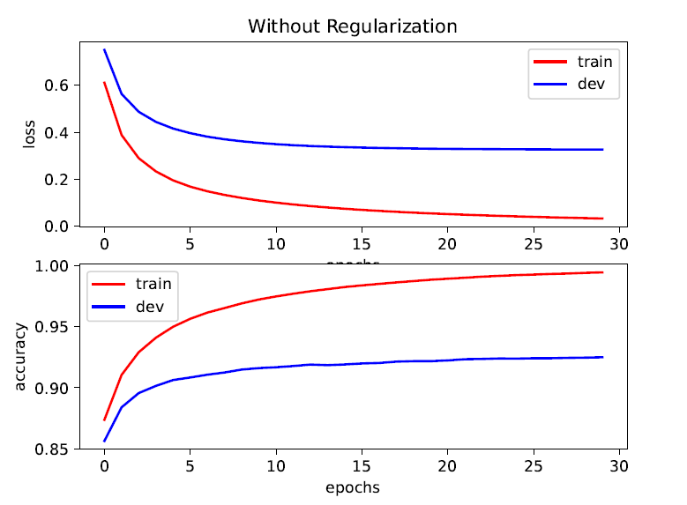

**Figure: 1**

**1.2: Answer: Regularized Model**

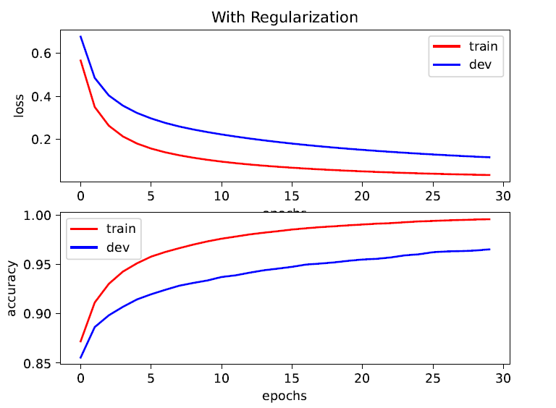

**Figure: 2**

**Note:** These models attained the same level of accuracy on the training set which was actually almost optimal. But the gap from the training to the dev accuracy is greater in the Un-regularized baseline model. As a heuristic, this characteristic might indicate that compared to the regularized model, the baseline endured larger variance problem. Regularization did help in this case. And we expect better test accuracy on the second model (as we will see in the next sub-problem).

**1.3: Answer: Model Accuracy**

The model had the test accuracy of 0.9287 without regularization (baseline) and of 0.9676 with regularization (regularized). Regularized models often offer better generalization (apparently after some tuning), which leads to better test accuracy.

