**JASP**

*Just Another Space Pilot*

*Sound Design Document*

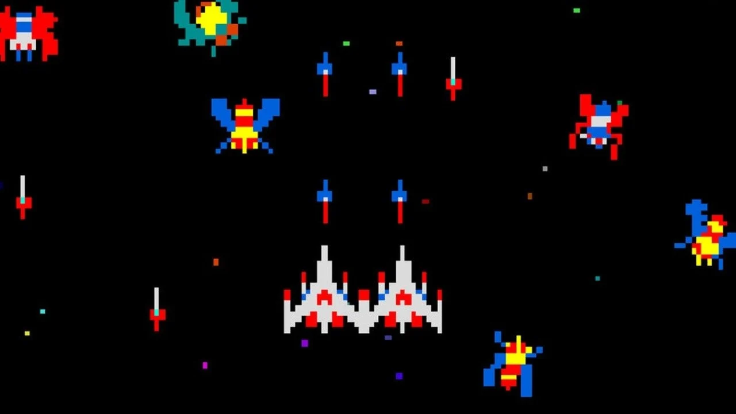

*Zachery Dyer, Blake Andrews & Bayley Fisher*

*Changelog*

*30th June    v1.0      initial document creation (GDD)*

*Table of Contents*

*GDD*

*Overview*

*Gameplay*

*Core Mechanics*

*Level Overview*

*SDD*

*SFX List*

*Description of SFX*

*Soundtrack*

*Animation*

*Character*

*Mechanics*

*Narrative*

*Sound Files*

*Risk Assessment*

*Peer Feedback*

**GDD**

**Overview**

|  |  |
| --- | --- |
| Genre | Arcade / Shooter / Simulator |
| Platform | PC, Mac, PS3 |
| Point of View | Third Person |
| Theme / Mood | Sci-Fi, Epic, Futuristic, Heroic |
| Target Audience | Fans of intense and fast paced arcade shooters that progressively get harder relatively quickly |

**Gameplay**

‘*JASP* ‘ has the player put into the majestic void of space with only their Starship and blasters in a wave-like space shooter, trying to fight off enemy attack ships that are trying to hinder and destroy the player.

**Core Mechanics**

At its heart, JASP is heavily inspired by the likes of Space Invaders and Galaga, but put into a 3D environment with complimentary colours of blue and orange to highlight the distinction between the world, the player and its enemies.

The game consists of an infinitely growing wave system that makes the game progressively get harder as the player tries to survive as long as possible against the enemy ships and asteroids.

**Player Ship**

The main ship is given full control to the player via omnidirectional, real world inspired ship controls. While not entirely accurate, it will give the player a feeling like they’re in the black abyss of space.

The player ship features a health bar, blaster heat, speed drive and a space rader in the UI in which the player must manage.

**Health Bar** is the player's overall health, which will be used to visually display the damage the enemy has done to the player.

**Blaster Heat** is a cooldown system that stops the player from spamming the blaster - doing so will lockout the player from shooting for an extended period of time.

**Speed Boost** displays the extra speed the player can access to propel themselves faster and further in quick succession, but will need time to cool down to reuse, to deter the player from constantly using it.

**Radar** displays all the current enemies in the general vicinity of the player - however, asteroids do not appear here so the player must remain vigilant.

**Asteroids**

Asteroids try to hinder the player by randomly flying in straight lines towards the player's general direction at different speeds. Colliding with the player will result in Game Over.

**Enemy Ships**

Enemy ships have the distinction between three main attributes: Health, Speed & Damage, each identifiable by the ship's design, and by what wave the player is currently on.

While enemies spawn, their rotation is randomised to give a better feel for open space gameplay. This helps solidify to the player that an “up” or “down” is not important in this setting.

**Level Overview**

*JASP* pits the player against progressively harder and more enemies as the player survives more and more rounds of *JASP*. When the player starts, they find themselves in an open environment that is filled with the void of space, stars, and asteroids… ASTEROIDS? The player will be forced to manoeuvre around these obstacles, and soon have to fend off against enemy starships - blowing them up!

Sound Files

|  |  |  |  |  |  |  |
| --- | --- | --- | --- | --- | --- | --- |
| **Sound** | **Filename** | **Loop** | **Variations** | **Notes** | **Status** | **Priority** |
| Star Ship Fly | ss_fly_01 | Yes | 3 | Played when player is at moderate speed | Not Started | High |