1. **Compose a list of responsibilities you will have to carry out as members of the BA team specific to this project**

* Had to do some researching on the project.
* Clarify not part of the project scope.
* Solve project objectives
* Complete tasks in areas of expertise
* Deliver project responsibilities within deadlines
* Communicate with project lead on roadblocks
* Document progress, setbacks, and new processes

1. **Formulate the key tasks which will be carried out in each stage of SDLC and justify the importance of each.**

* Ideation
* Requirements
* Design
* Development/implementation
* Testing
* Deployment
* Maintainance

1. **Justify which software development methodology will be more appropriate to be used.**

* Agile development methodology will be more approptiate to be used.Teams use the agile development methodology to minimize risk such as bugs , cost overruns and changing requirements when adding new functionality.In all agile methods , teams develop the software in iterations that contain mini-increments of the new fuctionality.There are many different forms of the agile development method , including scrum , crystal , extreme programming and feature-driven development.

1. **List down 3 requirement gathering techniques which will be more appropriate for the given system and elaborate how each technique will be implemented.**

* One-on-One Interviews

One-on-one interviews are the most common technique for gathering requirements, as well as one of the primary sources of requirements. To help get the most out of an interview, they should be well thought out and prepared before sitting with the interviewee. The analyst should identify stakeholders to be interviewed. These can be users who interact with the current or new system, management, project financers or anyone else that would be involved in the system. When preparing an interview is it important to ask open-ended questions, as well as closed-ended questions. Open-ended questions generally help in obtaining valuable information, based on various individuals and the way the different way they interact with, or view, the system.

* Questionnaires/Surveys:

Questionnaires, or surveys, allow an analyst to collect information from many people in relatively short amount of time. This is especially helpful when stakeholders are spread out geographically, or there are dozen to hundreds of respondents whose input will be needed to help establish system requirements.

* *User Observation:

The direct approaches of interviewing and questionnaires provide valuable user feedback based on the questions asked of them; however, there are times when direct observation may be better suited in requirement gathering. To get a better understanding of a user in their in current work environment, the analyst may observe the user themselves. User observation is helpful in assisting the analyst by getting a full grasp of how the user interacts with the system, firsthand.

**05) Compose a list of the functional and non-functional requirements and elaborate more on the selected nonfunctional requirements particular to the given system.**

Functional Requirements:

**1) Registration Process of SRS (Software Requirements Specification)**

**●** Adding Patients: The Hospital Management enables the staff in the front desk to include new patients to the system.

**2) Report Generation of SRS:**

● Information of the Patient: The Hospital Management System generates a report on every patient regarding various information like patients’ name, Phone number, bed number, the doctor's name whom its assigns, ward name, and more.

● Availability of the Bed: The Hospital Management system also helps in generating reports on the availability of the bed regarding the information like bed number unoccupied or occupied, ward name, and more.

**3) Database of SRS:**

● Mandatory Patient Information: Every patient has some necessary data like phone number, their first and last name, personal health number, postal code, country, address, city, 'patient's ID number, etc.

● Updating information of the Patient: The hospital management system enables users to update the information of the patient as described in the mandatory information included.

**Non- functional requirements:**

**1) Reliability:**

● Availability: The system is available all the time.

**2) Maintainability:**

● Back-Up: The system offers the efficiency for data backup.

● Errors: The system will track every mistake as well as keep a log of it.

**3) Performance:**

● Response Time: The system provides acknowledgment in just one second once the 'patient's information is checked.

● Capacity: The system needs to support at least 1000 people at once.

6)

* In this management system patient’s info is being recorded. And it’s been maintained in a database.
* Available Appointments, Scheduled Appointments and Selected ones are store in appointments database.
* Patient info with appointments, updated patient info & newly patient info stored in patients database.
* Prepare reports get data from patients database and appointments database & it provides appointment and patient report for Doctor.
* Billing and patient connected through appointments database.
* Perform billing provides patient payment info to billing and, billing will return payment confirmation after the payment completely done.
* Payment info & patient bill info done through perform billing.

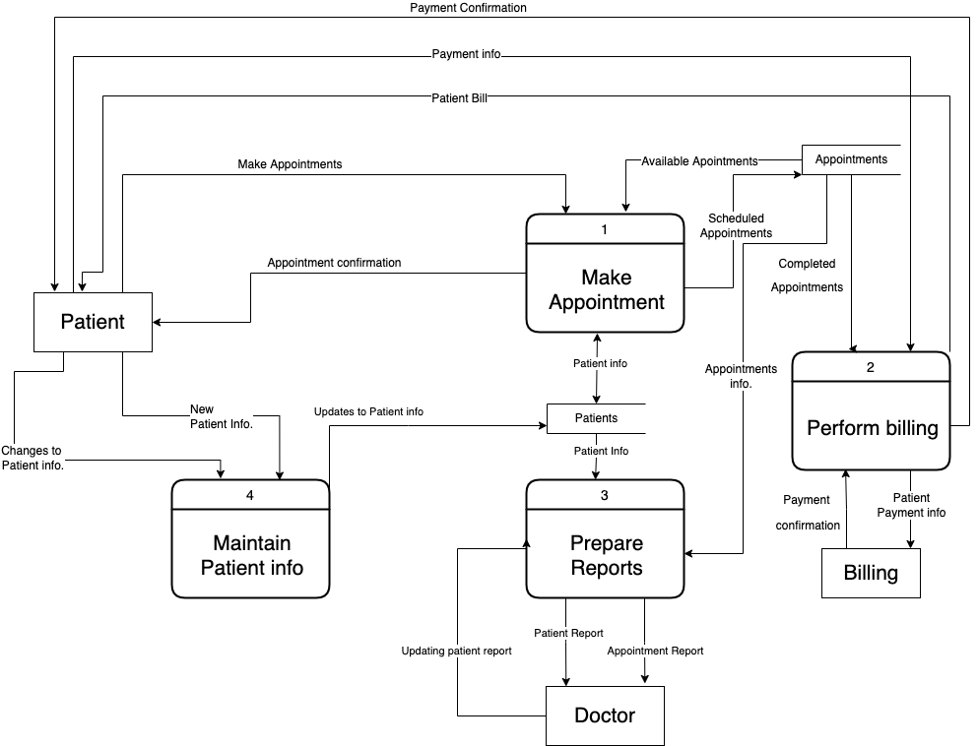

**7. Develop recommendations to improve the project initiation phase and requirement elicitation process and justify how that will improve the life cycle of the project**

+ Initiation Phase

*Know Why The Project Exists

*Define Major Stakeholders Early

*Document Stakeholder Commitments

*Complete The Project Management Initiation Phase Checklist

+ Requirement Elicitation Process

* Brainstorming Sessions

* Facilitated Application Specification Technique

* Quality Function Deployment

* Use Case Approach

**8. Recognize any risks associated with the project (if any)**

Because we are storing patients personal data they can be stolen by 3rd parties and use for criminal activities.