Tournament Manager
Presentation Report
A Java desktop application for organizing Swiss and knockout tournaments.

1. Project Overview
Tournament Manager is a Java desktop application for organizing and running small to medium tournament events. The application supports two common competition formats: Swiss tournaments and single-elimination knockout tournaments.
The main goal of the project is to reduce manual tournament administration. Instead of preparing pairings, tracking results, calculating rankings, and saving tournament progress by hand, the application provides a structured workflow for creating tournaments, selecting players, generating rounds, entering match scores, and reviewing standings.
The project also demonstrates a complete desktop application structure in Java: a domain model, tournament algorithms, a service layer, JSON persistence, automated tests, and a JavaFX graphical interface.

2. Main Features
- Creating tournaments with a custom name and selected tournament type.
- Managing a reusable global player directory.
- Adding existing players to new tournaments.
- Supporting Swiss and knockout tournament formats.
- Automatically generating tournament rounds.
- Handling BYE matches when the number of players is odd.
- Entering and editing match results.
- Resolving knockout draws with a tie-break winner.
- Calculating rankings from match results.
- Simulating a current round or a whole tournament.
- Saving and loading tournaments using JSON files.
These features make the application useful both as a working tournament tool and as a technical demonstration of object-oriented design.

3. Architecture
The project is divided into focused packages:
Package | Responsibility
model | Core domain objects such as Tournament, Round, Match, and Player.
pairing | Pairing algorithms for Swiss and knockout tournaments.
service | Business operations for creating tournaments, starting them, generating rounds, and simulating results.
persistence | JSON serialization and file storage.
ui | JavaFX application, controllers, view models, and UI-facing services.
controller | Legacy console interface.
This separation keeps tournament rules independent from the user interface. The JavaFX controllers do not directly implement pairing or ranking logic. Instead, they use TournamentApplicationService, which coordinates the domain services, repositories, player directory, and view models.
This design makes the project easier to test because the core logic can be verified without launching the graphical interface.

4. Tournament Logic

Swiss Format
In the Swiss format, players remain in the tournament across multiple rounds. The pairing strategy sorts players by their current score and tries to match players with similar results. It also avoids repeated pairings when possible.
Scoring rules:
- Win: 2 points.
- Draw: 1 point.
- Loss: 0 points.
- BYE: 2 points.
When the player count is odd, one player receives a BYE. The strategy prefers a lower-ranked player who has not already received one.

Knockout Format
In the knockout format, players are eliminated after losing. The first round is shuffled, and later rounds are generated from winners of the previous round.
The strategy calculates the next power of two to determine whether BYE matches are needed. This allows tournaments with non-standard player counts to still progress through a valid elimination bracket.
Knockout matches cannot advance on unresolved draws. If a match is tied, the application requires a tie-break winner.

Rankings
Rankings are calculated from played matches. The ranking table includes:
- Place.
- Player name.
- Points.
- Wins.
- Draws.
- Losses.
- Played matches.
- BYE count.
Players are sorted by points first, then by wins, and then by name for deterministic ordering.

5. User Interface
The JavaFX interface provides a visual workflow for tournament management. Users can create tournaments, select players, generate rounds, enter match results, and inspect rankings from the main application window.

Player Management
The player directory allows users to create and reuse players across tournaments.

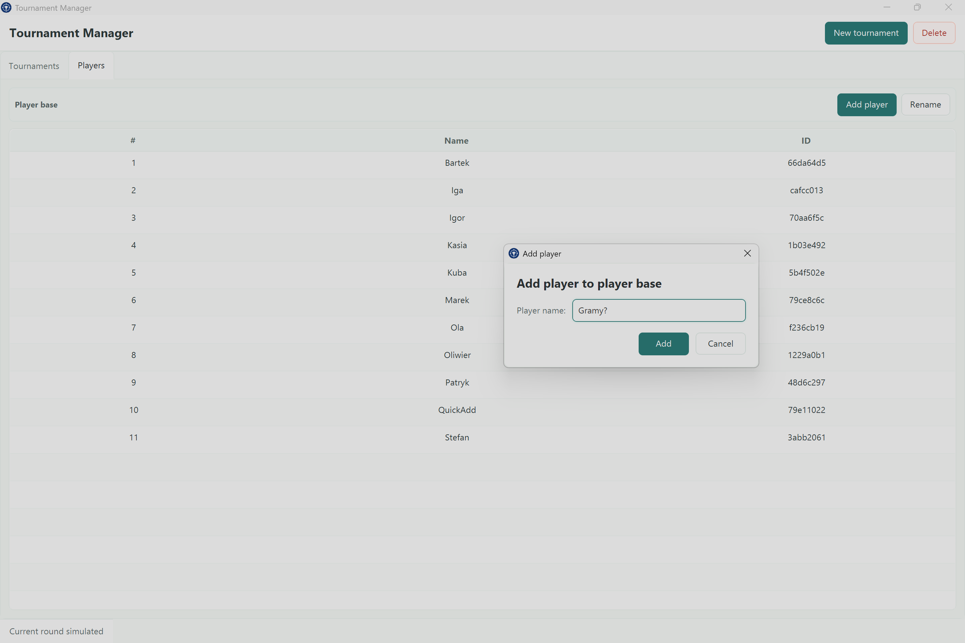
Adding a player
The player selection view helps build tournament rosters from existing players.
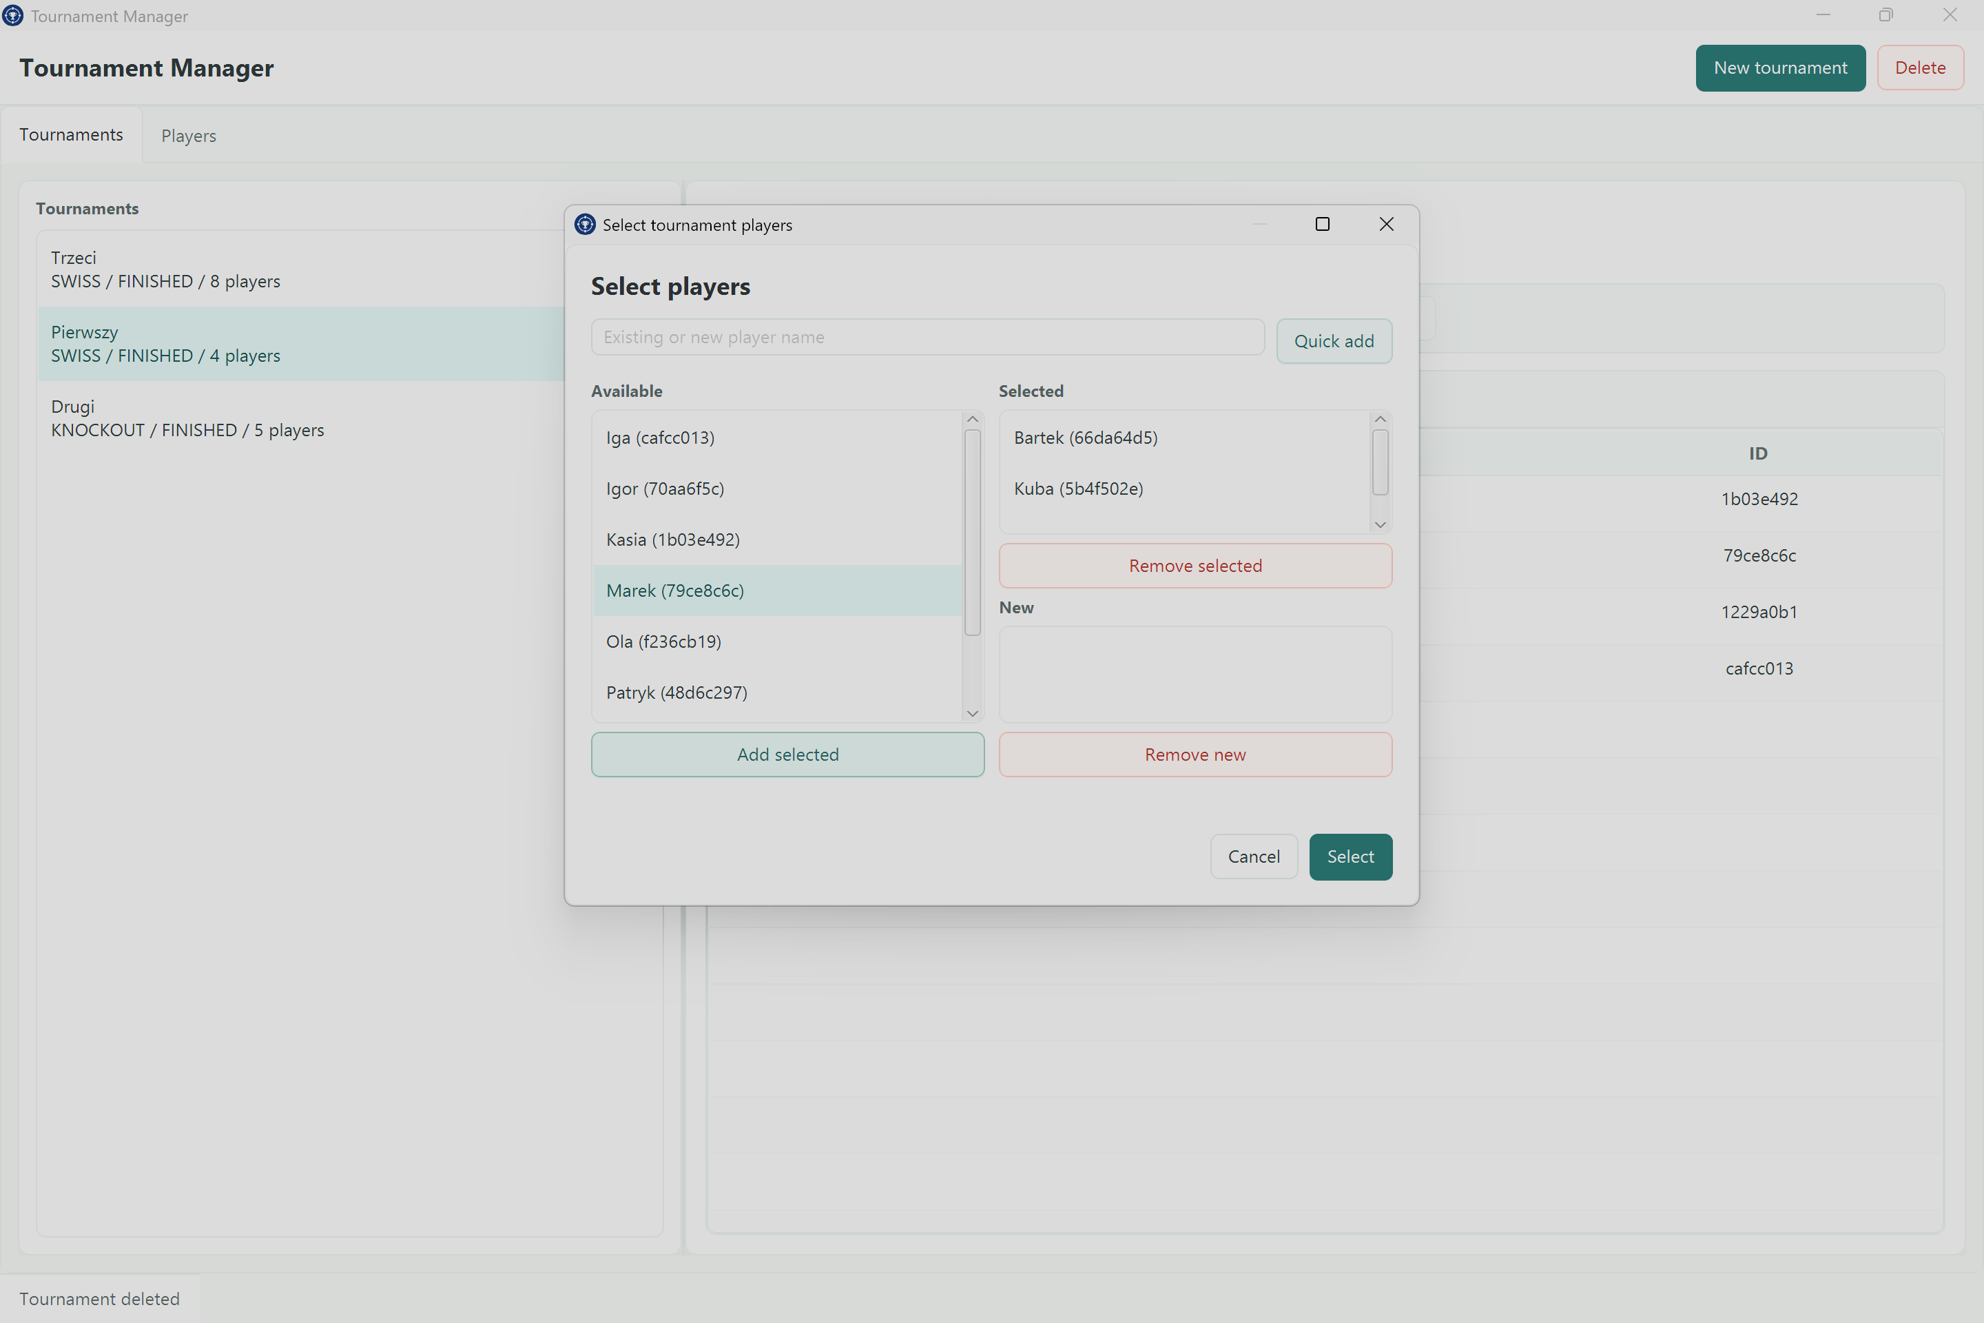
Player selection

Swiss Rankings
Swiss tournaments emphasize standings and accumulated results across rounds. The ranking table gives an immediate overview of tournament progress.
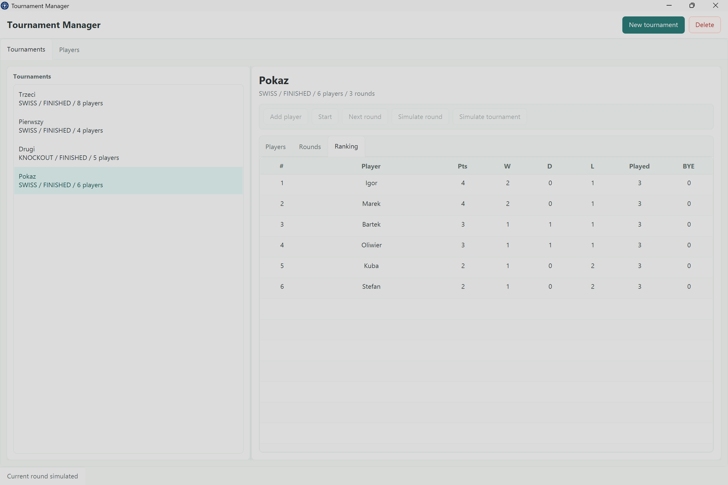
Swiss ranking

Knockout Rounds
Knockout tournaments focus on round progression and elimination. Winners advance into later rounds until one player remains.
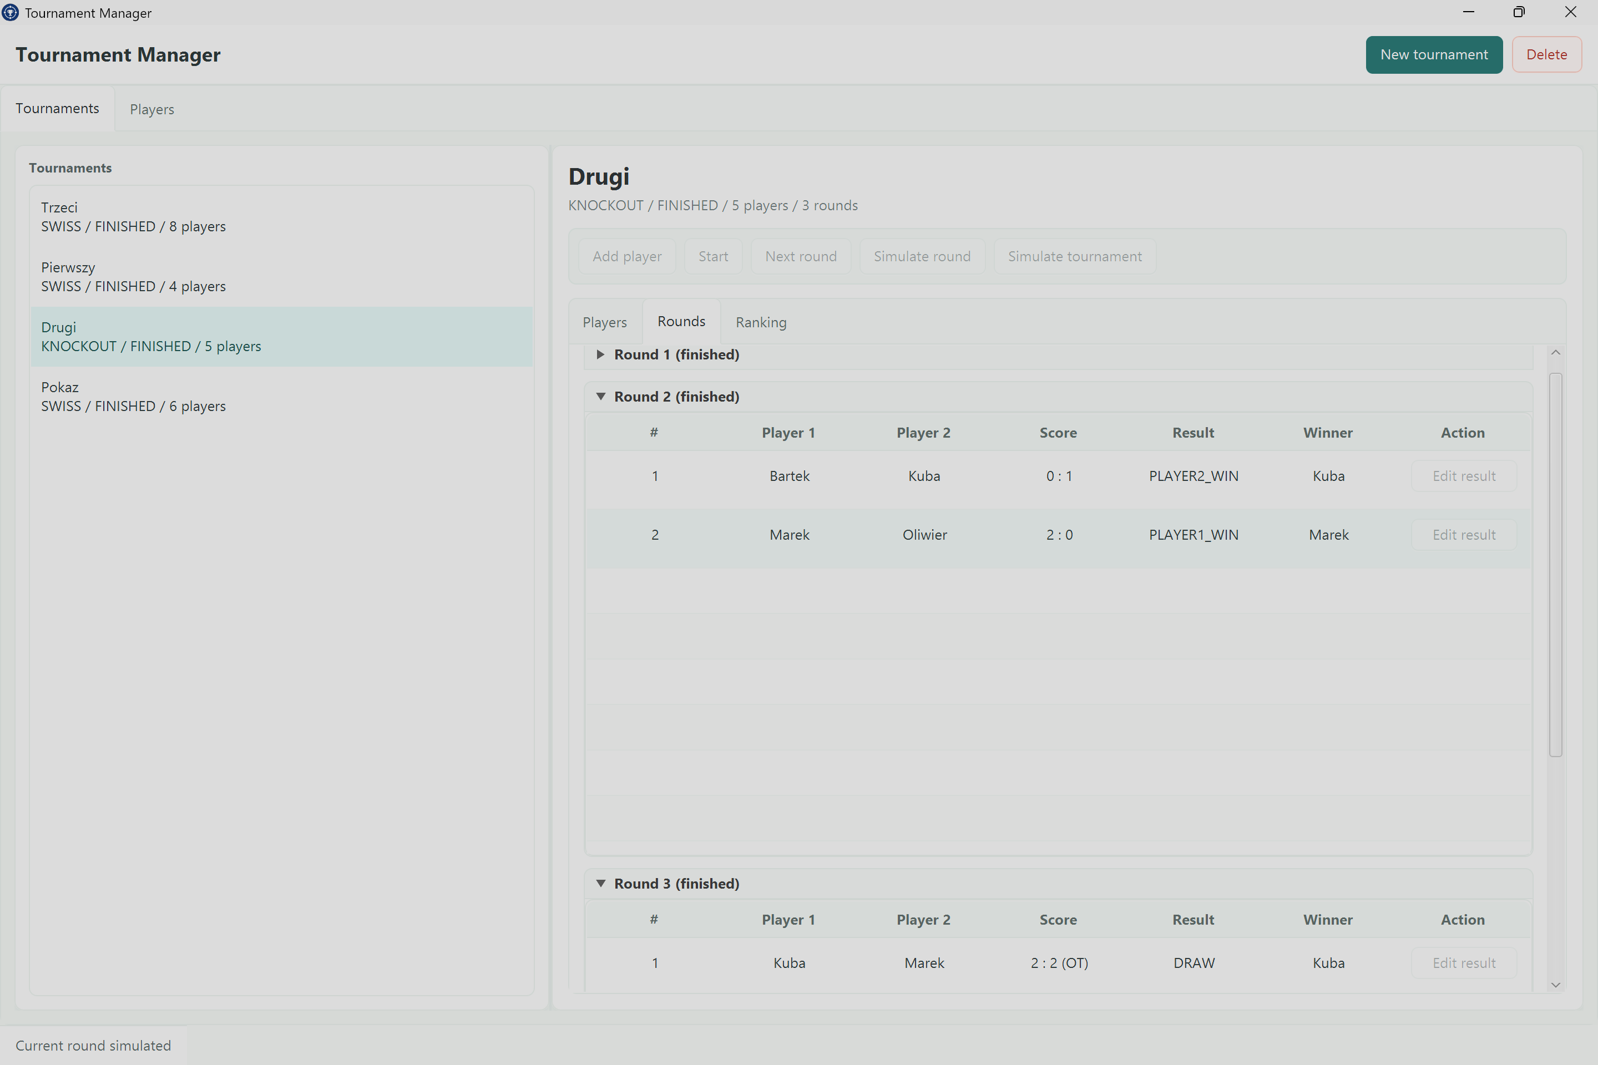
Knockout rounds

6. Persistence
Tournament data is saved as JSON in the data/tournaments directory. The persisted data contains the essential state needed to restore tournaments:
- Tournament identifiers.
- Tournament names.
- Tournament type and lifecycle state.
- Player rosters.
- Rounds and match results.
- Tie-break selections.
Derived values, such as formatted scores and ranking rows, are recalculated when the application loads data. This keeps saved files smaller and reduces the risk of stale calculated data.
The application also stores a global player directory, making it possible to reuse players across multiple tournaments.

7. Testing And Quality
The project includes automated tests for the most important behavior:
- Domain model validation.
- Match result handling.
- Round completion.
- Tournament lifecycle rules.
- Swiss pairing behavior.
- Knockout pairing behavior.
- Service layer operations.
- JSON persistence.
- Player directory persistence.
- UI application service behavior.
This test coverage is important because tournament software depends on consistent rules. Pairing generation, scoring, and persistence bugs can directly affect tournament results, so the tests focus on the logic that has the highest impact.

8. Challenges And Design Decisions
One important design decision was separating tournament logic from the JavaFX interface. The UI presents and triggers actions, but the rules live in domain and service classes. This avoids mixing visual code with business rules.
Another decision was to use a strategy-based design for tournament formats. TournamentType creates the appropriate pairing strategy, so Swiss and knockout tournaments can share the same high-level workflow while using different round generation logic.
Persistence was designed to store only essential tournament state. Rankings and view-specific values are recalculated from the stored rounds and matches. This keeps the data model cleaner and makes saved files easier to maintain.
Swiss pairing was also a meaningful challenge. The strategy must balance score-based pairings with repeated-opponent avoidance. The current implementation uses a practical deterministic approach that works well for the project scope.

9. Future Improvements
Possible improvements include:
- Exporting tournament summaries to PDF or CSV.
- Adding more advanced tie-break rules for Swiss rankings.
- Supporting configurable scoring systems.
- Displaying a full visual knockout bracket.
- Adding search and filters for larger player directories.
- Supporting multiple saved player groups or clubs.
- Adding validation summaries before starting a tournament.
- Improving statistics with opponent score and Buchholz-style tie-breakers.
These additions would make the application more useful for larger or more formal events.

10. Conclusion
Tournament Manager demonstrates a complete Java desktop application built around a clear domain problem. It combines object-oriented modeling, tournament pairing algorithms, persistence, tests, and a JavaFX interface.
The project is suitable for presentation because it shows both user-facing functionality and technical structure. From a user perspective, it simplifies tournament organization. From a development perspective, it demonstrates how a real application can separate domain logic, persistence, and UI concerns while remaining testable and maintainable.

