Project Name: Mercedes-Benz

Contents

Bug ID:01 2

Bug ID:02 2

Bug ID:03 3

<https://github.com/ajaytechfour/Test-Cases/blob/Assurant-MB/Mercedes-benz/phpUpgrade.xlsx>

https://github.com/ajaytechfour/Test-Cases/blob/Assurant-MB/Mercedes-benz/Attachment_Mercedese_Benz.docx

Bug ID:01  


Bug ID:02

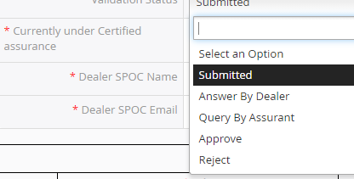

Bug ID:03

