**AGREEMENT**

Total record reflecting the value of ZERO

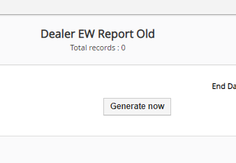

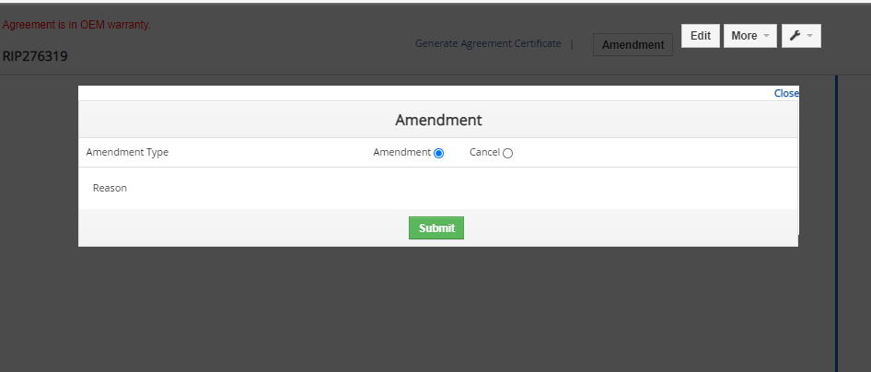

2.After clicking on Document, blank page, and jumps direct to the home page after clicking on back.

3.page is getting blank for adding part, labour, Miscellanious, Customer voice and symptoms,documents, and comment, and jumps direct to the home page after clicking on back.

**Claim**

1.These links are not working

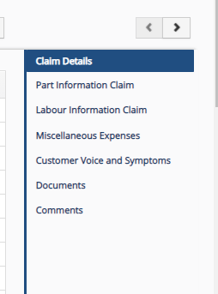

**EASY CARE SALES**

1.Not able to add documents for REC sales.

**Easy Care Claim**

**Physical Document Tracking(Incorrect date is accepting)**

