Bug Report

1.Logo name is not matching

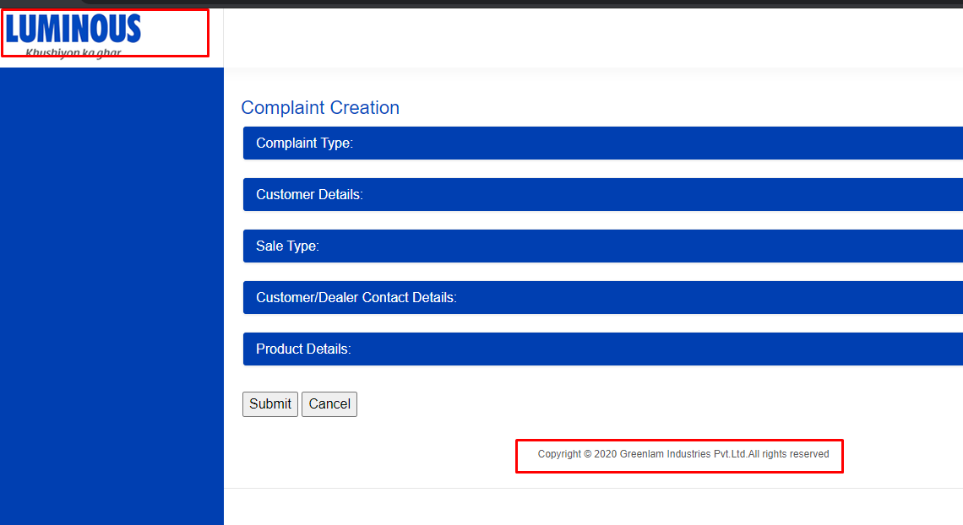

2.Submit Button can be Green and cancel button can be in Red

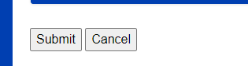

3.the default item is not getting displayed on drop down when the user first visits the page.

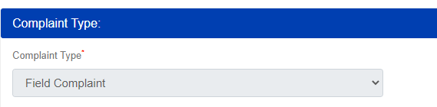

4.Spelling mistake of **Code** in alert message

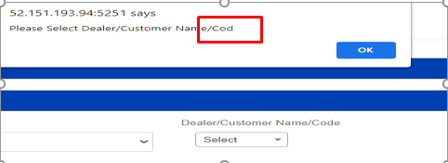

5.the cursor should be default into the **Dealer/Customer Name/Code** search bar Click.

6. on the creating new customer page fields should be in the **Sequential manner**(Country, State, City)

6.Mobile Number Text Field should accept only numeric value

7.City - Text field should accept alphabet values.

8.Country should Auto select based on the state

9.Pin/Zip code Text field should accepts only numeric value. validations required for alphabets and only accepts 6 digits

##### 10.Spelling mistake of **Country** in alert message and **Create New Customer** page

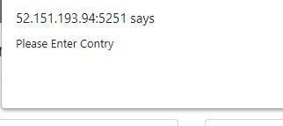

2.in case of Customer Mobile, Address1, Address2 fields require editable.

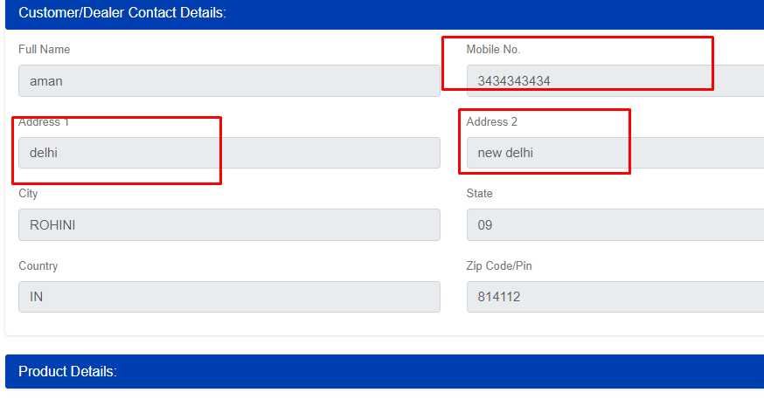

Dealer ID/Name field should be disable when **customer Type** is **Customer**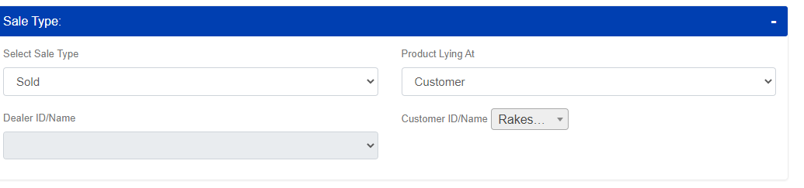

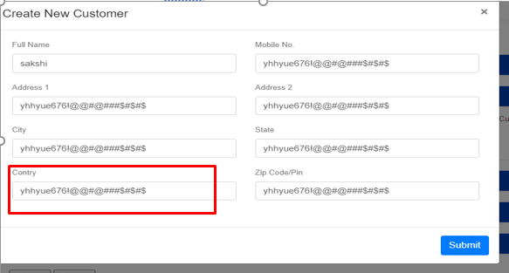

11.Space between words in Symptom dropdown.

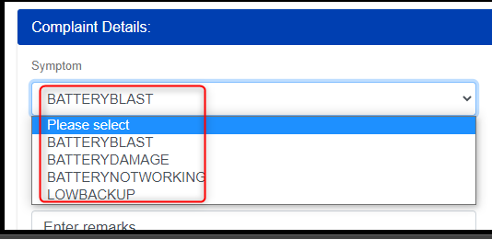

12.Overlapping issue and also System is allowing to update Complaint

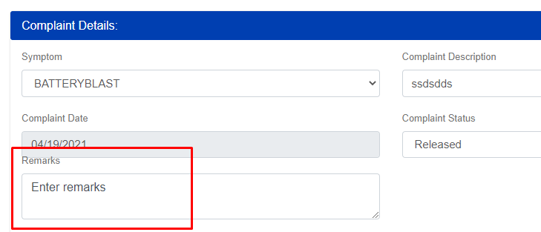

13. User is able to select and update complaint by selecting date less than complaint creation date.

