**SP Sales:**

1. UI Issue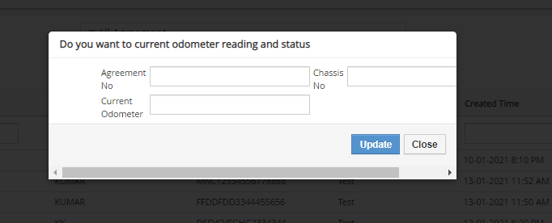

**1.**validation messages should be **.(Current odometer reading should be greater than** SP End KM)

**SP-Service Request**

2. Backed Punchig is not available

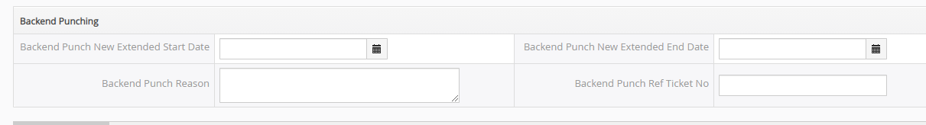

**Part Code and HSN/Code** Alphanumeric Caps(Validation)

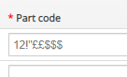

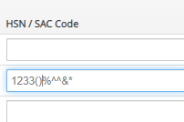

3.After decreasing the Qty Per Occurrence then Actual Cost Including GST is gettinh zero. It should be freeze.(fIXED)

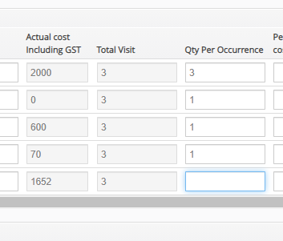

4.Qty per Occurrence should not ask to fill the data if user is not selecting any part.

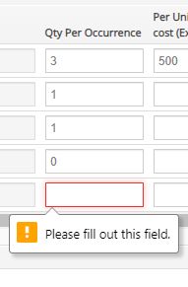

Field name **Actual Cost Including Tax** to be changed to **(Actual cost Including GST)** should be placed next to HSN/SAC. Should be freezed it should not change

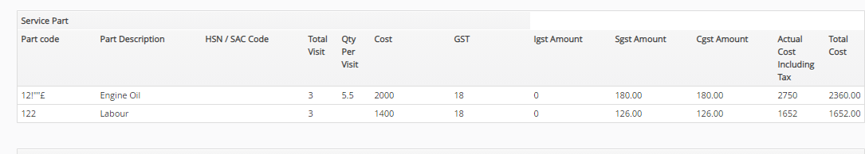

Dealer is able to claim without adding the labour cost.

Calculation part wrong(Price should not calculate if part is uncheck).

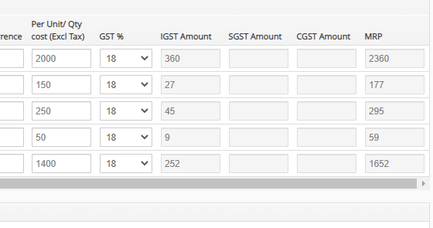

Date of job card should not be the back date of previous visit date. And all the form is editable.

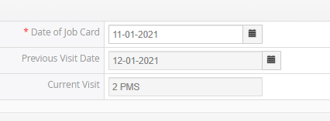

After saving the claim Service parts grid is not proper as per the requirement and aslo all the parts are visible which are not taken by the users.

