BOSCH

Table of Contents

Bug ID : 01 3

Bug ID : 02 4

Bug ID : 03 4

Bug ID : 04 6

Bug ID : 05 6

Bug ID : 06 7

Bug ID : 01  
There is no options for selecting the service package Plan for selected OEM Brand(HYUNDAI, HONDA, CHEVROLET, MAHINDRA, FIAT, NISSAN, SKODA, TOYOTA, FORD, VOLKSWAGEN, RENAULT, MARUTU/Nexa, MITSUBISHI)

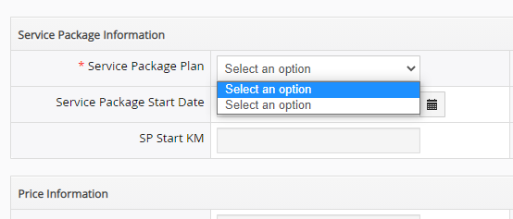

Bug ID : 02. Dealer is able to verify the invalid Vehicle First Registration date that is even after entering date of more than 12 years system is showing the plans.

there should be a proper and specific validation message for the same.

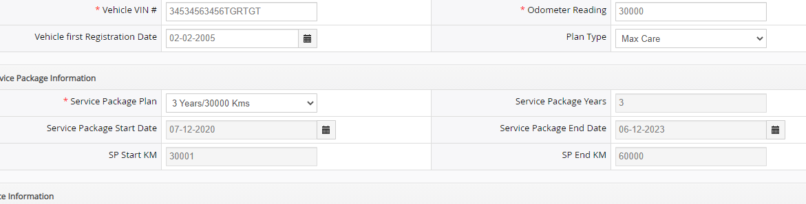  
  
  
Bug ID : 04  
Vehicle first Registration Date & Plan Type should marked with Asterisk symbol.

  
  
  
Bug ID : 05

### Amendment button is not available.

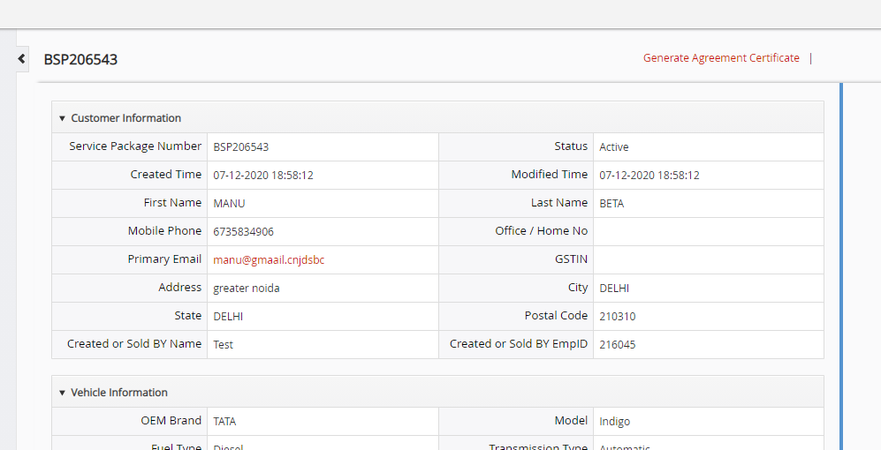

Bug ID : 06

Incorrect data is showing.

