1.There should be **Current Visit Date**

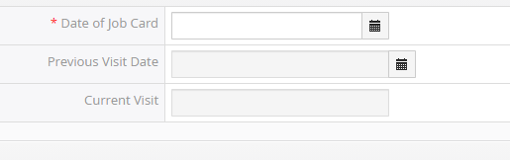

2.There should be validation for 15 days.



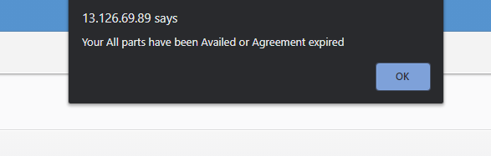

2. service part line items gets hidden after saving the claim form with blank data.

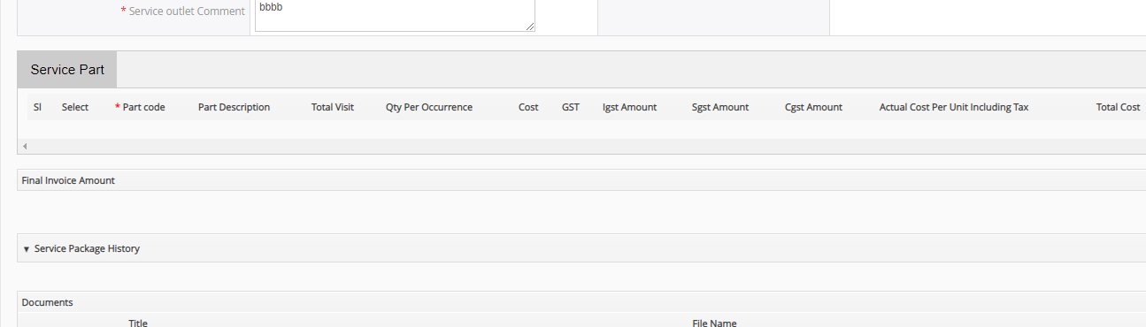

3.Field name need to be change.



4.

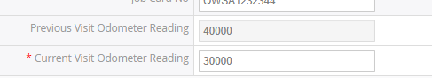

5.Employee code is not getting auto populate after saving the claim

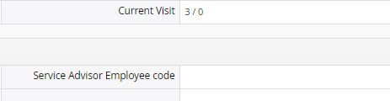

6.Plan Type is not getting auto populated after saving the claim.



7.After First Visit the claim service part line items are not displayed.

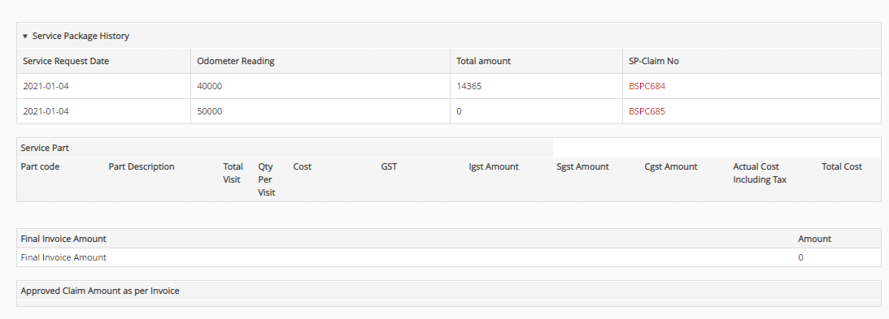

8.Total amount is showing ZERO when customer going for 2nd or 3rd time for claim.

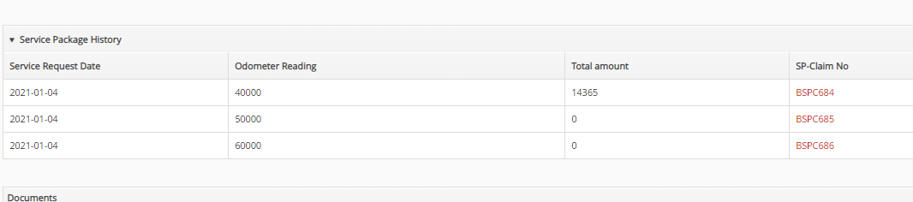

9.dealer is able to save the claim without entering the part code.

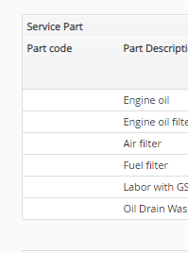

10.User is able to visit multiple times.

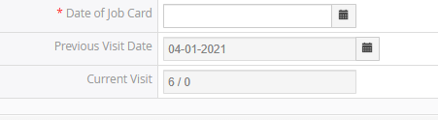

11.Incorrect data is auto fetched.

