**Bug Report of Re-Purchase**

1.Current details is not auto fetched.

2.When dealer is punching REC for the first time on the agreement detail page, Vehicle Chasis no coming with REC number.



1.There should be validation for current odometer field

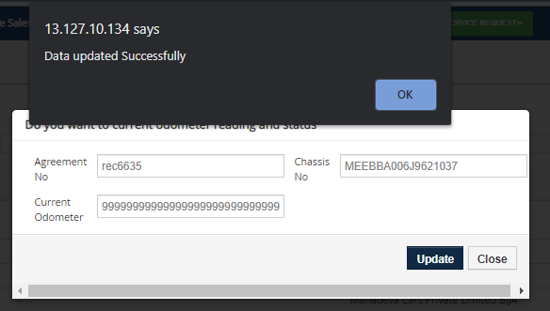

2. Document is not visible in the document details list in the agreement details page



3. user is not able to enter number 9 in Current odometer reading field

