BUG REPORT

1.Part Name is reflecting wrong as per the master shared with me for **“Wheel Alignment &amp; Bal.”** (In master “Wheel Alignment & Bal”.)



1.grand total value of Service labour (Which is untick) is reflecting by the time of selecting the agreement number

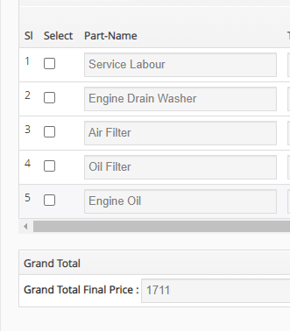

2.when user is not selecting any service part still system is asking for to fill the Part no.

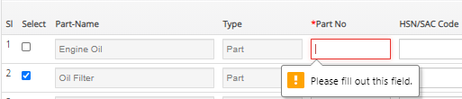

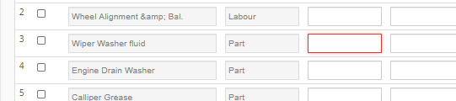

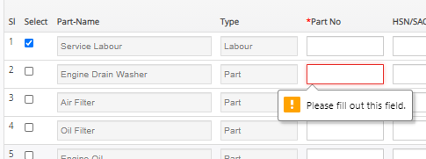

3.Field number should be **“Unit Price”** as per the feedback

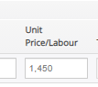

4.Total amount is coming wrong in the **Service package history**

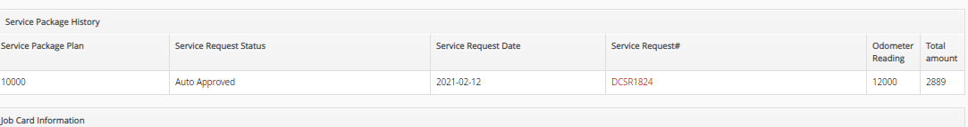

5.Unit cost to be changed as **“Unit price”** and Total Cost to be changed as **“MRP**” in the **service Request form**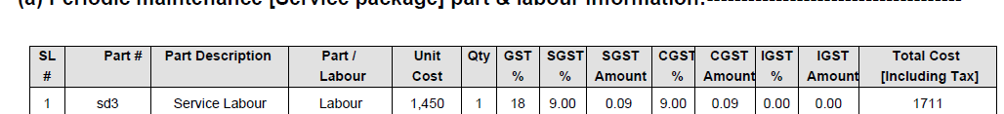

6.Wheel alignment is over lamping with the filed boundary in the **Service request form**

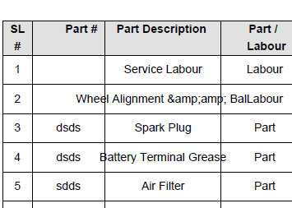

7.In **DC Claim Periodic maintenance** **“MRP”** to be change as **“Unit Price”**

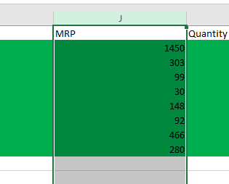

8.in Admin **side NC Claim periodic Maintenance** is not available.

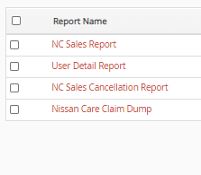

-----Part Name is reflecting wrong as per the master shared with me for **“Wheel Alignment &amp; Bal.”** (In master “Wheel Alignment & Bal”.)--------

