MegaMarket ? Playwright E2E Test Report
Generated: 2025-12-30T14:35:02

Run Summary
Start time: 2025-12-30T07:33:05.628Z
Duration (ms): 39750.842000000004
Total tests: 16
Failed: 0
Skipped: 0
Flaky: 0

Must-have Coverage (Automated)
- AUTH-001 ? Login (Admin) success
- AUTH-002 ? Login invalid credentials
- AUTH-003 ? Logout
- AUTHZ-001 ? Unauthenticated visit to / redirects to /login
- AUTHZ-002 ? Unauthenticated direct access to protected route redirects to /login
- AUTHZ-003 ? Role dashboards route correctly
- NAV-001 ? Profile page loads after login
- SMOKE-001 ? Products page loads and exposes filters
- SMOKE-002 ? Sale page renders POS shell
- SMOKE-003 ? Invoice page loads (cashier)
- SMOKE-004 ? Loyalty dashboard loads
- RES-001 ? API unavailable shows friendly error

Test Cases (Details)

AUTH-001 ? Login (Admin) success
Preconditions: API/UI running; admin exists (admin / Password123!).
Steps:
- Open /login
- Enter admin credentials
- Click Login
Expected: Redirects to /admin/dashboard; dashboard heading visible.
Automation: playwright/tests/dashboard.spec.ts

AUTH-002 ? Login invalid credentials
Preconditions: API/UI running.
Steps:
- Open /login
- Enter invalid username/password
- Click Login
Expected: Stays on /login and shows invalid credentials error.
Automation: playwright/tests/login.spec.ts

AUTH-003 ? Logout
Preconditions: Logged in.
Steps:
- Click Logout
Expected: Redirects to /login; authToken removed from localStorage.
Automation: playwright/tests/logout.spec.ts

AUTHZ-001 ? Unauthenticated visit to / redirects to /login
Preconditions: Not logged in.
Steps:
- Open /
Expected: Redirects to /login.
Automation: playwright/tests/access-control.spec.ts

AUTHZ-002 ? Unauthenticated direct access to protected route redirects to /login
Preconditions: Not logged in.
Steps:
- Open /admin/dashboard
Expected: Redirects to /login.
Automation: playwright/tests/access-control.spec.ts

AUTHZ-003 ? Role dashboards route correctly
Preconditions: Seed users exist for manager/cashier/warehouse.
Steps:
- Login as each role
Expected: Redirects to role dashboard and shows correct heading.
Automation: playwright/tests/role-routing.spec.ts

NAV-001 ? Profile page loads after login
Preconditions: Logged in.
Steps:
- Click My Profile
Expected: Navigates to /profile and shows My Profile heading.
Automation: playwright/tests/profile.spec.ts

SMOKE-001 ? Products page loads and exposes filters
Preconditions: Logged in.
Steps:
- Navigate to /products
Expected: Product Management heading, search box, and Add Product button visible.
Automation: playwright/tests/products.spec.ts

SMOKE-002 ? Sale page renders POS shell
Preconditions: Logged in.
Steps:
- Navigate to /sale
Expected: Point Of Sale heading visible.
Automation: playwright/tests/sale.spec.ts

SMOKE-003 ? Invoice page loads (cashier)
Preconditions: Logged in as cashier.
Steps:
- Navigate to /invoice
Expected: Invoice Management heading and search buttons visible.
Automation: playwright/tests/invoice.spec.ts

SMOKE-004 ? Loyalty dashboard loads
Preconditions: Logged in.
Steps:
- Navigate to /loyalty
Expected: Loyalty Dashboard heading visible.
Automation: playwright/tests/loyalty.spec.ts

RES-001 ? API unavailable shows friendly error
Preconditions: UI started with bad ApiBaseUrl.
Steps:
- Open /login
- Attempt login
Expected: Displays connection/refused error message.
Automation: playwright/tests/api-unavailable.spec.ts

Automated Test Results

Attached Artifacts
- Login page screenshot: e2e-report/artifacts/login-page.png (OK)
- Products page screenshot: e2e-report/artifacts/products-page.png (OK)
- Admin dashboard screenshot: e2e-report/artifacts/admin-dashboard.png (OK)
- Admin dashboard video (webm): e2e-report/artifacts/admin-dashboard.webm (OK)

Screenshots
Login page screenshot
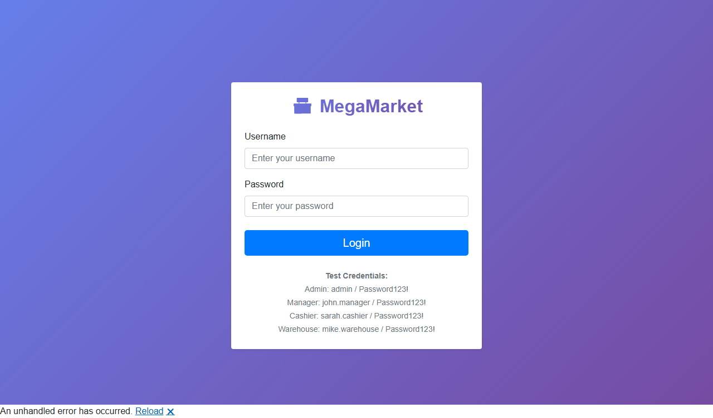
Products page screenshot
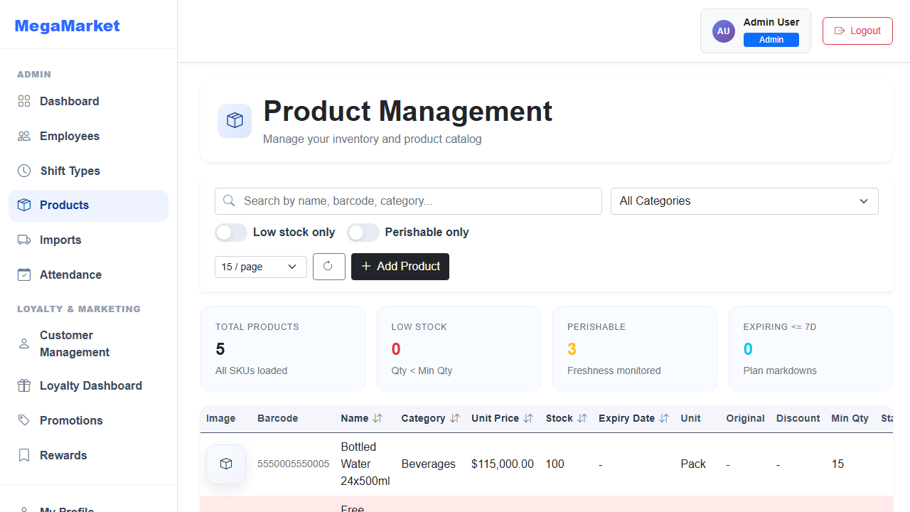
Admin dashboard screenshot
