**Wagon controller**

# Hardware

­­This small device can be used in two different modes:

1. As a replacement of the PCF8575 16 Bit I2C bus expander. In this mode, the RS485-Transceiver will not be used. The socket for this chip can be left open, R1..R6 are not needed.
2. As a node on a RS485-Network. Based on this physical layer, a ModBus-Client will be placed. ModBus is a very famous protocol, widely used in industry. Libraries for Arduino are also available. It allows a much more sophisticated control of the wagon, than a simple bus expander can provide.

The following description covers both scenarios. If all parts are placed, you can simply change the usage by changing the two jumpers JP1 and JP2. See section board for details.

## Schematic

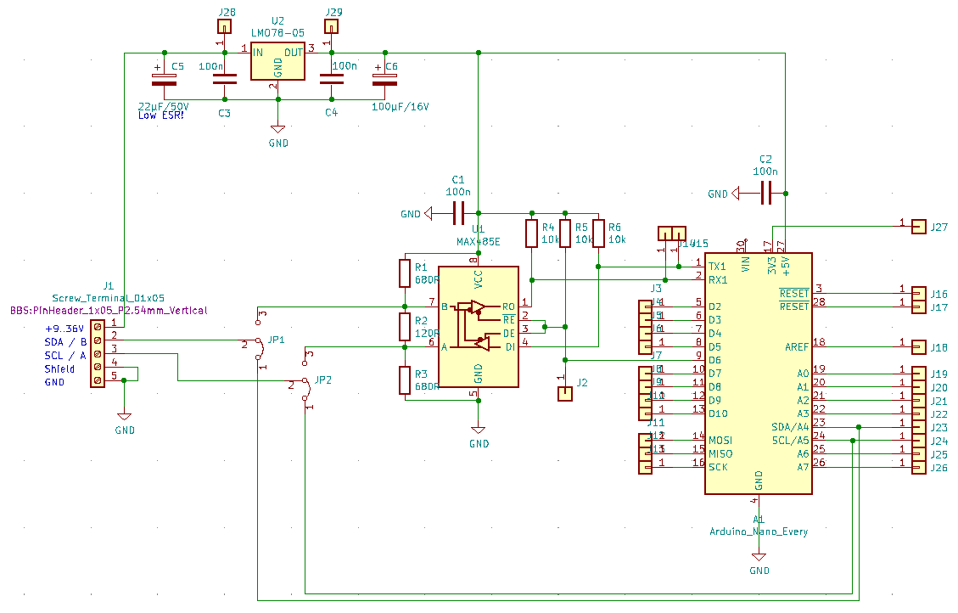

Changes to Rev.0:

* DC-DC-Converter replaced by a cheaper device with smaller footprint
* Additional holes to connect to +Ub and +5V for other equipment inside the wagon
* Add 3 Mounting holes
* Add Version number at the soldering side

## Board

To allow a small footprint, most of the parts were placed underneath the controller board. We do not use SMD packages to keep soldering simple.

The dimensions of the pcb are: 34,5 x 68,6 mm

Layout changes slightly to avoid vias. Now there are only 2 vias without a part. If you produce the pcb yourself, take care of these two vias an solder a short piece of wire on both sides to establish a connection through the hole.

If you order the pcb, the manufacturer will connect through all holes.

|  |  |
| --- | --- |
| FS1 | A Step-Down-Converter with a 5V / 500mA output and a wide input-range from 6,5V..36V. Using a DC-DC-Converter per node will eliminate noise coming along the main power supply from the loco. One power supply will fit all needs. |
| JP1, JP2 | These two jumpers connects terminal 2/3 to either the RS485 device or the SDL/SCL lines of the Controller. The jumpers must only be changed, if the firmware at the node changes. So if you do not plan to change the operation mode, you can use 2 short wires as well.  1-2 = I2C mode  2-3 = RS485 mode |
| Address | To spare I/O-pins, the address of the device must be set via source code. By doing so, any address in the range from 0x01 to 0xFF is possible.  In RS485-mode, it will be possible to change the address via ModBus protocol. |
| R1,R3 | They provide a save potential at the lines A and B, if no sender is active. These resistors are only for safe operation and must not be placed several times. Place them at the first node in the chain and only, if you are using RS485 mode. |
| R2 | Terminating resistor. Must correspond with the impedance of the wires. 120 Ohm will fit most needs.  Needed only at the beginning and the end of the bus and only, if you are using RS485 mode. |

Schematic as well as the board were made with KiCAD, with is available for free   
(see <https://www.kicad.org/> ).

## Bill of material

All parts can for this pcb can be ordered at Reichelt. See: <https://www.reichelt.de/my/1984952>   
Reichelt is a german distributor. Maybe you prefer to order at Amazon o.e.

# Wiring

We agreed to use small magnetic connectors.

## Bill of material

|  |  |  |
| --- | --- | --- |
| Nr | Source | Picture |
| 1 | [Magnetic connector](https://de.aliexpress.com/item/1005003853427502.html?spm=a2g0o.order_list.0.0.4ea75c5fqTeoqi&gatewayAdapt=glo2deu), 1 pair per wagon  These connectors allow a max. current of 2 A. If one wagon draws the full current allowed by the DC-DC-Converter (0,5 A), we are able to run 10 animations at the same time. This seems to be sufficient. |  |
| 2 | [Wires for the power lines](https://www.amazon.de/dp/B09P8PMWVZ/ref=pe_27091401_487024491_TE_item)  A closer look at the requirements for the power supply cables resulted in the above mentioned conductor diameter. With fewer wagons, the diameter can be smaller. There is a small Excel file to address this issue (🡪  Wiring.xlsx). |  |
| 3 | [Wire for Data lines](https://www.amazon.de/dp/B07NQCB92N/ref=pe_27091401_487024491_TE_item)  When used as an RS485 node, the data line must be twisted in pairs. The conductor diameter, on the other hand, is of no particular importance. |  |

These are suggestions only. The explanatory text explains only briefly how we came to the selection.

To ensure interoperability, we also need to agree on a common physical layer. This means primarily orientation and signals on each pin of the connector.

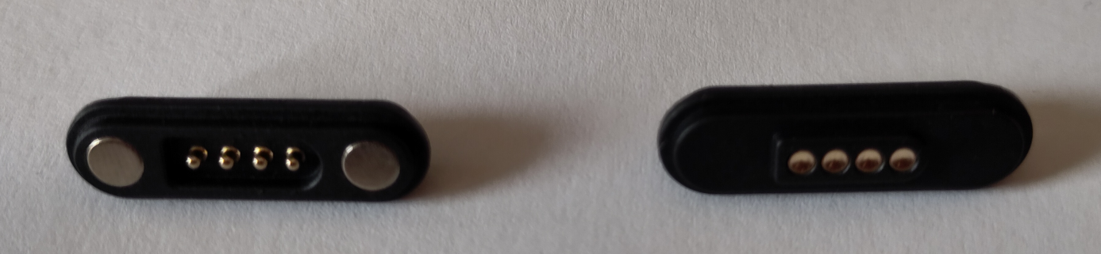

Left or Frontside

Right- od Backside

+12V | SDA | SCL | GND

+12V | SDA | SCL | GND

# Sources

PCF8575 datasheet

<https://www.ti.com/lit/gpn/PCF8575>

MCP 23016 datasheet (alternative to PCF8575, not used here)

<https://ww1.microchip.com/downloads/en/DeviceDoc/20090C.pdf>

RS485 Bus transceiver

<https://datasheets.maximintegrated.com/en/ds/MAX1487-MAX491.pdf>

Arduino Nano Every

<https://docs.arduino.cc/hardware/nano-every>