System(s) programming

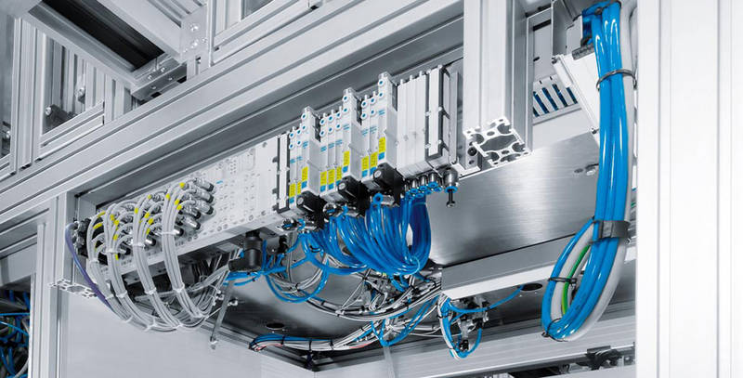
Van Gysegem Thomas
Table of contents
System(s) programming 1
Van Gysegem Thomas 1
Introduction 3
What you have to know 3
So what is “System(s) programming” ? 4
Reaction time 4
Interruption 5
Deadlock 5
Priority 6
Robot 7
Assembly line 7
Boe-bot 7
Quad-copter 8
Conclusion 9
Q: Does “System(s) programming” refer to electronic systems or to operating systems ? 9
Q: What is the best system programming language ? 9
Q: What are the main problems encountered with SP ? 9
Q: Could you by any chance explain what ‘real time SP’ is and what it’s used for ? 9
Bibliography 10
Website 10
Literature 10

Introduction

When we heard of programming, we often heard about some “System programming” or “Systems programming”, but what is really underneath this obscure title ? What are the differences with the common application(s) programming ? Why can't everybody practice this ? There is a lot of question tat come in mind when we think about it and I will try to provide as many answers as possible to them throughout this document. There is a lot of things to learn before we can truly understand what “System(s) programming” means.

What you have to know

First of all, you have to know that when you turn on your computer everyday, he launch a software called an operating system (i.e. OS). The most famous of them is Windows but you can also hear about Unix or Mac OS.

Another thing to have in mind is that this kind of OS is mainly focused on providing an interface to the user that he can use to launch some software like musics or movies players, web browsers, games, text editors and many other things. To run a lot of software in parallel, the OS gave a given amount of time to each of them each second. To do so, he use what we call a “dispatcher” who choose which software can run at a given time.

Last thing to know about is the I/O concept, to use a computer, you have to send him some orders (i.e. input) with a keyboard, a mouse or anything else. The computer will then process your request and react to them, you can see this reaction on a screen which is called an output device. There is a lot of different input output devices and some of them are not designed to used by an user (like some sensors or motors).

So what is “System(s) programming” ?

“System(s) programming” is a wide domain in computer sciences. You can say that “System(s) programming” is the activity of writing a software that must run with a given hardware and will focuses on this hardware. “System(s) programming” is needed to develop assembly line, electronic board, and much other things.

Reaction time


On Windows 7, when the dispatcher receive an input, he can't react to it immediately because, for example, he is busy with another software that use all the CPU (the component who do all the work in your computer) so he put the received input in a list that he will take care of later. But when is this “later” exactly ? In a common OS, we cannot know that and the output can even be ignored ! When you do what we call “System(s) programming” you must be certain that your input will be processed in a given amount of time. Why ? Because if you run a software that control a saw and, suddenly, some sensors detect a hand on the saw's path he must stop the saw immediately ! In this kind of situation, some milliseconds can save a hand. This example is kind of an extrema but that's the idea of why you need this reactivity from the operating system.

Interruption

When you write a program for a given hardware, you know that some censor can suddenly send some important information at any given time. For this reason you have to write something to handle this. This is what we call an interrupt handler. When the censor send the information, the program is interrupted and your handler is executed.

This allow us to take care of some error during a process (something fall on the assembly line, some motor did not run like we want, …) and these interruptions will be handled in a given time (like I said in the “Reaction time” chapter).

Deadlock

If your hardware is really complex (for example, multiple station for an assembly line), you have to write a lot of program to handle each station separately. But sometimes, a program will try to access a shared memory (where we stock the sensors state for example) and if another program is already reading this memory, then our program will be blocked, he have to wait for the other program to liberate the memory. This process is made possible by the mutex, a given memory is protected with a mutex and each process have to lock this mutex, use the memory and then unlock the mutex. If the mutex is already lock, the program must wait another program liberates the mutex.
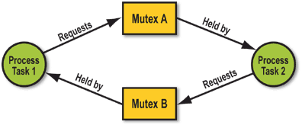
With this, a program can wait for another program to liberate memory. But if this program is also waiting for our program to liberate the memory, the system will be blocked forever. This is what we call deadlock. When you write your program you must consider this very carefully because if this happen on your assembly line, she will no longer produce the desired output which, in a big company, can lead to huge losses.

Priority

Some process (a process is a running program) will sometimes need another process in an assembly line. For example, a process can be used to refresh the sensors state in the computer memory and another process can react to some sensors change. If the process who refresh the sensors is not running, the second process will run for nothing. The dispatcher must give more time to the process who refresh the sensors and less time to the second process. This is what we call priority.

Robot

In this chapter I will try to show you what kind of hardware can need a “System programmer”.

Assembly line

This kind of robot can be very simple (like PETRA) or very complex (like on this picture).
The purpose of this robot is to produce as many as possible output with can be a car, a train, a plane, a screw, …

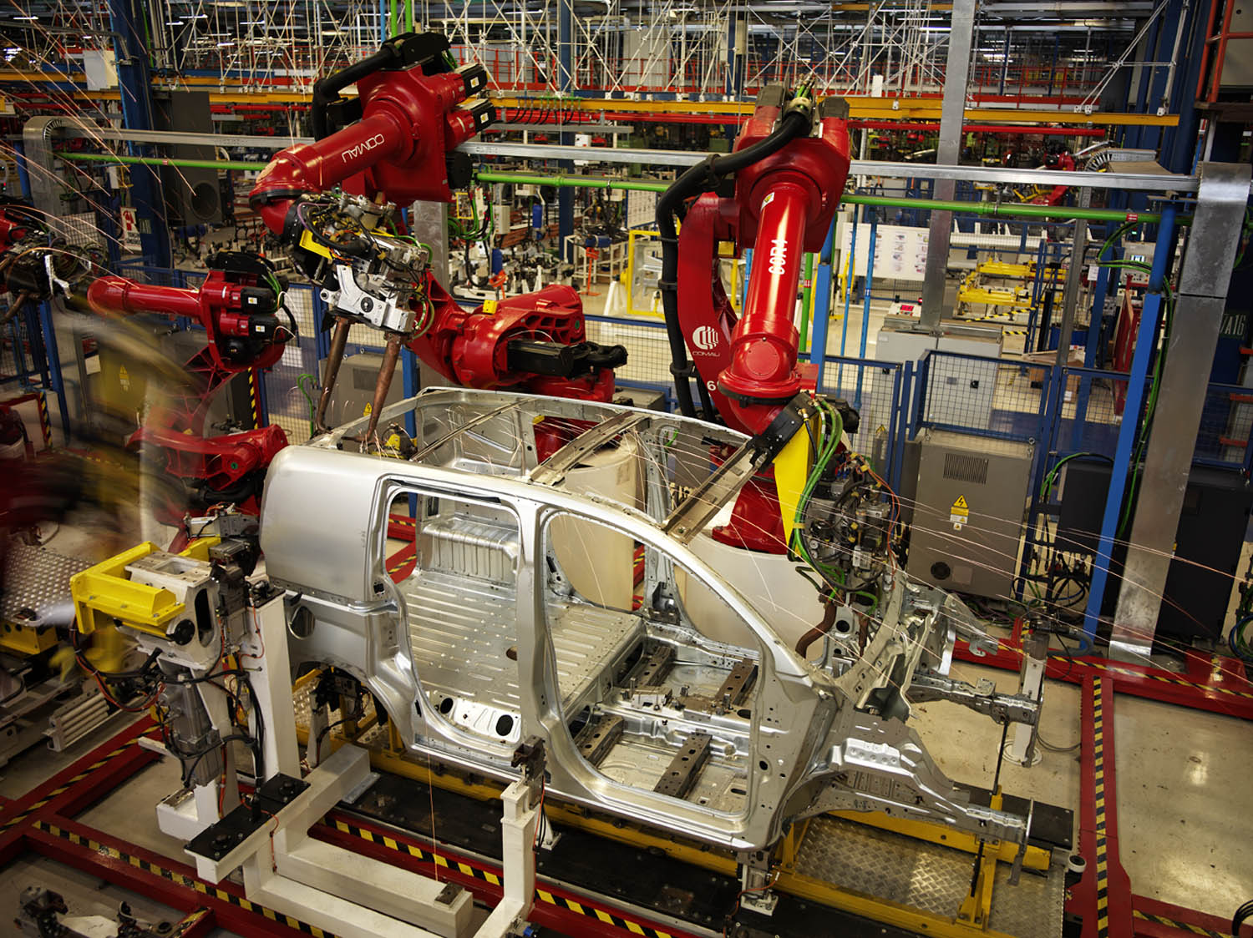

Boe-bot

A boe-bot is a small robot with 3 wheels (two of them can be controlled) and many other sensors. It is controlled by a PCB (electronic board) located on the top of the boe-bot.
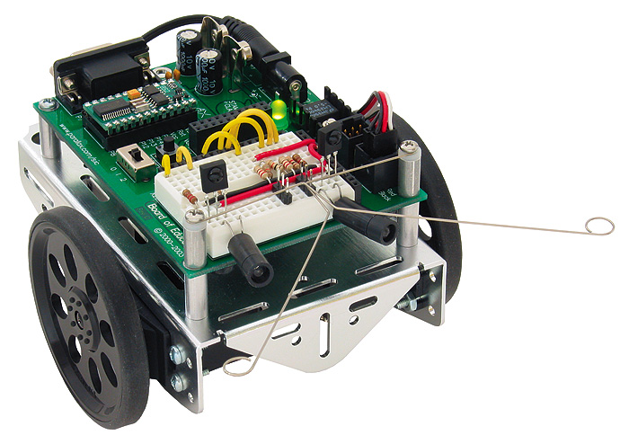

Quad-copter

This kind of robot can be controlled with a smart-phone. It is the most accessible robot.

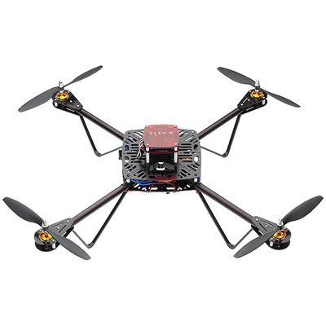

Conclusion

In this paper I have tried to provide answers to a list of frequently asked question that I was given. I am going to answer to each of them separately with the rest of this document in mind.

Q: Does “System(s) programming” refer to electronic systems or to operating systems ?

A: It refer to operating systems, but since the react time is a key in “System(s) programming”, you have to take care of the electronic system as well because a given hardware can react in a given time to a given input where another hardware will not react in the same time.

Q: What is the best system programming language ?

A: There is no such thing, some language are better than others but it's up to the programmer to choose between all the language for a given problem. The only constraint for me is that you have to choose a compiled language and not an interpreted one because they are much slower (and therefore, can not react in a good time to an input).

Q: What are the main problems encountered with SP ?

A: For me, the main problem in system programming is the deadlock, which may result in being fired.

Q: Could you by any chance explain what ‘real time SP’ is and what it’s used for ?

A: It is the is the activity of programming system software which can be used on an assembly line and many other robots.

Bibliography

Website
- https://en.wikipedia.org/wiki/System_programming – Wikipedia
- http://www.barrgroup.com/Embedded-Systems/Glossary-D – Barr group
- http://www.topendsports.com/testing/reaction-tests.htm – Top end Sports
- http://www.psa-peugeot-citroen-press.co.uk/releases-2007.php – Citroen
- https://secure.robotshop.com/parallax-elev-8-quadcopter-uav.html – Parallax

Literature

- Mr. Starzack's book about POSIX 1b and “System Programming”

