Professor Peter Dodds

Introduction to Complex Systems, University of Vermont

Sunday, November 20, 2022

**Fractal Analysis of Crime Baltimore Police District Crime Reports.**

**Frederick R. Carlson**

Introduction. The crime problem in Baltimore has been persistent for decades and has been rated as the number one public problem in the city for at least the last ten years. The city of Baltimore keeps excellent data on crime events over the last 10 years. Critically these cases all have position, location and time values.

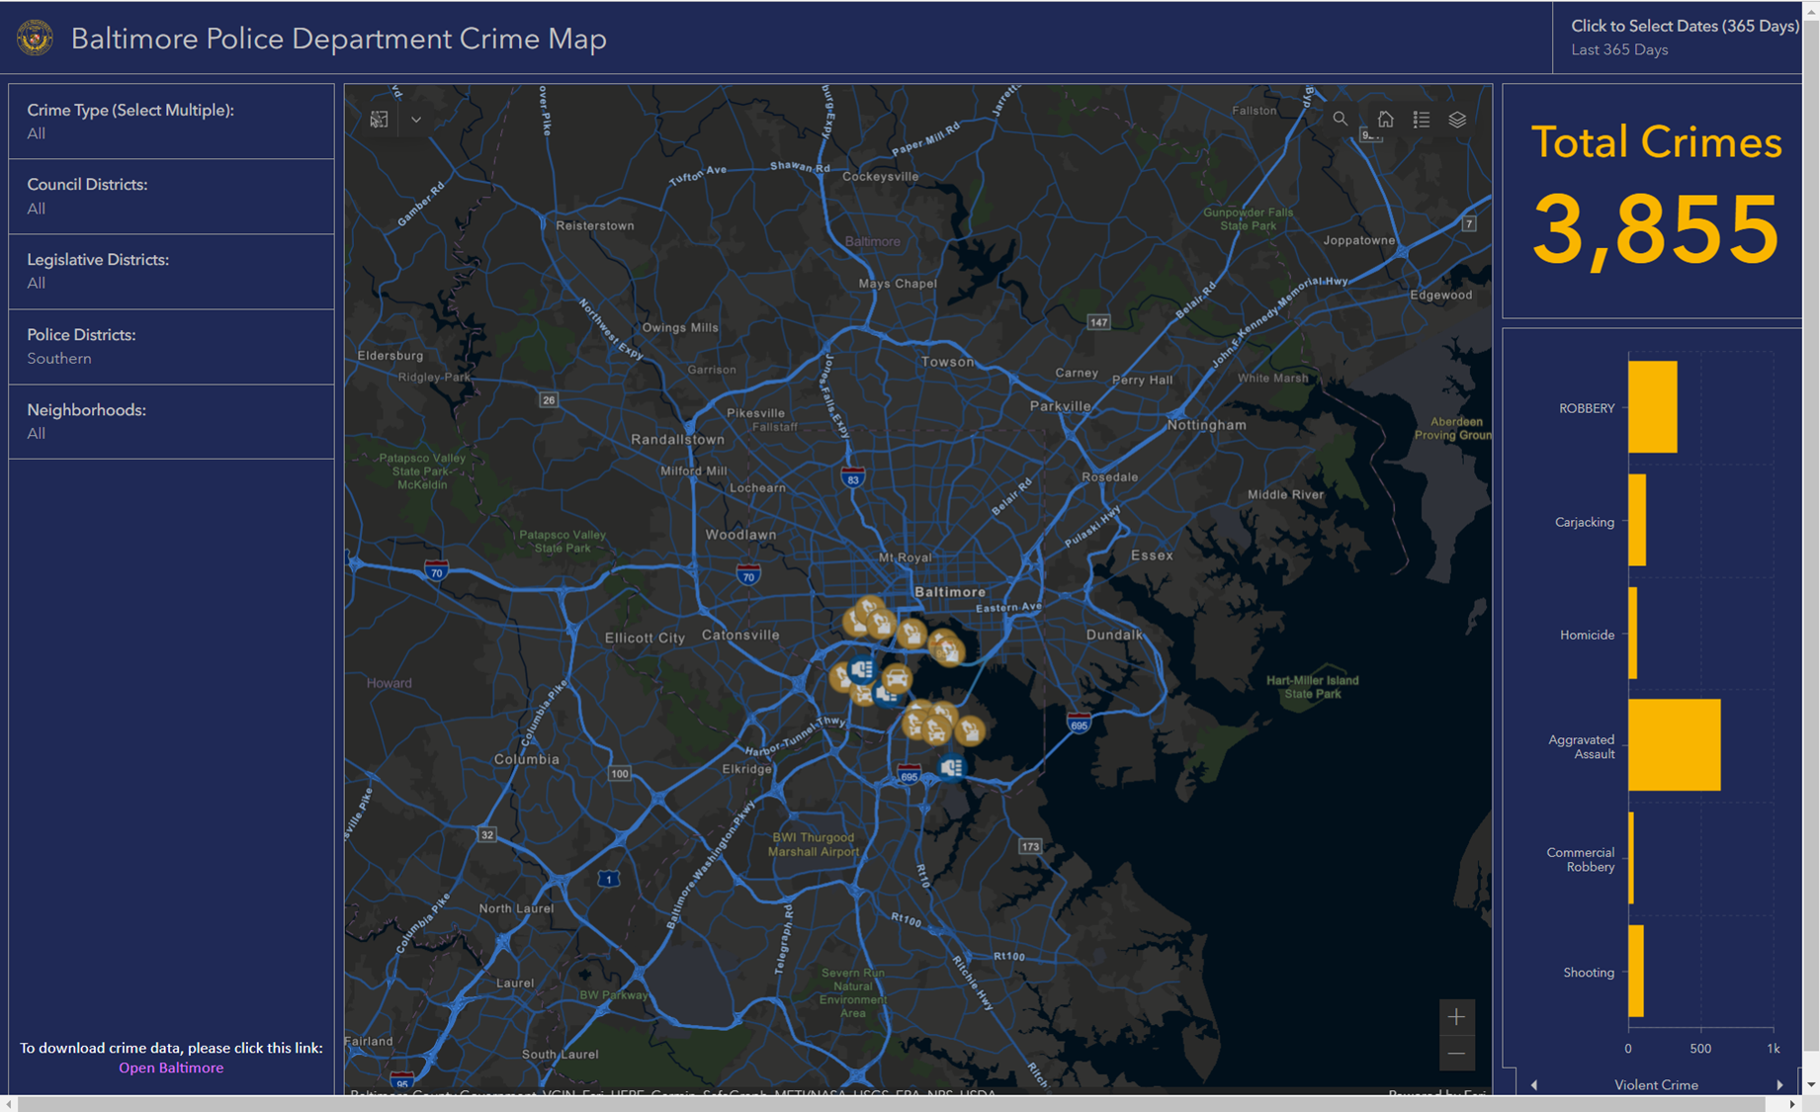

The dataset is from the Open Baltimore project. Below is an example of the results from the Geographic Information system. This is where the majority of the data will be obtained for this project.

The ultimate Goal of this project is to see if there are dramatically different Rescaled Range Analysis across districts and then cross check to see if persistence in urban blight causes persistence in crime. This paper is the first step in this effort, which is to get a complex systems view of the districts crime data.  
  
Before we do the Rescaled Range Analysis, it makes sense to do some descriptive statistics to get a lay of the land.

Below is a snapshot of the complete crime reports in Baltimore over the last 10 years.

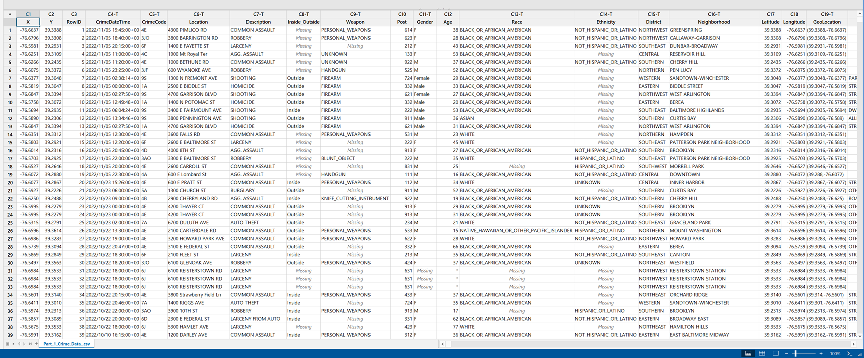

Figure - Baltimore Crime Dataset

Below is a chart breaking down the aggregate crime counts in Baltimore varied by the nine police districts. Note that the Northeast and Southeast Districts dominate the aggregate numbers of crime. This was an unexpected finding.

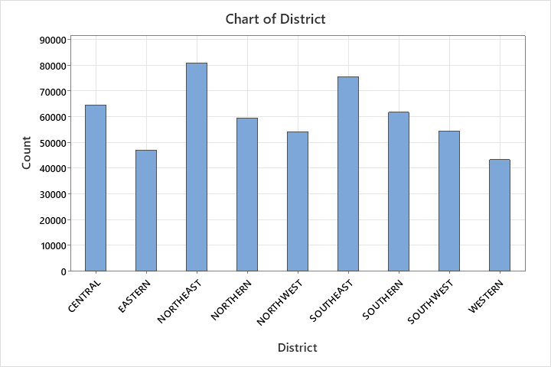

Figure - Crime by Baltimore District 2012-2022

The next chart shows the type of crime in the aggregate over the last ten years.

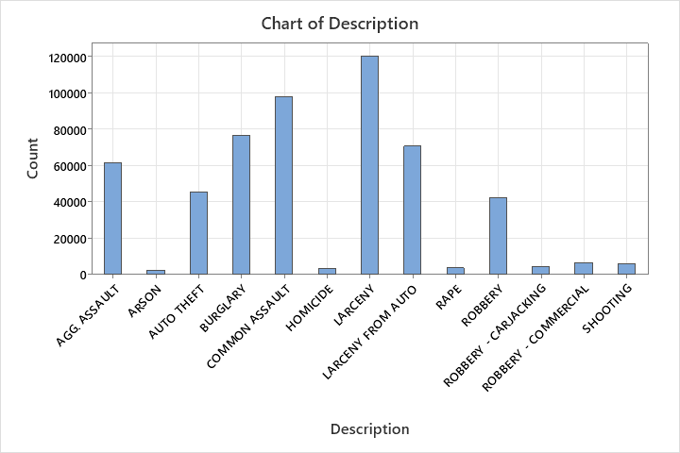

Figure - Crime by Type 2012-2022

The next chart shows the crime in the Southwestern District, by neighborhood.

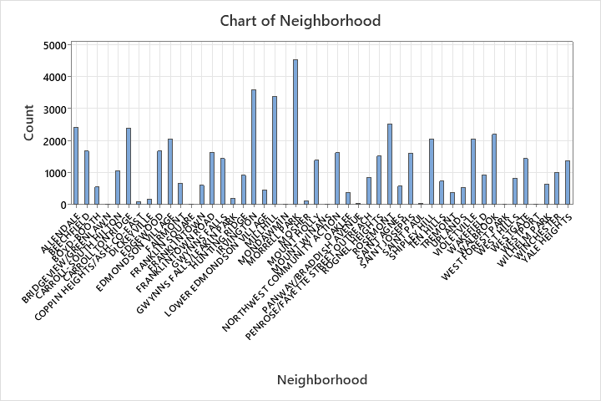

The next chart shows the lat-long of crime in Baltimore. Note how it outlines the city.

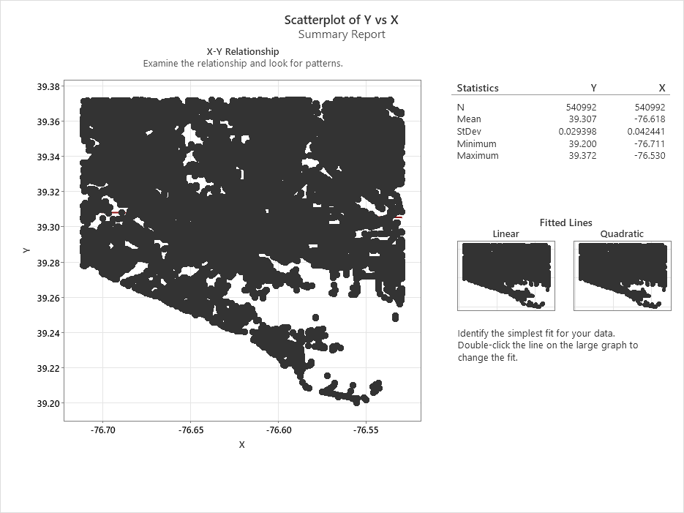

The next chart shows the lat-long of crime by type

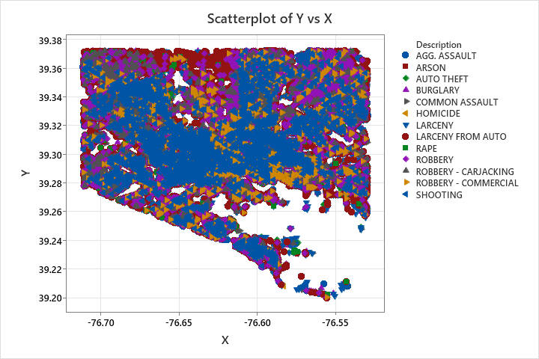

Next Chart Shows a Rescaled Range analysis and Hurst Exponent of 0.608.

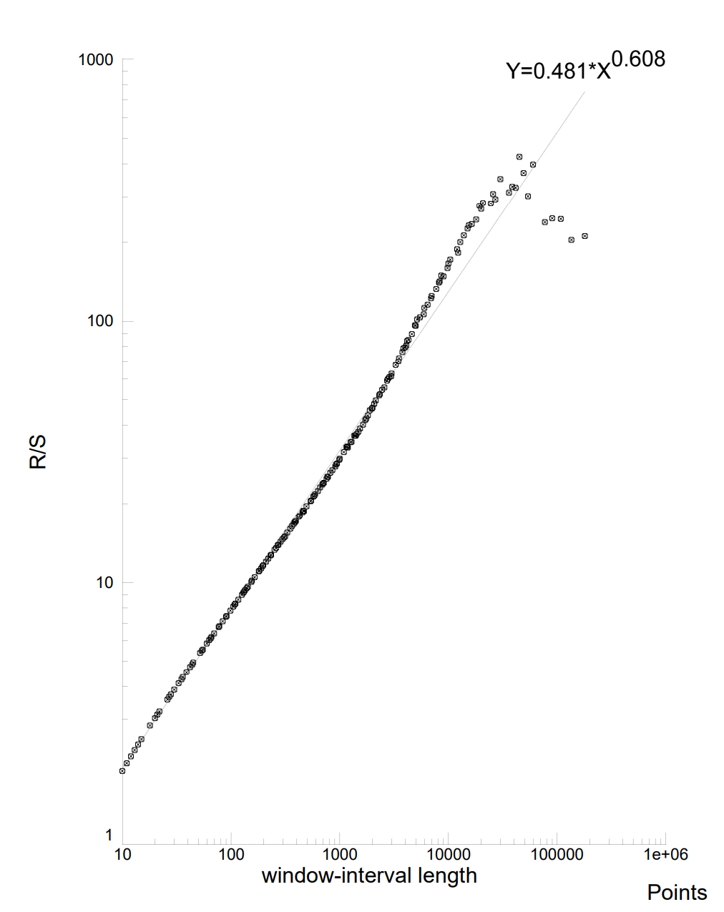

This Rescaled Range analysis and Hurst Exponent of 0.608 which is very close to a H of 0.625 in Varma’s analysis of Vancouver Crime Data.

Notes

<$--ENDNOTES-->

Works Cited

Multifractal Approach to the Analysis of Crime Dynamics: Results for Burglary in San Francisco – Melgarejo and Obergon

Fractal Dimension of Policing - Verma